 | MAY 2024
 | AMAZING GRACE  CONNECTIONS  Faith > Family > Community
Grace Lutheran Church of Lily Lake
5N600 Hanson Rd, St. Charles, IL 60175
Pastor David Mercurio

Worship every Sunday
At 9:30 am with Communion
- May 5 – Worship with Sunday School and coffee hour
- May 12 – Worship,
- May 19 – Worship with Sunday School
- May 26 – Worship

- June 2 – Indoor worship with coffee hour and Congregational meeting
Outdoor worship will begin on Sunday, June 9th.


This Photo by Unknown Author is licensed under CC BY-NC-ND
SUNDAY SCHOOL
Sunday School for 3 through 13 year olds EVERY 1ST and 3RD SUNDAY at 9:30 am in the Grace Room.
May dates are Sundays the 5th and 19th.
Then summer break until September.

CONGREGATIONAL MEETING, Sunday, June 2nd following worship: quorum of at least 32 members needed. Vote to be taken to approve the 2023 Audit. Discussion will also include our mortgage, update on the boiler and possible new use of some basement space.
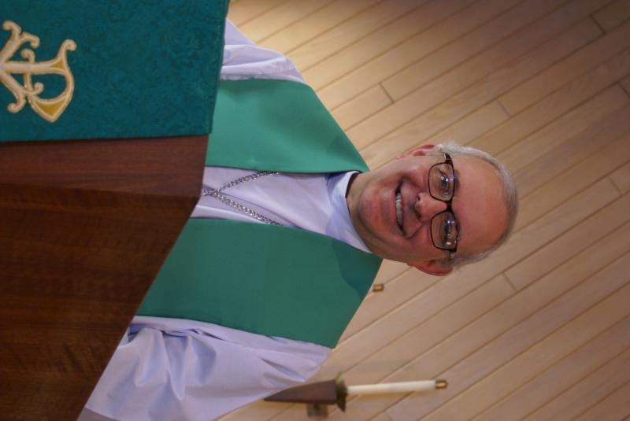
FROM the DESK of PASTOR DAVID, May 2024

The eighteenth-century poet Alexander Pope wrote that hope springs eternal. I just hope that spring replaces what seems like an eternal winter. Regardless of my meteorological musings, there is much to be excited about. Our new Vision Team is already hard at work managing the “business” of running a church and they are prioritizing two of our most pressing challenges: our mortgage and our boiler. I know that God is guiding them with great wisdom.
Our weekly attendance remains the highest it has been in the last three years, and we are seeing both new and returning members. Keep an eye out for a new Eagle Scout project and a new Girl Scout project on our grounds this summer. Our children’s Sunday School teachers are doing an awesome job with a growing number of kids. I know this to be true because I see their smiling faces after each class. Thank you again Pat, Nancy, Janice, and Natalia.
I’m very excited about the rest of 2024. We’re looking forward to the first of our two rummage sales in May. These are great fun, we meet many new folks, and the money raised helps to support our mission. I’m already working on our Lenten study series. And there is a new community project being worked on that has the potential to add even more blood to the veins of Grace Lutheran Church. It's too early to reveal any details yet, but I will definitely provide updates at the appropriate time.
It's an exciting time to be a member of Grace and I encourage everyone to become even more active in our programs here. I promise you will get back tenfold what you give in time and effort. May our God continue to bless you and your families this year as your witness gives hope and light to the world around us.
Blessings to you.
Pastor David
Pastor’s Hours: Tuesdays and Thursdays from 6 pm – 9 pm, and Sundays from 8:30 am for 3-4 hours and by appointment when requested.


MANY THANKS AND PRAYERS TO THOSE WHO HAVE RECENTLY DONATED THEIR TIME AND TALENTS, including, but not limited to:

- .All those who assisted with the spaghetti dinner on May 13th, especially our coordinator, George Theros
- All those who participate in our prayer chain. If you are interested in joining the chain, please contact Kathy Hooey
- Trish Painter, Cathy Whiteside and Linda Smykowski for all the pre-rummage sale work that has already been done. See below for drop off times and sale times.
- Nancy Corbige for teaching the weekly line dancing event (It has been very successful for over a year. Last class before summer break is May 8. She also sends out our weekly Eblasts!
- The choir for all the wonderful music the last few weeks and Twyla and Lee for a “beautiful” duet last Sunday and Natalia’s beautiful piano playing
FINANCIAL MATTERS –MAY 2024
- Our Easter Breakfast raised $290 in freewill offerings. The community spaghetti dinner on April 13, raised $853, and half of these proceeds will be shared with Northern IL Food Bank.

- Thrivent Choice Dollars received in the 1st qtr 2024 = $1,370. Funds were designated to Grace of Lily Lake by the Thrivent member. Our Grace gratitude to members, and non-members, who selected Grace as the recipient.

- Nancy Corbige has graciously shared her time, talents and leadership with bringing line-dancing to Grace AND our community, on Wednesday evenings. Fun, fellowship and exercise in our community = has also raised over $1,200.

- The Building Maintenance Team continues to address building and safety needs. If you wish to donate to this specific fund, please notate “Building Maintenance Fund”, so the donation will be designated accordingly. Present Building Maintenance Fund balance is $7,880.
Brief recap of March financials:
2024 2023
March 2024 Year-to-Date Year-to-Date

INCOME $ 23,225 $ 53,864 $ 49,654
EXPENSES $ 16,074 $ 45,237 $ 47,757
NET +/- $ 7,151 $ 8,627 $ 1,897

Pray for blessings upon Grace as we continue our missions with goals and challenges. Tricia Painter

APRIL VISION TEAM REPORT
- Approved minutes and treasurer’s report from March
- An average of 30 people attended the Lenten study series each week
- A Mortgage Committee has been formed to find more ways to address this cost
- Discussion of possible new use for basement space is in progress
- New office phones have been purchased due to problems with our very old phones
- The main lawn mower has been serviced and repaired (very few repairs were needed and a new battery was installed)
- Approved having the Fellowship Hall floor cleaned sometime early/mid June (it has not been cleaned for many years)
- There will be a workday (clean up, minor repairs, etc.) at church on Saturday, June 29th at 9 am. Many helpers will be needed
- Dallas is working with our insurance company regarding our need to replace the boiler
Grace music and arts forum


The purpose of the Grace Music Arts Forum is to foster and further the development of music and arts at Grace Lutheran Church and in the greater Lily Lake community, including Music/Art Studies, Music/Art Events or Music/Art Lessons and fundraising. A yearly amount up to $500.00, which is administered by the Rebecca Circle, is available. Applications are due by September 1, 2024. Please contact Twyla Strom if you are interested.

UPCOMING SPECIAL DATES
- ADOPT-A-HIGHWAY SATURDAY, MAY 4TH AT 8 AM. We will meet in Fellowship Hall with the Scouts for clean-up on Empire Road. Wear you protective boots or shoes (nothing open-toed), long pants suggested and your gloves and poking sticks. With 2 sets of groups working, we are usually completed within 3 hours. There will be a sign-up sheet on the bulleting board in the gathering area.
- LINE DANCING every Wednesday from 6-7 pm in the Fellowship
Hall. Last class before summer break is May 8th.
- SUNDAY, JUNE 2ND – INDOOR WORSHIP, COFFEE HOUR AND CONGREGATIONAL MEETING – quorum is needed!
- SUNDAY, JUNE 9TH – Outdoor worship begins
- SATURDAY, JUNE 29TH at 9 am – CLEAN UP DAY AT CHURCH! Lots of hands are needed.


REBECCA CIRCLE

PLEASE JOIN US on May 21st for our REBECCA CIRCLE meeting. We'll gather in the Fellowship Hall at 1pm to continue planning for the year and share your ideas. We will also celebrate the lives of Lee Gerke, Eileen Morris and Marlene Klingner, so bring your memories!

Please don't forget your roll call items - food for the Elburn Food Pantry These donations have been a project of ours for many years and many of our members are active in the food pantry. Especially needed: low sugar “adult” cereals.
Looking forward: July meeting will be our annual picnic.
SPRING RUMMAGE 

We are getting ready for our Spring Rummage Sale on May 17 (9am-4pm) and May 18 (9am-2pm) - please mark your calendars ~
We kindly ask that you hold your donations until May as we are trying to not clutter up entryways, doorways, walkways, etc. We are scheduled for a fire inspection in April. If you have items that can be stored in the garage (nothing with cloth or fabric please), stored in critter proof containers - please contact Linda Smykowski to coordinate drop-off (708-309-3444). If you have a clothing donation, please contact Cathy Whiteside (630-605-1096) - **she collects clothing year-round & pls contact Cathy if you can help throughout the year also**
Also, when considering your donations, please ask yourself "would I purchase this?, does it work/operational?, are the cords or all pieces intact?, doesn't smell like smoke and free of pet hair?, it is (fairly) clean, etc.?" - if not, please understand if we say 'no thank you' - we don't have the volunteers nor time to go through it all. As a reminder, we cannot accept TV cabinets, older TVs, and large furniture pieces. Thank you for your understanding and cooperation.
MAY - Drop-Off Times:
Monday, May 13 - 6-7pm
Tuesday, May 14 - various times - pls watch weekly announcements
Wednesday, May 15 - 10am - 6pm
Thursday, May 16 - 10am-3pm; set-up volunteers needed throughout the day
Friday, May 17 - volunteers needed all day of sale (9am-4pm)
Saturday, May 18 - volunteers needed all day of sale (9am-2pm) & sale clean-up - 2pm until ??
Any further questions, please contact me = Tricia Painter, 708-624-0400 (leave message or text)

 ROAD RUNNERS TRIP 2024
Registration for the September Roadrunner trip has begun. We will be leaving Grace on Sunday, September 15th and return Saturday, September 21^{st.} Some places we’ll be visiting are Anakeesta: a new attraction in Gatlinburg, Dollywood, the Island in Pigeon Forge, The Biltmore in NC and Brushy Penitentiary. The estimated cost of this trip will be $1400-$1450. Registration forms will be in the Roadrunner mailbox in the church office or see Suzanne Girsch.

NOISY OFFERING
Every Sunday we collect a “noisy offering” when you wish to empty your change purse or pockets. We are currently collecting for maintenance items, including our boiler. Thank you.

COVID 19, FLU AND RSV SAFETY PROTOCOLS
We follow the recommendations of the CDC, ELCA and IL Department of Health.
If you wish to mask and social distance, please do so. Please do not come to church if
have symptoms of illness. If you do not feel comfortable worshipping with others, we invite
you to join us for worship via our website.

CONTACTS:
For emergencies, please contact the church office at 630-365-6751.
For prayer requests or other needs please call Kathy Hooey at 630-341-2293 or leave a message at the church office at 630-365-6751. Messages are checked daily at noon & 5 pm.

Information for the June newsletter will be due by May 25th – please send it to Marty Bradley at martybradley@mchsi.com. Thank you

