 | MAY 2026
 | AMAZING GRACE  CONNECTIONS  Faith > Family > Community
Grace Lutheran Church of Lily Lake
5N600 Hanson Rd, St. Charles, IL 60175
Pastor David Mercurio

Worship every Sunday
At 9:30 am with CommUNION
- May 3 – Worship, Sunday School and Coffee Hour
- May 10 – Worship
- May 17 – Worship and last Sunday School class of the school year
- May 24 – Pentecost Sunday Worship
- May 31 – Worship

THE EASTER SEASON in the Lutheran Church is a 50-day celebration of Christ’s resurrection, marked by joy, liturgical festivity, and reflection on new life in Christ.
It begins on Easter Sunday and lasts for seven weeks, culminating on Pentecost. It is considered the high point of the Christian church year, celebrating the resurrection of Jesus Christ and the gift of new life through baptism. This period emphasizes grace, justification, and the transformative power of the resurrection, encouraging believers to live as holy people in response to God’s gift.
We light the paschal (Christ) candle at every service as a symbol of the risen Christ. We use white and gold liturgical colors, symbolizing joy and victory.
We proclaim the Easter greeting: “Alleluia! Christ is risen! Christ is risen indeed! Alleluia!” throughout the season.


This Photo by Unknown Author is licensed under CC BY-NC-ND
PENTECOST SUNDAY, MAY 24, 2026
Pentecost in the Lutheran tradition celebrates the outpouring of the Holy Spirit marking the birth of the Christian Church and the fulfillment of Christs promise to his disciples. Pentecost, from the Greek Pentecoste meaning “fiftieth,” occurs fifty days after Easter, concluding the Easter season and commemorating the sending of the Holy Spirit upon the apostles (Acts 2:16). This event empowered the disciples to speak in various languages, enabling the Gospel to reach all nations, and led to the baptism of about 3,000 people, symbolizing the first “in-gathering” of believers into the church.
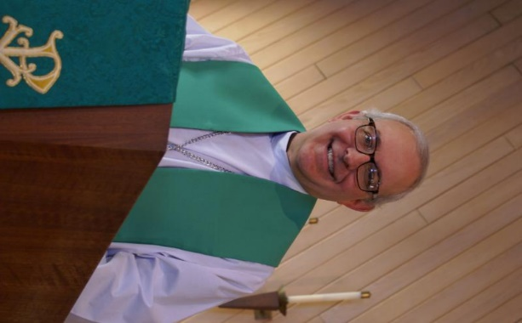
FROM PASTOR DAVID, MAY 2026

What an amazing Lenten Season we have just gone through. We started out with a blessed Ash Wednesday morning of service at the Elburn Train Station with the help of Nancy Burtnette and Steve Butcher. We had more people requesting ashes than we’ve had in years, including two Elburn detectives who came by specifically to receive a blessing! We then had an average weekly attendance of twenty at our Lenten Bible study on Judaism, during which we all learned a great deal about our common heritage.

On Maundy Thursday, we held our Seder Dinner celebration of Passover/
The Last Supper with 29 in attendance. A big shoutout to all the volunteers who put it together, especially Marty Bradley, for organizing the entire event. We then enjoyed a community Good Friday Service with Burlington Methodist Church and Country Covenant Church with 49 in attendance. It all came to a glorious conclusion with our Easter Service with 108 in attendance!

Now we enter what is known in the Church Calendar as “Ordinary Time.” This doesn’t mean it is unimportant or uneventful. The word “ordinary” refers to an order of things. It is a time to focus our attention on one of the four Gospels, and it carries us to Advent before Christmas. The Book of Ecclesiastes tells us:
“There is a time for everything, and a season for every activity under the heavens.”
And the same is true with life in the Church. The Christian life is a marathon, not a sprint. So, as we go into “ordinary time,” don’t think of it as routine, rather see it as a time we can continue to meet and greet, to worship the Lord, and to serve each other and our neighbors. God has great things in store for Grace Lutheran Church!

Pastor’s Hours: Mondays, Wednesdays and Fridays plus Sundays and as needed and by appointment when requested.

SPECIAL THANKS TO ALL WHO HAVE GIVEN OF THEIR TIME, TALENT AND GIFTS
- All who assisted with worship in April!
- Marty would like to especially thank Nancy Burtnette, Kathy Hooey, Helen Gurber and Vickie Linden for set up and food assistance and others who assisted with preparation of food for the Seder Meal.
- Ann Butcher, Rebecca Circle and helpers for putting together the Bread Monk program.
- Twyla Strom, Kathy Hooey for purchasing our flowers and those who sign up to donate them and deliver some to our homebound as needed.
- Janice Muncie (Director/teacher) and Donna Scola (teacher) of our wonderful Preschool.

VISION TEAM REPORT
If you have any questions or concerns, please contact a Vision Team member:
Dallas Peters (President), Steve Butcher, Cathy Lindquist, Nancy Schnaitman, & Lee Strom
At their April meeting the Vision Team:
- Approved minutes and treasurer’s reports
- Pat Penfold and Dottie Mantsch to represent us at the Chicago Synod annual meeting in June. A new bishop for the Chicago Synod will be elected.
- Annual insurance quote is just over $310 over our current budget.
- Process for replacing bulbs in the sanctuary is in process using a rented lift.
- Norm Turner and Ann and Steve Butcher will be assisting with our clothing drive.
- Cathy Whiteside is stepping down from her volunteer work.
- Discussed providing meals to members as needed.
- Linda Smykowski has volunteered to open the building as needed when Ian Engberg is not available.
- The tech assistant program is $565 monthly, currently $1,147 over our annual budget.
A new ladder was purchased for Grace. Dallas & Kurt will be checking/cleaning gutters.
- Masonry repairs have begun.
- Pending maintenance items include: parking lots, baggy carpet, pavilion roof leak and what to do with the parsonage.

FINANCIAL MATTERS – MARCH 2026
Brief recap of April financials:
“He is Risen Indeed” ~ April was a very busy month with joyful Easter preparations.
- Easter events: Lenten Bible Study, Maundy Thursday Seder dinner, Good Friday Community Service, Easter celebration service. Our thanks for hosts: Cara and Ken Kusch for our Easter Breakfast. We received $464 in freewill offering and allocated funds to the Cap. Improvement savings.
- If you wish to donate to the Capital Improvements savings fund, please note that on your donation. This fund is for repairs and maintenance on our church home - project at hand is the structural pillar repair.
- We thank members who have designated their donations via retirement fund accounts – saving them tax dollars, and for the Thrivent members who have designated their Choice Dollars to Grace.
- Grateful thanks to Norm Turner for several donations of printer ink cartridges, to Pat/Chili Lindgren for their donations of cases of copy paper, Tricia Painter for a roll of postage stamps – all donations help to offset costs of church activities.

March 2026 March 2026 2025
Year-to-date Year-to-date Year-to-date
INCOME $ 25849 $ 67,673 $ 103,385
EXPENSES $ 31,762 $ 69,272 $ 57,047
NET +/- $ -5,913 $ -1,599 $ 46,448

Submitted by Tricia Painter, Treasurer

MEET THE LINDGREN’S May 2026

Pat and Chili Lindgren have been members of Grace of Lily Lake for 56 years !! They had been members at St. Peter’s Lutheran Church North Plato before joining Grace in 1970.
Pat was born in Elgin and grew up on a farm in Plato Township. Chili was born in Sycamore and grew up on a farm. Charles got his nickname, Chili, from his mom’s hotdish that was like a goulash, but they called it chili. Pat’s uncle set them up on a blind date, and the rest is history!
Before Pat and Chili got married, Chili served 2 years in the Army. They celebrated their 63rd wedding anniversary on April 20th this year.
They built their first ranch home nearby on Rt. 64. As their family grew, they moved to a 2-story home on McDonald Rd. between Rt 47 and Burlington Rd. After 36 years there, they downsized and now live in the Edgewater Del Webb Community for the past 13 years.
Chili worked for the Kane County Highway Dept. for 35 years, and often worked 2 jobs allowing Pat to stay home with their children. Pat worked in various secretarial and accounting jobs. After the children were older, Pat worked in the Kane County Supervisor of Assessments office for 28 years, working her way up to the position of Chief Deputy. Pat served in the church choir, women’s groups, altar committee and as a lector.
Pat and Chili have 3 children: Sandy (Bloomington, IL), Brad (MN), Mark (MO). All 3 where confirmed at Grace. They have 9 grandchildren (5 girls and 4 boys) and 2 great granddaughters, 1 great grandson and another great grandson expected in October.
In their retirement years, Pat and Chili have enjoyed traveling to Alaska, Colorado, Arizona, Florida and on a cruise. They also have a trailer on Bass Lake in MN. They try to get as many family members there for a week in the summer!
Chili has survived cancer and Pat has had a handful of surgeries in the past 10 years. Pat will be 83 in May, Chili will be 92 in August. They miss everyone at Grace and are not able to get to our services or events.

They “send their wishes and welcome visitors at any time.”


REBECCA CIRCLE
Rebecca Circle will meet on May 19th at 1 pm in Fellowship Hall. Kathy Hooey and Linda Symkowski are the hostesses for this month. We could still use a few volunteers to help take plants to our homebound members. We will need 1 or 2 members to take geraniums after Pentecost Sunday on May 24th. Please let Twyla Strom (847-977-5891) know if you can help in this way.
As always, the Elburn Food Pantry can use donations - consider ketchup, mustard, baking mixes, chili or canned stew, etc.

Geranium orders for Pentecost: $5.00 each or buy 4 and get 1 free. Return the form (in the pews) along with payment by May 17th. Please make checks out to Grace Lutheran Church and put in an envelope marked “Geranium” and put in the offering plate. We have only ordered 140, so get your orders in right away!


RUMMAGE SALE, MAY 15 & 16

We are on the final prep weeks for our Spring Rummage Sale on May 15 (9am-4pm) and May 16 (9am-2pm) ~ please mark your calendars ~

Requesting "seasonal" (spring and summer clothing donations) to be dropped off on Sunday mornings OR during the week left between the double entryway on upper level. Please write on the bag or box that it is for “Rummage Clothing sale”. Thank you.

If you have items that can be stored in the garage (nothing with cloth or fabric please) or stored in critter proof containers - please contact Linda Smykowski to coordinate drop-off (708-309-3444).

Please note, when considering your donations, please ask yourself "would I purchase this?, does it work/operational?, are the cords or all pieces intact?, doesn't smell like smoke and free of pet hair?, it is (fairly) clean, etc.?" if not, please understand if we say 'no thank you' - we don't have the volunteers nor time to go through it all. As a reminder, we cannot accept TV cabinets, older TVs, and large furniture pieces. Thank you for your understanding and cooperation.
MAY - Drop-Off Times:
Tues. May 12 - various times - please contact Linda or Tricia
Weds. May 13 - donations accepted 10am - 4pm; volunteer sale set-up hours anytime 10am - 5pm
Thurs. May 14 - donations accepted 10am-3pm; volunteer sale set-up hours anytime 10am - 5pm;
Friday May 15 - volunteers needed all day of sale (9am-4pm) & Saturday, May 16 - volunteers needed
all day of sale (9am-2pm) & sale clean-up - 2pm until ??

Further questions, please contact Tricia Painter, 708-624-0400 (leave message or text)

PRESCHOOL NEWS from Janice Muncie, Director
Grace Lutheran Church Preschool takes place every Monday and Wednesday from 9:15am to 1:15pm during the school year. We will be adding a 2 year old class on Tuesdays from 8:45am to 10:45am in the fall of 2026. We are full for the Monday/Wednesday class with one on the waiting list. We have 4 signed up for the 2 year old class (maximum is 8). Thank you God for continuing to expand this program.

ROADRUNNERS 2026 TRIP

The next Roadrunners trip is scheduled for September
21-25 (or 26), 2026. We will be going to Frankenmuth, Michigan. Save the dates – more information to come.

NOISY OFFERING Every Sunday we collect a “noisy offering” when you wish to empty your change purse or pockets. We are currently collecting for maintenance items. Thank you.

SPECIAL MINISTRY INFORMATION
Bridge to Life Group’s Jesus Closet (homeless in Elgin): Items needed are backpacks, blankets, gym shoes, t-shirts, jeans, coats and socks. Thank you for all the donations. Clothing and miscellaneous items for those in need in Chicago are collected and given to Pastor Anna-Kari Johnson for distribution in Chicago. Thank you to all who donate. A new volunteer is need to continue to coordinate this ministry. Let Pastor know if you can help.

HABITAT FOR HUMANITY - POTTAWATOMIE
Grace Lutheran is a partnership church. Nancy Corbige, our representative to Habitat for Humanity, reports that they have started building a new house in St. Charles, north of Rte 64 and that volunteers are needed. Times you may volunteer include, Wednesday, Friday or Saturday from 8:30 am to 4 pm.
If you can volunteer a day or more, please send your name and email address to Nancy at ncorbige@gmail.com. She will keep us updated on the progress of the build. Volunteers do a variety of jobs, including providing lunches, doing clean up, painting and construction work.

MISCELLANOUS INFORMATION
- SPECIAL TECH NEED: Are you familiar with IT / computer technology / streaming ?? We are asking for several people to become familiar with or learn the technology that we use to record our church services with. Seeking several people so we will be able to spread out the weekly tasks ~ contact Pastor or Tricia Painter
- If you can knit or crochet, we need you to help make more prayer shawls as we are running low. We have the yarn so please contact Helen Gruber if you can help. If you know of someone needing a PRAYER SHAWL, please let Twyla Strom know.
- The Finance Team is looking for volunteers to sign up as counters (counting our weekly offerings after worship). Please see Linda Smykowski or Tricia Painter.

CONTACTS:
For emergencies, please contact the church office at 630-365-6751. For prayer requests or other needs please call Kathy Hooey at 630-341-2293 or leave a message at the church office at 630-365-6751. Messages are checked daily at noon & 5 pm.

Information for the June newsletter will be due by May 25th– please send items to Marty Bradley at masbradley50@gmail.com. Thank you

SEDER MEAL SET UP
Showing the Christ table, foot washing area
and head table/lecturn
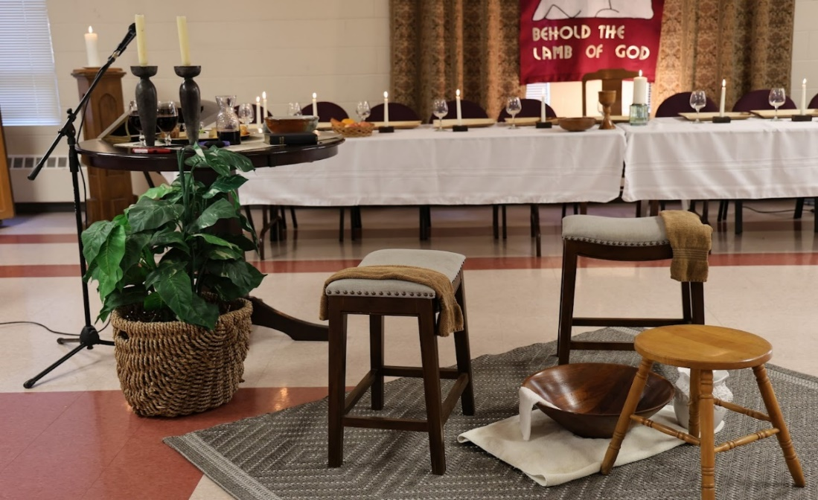

EASTER AT GRACE
