.APRIL 2022, VOL. 28
 | AMAZING  GRACE  CONNECTIONS
Our Mission: faith > family > community

Welcome to Amazing Grace Connections, the newsletter of Grace Lutheran Church of Lily Lake.  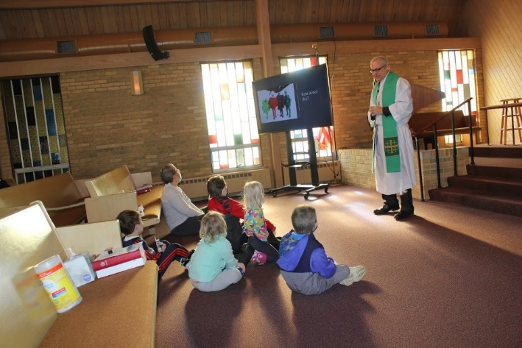  Pastor David Mercurio  Join us for Worship every Sunday at 9 am |   Holy Week Schedule  Palm Sunday, April 10  9 am Worship & Baptism  Maundy Thursday, April 14  6 pm Seder & Communion Reservations required  by Thursday, April 7th  Good Friday, April 15  7 pm Community Service  Worship Service at Country Covenant Church  (43W510 McDonald Rd. Elgin IL 60121)  Easter Sunday, April 17  9 am Worship & Baptism  Coffee hour following
GRACE LUTHERAN CHURCH
5N600 Hanson Road
St. Charles, IL 60175
630-365-6751
Graceoflilylake.com
ELCA

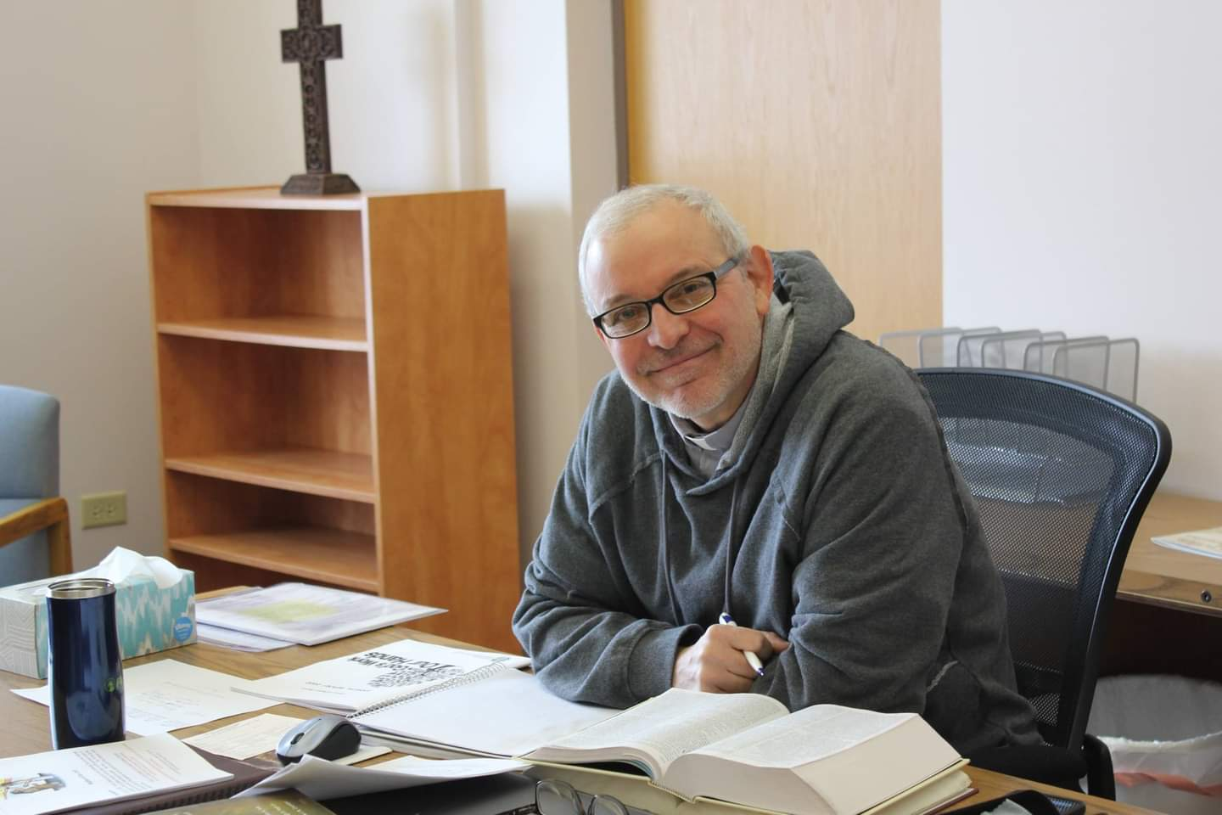
PASTORS MESSAGE
Grace Newsletter April 2022
Greetings to the Grace Lutheran Church community. This month we celebrate our most blessed event of the year, the risen Christ. While Easter is a time to praise our God for the incalculable gift of salvation we have been given, it is easy to be discouraged and have doubt. Will Covid ever go away? Will the war in Eastern Europe spread? Will my budget survive these higher prices? Will I stay (or ever get) healthy? As Jesus teaches us in the parable of the barren fig tree (Luke 13: 1-9), we are fallen people who live in a fallen world. As a result, we are not immune from the trials and tragedies that befall all humanity. But if we keep an eternal perspective and stay faithful to our Lord, then “our light and momentary troubles [will] achieve for us an eternal glory that far outweighs them all.” (2 Cor. 4).

On the positive side, we have started up our Children’s ministry which is going very well and causing great excitement for the children. We have a number of baptisms planned for this month and spring is finally in the air. Don’t limit your expectations of what remarkable things Our Father has planned for us this year, for our God is an awesome God. May He bless you and your family richly this Easter season.

Blessings to you,
Pastor David
Pastor’s Hours at church
Tuesdays and Thursdays from 6 pm – 9 pm
Saturdays from 9 – noon
Sundays from 8:30 am for 3-4 hours

COVID-19 Safety Protocols
Updated March 27, 2022:
We will follow the recommendations of the CDC and the IL Department of Health. Currently, Kane County is considered a location of “low transmission” and therefore, face masks are recommended, but optional. We continue to encourage everyone who is eligible to be vaccinated and boosted. This is the single, most effective way for us to protect ourselves and each other during this pandemic.
If you don’t feel comfortable gathering indoors with others at this time, we understand, and invite you to join us virtually for worship via our website.
VISION TEAM NOTES

We reviewed our mask protocol by phone and in person and decided unanimously to make masks optional beginning March 27th. Many members weighed in on this decision.
The Vision Team met on March 8^{th.} Discussion included:
- We are still looking for two members to attend the ELCA Metropolitan Synod Assembly on June 4. They would each have a vote at the assembly. The synod has not yet announced the place or time. Please see Marty if you are willing to attend on behalf of Grace.
- Discussed our stewardship in regards to the need for more volunteers and our financial needs. Please see the financial information in this newsletter.
- As we are unable to provide VBS at Grace this year, St Peter Lutheran Church on Plank Road and 47 has graciously invited any of our children to attend their VBS the week of June 22. If you would like to volunteer to help them, please contact Pam Neisendorf at 847-683-3252. Adults and/or youth would be welcome.
- Please note that we have published our ad for an Office Administrator. Please spread the word and let Marty know if you have anyone who is interested. It would be perfect for a mother who wished to work while her children are in school. Good/great computer skills are needed. We are taking applications through April 14 or as long as necessary.
- Once again, we will participate in Adopt-a-Highway and Grace will serve as a polling place June 28th and November 8th.
- If you have agenda items for the Vision Team, please get them to Marty at least one week ahead of the meeting which is the second Tuesday of each month.


MAUNDY THURSDAY SERVICE
Our Maundy Thursday Service this year will be at 6 pm on April 14th and will include communion, foot washing and a Seder Meal, which celebrates the freeing of the Israelites from Egypt. The meal will be a simple meal of traditional items used in the Seder as well as several items that were available in Israel at the time of Christ. RESERVATIONS ARE REQUIRED and will be taken through April 7th. If you do not sign up on a Sunday, please contact Marty Bradley (630/777-1074 or martybradley@mchsi.com) to reserve a spot. Seating will be limited to approximately 40.

TREASURER’S REPORT
"Thank You" to all Thrivent members, and friends of Grace, who designated their Thrivent Choice Dollars to Grace – so far we have received $231 from Thrivent and anticipate another donation in April. AmazonSmiles donations to date since December: $18.01
Maintenance expenses we have incurred/to be incurred:
- Fire sprinkler system was maintained, updated and certified (Required every 5 years) – $2,488
- Elevator inspection and certification (Required every 2 years): $ 990
- Grace members approved the heating system addition (for the sanctuary) ; proposed to be installed by the end of March: $11,650

Noisy Offering being collected in April & May will go toward the expenses in getting our 3 pianos tuned. We have a member who said they will cover the cost for 1 piano to be tuned and our thanks for their generous donation towards this cost. Also, our heartfelt thanks to our member who has covered the cost of our church ad to be run in the local newspaper for an entire year (we had previously been collecting Noisy Offering for that goal)!

 |  |  |  | 2022 |  | 2021
 |  | February, 2022 |  | Year-to-Date |  | Year-to-Date
INCOME |  | $10,797.01 |  | $27,864.84 |  | $34,762.95
EXPENSES |  | $15,953.75 |  | $32,769.32 |  | $31,520.69
NET +/- |  | -$5,156.74 |  | -$4,904.48 |  | $3,262.26


MANY THANKS AND PRAYERS TO THOSE WHO HAVE RECENTLY DONATED THEIR TIME AND TALENTS, including, but not limited to:

- Our photographers, Cara Turner and Cathy Whiteside
- Those who donated to publishing our church ad
- Those who provided and are planning to provide children’s sermons
- George and the Worship Team and Nathan Anderson for stepping up to assist with the computer side
- Norm Turner for placing the office administrator ads in many places
- Pastor for putting together the Lenten soup programs and leading on Wednesday evenings. Also, to the Thursday Lent lunch leaders: Margaret Swanson, Kurt Redemann, Kathy Hooey and Marty Bradley.
- Our every Sunday counters, Linda Smykowski and Cathy Lindquist
- To Trish Painter for her many hours spent keeping us up to speed with all the financial requirements of our congregation and also for coordinating and ramping us up for our rummage sale coming on May 13 and 14.
- Ken Kusch for making repairs in our sacristy bathroom.
- And to all of those who are not mentioned here but help us in so many ways to fulfill our mission to be servants of Christ.

If you wish to volunteer, please contact Pastor or any
Vision Team member.
SUNDAY SCHOOL

Sunday School for three – ten year olds will be held
during worship on the following Sundays in the nursery;
April 3 and April 24
May 1 and May 15
No Sunday School during June, July and August

You are free to use the nursery if needed on other Sundays.
The service is available on the TV in the room.
Noisy Offering - donations being collected will go towards the expenses in getting our 3 pianos tuned. We have a member who said they will cover the cost for 1 piano to be tuned & a big "Thank you!!" for that generous gift. Also, our thanks to our member who has covered the cost of our church ad in the local paper, for an entire year - truly a blessing in our efforts to reach many.


"SPRING RUMMAGE SALE " Please mark your calendars to help and volunteer at our Spring Rummage Sale - May 13 + 14 -- with all hands on deck for set up on Thurs, May 12 and clean-up after the sale. We will be scattering and spacing items in Fellowship Hall, using outside tables, items in garage and clothing under the pavilion. Would you have a canopy-type tent or tarps to lend to help cover outdoor items? We will need many helping hands to be throughout the areas during set-up and especially at sale time. We will be accepting small boxes/bags of donations after Easter. Larger items to be dropped off on Sun, May 8, Wed, May 11 or Thurs, May 12 - please contact Tricia Painter with questions or how you can help - cell# 708-624-0400 text, or pls leave a message.

**Gentle reminder, please no older TVs - "we" have to pay to have these go to the recycling center(!). No TV cabinets (Salvation Army nor Goodwill even take these). Items that are cleaned, vacuumed and in working order only please. Ask yourself: "Would I buy this?" if your answer is no, we would sincerely appreciate you passing it on yourselves - and not bring to church. Thank you for all of your consideration of donations.
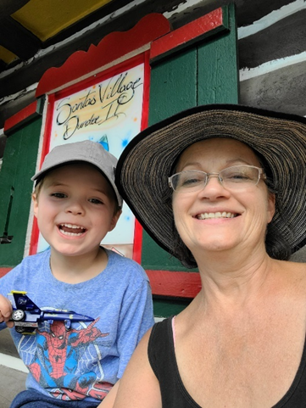

Getting to know
Cara Turner

I was born in Chicago Illinois and then moved from there to Hanover Park when I was 3 years old. My parents Carole and Richard Parker had six children. I remember attending Advent Lutheran Church when I was young. We didn’t go often, but it must have made some impact on me.
I have 2 sons, Miles, and Corbin. Both of my sons were baptized at Grace Lutheran Church. I have one grandson; his name is Odin. He will be turning 5 in April of 2022. He is like his dad and Uncle who are kind, caring and love to have fun. Odin loves going to church, and he talks about Pastor Dave, which tells me he enjoys church.

I started going to Grace many years ago. I believe I came to Grace because one of Miles’s friends (Bill Blase) said the people were nice there. I taught Sunday school there for years. I remember one year one of the students that the kids knew at school had passed away. It was a sad time. My Sunday school class made a blanket and painted all the special memories on it, and we gave it to her parents. They were so proud of the blanket. It warmed my heart.

I worked at United States Post Office for 22 years before I decided to go back to school and become a nurse. It was a difficult time going to school at an old age of 43
(not so old now). Miles was in college and Corbin was still in High School. I never thought I could be this happy doing what I love.

I met and married Ken Kusch in 2012. We now have 8 grandkids. Ken and I love to camp anywhere in our camper. The kids and grandkids enjoy that as well. I adopt senior dogs whenever I can. I enjoy the outside. I also enjoy photography. I hope to do more with my pictures one day when I retire. I would also like to play the piano. I enjoy walking the dogs thru the woods.

Grace Lutheran Church is important to me. It gives me peace.

Submitted by Cara Turner

GRACE LUTHERAN CHURCH
HELP WANTED!
Part-time job for an Office Administrator
Immediate Opening

The right person is looking for 12-15 hours per week, is a master multi-tasker with excellent communications skills, has an upbeat and welcoming attitude and works well as a team player and is able to work with volunteers. Applicant must also have excellent Microsoft Office skills and computer experience (Word is a must, Outlook, Powerpoint, Publisher, Excel and Church Windows a plus).

Grace Lutheran Church is an ELCA congregation which focuses on Faith, Family and Community. The church is active in the community and welcomes everyone. If you are interested in this position, please submit a cover letter and your resume including Objectives, Education, Previous Employment with dates, Skills and related references if available by April 14th to general@graceoflilylake.com. For questions, contact Grace Lutheran Church at 630-365-6751 or check out our website and Facebook pages to get more information about us. Thank you for your interest.
Please spread the word.
Adventure! MISSION TRIP To El Salvador Central America August 1- 7, 2022
YOU CAN MAKE THE DIFFERENCE

El Salvador Trip 2022 – You are invited to come to El Salvador for an annual mission experience, August 1-7th, 2022! Pastors Kristian and Anna-Kari Johnson of Pilgrim Lutheran Church and School, Chicago, have been leading delegations to accompany the Lutheran Church of El Salvador for nearly 25 years. We walk alongside the Salvadorans as they support children to go to school, install solar panels, help build churches, conduct medical campaigns, and participate in a peace march for human rights. This year’s trip brochure can be found here: https://tinyurl.com/elsalv22bro For more information, contact pastorkristian@pilgrimchicago.org

CONTACTS:
For emergencies please contact Marty Bradley, President, at 640-777-1074 or to leave a message call the church office at 630-365-6751.

For prayer requests or other needs please call Kathy Hooey at 630-341-2293 or to leave a message call the church office at 630-365-6751. Messages are checked daily at noon and 5 pm.

ELCA MISSION WEBSITES

LUTHERAN DISASTER RESPONSE:
https://www.elca.org/our-work/relief-and-development/lutheran-disaster-response

ELCA WORLD HUNGER APPEAL:
https://www.elca.org/Our-Work/Relief-and-Development/ELCA-World-Hunger

LUTHERAN WORLD RELIEF:
https://lwr.org/

REFUGEE ONE:
https://www.refugeeone.org/

Information for the May newsletter
will be due by April 20th

