 | OCTOBER 2026
 | AMAZING GRACE  CONNECTIONS  Faith > Family > Community

Grace Lutheran Church of Lily Lake
5N600 Hanson Rd, St. Charles, IL 60175
Pastor David Mercurio

Worship every Sunday
At 9:30 am WITH celebration of HOly CommUNION

- October 4 – Worship, and Sunday School
- October 11 – Worship and Coffee Hour
- October 18 – Worship, and Sunday School
- October 25 – Worship
Sunday School for 3 years through 5th grades every 1st & 3rd Sundays of the month.

LOOKING AHEAD
- Rummage Sale October 2nd and 3rd.
- Rebecca Circle meetings: Oct. 20th and Nov. 17th, 1 pm at Grace.
- Election Day, November 3rd (Grace is a polling site).
- Thanksgiving Community Worship at Grace on Sunday, November 22nd at 7 pm. Coffee and dessert following.
- The new church year begins on November 29th, the first Sunday in Advent.
- December 1st Rebecca Circle Christmas Luncheon at Sorrentos at noon. Women and men welcome. Registration/payment due by November 17th.
- Cookie Walk/Christmas Market on December 12th, 9am-1pm. Candice Verner is the contact.
- December: ELCA God’s Good Gifts giving opportunities available through the end of the year. Catalog/tree in gathering room.
- New Year’s “eve” family event at Grace on Thursday, December 31st from 10am – 1 pm.
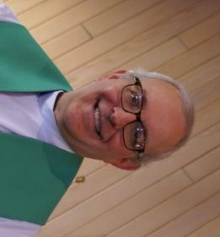
FROM PASTOR DAVID, OCTOBER 2026

Three signs that the U.S. is devolving into a third-world country:

Anyone who has ever visited a “developing nation” notices immediately the chaos of the country’s road system. Road signs are just suggestions; speed is only limited by any obstacle in the driver’s path; there is no effective enforcement of road rules; there is a constant cacophony of horn blowing; pedestrians and cyclists take their lives in their own hands if they attempt to use the roadways; it’s an “every man for himself” attitude as each driver tries to outmaneuver the next; you should not be surprised to see any piece of metal with two wheels and an engine (now include a battery) clogging every inch of a road system that is badly in need of repair. If that sounds like I just described what is increasingly the state of driving in our country, sadly, it is. The educational system of a third world country is weak, propagated more by propaganda than the dissemination of knowledge, and intended to suppress the masses and enable the elite. Any high-quality education is unaffordable to most. Students develop an attitude disdaining the value of a good education. Parents are
frustrated that their children are not learning to be productive members of society, yet are themselves unwilling to play a large and necessary part in educating their children at home by helping with homework and teaching manners and discipline. Anyone who has a child in school here or who follows the US education system will recognize similar problems plaguing us.

Christianity might be the prevalent religion, but it has negligible effect on the hearts and minds of the people. The practice of religion is highly “on display” with rituals and celebrations, but in name only. Clergy stress a works-based approach to salvation. Within the general population, the true virtues of wisdom, justice, courage, and temperance have been replaced by artificial intelligence and the court of public opinion, bribery and nepotism, bullying and cowardice, and gluttony. Finding anyone practicing true discipleship, even in the church, is a rare find, even here.
Jeremiah 17:9: “The heart is deceitful above all things, and desperately sick; who can understand it?”

Genesis 6:5: “The Lord saw that the wickedness of man was great in the earth, and that every intention of the thoughts of his heart was only evil continually.”
Romans 3:23: “For all have sinned and fall short of the glory of God.”
Ecclesiastes 7:20: “Surely there is no righteous man on earth who does good and never sins.”

God has blessed the United States in immeasurable ways for 250 years, but every empire has its day in the sun, and eventually suffers decay and death. Whether that death for us is in ten years or a thousand, only God knows. Our response in the face of discouragement over things we cannot control is not to give up. Remember Paul’s words to the church in Ephesus: “I pray that the eyes of your heart may be enlightened in order that you may know
the hope to which he has called you, the riches of his glorious inheritance in his holy people.”

We were called for a time such as this to be a remnant, to bring hope to a hopeless world, to be a light in a dark world, and to share the Good News of reconciliation that God offers to a broken people through faith and obedience to his son, our Lord and Savior, Jesus Christ.
To Him be all glory and praise. Amen.

Pastor’s Hours: Mondays, Wednesdays and Fridays plus Sundays and as needed & by appointment.


SPECIAL THANKS TO ALL WHO HAVE GIVEN OF THEIR TIME, TALENTS & GIFTS
This Photo by Unknown Author is licensed under CC BY-NC
- Rebecca Circle for providing the oversight and finances for the painting of the Fellowship Hall. If you haven’t seen it, it is worth a look!
- Linda Smykowski and Andra Norwood for putting together a great Oktoberfest.
- Tricia Painter and crew for making the Rummage Sale happen.
- Kurt Redemann for all the work he does around the building.
- Vision Team members for their hard work and dedication.
- Cara Turner for taking all those pictures every week.
- Nancy Corbige for sending out our weekly eblast, for keeping info on our Facebook site and for teaching line dancing.

FINANCIAL MATTERS – AUGUST 2026
Welcome to the 4th qtr. of our church year. We note that our summer months fall a little short of our monthly goals. We have received some large one-time donations that have aided our keeping near our proposed 2026 budget. We are blessed with our member’s faithful giving of time, talents and tithes, which allows Grace to keep our church functioning, expanding our ministries and supporting our community.
- Aug. 14, we renewed a maturing CD for 6 months @ 4% ($38,220)
- Vision Team anticipates a brief Special Congregational meeting to be held in
November to Accept the 2025 Audit Report. Details will be announced for this
meeting date. *Noting on 2027 calendar: Annual Meeting will be Jan. 31, 2027.
- Capital Improvement building expenses this month were window blinds being
installed in the preschool room, work room and office, Fellowship Hall and the
first SS room on the lower level (getting rid of cords – a hazard for children). A
generous gift from a member offset a substantial portion of this cost. Gutter
cleaning and gutter repairs were also performed. This account balance: $600.

Brief recap of August financials:

August 2026 Year to date 2026 Year to date 2025
INCOME $ 15,679 $ 201,282 $ 194,663
EXPENSES $ 22,485 $ 185,934 $ 154,769
NET +/- $ -6,806 $ 15,358 $ 39,894

We pray for continued blessings upon our Grace family in the last quarter of 2026
~ Tricia Painter, Treasurer
VISION TEAM REPORT
If you have any questions or concerns, please contact a Vision Team member:
Dallas Peters (President), Steve Butcher, Cathy Lindquist, Nancy Schnaitman, & Lee Strom
At their September meeting, the Vision Team:
- Approved minutes and treasurer’s reports
- Oktober Fest was held on September 26th with a good crowd and donations over $1,000.
- Our gutters have all been caulked and repaired/replaced.
- Updates to the Sancturary sound system have been made.
- Discussed a reserve fund for large ticket upcoming capital expenses (outside ACunit, carpet, parking lots, and parsonage).
- Discussed 2027 budget advanced planning (possible higher support for Christian Ed and parttime secretary.

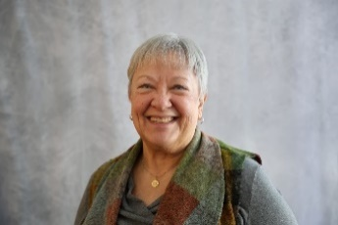
Getting to know SUZANNE STROM GIRSCH
The first four/five years of my life began right here in Lily Lake! I was born Oct. 12,1952 at the old Geneva Community Hospital and lived in a 3-unit apartment building right across Rt. 47 and IC Trail. So, I’ve been a member of Grace Lutheran Church my entire life! It was quite the family affair with my grandma, aunts, uncles and cousins attending here as well. As my family grew, we moved to St. Charles where I attended school through high school. I graduated from Western IL University with an elementary teaching degree and got my master’s degree through St. Xavier University. I taught 3 rd , 4 th and 5 th grades in Kaneland for 34 years. I retired in 2010 and continued to substitute at the Kaneland elementary schools until 2020.

I love to travel! I’ve been to Alaska, Hawaii, many European countries, Australia and New Zealand. One very special trip was to Sweden with my sisters and some cousins. We were able to visit the churches where my grandparents and great grandparents attended. We had a private service there with my cousin’s son giving the sermon and a cousin’s wife playing the organ. During communion we used the wind chalice that my ancestors probably used. This love of traveling has led me to help plan Grace Roadrunner trips, the third week of September, by motor coach.

In the past at Grace, I have been the SS Superintendent and Funeral Lunch contact, and presently am involved with Rebecca Circle and rummage sale (jewelry area). I have a sister, Nancy, who lives in Barrington, a sister, Carol, who lives in Ohio, and a brother Rich, who lives in St. Charles. I’m blessed with nine nieces and nephews and thirteen great nieces and nephews. I moved in 2024 to River Glen of St. Charles, a senior living community. I enjoy residing here and have made many new friends.

Written by Suzanne Strom Girsch 9-1-26


LINE DANCING
Line dancing at grace is every Tuesday from 6:30 to 7:30 pm and going through December 8th.
Join us for this fun, educational and good-for-you program. If you have questions, please contact Nancy Corbige at 847-212-0237.

REBECCA CIRCLE

Rebecca Circle will meet on Oct. 20th @ 1:00 in Fellowship Hall.
Vicki Linden and Jan Meyer are Hostesses.
Please contact Twyla Strom at twy.strom@gmail.com if you have any questions about joining this engaging women’s church group. They meet monthly, March thru November, on the third Tuesday and have a Christmas luncheon in December, support many church outreach programs, and enjoy fellowship with all ages of church women.
The Elburn Food Pantry is looking for the following items: Sugar, spaghetti sauce in jars, juice, chili, large soups, baked beans, adult cereals, canned potatoes, sweet potatoes, applesauce, boxed pasta, crackers.

PRESCHOOL NEWS from Janice Muncie, Director
Grace Lutheran Church Preschool is excited to begin the new school year on Tuesday, September 8th ! Our new 2-year-old class is full with 8 students and will run on Tuesdays from 8:45am to 10:45am. Our Mixed-Age-Class is also full with 18 students and will run on Mondays and Wednesdays from 9:15am to 1:15pm. We have a lot of fun activities planned for the upcoming school year including singing to the congregation with the Sunday school children on Sunday, December 20th . We are so thankful for the church’s continued support in this outreach ministry!


ROADRUNNERS 2026 TRIP RECAP
ADVENTURES IN THE MITTEN STATE

The Roadrunners had a beautiful fall week (Sept. 21st thru 26th) traveling to Grand Rapids, Frankenmuth, Dearborn and Plymouth, Michigan. While at the Gerald Ford presidential museum we experienced Art Prize, a yearly international art competition and cultural festival. Art is displayed not only at the museum but all over town. Then we spent two days in Frankenmuth, known as “Michigan’s Little Bavaria” for its rich German heritage and Bavarian Style architecture. We toured St. Lorenz Lutheran Church, cruised the Cass River on the Bavarian Belle riverboat and visited the Frankenmuth Historical Museum and Michigan’s Heroes Museum. We shopped all over town and at the famous Bonner’s Christmas Wonderland.

On our way to Dearborn, we toured Meadow Brook Hall, the historic Tudor home of Matilda Dodge Wilson. Matilda was the founder of Oakland University and widow of auto pioneer John Dodge. We got our steps in at the Henry Ford which includes the Henry Ford Museum, The Ford Rouge Plant where the F-150 truck is assembled and Greenfield Village an 80 acre living historical indoor/outdoor museum featuring buildings that explore 300 years of American living. Our final stop on the way home was at the Air Zoo Aerospace and Science Center with over 100 rare airplanes and spacecraft.

A wonderful week of fellowship and beautiful weather. On Sunday, October 18th the Roadrunners will meet for a potluck at Grace to decide where we will travel next year. Until then, we’ll put our feet up and rest dreaming of future travels.
FALL RUMMAGE SALE
Our fall rummage sale will be held on October 2nd and 3rd

We are getting ready for our Autumn Rummage Sale in October ~ please mark your calendars ~ We kindly ask that you hold your donations until late September, after Oktoberfest, as we are trying to not clutter up entryways, doorways, walkways, etc. We also have preschool, Line Dancing and Scouts, so we cannot have extra items "in the way." If you have items that can be stored in the garage (nothing with cloth or fabric please), or stored in critter proof containers - please contact Linda Smykowski to coordinate drop-off (708-309 3444).

Clothing items: You can drop off your clothing items to church anytime someone is there. For now, we take clothing items throughout the year. This makes it easier for a group of gals who periodically sort through the clothes. Fall/winter clothes are particularly needed for the sale. We will also take unsalable items if you mark them “recycle” as we drop them off to a recycling textile facility. Questions, contact Cara Turner at 630-291-6896.

Please note, when considering your donations, please ask yourself "would I purchase this?, does it work/operational?, are the cords or all pieces intact?, doesn't smell like smoke and free of pet hair?, it is (fairly) clean, etc.?" if not, please understand if we say 'no thank you' - we don't have the volunteers nor time to go through it all. As a reminder, we cannot accept TV cabinets, older TVs, and large furniture pieces. Thank you for your understanding and cooperation.

Late SEPT - Drop-Off Times:
Tues, Sept. 29 - various times; Wed, Sept. 30 -donations accepted 10am-4pm volunteer sale set-up hours anytime 10am - 5pm
Thurs, Oct. 1 - donations accepted 10am-3pm; volunteer sale set-up hours anytime 10am - 5pm;
Friday, Oct. 2 - volunteers needed all day of sale (9am-4pm) & Saturday, Oct. 3 - volunteers needed all day of sale (9am-2pm) & sale clean-up - 2pm until ??

Any further questions, please contact Tricia Painter 708-624-0400 (leave message or text)

NOISY OFFERING Every Sunday we collect a “noisy offering” when you wish to empty your change purse or pockets. We are currently collecting for maintenance items. Thank you.

A Seasonal Job with an Eternal Purpose
Samaritan's Purse is looking for individuals to serve as seasonal employees for our Operation Christmas Child project.
Positions are available at our eight U.S. processing centers to help prepare millions of gift-filled shoeboxes for boys and girls in need around the world. We invite you to help us spread the word by sharing this exciting opportunity with those in your church!
These paid positions run approximately from mid-November to mid-December with a wide variety of roles available. Come be a part of sharing the Gospel of Jesus Christ with children, families, and whole communities in more than 100 countries!

Declare His glory among the nations!
Psalm 96:3
Call Samaritan’s Purse
Aurora, IL
630-474-9478

Operation Christmas Child® is a project of Samaritan's Purse®.
Franklin Graham, President © 2026 Samaritan's Purse PO Box 3000, Boone, NC 2860

MISCELLANOUS INFORMATION
- SPECIAL TECH NEED: Are you familiar with IT / computer technology / streaming ?? We are asking for several people to become familiar with or learn the technology that we use to record our church services. ~ contact Pastor or Tricia Painter
- The Finance Team is looking for volunteers to sign up as counters (counting our weekly offerings after worship). Please see Linda Smykowski or Tricia Painter.

CONTACTS: For emergencies, please contact the church office at 630-365-6751. For prayer requests or other needs please call Kathy Hooey at 630-341-2293 or leave a message at the church office, 630-365-6751. Messages are checked daily at noon & 5 pm.
Information for the November newsletter will be due by October 25th– please send items to Marty Bradley at masbradley50@gmail.com. Thank you

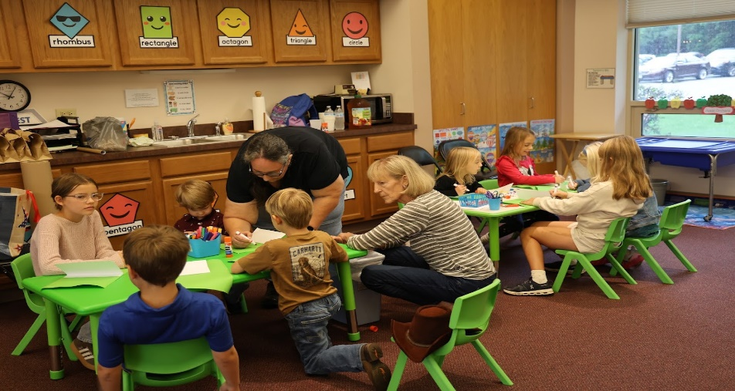
First Fall Sunday School Class

