NOVEMBER 2022, VOL. 35
 | AMAZING  GRACE  CONNECTIONS
Faith > Family > Community
Grace Lutheran Church of Lily Lake
5N600 Hanson Rd, St. Charles, IL 60175
Pastor David Mercurio

Worship indoors every Sunday at 9 am
with Communion
Sunday, November 6 , Worship and Sunday School, All Saints Day
Sunday, November 13, Worship
Sunday, November 20, Worship and Sunday School, Pledge Day
November 20, 7 pm Community Thanksgiving Service
At Grace with coffee hour following
Sunday, November 27, Worship, First Sunday of Advent
(The nursery is available on Sundays for use by any parent when
Sunday School is not in session.)


This Photo by Unknown Author is licensed under CC BY-NC-ND
ALL SAINTS DAY, NOVEMBER, 6TH
For Lutherans, All Saints Day resonates with the conviction that in Christ every saint is a sinner and every sinner is a saint. We remember on this feast day that it is God’s grace, apart from our works, that makes us saints. We find lasting rest in the mercy of God. All Saints proclaims a mystery. We remain in communion with those who have returned to the earth ahead of us. We especially remember those who have died this past year. All Saints is commemorated when much of the North American landscape appears to be dying down. Days are shorter, tree branches are becoming bare, the air is colder and fields have been stripped of their harvest. We call to mind on this day the great company of saints as we join their unending hymn around the communion table. We bear witness to new saints being born from the baptism waters. We contemplate the hopes and fears of all creation, watching and waiting for signs of a new day dawning for all of us.

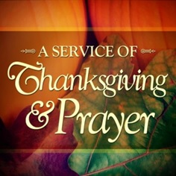
Community Thanksgiving Service
.
Sunday, November 20th at 7 pm at Grace
This is an annual service shared with the Congregational Church of Lily Lake,
Country Covenant, Burlington Methodist and Grace Lutheran
SEE YOU THERE – JOIN US TO GIVE THANKS
COFFEE HOUR FOLLOWING

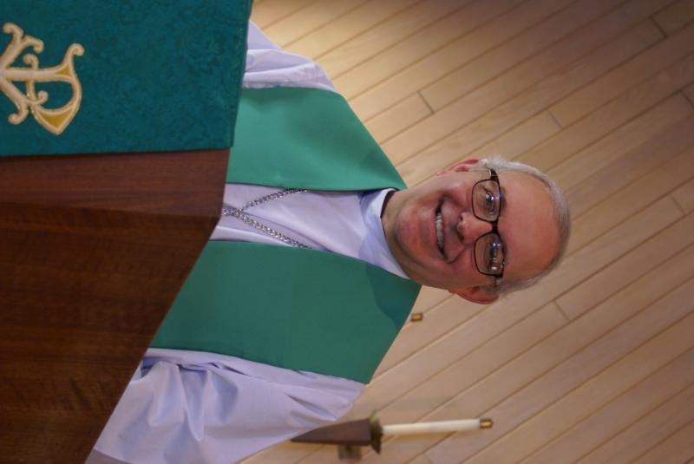
PASTOR’S MESSAGE

A Message from Pastor David for November 2022

Greetings beloved,
We are soon to enter the “busy” time of year, from the viewpoint of both the church calendar as well as family traditions. Advent, Thanksgiving, Christmas Eve, Christmas Day will all be upon us in a hurry and there is always a tendency to get frazzled at this time of year. Can I afford all the parties and presents with prices so high? Will Uncle Bob get along with our daughter’s new boyfriend? When will I have time to decorate? I have three events to attend on the same night-what should I do? Am I doing enough to help the church?
My advice is this: The main thing is to make sure the main thing is the main thing. And the main thing for us is to remember that God loves us and cares for us. Jesus reminds us not to worry in Matthew 6:
So do not worry, saying, ‘What shall we eat?’ or ‘What shall we drink?’ or ‘What shall we wear?’ For the pagans run after all these things, and your heavenly Father knows that you need them. But seek first his kingdom and his righteousness, and all these things will be given to you as well. Therefore do not worry about tomorrow, for tomorrow will worry about itself.

So enjoy the blessings of the holidays and know that God loves us..
Blessings to you,
Pastor David
Pastor’s Hours at church
Tuesdays and Thursdays from 6 pm – 9 pm
Saturdays from 9 – noon Sundays from 8:30 am for 3-4 hours

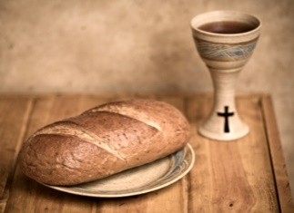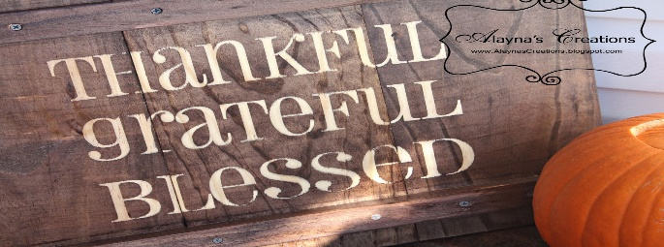
This Photo by Unknown Author is licensed under CC BY-NC-ND
This Photo by Unknown Author is licensed under CC BY-SA-NC

FALL STEWARDSHIP PROGRAM 2022

This years stewardship program will be a part of worship on Sundays, October 30, November 6, November 13 and November 20. Each week there will be a very short reading and comments by members of the congregation. Everyone will receive a letter and pledge card in the mail in mid-November with pledges received on November 20th through mid-December.

The Lord’s Supper and Giving in Faith

This year’s stewardship focus is about holy communion and discipleship. It is about Jesus being present in the congregation through our partaking of the bread and the cup. We take communion as a community, a congregation, not just as individuals. We can count on encountering Jesus as we gather at the table. Therefore, for the next few Sundays we will gather at the rail (as you are able) to take communion. As a community we are people in covenant with one another and committed to a common life and purpose.

The Last Supper story assures us of Jesus’ continuing presence especially as we follow Jesus in discipleship. GIVING IN FAITH IS AT THE HEART OF THE IDENTITY AND ACTION OF A CONGREGATION OF DISCIPLES. The story of the Lord’s Supper inspires us to persevere in faithful discipleship.

The focus of biblical stewardship is not on the congregation’s needs at all, but rather on the fact that generous giving is one of the basic acts of discipleship. This biblical stewardship is to help God’s people grow in relationship with Jesus through the use of the time, talents and finances God has entrusted to us. Jesus died on the cross so that we would be disciples and make disciples.

Each time we partake of the Lord’s Supper, we should ask the questions, “How is God calling me to respond to God’s presence in our lives?” How we use our time, talents, and finances is not separate from the spiritual life of our congregation. It is infused in us each time we eat of the bread and drink of the cup.

Our stewardship focus this year is on our community as we gather to take Holy Communion – as we remember that we do this together in remembrance of our Lord, not just as individual believers. That there is bread and wine, discipleship and giving.

As a community, we will take communion at the rail during stewardship Sundays. PLEDGE DAY WILL BE NOVEMBER 20TH.

FINANCIAL MATTERS – September 2022

- Noisy Offering continues to be collected and our next goal is to help offset the expenses of having the (specialized) lightbulbs replaced in our sanctuary and the front and back parking lots, & possibly the rental cost of a lift to get to the high ceilings. As of Oct. 11, we have collected $486. Look for the “Noisy Offering” buckets as we will graciously accept those heavy coins in your pocket.

- We are trying to track your donations for goods and supplies that our members do not ask for/want reimbursement for. We are grateful for these donations, and ask that you submit a copy of your receipt(s) to Tricia, so we can try to tally the ‘extra costs’ for the many activities at Grace (you will keep your own receipts for tax purposes – these ‘donations’ are not reflected on your Giving statements). We are hopeful to have a tally at year-end to report.

- Giving a gift from a tax-deferred retirement account can be one of the most tax-efficient ways to be charitable both during your lifetime and through your estate. Unlike a distribution to you or an heir, which would be a taxable event, charitable donations from retirement accounts lay no additional tax burden on you or the charity. Estate gifts from these accounts can go directly to charities through a donor-directed distribution agreement or fund named endowments, i.e. Grace Lutheran Church of Lily Lake. Have you prayerfully considered naming Grace Lutheran Church of Lily Lake in your Trust or Will?

- You are able to make your offering donations electronically -- the Subsplash Giving Link is: - https://graceoflilylake.com/give. On our website, graceoflilylake.com, click on the "Giving" link, "Give" , scroll down on the populated page and it will guide you to make a one time, or a recurring donation. We are truly grateful for your financial support @ Grace of Lily Lake.

- Shopping?? Shopping?? Please support Grace through your Amazon purchases via "AmazonSmiles" link and earmarking Grace Lutheran of Lily Lake as your charitable organization. "Grace of Lily Lake" link is: https://smile.amazon.com/ch/36-2806605 . Note: Please ensure it says "St Charles, IL" as the location (there are many organizations that will be closely named). Grace receives a direct quarterly distribution from Amazon - though unfortunately, we did not receive any funds in the 3rd quarter.

Brief recap on our September financials:
 |  |  |  | 2022 |  | 2021
 |  | Sept, 2022 |  | Year-to-Date |  | Year-to-Date
INCOME |  | $ 11,251.06 |  | $121,459.32 |  | $119,026.86
EXPENSES |  | $13,571.55 |  | $151,467.96 |  | $131,290.81
NET +/- |  | -$2,320.49 |  | -$30,008.64 |  | -$12,263.95

In Peace ~ Your Fellow Grace Member,
Tricia Painter, Treasurer

SING TO THE LORD A NEW SONG
Yes, we all can sing to the Lord. George Theros is looking
for more voices to help with music during advent candle lighting.
Please consider joining this special “choir.”
Contact George if you can join in.

OCTOBER VISION TEAM REPORT
The Vision Team meets on the second Tuesday of each month. If you have items you feel should be discussed by the team, please send them to Marty by the first Tuesday of the month.
- The Vision Team approved the treasurer’s report noting the status of our savings and maintenance fund accounts and bills due. Current service and repairs to the boiler will use up the remainder of our Building Maintenance Fund.
- Discussed and approved the proposed stewardship program for this fall.
- Approved a request by Nancy Corbige to lead a line dancing class at Grace.
- Discussed possibilities of a cookie sale and spaghetti dinner.
- Approved renewal of our service contract with CMS for annual servicing of our heating and air conditioning. Briefly discussed options for heating the basement and the cost involved.
In Christ, Marty Bradley

COVID-19 Safety Protocols
We follow the recommendations of the CDC, ELCA and the IL Department of Health. Face masks are recommended, but optional. We will continue to practice social distancing in the back half of the sanctuary. If you wish to sit closer with others the front half the sanctuary is open If you don’t feel comfortable worshipping with others we invite you to join us virtually for worship via our website.


MANY THANKS AND PRAYERS TO THOSE WHO HAVE RECENTLY DONATED THEIR TIME AND TALENTS, including, but not limited to:

- Tricia Painter for all her hard work in putting the October Rummage Sale together and to all those who donated and worked during the sale.
- Special thanks to our Sunday School Teachers this fall: Pat Penfold (leader), Nancy Corbige, Kelly Diehl, Natalia Diehl and Janice Muncie and to all the wonderful participants.
- George and Kurt for watching over the fall service of our boiler system.
- Ian Endberg for being available to open the church for service calls.
CONTACT A VISION TEAM MEMBER IF YOU WISH TO VOLUNTEER


NEW PRAYER CHAIN

If you are interested in being a part of Grace’s new phone/internet prayer chain, please contact Kathy Hooey and she will send you the information.


DECORATING OUR CHURCH FOR CHRISTMAS

Join in the fun of decorating the church for Christmas on
SATURDAY, NOVEMBER 27TH AT 9 AM
All helpers are welcome


This Photo by Unknown Author is licensed under CC BY-SA-NC
ELCA GOOD GIFTS AND GLOBAL BARNYARD

Once again the Rebecca Circle is sponsoring Grace’s support of the ELCA’s Good Gifts/Global Barnyard. A catalog of gifts that you can purchase is available in the Narthex. There are many new gifts such as blankets, counseling, Sunday school kits, Bibles, vocational training, health care as well as the barnyard possibilities. Purchases can be made beginning November 27th and continuing through the end of December.

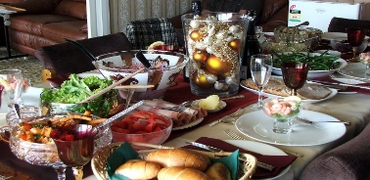
This Photo by Unknown Author is licensed under CC BY-SA-NC
CHRISTMAS LUNCHEON HOSTED BY OUR REBECCA CIRCLE

Our Rebecca Circle will host the annual Christmas Luncheon Party at Sorrento’s on Route 64 in Maple Park on Tuesday, December 6th at noon. Everyone is invited (even you handsome gentlemen). Meals range from $17 to $28 with tax and gratuity included. Sign up forms available in the narthex. Please complete and return with a check made out to Rebecca Circle by November 19th or call Kathy Hooey or Jan Docherty if you have questions.


COOKIE EXCHANGE / HOLIDAY BIZARRE
SATURDAY, DECEMBER 17TH, 9AM – 1
At Grace in Fellowship Hall

We are now collecting small to medium cookie tins - there is a collection bin in the Narthex. There will be a baker's sign up sheet posted in the Narthex later this month - we can use your favorite cookies! We are you looking for a couple of more vendors who would like to host a table (we possibly have Tupperware, MaryKay, local honey vendor, bake sale) ; we are looking to those within Grace first, before opening to outside vendors.

At this holiday bizarre, you can do some Christmas shopping with a variety of vendors, fill your own tins with baked cookies ($amt TBD), children can decorate a sugar cookie, there will be a hot cocoa stop and we believe Santa is going to be present - there's a photo op for you!!
If you have questions or would like to help with this event, please contact Candice Verner 630-362-4659 or email: candicehopkins31@gmail.com

AUTUMN RUMMAGE SALE RECAP - OCTOBER 7, 8, 14 & 15

Yes, our 2-day sale turned into a 4-day sale! With so many donations, and so much time spent on set up, volunteers were available another Friday and Saturday, so we carried over into the next weekend. What a wonderful community event with visitors and repeat shoppers coming to Grace , showing their support within our community. “Thank you’s” to the many who had accumulated and saved your donations. We were spread out on Grace property: under the pavilion with clothing, etc. (coordinated by Cathy Whiteside) garage/outdoor related items (coordinated by Linda Smykowski), jewelry and fine collectibles (coordinated by Margaret Swanson and Suzanne Girsch), and household items were on display at lower entryway, Fellowship Hall, and 2 Sunday School rooms. Utilizing so many areas, allowed many shoppers to casually peruse + shop. The weather was chilly each morning – autumn was truly in the air (the workers in pavilion were frozen)! I am certainly appreciative and grateful of all of your support and assistance from many of our members with the numerous tasks before, during and after the sale. Some pre set-up in Fellowship Hall by the Scouts after their meeting on Monday night, followed by other volunteers Ian Engberg, Cara Turner, Twyla Strom, Debbie Brown, Cathy Whiteside, Karen Patterson, Marty & Craig Bradley, Lee Gerke, + granddaughter: Becca Gerke, grandson: Austin Lilly, Chris Gerke, Jon Whiteside, Nancy Corbige, Helen Gruber, Linda Smykowski , Dottie & Paul Mantsch, Nancy Schnaitman, Kathy Hooey, Kay Kinsel, John Verner, Kathy Fritschel, Kurt Redemann, Shirley Turner, Cheryl Nelson, Margaret Swanson, Suzanne Girsch, Andra Nordwind, neighbors/visitors: Renee Adrian and Katie Delahanty, Bev Crosby + daughter Cassie. Sale signs were set up/placed/taken down by Bill + Lori U’Ren, Heidi + Mark Anderson, Dottie & Paul Mantsch, George Theros, Cara Turner, Tricia. The success of this sale comes from a church-wide effort with all of your ‘material’ donations and contributions along with your extra time and talents. (** I apologize as I may have missed a name or two – tho, I do try to track the willing hands that are with us during the plethora of sale tasks each day ). Special note of thanks to Heidi who helped coordinate in finding a venue for some of our leftovers, along with a few others making their way to Salvation Army with some leftovers; and thank you to Ian Engberg who helped get Fellowship Hall prepped for the Roadrunners luncheon on the following day.

Ongoing thanks and gratitude to Cathy Whiteside ( please greet her with your thanks!) who continues to coordinate several avenues and charities before and after the sale, taking clothing items that are very welcomed : select items for Carol Langseth’s connection with the ladies who sew LWR Quilts and layettes (in hopes that some of their handmade items, made with love and prayers, may continue to reach some Ukraine refugees too) , Redeemer Fellowship Church (St Charles) , Elgin Homeless and small items to be used to fill some Operation Christmas Shoeboxes; Heidi Anderson and her sister Peggy, Mark Anderson and Kurt Redemann in loading up leftovers + getting items to ReStore (a public shop on behalf of Habitat for Humanity), children’s items were collected for the Joe Boway Family for the Liberian Children’s Mission.

So many of you reading this report were a part of this sale, in big and small ways, from donating items (and we don’t always know who the donors were) to volunteering at the sale. It is gratifying to see so many helping hands. I was exhilarated At the end of day # 4, we had less to clean-up, with many helping hands diving in - an efficient routine. I feel so blessed that so many of you dedicate your time to help and support this fundraiser for Grace. And certainly I’m unable to coordinate these sales without all of you. Our shoppers were given a Grace flyer and welcomed them to visit Grace for worship. Our 4-day sale netted just over $6,750 – blessing abound! The dollars raised certainly help our finances, as we are incurring building maintenance expenses. I thankfully pray for all of the support that so many of you have given – many hands does make all of the tasks at hand, run smoothly. The fellowship and support are priceless!
In Peace, from Your Fellow Grace Member, Tricia Painter, Rummage Sale Coordinator
(**May 2023 for next sale?)

Lord of Life Lutheran Church in Schaumburg, Il Quilters Group continues to make quilts for Lutheran World Relief and local charities. From October 1, 2021 through September 30, 2022 they have created 278 quilts (that’s one every 1/3 day)! Over 37 years, starting in 1985 they have made 9,504 quilts. Grace continues to donate material, cutting squares, tops and money to this effort. Thank you for you continuing to support this amazing ministry. See Cathy Whiteside if you have donations. If you have questions about their quilting groups. Plcase contact Mary Meyer or Cathy Thoma at the church at 847-895-8877.
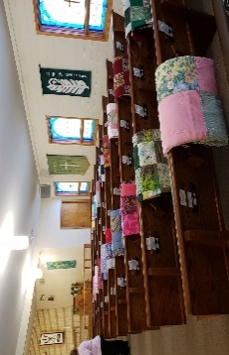

UPDATE FROM THE ROAD RUNNERS
.

The Grace Roadrunners traveled to Wisconsin and Minnesota in September. Highlights were the international Crane Foundation in Baraboo, touring a fifth generation cranberry farm in Warren, the American Swedish institute in Minneapolis and the National Eagle Center in Wabasha. We continue the Roadrunner tradition of enjoying fellowship during our traveling adventures and eating well on our trips! October 16th we met for a potluck in the fellowship hall at Grace and voted on where we’ll travel to in 2023. Mark your calendars for the third week in September (the week we always go), September 18-23, for a trip to Niagara Falls! This was trip we had all planned, but then canceled because of Covid. More information will be given as we go over the itinerary in 2023. Contact Suzanne Gersch for more information

POLLING PLACE: FYI: Grace Lutheran will be a polling place on Tuesday, November 8th. People will be coming and going all day and into the evening.
CONTACTS:
For emergencies please contact Marty Bradley, President, at 640-777-1074 or leave a message at the church office at 630-365-6751.
For prayer requests or other needs please call Kathy Hooey at 630-341-2293 or leave a message at the church office at 630-365-6751. Messages are checked daily at noon & 5 pm.
ELCA MISSION WEBSITES

LUTHERAN DISASTER RESPONSE:
https://www.elca.org/our-work/relief-and-development/lutheran-disaster-response
ELCA WORLD HUNGER APPEAL:
https://www.elca.org/Our-Work/Relief-and-Development/ELCA-World-Hunger
LUTHERAN WORLD RELIEF:
https://lwr.org/
REFUGEE ONE https://www.refugeeone.org/
Information for the December newsletter will be due by November 25th – please send it to Cathy Whiteside Cathy@imotay.com Thank you!

