NOVEMBER 2023, VOL. 46
 | AMAZING  GRACE  CONNECTIONS

Faith > Family > Community
Grace Lutheran Church of Lily Lake
5N600 Hanson Rd, St. Charles, IL 60175
Pastor David Mercurio

Worship every Sunday
At 9:30 am with Communion
(remember to set your clocks back before going to bed on November 4th)
Sunday, November 5, ALL SAINTS SUNDAY, Worship and Sunday School. Coffee hour with celebration of Marge Granquist’s 90th birthday.
Sunday, November 12, Worship
Sunday, November 19, Worship and Sunday School and
7 pm Community Thanksgiving Service, at
Country Covenant Church, Rte 47 & Mcdonald Rd
Sunday, November 26, Worship

2023 FALL STEWARDSHIP PROGRAM
Theme: PREPARE YE THE WAY OF THE LORD
Our Stewardship program this fall will begin on November 5th and continue through December 10th when pledge cards will be collected. Several members of Grace will be giving short temple talks during worship to encourage us as God’s stewards and to keep us up-to-date on Grace’s ministries, ways to participate as well as our financial picture. Please note our current financial report below.

 ALL SAINTS SUNDAY – NOVEMBER 5TH

On this day, we proclaim that we are who we are because of those who have gone before. But we also give thanks for the saints who are still with us; today is a celebration of the life and ministry of the church. We also hold out hope for the vision of the church to be, the church of every nation. This is a time to celebrate who Grace Lutheran is in Christ.

In so doing, we are not only recognizing and celebrating the church that was, but we also acknowledge and give thanks for the church we are becoming. This is a wonderful day to thank those who have gone before and those who continue to labor in the fields of the Lord.

The other encouragement comes from a phrase in Revelation 7:9: “From every nation, from all tribes and peoples and languages.” Today is a great day for recognizing the multicolored, multiethnic, multinational nature of the church of Jesus Christ. There is diversity of various kinds in our local congregations, but the diversity enlarges when we remember that there are brothers and sisters around the world who are part of the body that gives us our identity and our hope. Today, we acknowledge the glory of a worldwide church.

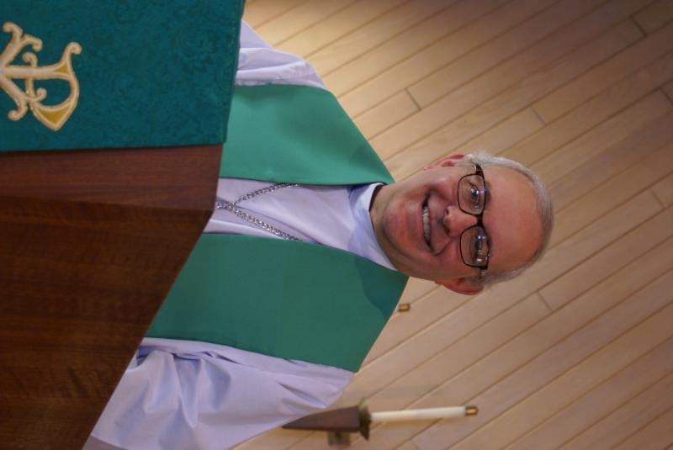
PASTOR’S MESSAGE NOVEMBER 2023
I recently had the immense pleasure of reading a significant Grace Church historical document- the 1994 Membership Directory. The 1994 edition was particularly special because it was the 100th anniversary celebration of Grace’s founding. Allow me to make a few random observations from this document:
- I finally got to see the pictures of people whose names I have been hearing about since I got here, but never had a chance to serve.
- It's amazing how much all of you look the same as you did even 30 years ago. You haven't changed a bit!
- There were even group photos of current and former Grace pastors. I am sorry that I never got to meet any of them, but I am honored to be part of that lineage.
- In 1994, Grace had 600 baptized members and 16 Sunday School teachers!

One particular sentence in the booklet caught my attention: “In the early afternoon, a special service was held in which previous pastors and vicars reminisced about the past and offered challenges for the future.” Of course, those words are now lost, but I would love to know what future challenges with which they were most concerned. Were they worried about having enough space for all the current and future congregants? Maybe they started planning how to train more Sunday School teachers. Or how to prioritize spending the cash
(continued on next page)
surplus, what missions to support, or maybe even what improvements they could make to the Parsonage to attract a suitable candidate for the next call from the large pool of seminary graduates available. I don't think they would have worried about, or even anticipated, two financial crashes, a pandemic, and a wholesale change in the U.S. toward a secular society. They also most likely did not worry or think about any of the deleterious influences, especially on our youth, that we see today: drug abuse, legalized gambling, crime, depression/ suicide, abusive social media, the polarization of society, etc.
Oh, for the good old days. But enough daydreaming. That ship has sailed and most of us will never live to see such times again. The best we can say is how blessed a time it was to have lived during such blissful times and to have experienced so much security, joy, and tranquility. The question now ahead of us is this: How do we live in a society such as ours? Do we flee to cloister into our little community as the monks did in the Middle Ages? Definitely not! “The Spirit you received does not make you slaves, so that you live in fear again; rather, the Spirit you received brought about your adoption to sonship. And by him we cry, Abba, Father.” (Romans 8:15).
So, as we approach this year's Advent Season, we should respond to the times as all Christians under duress have always responded, and according to the instructions our Lord has given us. We are to continue giving sacrificially of our time, our money, and our talents. We will love and forgive unconditionally. We must resist evil with Godly wisdom, Scripture, and prayer. We shall love the Lord with all our heart, soul, mind, and strength. And we can continue to love and support each other.
Finally, remember that Advent is not just a celebration to remember when Jesus came to us the first time. It is also a time to be reminded he will come to us again, but not as a helpless infant in a manger. No, the next time he will come to us as a mighty, invincible warrior to claim us as his own. So don't daydream about the past, as I am prone to do. Be joyful and secure in the assurance that our light and momentary troubles will soon be behind us and long forgotten.
May God continue to bless you and your families during this time of giving and receiving.

Pastor David
Pastor’s Hours at church Tuesdays and Thursdays from 6 pm – 9 pm
Saturdays from 9 – noon Sundays from 8:30 am for 3-4 hours

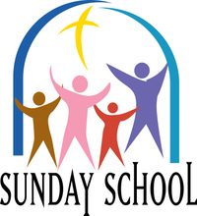
This Photo by Unknown Author is licensed under CC BY-NC-ND
SUNDAY SCHOOL
Sunday School for 3 through 13 year olds EVERY 1ST and 3RD SUNDAY at 9:30 am in the Grace Room. November dates are Sundays the 5th and 19th.

OCTOBER VISION TEAM REPORT
The Vision Team met on October 10th

- September Vision Team minutes and treasurer’s report were approved.
- New fire detectors were installed in the sanctuary, sacristy and kitchen.
- Reviewed and approved stewardship program for this fall.
- Reviewed asbestos inspection report for the parsonage – asbestos only found in three areas in the basement on old furnance ducts.
- Reviewed and approved proceeding with congregation approval of ELCA required revisions to congregational constitutions. Will be presented to the congregation 30 days prior to the anuual meeting at which time we will vote to accept/deny the changes.

Please remember to greet visitors each Sunday and ask them to sign the register.

The Vision Team will meet next on Thursday November 14th! If you have items you feel should be discussed by the team, please send them to Marty by the first Tuesday of the month.
Blessings, Marty Bradley, President


MANY THANKS AND PRAYERS TO THOSE WHO HAVE RECENTLY DONATED THEIR TIME AND TALENTS, including, but not limited to:

- Cara Turner-Kusch for refreshing our first aid kits
- Kristen Berggren for sharing her Global Mission experiences in Argentina with us during worship on October 15th
- To all who attended Oktoberfest. $1110 was raised with $555 sent to assist Hesed House
- Trish Painter and all rummage sale workers – another very successful sale!

VOLUNTEER NEEDED TO ASSIST IN CHANGING THE SIGN BOARD IN FRONT OF THE CHURCH. Please contact Marty if you can help.

FINANCIAL MATTERS – NOVEMBER 2023

Financial Matters – November 2023
- Autumn is in the air... Oktoberfest and Rummage Sale events took place in Oct. (* see Rummage Sale summary in this Nov. newsletter)
- Church mortgage – our mortgage is up for its 5 year review/rate conversion, in February 2025. The Vision Team had some preliminary discussions re: if interest rates remain where they’re at presently, our mortgage payment ($7,178/mo. @ 4.01%) will increase significantly in 2025.
- Reminder – RE: Building Maintenance Fund: If you wish to donate to this specific fund, please note “Building Maintenance Fund” on your donation to ensure it will be designated accordingly.

Brief recap of September financials:
2023 2022
Sept 2023 Year-to-Date Year-to-Date

INCOME $ 10,873 $ 127,853 $ 121,459
EXPENSES $ 12,947 $ 134,552 $ 151,467
NET +/- $ -2,074 $ -6,699 $ - 30,008

Your continued donations are a blessing to Grace and allows a variety of ministries to continue at Grace and in helping to serve in our community. Blessings to you all as we continue our mission and ministry, with goals and challenges for the 4th quarter of 2023.
In Peace, Tricia Painter

Pray for blessings upon Grace as we continue our mission and ministry, with goals and challenges for the second half of 2023. ~ In Peace ~ Tricia Painter, Treasurer

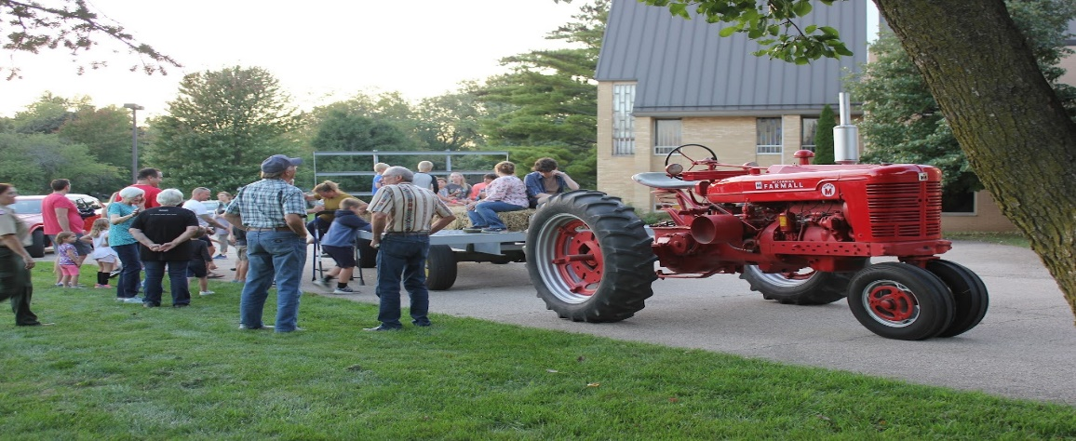
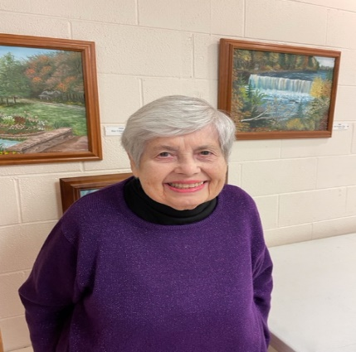
GETTING TO KNOW YOU – MARGE GRANQUIST

I was born on November 14, 1933 to Curtis and Vera (Allen) Piffner in Barrington, IL. After my parents’ divorce in 1946, I lived with my grandmother in Galena, IL for two years. I was baptized in the Presbyterian Church where my grandmother attended.
When Dave and I married in 1957 at Grace Lutheran Church of Lily Lake, I made the decision to join his church. I have been happy here ever since.
I worked 9 1/2 years as a secretary at Mooseheart. Then I worked over twenty years as a library clerk and school secretary at various schools in the St. Charles school district.
Although I’m not as active as others, I did help for a time on Friday mornings folding bulletins etc. when Pastor Rex was here. I also helped with funeral luncheons and thoroughly enjoyed the ladies I worked with. I have belonged to the Rebecca Circle for a long time, and was treasurer for the group several years. When I retired, Dave and I went on the Roadrunner trips. We loved it! I even was on the planning committee several years.
I have two children, four grandchildren and one great grandson.
I’ve been able to attend church services thanks to Marlene and Suzanne. We are blessed with a wonderful congregation.
Blessings to all,
Marge


REBECCA CIRCLE

.
Our October Rebecca Circle meeting was a busy one. Thanks to Jan Myers and Shirley Turner for hosting and sharing devotions. We learned how to shop at God's Grocery Store and asked our Lord to "Open Our Eyes". We prayed for many Grace members and friends, sent remembrances to our college kids (mainly grandkids), planned for our Christmas Luncheon, brought food for the Elburn Food Pantry, planned for a Santa Lucia celebration on Dec. 3rd, and Marge Granquist’s 90th birthday party on Nov. 3rd, the Poinsettia sale, and God's Global Barnyard. Many other things also! We had a great turnout, but missed those who couldn't be there!

Please come and celebrate with us the 90th birthday of long time member Marge Granquist. We will gather just after worship (10:30am) on Nov. 5th. Marge has been a real blessing to Grace and an example to all of us. Hope we'll see you there!

The November meeting of the Rebecca Circle will be held on Nov. 21st at 1 pm in the Fellowship Hall here at Grace. Hostesses are Jan Docherty, Suzanne Girsch and Kathy Hooey. Come and help us finish up 2023 plans and continue new planning for 2024. Lots of great ideas coming from all. (continued on next page).

Our annual Christmas Luncheon will be held on Dec. 5th at noon at Sorrentos on Rt. 64 in Maple Park. There are info sheets around church and we need to know if you are coming, and what you would have to eat, by Nov. 19th. This is a very special social event that we look forward to each year and would love to have you celebrate with us.

We will again be sponsoring a Poinsettia sale to decorate our church for Christmas, and then for you to take and decorate your home (or someone's home). They will cost $11 per plant and will be the same size as always - in a 6" pot. Order forms will go into the pew racks on Thanksgiving weekend.

UPCOMING SPECIAL DATES
- November 4th – Daylight savings time changes – set your clocks back
- November 10th – Life Line Screening at Grace, call 800-640-6307 for appointment
- November 19th at 7pm, Community Thanksgiving Service at Country Covenant Church at Route 47 and McDonald Rd.
- December 3rd - beginning of the new church year and ADVENT
- December 5th – Rebecca Circle Luncheon at Sorrentos in Maple Park at noon. Please complete a registration form by Nov. 19th.
- December 10th, Pledge Card Sunday (cards must be in by the 15th)
- December 16th - Christmas Walk & Cookie Exchange at Grace – contact Candice
- GRACE LUTHERAN ANNUAL MEETING, Sunday, January 28th immediately following worship. A quorum is needed to accept ELCA required changes to our constitution and as well as to elect new Vision Team and Committee members!

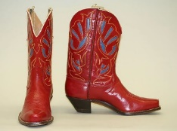
LINE DANCING Every Wednesday from 6 – 7 pm
Beginners to advanced welcome. Free will donation welcomed. 100% of the donations go to Grace Lutheran Church to continue spreading God’s love and loving one another! Benefits: Lifts your spirit, exercise (lost lbs?), good for muscle memory, socialization and fun! Dancers and Spectators welcome.

 CHRISTMAS COOKIE / BAKED GOODS BAZAAR

Grace's Christmas Cookie/Baked Goods/Bazaar will be held on Saturday, Dec. 16 from 9am - 1pm. We are requesting if the bakers out there would graciously donate homemade cookies or baked goods for this end of the year fundraiser (*baked items dropped off by Dec 15). If you would like to have a vendor table ($20 donation), please contact Candice Verner at 630-362-4659 or Tricia Painter at 708-624-0400 (cell # - please leave a message or text) to reserve your table.

**We already have the holiday decor set up after the rummage sale - we are not seeking anymore holiday donations, nor cookie tins - thank you for these previously donated items.

 ROAD RUNNERS TRIP 2024
The Grace Roadrunners decided at their October potluck to travel to the Smoky Mountains/Gatlinburg, TN area in 2024. They will be leaving Grace on Monday, September 16^{thand} return on the 20th or 21st, 2024. The planning committee will begin meeting the first Tuesday of the month starting January 2024.

Autumn 2023 Rummage Sale Update
Our Autumn Rummage Sale was held on October 6 & 7. During the week of the sale (and even before then) preparations of various kinds took place: sorting clothing and moving it all to the pavilion, organization + clean up in garage + moving stored containers inside church, table set up in Fellowship Hall and several classrooms, and moving donations to their proper areas. Accepting donation drop-offs, unpacking of your generous donations, sorting and staging, through Thursday evening. At the sale, we had a steady flow of visitors/shoppers, lunch was prepped for our volunteers on Friday and Saturday. Our separate areas to shop are spread around the Grace property: under the pavilion with clothing, etc. (coordinated by Cathy Whiteside) garage/outdoor related items (coordinated by Linda Smykowski), jewelry and fine collectibles (coordinated by Margaret Swanson and Suzanne Girsch) and Fellowship Hall (coordinated by Twyla and Tricia) and many volunteer hours from others. **Some household items are for sale on lower level entryway.** Utilizing so many areas, allowed many shoppers to casually peruse + shop.
(continued on next page)
We certainly are grateful for all of your support and assistance with the numerous tasks before, during and after the sale. The Boy Scouts set up tables and stacked chairs, followed by other volunteers throughout the week: Linda Smykowski, Ian Engberg, Cara Turner, Twyla Strom, Debbie Brown, Cathy Whiteside, Karen Patterson, Marty Bradley, Chris Gerke, Diane Lilly, Becca Gerke and friend Jimmy, Jon Whiteside, John Verner, Nancy Corbige, Helen Gruber, Candice Hopkins, Cathy Lindquist, Kathy Hooey, Kay Kinsel, Kathy Fritschel, Kurt Redemann, Cheryl Nelson, Margaret Swanson, Suzanne Girsch, Jan Myers, Katie Delahanty, Vicky Linden, Nancy Schnaitman, Heidi Anderson and sister Peggy, Shelly P. Sale signs were set up/placed/taken down by Bill/Lori U’Ren, Dottie/Paul Mantsch, Cara Turner, Heidi Anderson, Kurt Redemann, Tricia. The success of this sale comes together, just like a recipe, and with each sale – it is getting to be a well-oiled wheel. (** I apologize as I may have missed a name or two – tho, we do try to track the willing hands that are with us during the many tasks each day ). Special note of thanks to those that helped in our clean up efforts and filled their cars with some of our leftovers – as we had Fellowship Hall packed up by 4:30pm.

The blessings continue to abound! Ongoing thanks and gratitude to Cathy Whiteside who coordinates “her crew” diligently (and from afar when she couldn’t be here) and Lee Gerke’s daughters and granddaughter who volunteer with the memory of Lee – and missing her presence. Cathy continues to coordinate several avenues and charities before and after the sale with various clothing items for: the Jesus Closet/New Covenant Church for Elgin homeless, fabrics to Lord of Life Lutheran Church, Schaumburg, to help the ladies in sewing LWR Quilts, Operation Christmas Shoebox, Pastor Anna-Kari meets homeless refugees arriving in Chicago, a shopper collects items for the Joe Boway Family for the Liberian Children’s Mission school, a community neighbor/shopper ships items to Honduras supporting nuns help their local homeless and domestic violence shelter for women and children, donations to the TLC Pregnancy Center in Elgin. Cathy is the conduit for quite a plethora of venues where your donations continue to make a difference in neighboring communities and overseas! A community friend collects leftover books/cds/dvds and delivers to the Elburn Library, and a metal recycling man collects after our sale.

As many of you reading this report were a part of this sale, in big and small ways, from donating items to volunteering at the sale, it is gratifying to see our Grace “church community” with so many helping hands. We are blessed to have many dedicate their time, talents and goods, to support this semi-annual fundraiser for Grace. What a wonderful community event with visitors and repeat shoppers coming to Grace, showing their support within our community. Our 2-day sale netted just over $5,580. The dollars raised certainly help offset some of our building maintenance expenses, in our perpetual care of God’s house here at Grace. I’m grateful and thankfully pray for all of the support that so many of you have given – many hands DO make all of the tasks at hand, run smoothly. The fellowship and support are priceless! In Peace, from Your Fellow Grace Member, Tricia Painter, Rummage Sale Coordinator
(**Spring 2024 Sale dates: May17+18 ?? - TBD)

LUTHERAN DISASTER RELIEF FUND
In response to the escalating violence in and around Gaza, Presiding Bishop Elizabeth Eaton has extended a letter of support to Bishop Sani-Ibrahim Azar of the Evangelical Lutheran Church in Jordan and the Holy Land. In it she pledges to accompany and support the Evangelical Lutheran Church in Jordan and the Holy Land and its ministries. Images in the news are heartbreaking, and we extend our prayers to all those who have lost loved ones and are living in fear and uncertainty.
The ELCA has long-standing relationships with many partners in the region, including the Evangelical Lutheran Church in Jordan and the Holy Land and Augusta Victoria Hospital, which is operated by the Lutheran World Federation.
The most pressing needs that Lutheran Disaster Response and our partners can address are food, water and medical supplies. Support for hospitals will be another priority as the need for medical assistance continues to grow. Additionally, Lutheran Disaster Response is coordinating with the Arab and Middle Eastern Ministries desk to provide interfaith emotional and spiritual care support for communities in the United States.

We must also pray and care for the many refugees in our own country.
We are called to action: PREPARE YE THE WAY OF THE LORD.
“I encourage the people of the Evangelical Lutheran Church in America to unite in prayer for the families of innocent civilians whose lives were lost, as well as pray for healing for all the injured, fearful and traumatized.”
Lutheran Disaster Response has a history of providing support for our partners and anticipates answering calls for assistance when the time comes. Gifts to “Middle East Crisis” will be used to address humanitarian needs in the region. Above all, we pray for peace.

If you wish to donate to the Lutheran Disaster Response Fund you can go online at ELCA.org and search Lutheran Disaster Respons. To mail a check:

Mail your donation
Make checks payable to Lutheran Disaster Response (if designated to a specific disaster, please indicate in the memo line).
Evangelical Lutheran Church in America
ELCA Gift Processing Center
P.O. Box 1809
Merrifield, VA 22116-8009

MISCELLANEOUS
Reminder: please save shoe boxes with lids and wrapping paper and bring them to church for Operation Christmas Shoebox. Volunteers will be needed to wrap the boxes and lids. See Cathy Whiteside for more information.

NOISY OFFERING
Every Sunday we collect a “noisy offering” when you wish to empty your change purse or pockets. We are currently collecting for additional window work. We have several windows that need help. Thank you.

COVID 19, FLU AND RSV SAFETY PROTOCOLS
We follow the recommendations of the CDC, ELCA and IL Department of Health.
If you wish to mask and social distance, please do so. Please do not come to church if
have symptoms of illness. If you do not feel comfortable worshipping with others, we invite
you to join us for worship via our website.

CONTACTS:
For emergencies please contact Marty Bradley, President, at 640-777-1074 or leave a message at the church office at 630-365-6751.
For prayer requests or other needs please call Kathy Hooey at 630-341-2293 or leave a message at the church office at 630-365-6751. Messages are checked daily at noon & 5 pm.

Information for the December newsletter will be due by November 25th – please send it to Marty Bradley at martybradley@mchsi.com. Thank you

