n
 | NOVEMBER 2024
 | AMAZING GRACE  CONNECTIONS  Faith > Family > Community

Grace Lutheran Church of Lily Lake
5N600 Hanson Rd, St. Charles, IL 60175
Pastor David Mercurio

Worship every Sunday
At 9:30 am with Communion
(Reminder: Daylight Savings Time goes off – fall back one hour Saturday night, November 2 before bed.)
- Nov 3 – Worship and Sunday School and Coffee Hour
All Saints Sunday
- Nov 10 – Worship
- Nov 17 – Worship and Sunday School
- Nov 24 – Worship, Christ the King Sunday
- Nov 24 – 7 pm Community Thanksgiving Service at Burlington Methodist Church

The new church year will begin on December 1st with the four week Advent season.

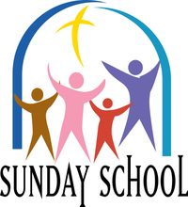
SUNDAY SCHOOL – FALL 2024

Fall Sunday School for 3 year olds – 13 year olds will meet every 1st and 3rd Sunday. The children will be singing at worship on December 15th !
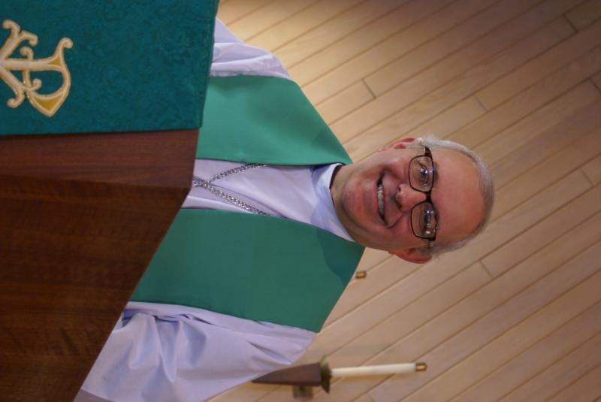
From PASTOR DAVID, November 2024

What goes around comes around. “Things are Tough All Over” was the title of a 1982 Cheech and Chong movie made during the high inflationary period of those days. And here we are again. The demand for affordable housing far exceeds the supply. The world of work is changing rapidly, and no one knows which jobs will survive. Prices are up significantly for many goods and services. Let me share a personal story to that end. My 20-year-old car with 150,000 miles finally cried “no mas” and tapped the mat. I am now of the age in which many new cars for sale today are selling for more than I paid for my first house many years ago. To paraphrase Rodney Dangerfield, used cars are no bargain either. Many of the better-named brands less than 5 years old, but still with 100,000 miles on them, are selling for not much less than their newer models! Through God’s providence, I found the deal of a lifetime in a 10-year-old car with 90,000 miles and a manual transmission for a very reasonable price. Value truly does lie in the eye of the beholder.
But even I as a pastor catch myself occasionally fantasizing about cruising down the street in my brand new, fully-paid-for Tesla with leather seats and all the razzle dazzle technology. It’s an easy trap to fall into, living in a land of plenty and prosperity. But don’t worry. This letter is not an appeal for you to give more money to the church. We’ve certainly done enough of that this year and your faithful support continuously inspires me. This letter is more a warning not to be enchanted by the allure of materialism, especially as we enter the frenzied period of “Holiday Sales.”. As the divide between the “haves” and the “have-nots” grows, it is easy to look at the shiny, sparkly things the world tempts us with. If we work harder to chase the glitter, then we take our eyes off the real prize.

“No one can serve two masters. Either you will hate the one and love the other, or you will be devoted to the one and despise the other. You cannot serve both God and money.” (Matthew 6:24)

Blessings to you.
David

Pastor’s Hours: Tuesdays and Thursdays from 6 pm – 9 pm, and Sundays from 8:30 am for 3-4 hours and by appointment when requested.

STEWARDSHIP 2024
A Special Message from Pastor David
I was thinking the other day about all the things that Grace does for its neighbors, including (in no particular order): Oktoberfest, potluck dinners, Boy Scouts, Girl Scouts, Habitat for Humanity, Prayer Shawls, Ash Wednesday at the train station, Elburn Food Pantry, Northern Illinois Food Bank, Feed My Starving Children, Parents Day Out, the semi-annual rummage sale, Line Dancing, Life Line screening, Giving Tree, ELCA Good Gifts, Lazarus House Lunches, to name a few, but not all.
In the universe of churches, you are a David among Goliaths, and given our relatively small size, you do more for the community, pound-for-pound, than any other church I have ever seen. And this love and support for your neighbors is no random anomaly. You have served this community for generations. How? Only through your sacrificial and loving donations of money, time, talents, blood, sweat, and tears. And most of what you do is hidden from the limelight, behind the curtain if you will, because you ask for no recognition for yourselves but give all glory and honor to our Father in heaven and His son, our savior.
Normally around this time, we start our annual stewardship campaign including a request that you fill out a pledge card indicating your planned giving for the following year. We’re going to skip the cards this year. I want no one to feel burdened by a card, but rather that you give freely as the Spirit moves you. As you give by faith, the Vision Team will run the church by faith. I am convinced that God will bless all of us abundantly next year.
In my three years here, you have never failed to inspire me with your maturity and love for one another. I am so excited to see what next year brings.
Blessings to you, Pastor David


MANY THANKS AND PRAYERS TO THOSE WHO HAVE RECENTLY DONATED THEIR TIME AND TALENTS, including, but not limited to:

- All those who he
- lped with the 130th Year Celebration of Grace Lutheran with special thanks to Pastor Anna-Kari Landseth-Johnson for her special messages and to Shirley and Norm Turner for sending Grace a birthday card for our 130th celebration, “wishing Grace a day that is truly one to remember.”
- All who helped with Oktoberfest and attended.
- Those who are being trained to learn the maintenance needed for our new boiler.
FINANCIAL MATTERS - NOVEMBER 2024

Winding down to the last months of 2024 (yes, already!) All the donations to Grace, allow a variety of ministries to continue, or start-up (Parents Day Out) and help to serve our community.

- The new program “Parents Day Out – Pre-School” began in September. This program is funded by the General Fund – with the goal of it being self-sustaining next year. Please look for highlights of this precious ministry in this newsletter, website and Facebook.
- Oktoberfest was blessed with wonderful weather, which captured a wonderful turnout, great food and fellowship in our community. Half of the donations collected were donated to the Elburn Food Pantry: $ 415 donation.
- Rummage Sale collected $5,400+ in its 2-day sale. See recap in this newsletter.
- Our 130th year celebration at Grace received offering of $15,519. With autumn rummage sale proceeds, further donations received, and on-line donations, we have made a principal payment of $22,328 towards our mortgage. ** Please note, we will continue to accept “mortgage principal donations” through the end of the year – please indicate that on your check .
- Please contact me (Tricia) to advise me (well, remind me) If you have opened a new account at the American Eagle Bank in 2024. We know several people have and I am needing to get a count again. Thank you!

Brief recap of September financials:
2024 2023
Sept 2024 Year-to-Date Year-to-Date

INCOME $ 14,690 $ 143,426 $ 127,853
EXPENSES $ 16,919 $ 133,105 $ 134,552
NET +/- $ -2,229 $ 10,321 $ - 6,699

Pray for blessings upon Grace as we continue our mission and ministry, with goals and challenges for the last quarter 2024. ~ In Peace ~ Tricia Painter, Treasurer


This Photo by Unknown Author is licensed under CC BY-ND
Parents day out
A new ministry at grace

Our new Parents Day Out program, under the direction of Janice Muncie will begin on Monday September 9th. The program for children 3 – 5 years (potty trained only) will be open on Mondays and Wednesdays in Fellowship Hall from 9:15 am – 1:15 pm. Two teachers will be on site each day. The program will be using Christian materials. Costs and registration are now open. If you wish to register your child or volunteer to be a substitute teacher, please contact Janice at Janice.muncie@gmail.com.

VISION TEAM REPORT
Meeting was held on October 10, 2024
Next meeting, November 12th
- Minutes and treasurer’s reports from September were approved
- Latest info: Parents’ Day Out now has 7 students
- Pastor now has access to Church Windows and spoke with them. They advise that our data seems to be correct and discussed how the entries should be classified and entered. Motion was made to hire the Church Windows support person to assist Tricia with further training; cost is $85/hr – six hours for $510. Motion was approved.
- October Rummage Sale brought in $5,400.
- Octoberfest brought in $830, half was donated to the Elburn Food Pantry.
- Monies collected at the October 13th worship service will go towards paying down the mortgage.
- Boiler replacement/installation has been completed and a number of people have been trained on the boiler maintenance..
- Tricia will schedule the required fall and spring maintenance for all our heating and AC equipment.
- George Theros has noted that the worship recording camera is broken. Motion made to allow George to purchase a new camera with a $1000 limit. Tricia will contact memorial fund donors for approval to use these funds to purchase the camera. Motion approved.
- See the posted Vision Team minutes for additional information on Building Maintenance.

MISCELLANOUS INFORMATION
- The Finance Team is looking for volunteers to sign up as counters (counting our weekly offerings after worship) to have a rotating list of counters Please see Linda Smykowski or Tricia Painter for further details.
- The Worship Team is seeking additional volunteers to sign up to help run our power point during worship which brings the bulletin onto the TV screens in the sanctuary. Especially needed on the 1st and 3rd Sundays of the month. Please see Tricia Painter. If interested.
- If you know of someone who could benefit from having a PRAYER SHAWL, please let Twyla Strom know. We would like to share them with those in need.
- Spare BIBLES? If you have extra Bibles you are not using, please bring them to church as we are supporting a ministry that is sending Bibles to South Africa. Please leave them on the balcony steps on the 1st Sunday of the month.
- Our new website sign on is graceoflilylake.org (not .com)

UPCOMING SPECIAL DATES

LINE DANCING begins again on Wednesday, September 11th and continues on Wednesdays through December 15th from 6-7 pm in Fellowship Hall.
- Saturday night November 2 – remember to SET YOUR CLOCKS BACK 1 hour so you don’t come early to Worship on Nov. 3rd.
- Tuesday, November 19th – final yearly REBECCA CIRCLE MEETING, 1 pm.
- Sunday, November 24th – COMMUNITY THANKSGIVING SERVICE at Burlington Methodist Church at 7 pm.
- Saturday, November 30 at 9 am – join us to DECORATE THE CHURCH for the Christmas Season.
- December 1st – The Advent Season begins the new church year.
- Tuesday, December 3rd at noon – REBECCA CIRCLE CHRISTMAS LUNCH at Sorrentos in Maple Park on Highway 64. All are welcome.
- December 14th – HOLIDAY BAKE SALE/BAZAAR from 9am – 1pm in Fellowship Hall at Grace (see flyer below).
- Sunday, December 15 – SPECIAL MUSIC by our Sunday School children and Parents Day Out friends.


REBECCA CIRCLE

It was just about perfect fall weather on October 19th when some Rebecca Circle members and friends took a paddleboat Cruise up the Fox River out of St. Charles. The colors were lovely, the scenery was great and so was the company! Most of us started the afternoon with lunch at the Brunch Café, with good food and lots of conversation! We truly realized the many God given blessings of family, friends and time together! (See photo at end of newsletter)

PLEASE JOIN US for our final formal meeting of the Rebecca Circle for this year. On Tuesday, Nov. 19th, we will gather in the Fellowship Hall to finish out our 2024 work and begin planning for 2025.
Then on Tuesday, Dec. 3rd, we will be gathering at noon at Sorrentos Ranch in Maple Park for our annual Christmas Luncheon. Everyone is invited, so check your calendars. We would love to have you join us. The invitations and menus are on the Welcoming Table at Grace. For questions or more information please contact Cheryl Nelson or Kathy Hooey.

HOLIDAY BAKE SALE

Candice Hopkins is coordinating the bake sale again this year on Dec. 14th. We are looking for BAKERS ! Candice has secured Thrivent Action Team funds and will be able to purchase some baking ingredients for you to use again. To help in your baking tasks, flour, sugar, brown sugar, and misc. will be available for you to pick up on Saturday, Nov. 30th morning and available through the following week, in the kitchen/lower level.
Tricia Painter is coordinating any vendors who would like to have a table for a $20 donation – please contact her to reserve your spot.




ROAD RUNNERS TRIP 2024
AND 2025 TRIP

Twenty-two Roadrunners gathered on Sunday, October 20th to share memories of this year’s trip to Gatlinburg, TN and Asheville, NC and to vote on where to go next year. It was narrowed down between Frankenmuth/Detroit, MI and Dubuque/Cedar Rapids, IA to mid IA. Iowa received the most votes! So, mark your calendar for the 2025 Roadrunner Trip to Iowa on September 22-27.

Autumn 2024 ~ Rummage Sale
The Autumn Rummage Sale was held on Oct 4+5 – with some wonderful autumn weather to assist us. Set-up starting taking place after the Scouts Open House on Monday evening, volunteers assembled and worked away on Wednesday and Thursday with many helping hands working on staging our donation items. “Thank you” to the many ‘donors’ who had accumulated and saved their donations. As we are able to repeat, the sale areas were spread out on Grace property: under the pavilion with clothing, etc. (coordinated by Cathy Whiteside) garage/outdoor related items (coordinated by Linda Smykowski), jewelry and fine collectibles (coordinated by Margaret Swanson and Suzanne Girsch), and household items were on display at lower entryway, Fellowship Hall, and 2 Sunday School rooms (coordinated by Twyla Strom) . We certainly are grateful for all of your support and assistance with the numerous tasks before, during and after the sale. Some pre set-up in Fellowship Hall by the Scouts after their meeting on Monday night, followed by other volunteers Ian Engberg, Twyla Strom, Debbie Brown, Cathy Whiteside, Karen Patterson, Chris Gerke, Diane Lilly, Jon Whiteside, Becca Gerke, Nancy Corbige, Helen Gruber, Linda Smykowski , Cathy Lindquist, Dottie & Paul Mantsch, Marty Bradley, Kay Kinsel, Kurt Redemann, Cheryl Nelson, Margaret Swanson, Suzanne Girsch, Vicky Linden, Ann Butcher, Janice Muncie, Nancy Schnaitman, Megan Brannen, Heidi Anderson and her sister Peggy, Bill/Lori U’Ren. Sale signs were set up/placed/taken down by Bill/Lori U’Ren, Kurt Redemann, Heidi Anderson and Tricia. The success of this sale comes from a church-wide effort with all of your ‘material’ donations and contributions along with your extra time and talents. (** I apologize as I may have missed your name as I do try to track the willing hands that are with us during the many tasks each day, tho may not see you in garage or clothing areas ).

Special note of thanks to those that helped in our clean up efforts and helped load a few cars with donations – delivered to Salvation Army. I’m grateful to Heidi and her sister Peggy, who finished the final packing up in Fellowship Hall. Followed by Ian Engberg who helps to get Fellowship Hall back to pre-school set-up mode, tables and chairs back to main hall, misc clean-up. Kurt Redemann breaks down and recycles leftover cardboard boxes. Thank you Janice Muncie (and parents!) for accommodating our sale and allowing us to utilize the preschool space during the sale also!

Ongoing thanks and gratitude to Cathy Whiteside, with her ‘team’, who continue to coordinate several avenues and charities before and after the sale with various clothing items: select items for Christmas Shoeboxes, in-season clothes are assembled and given to Pastor Anna-Kari for the people coming into Chicago (all ages); Karen Broten with various items she sends to the Joe Boway Family for the Liberian Children’s Mission school, in Liberia (shoes, some clothes, toys, equipment, books); Pregnancy Center in Elgin (0-5 year old clothing); Elgin Homeless (men); MSHV/Help-A-Veteran (clothing and some housewares for Wheaton & Downers Grove locations), Opportunity House (adult disabilities facility in Sycamore), Elburn Library (ongoing book sales).

Many of you reading this report were a part of this sale, in big and small ways, from donating items to volunteering at the sale, and praying over us! It is gratifying to capture so many volunteer helping hands. Without the help of many of you, it would not be such an efficient routine. I feel so blessed that so many of you dedicate your time, talents and goods to support this semi-annual fundraiser for Grace. What a wonderful community event with visitors and repeat shoppers coming to Grace , showing their support within our community. Our 2-day sale netted ~ $5,400 – which is being made as a contribution to our church mortgage. I’m grateful and thankful for all of the support that so many of you have given – many hands does make all of the tasks at hand run very smoothly. The fellowship and support are priceless! In Peace, from Your Fellow Grace Member, Tricia Painter, Rummage Sale Coordinator
(**Spring 2025 Sale dates: May 16+17 to be “confirmed”)

SPECIAL MINISTRY INFORMATION:
Operation Christmas Child –Shoe Box Ministry: Need shoe boxes, toys, and more ideas can be found at https://www.samaritanspurse.org/what-we-do/operation-christmas-child/ Cathy Whiteside (630/605-1096) contact person@ Grace. Thank you to all helping with this ministry.
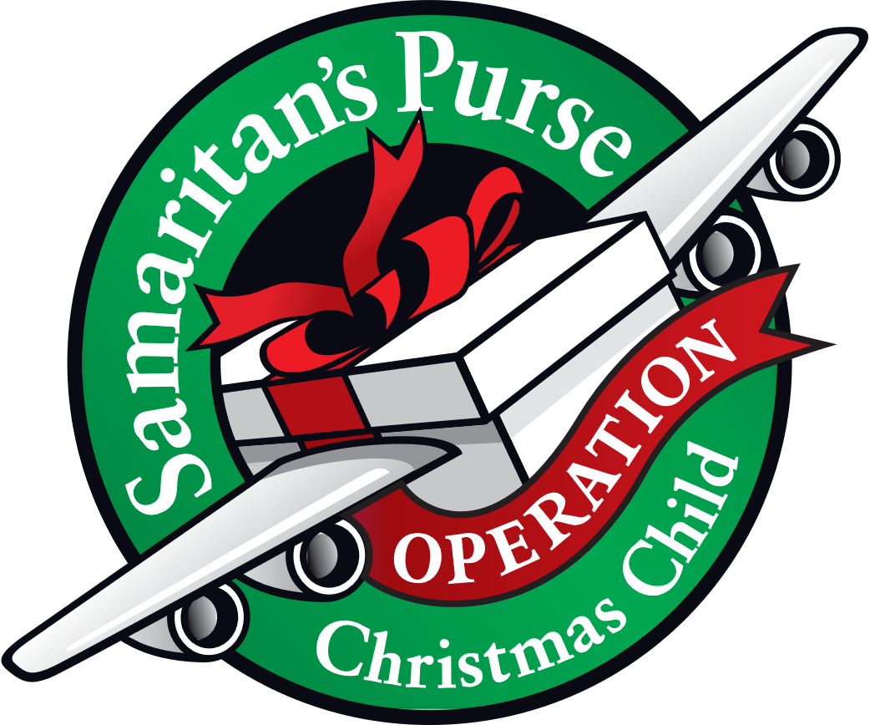
NEEDED: EMPTY SHOE BOXES
For:“Operation Christmas Child” Mission.
Please place shoe box donations in front entrance to the church. For more information:https://www.samaritanspurse.org/operation-christmas-child/mission- and-history
Bridge to Life Group’s Jesus Closet (homeless in Elgin): Items needed are backpacks, blankets, gym shoes, t-shirts, jeans, coats and socks. Please mark donated items to the attention of Cathy Whiteside (630/605-1096). Thank you for all the donations.
Clothing and miscellaneous items for the migrants in Chicago are being collected by Cathy Whiteside (630/605-1096) to be given to Pastor Anna-Kari Johnson for distribution in Chicago. Thank you to all who have donated in the past. Left overs from our Spring Rummage Sale were already passed on to this ministry in June.
Plastic bins are no longer needed. We have plenty. Thank you!

NOISY OFFERING

Every Sunday we collect a “noisy offering” when you wish to empty your change purse or pockets. We are currently collecting for maintenance items, including our new boiler. Thank you.

COVID 19, FLU AND RSV SAFETY PROTOCOLS
We follow the recommendations of the CDC, ELCA and IL Department of Health.
If you wish to mask and social distance, please do so. Please do not come to church if you have symptoms of illness. If you do not feel comfortable worshipping with others, we invite you to join us for worship via our website, graceoflilylake.org

CONTACTS:
For emergencies, please contact the church office at 630-365-6751.
For prayer requests or other needs please call Kathy Hooey at 630-341-2293 or leave a message at the church office at 630-365-6751. Messages are checked daily at noon & 5 pm.

Information for the December newsletter will be due by November 25th – please send items to Marty Bradley at martybradley@mchsi.com. Thank you

