OCTOBER 2023, VOL. 45
 | AMAZING  GRACE  CONNECTIONS

Faith > Family > Community
Grace Lutheran Church of Lily Lake
5N600 Hanson Rd, St. Charles, IL 60175
Pastor David Mercurio

Worship every Sunday
At 9:30 am with Communion
Sunday, October 1, Worship and Sunday School
Sunday, October 8, Worship
Sunday, October 15, Worship, special guest, Kristen Berggren, ELCA Global Mission Representative & Sunday School
Sunday, October 22, Worship
Sunday, October 29, Worship


ECUMENICAL WORLDWIDE SEASON OF CREATION SEPTEMBER 1 – OCTOBER 4
Theme for 2023:
LET JUSTICE AND PEACE FLOW
Amos 5: 24 “Let justice roll down like waters, and
righteousness like an everlasting stream.

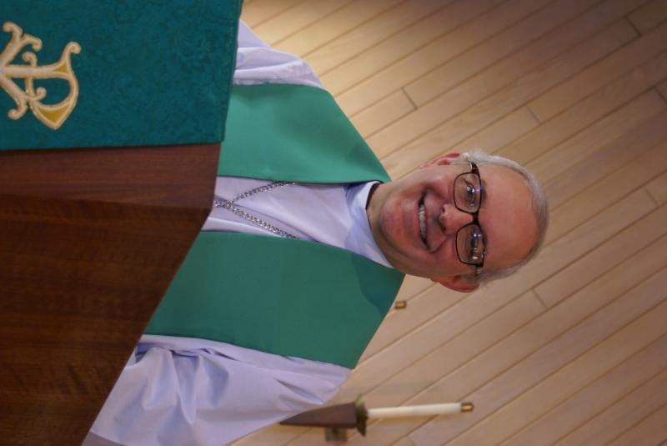
PASTOR’S MESSAGE OCTOBER 2023
Well, there’s more bad news from the “Decline of Civilization” file. It is being reported that the repopulation rate (births minus deaths) is in freefall throughout much of the Western world. Experts believe some of the reasons are environmental. Pesticides, plastics, and radiation from an explosion of electronic devices have all contributed to a decline in fertility. But there are societal factors too. Social media platforms give people lots of connections, but no real friends. And young men and women are delaying or even foregoing marriage to pursue their careers. The repopulation rates of most of the West are all below the rate necessary to grow, or even hold steady, their existing populations. That means they are in decline. The only exception and bright spot is the continent of Africa where fertility rates are exploding. Is it any coincidence that the growth of Christianity in Africa is exploding too? Hmmmmm.

The decision to delay or forego marriage is particularly discouraging from a Christian perspective. God gave us marriage for procreation, for companionship, and to model His love for us in the form of families. Christian marriages are by no means perfect, but you can always spot one by the selfless love shown by husbands and wives for each other and for their children. I have noticed that trait here at Grace particularly among those of you who have been married 30, 40, even 50 years or longer. As we age, the mind might stay sharp, but this tent called our bodies takes its natural course and begins to deteriorate, and we find ourselves needing therapies, treatments, and replacement parts, often leaving us temporarily or even permanently incapacitated.

And these are the times and situations where I have seen real love kick in. It’s no fun sitting at someone’s bedside 24/7, and no mere friend would ever do that for us. But those spouses who have honored their commitment to love “in sickness and in health” are a perfect and shining representation of God’s promise to care for us throughout eternity. May our God continue to bless each and every one of you.

Amen
Pastor David
Pastor’s Hours at church Tuesdays and Thursdays from 6 pm – 9 pm
Saturdays from 9 – noon Sundays from 8:30 am for 3-4 hours

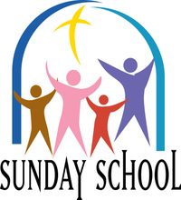
This Photo by Unknown Author is licensed under CC BY-NC-ND
SUNDAY SCHOOL
Sunday School for 3 through 13 year olds EVERY 1ST and 3RD SUNDAY at 9:30 am in the Grace Room.

JULY VISION TEAM REPORT
The Vision Team met on September 12th

- August Vision Team minutes and treasurer’s report were approved.
- Approved moving a portion of our savings into a CD with a much higher return. Return on the remainder of the savings account will remain the same.
- Church brochures have been given to the Village of Lily Lake to include in their new resident packet. Elburn sends only a short letter containing no information about churches to new residents.
- Don’t forget the Rummage Sale on October 6 & 7.
- Fall Stewardship Program to begin late October into November. VOLUNTEERS NEEDED!
- Two new fire detectors have been placed in the sanctuary/sacristy and one in the kitchen.
- Please note in the treasurer’s report that we are slightly behind in donations according to our budget.

Please remember to greet visitors each Sunday and ask them to sign the register.

The Vision Team meets on the second Tuesday of each month. If you have items you feel should be discussed by the team, please send them to Marty by the first Tuesday of the month.

Blessings, Marty Bradley, President


MANY THANKS AND PRAYERS TO THOSE WHO HAVE RECENTLY DONATED THEIR TIME AND TALENTS, including, but not limited to:

- Nancy Corbige for taking over the sending of the weekly Eblast and the new start up of line dancing.
- George/Gloria Theros and committee for the planning and execution of the Oktoberfest
- Pat Penford, Janice Muncie, Natalia Diehl and Nancy Corbige for volunteering to teach and run Sunday School this church year. Special thanks to Janice for the signs posted around the committee about Sunday School
- Kathy Hooey for all she does, especially for the weekly “What’s Happening at Grace”
- Rebecca Circle for assisting in providing communion for our shut-ins
- And again, for Linda Smykowski, gardener extraordinaire
- For all who assisted with set up and take down during our outdoor worship season; and those who are assisting with our weekly technology needs
- Tricia Painter for all those hours keeping our finances in order and bills paid

FINANCIAL MATTERS – OCTOBER 2023

Financial Matters – October 2023

Autumn is in the air, school sessions as well as Sunday School have begun. Your continued donations are a blessing to Grace and allow a variety of ministries to continue at Grace and help to serve our community.

- Presently the Building Maintenance Fund balance is $ 925. The Building Maintenance Team reviews building and safety needs, outside of the regular maintenance services. If you wish to donate to this specific fund, please note “Building Maintenance Fund”, so the donation will be designated accordingly.
- FYI – if you didn’t see this notice last month … Tricia was able to capture some Unclaimed Funds from the Illinois State Treasurer - $143 from 2 separate vendors who we no longer use (were overpaid or we had credit from). You can visit the site yourself: unclaimedproperty@illinoistreasurer.gov. -- and enter your name, loved ones’ name AND possibly find some funds to claim.
- Rummage sale highlights next month

Brief recap of August financials:
2023 2022
Aug 2023 Year-to-Date Year-to-Date

INCOME $ 10,923 $ 116,980 $ 110,208
EXPENSES $ 16,274 $ 122,932 $ 138,796
NET +/- $ -5,351 $ -5,952 $ - 28,588

Pray for blessings upon Grace as we continue our mission and ministry, with goals and challenges for the second half of 2023. ~ In Peace ~ Tricia Painter, Treasurer

UPCOMING SPECIAL DATES


LINE DANCING Every Wednesday from 6 – 7 pm
Beginners to advanced welcome. Free will donation welcomed. 100% of the donations go to Grace Lutheran Church to continue spreading God’s love and loving one another! Benefits: Lifts your spirit, exercise (lost lbs?), good for muscle memory, socialization and fun! Dancers and Spectators welcome.


This Photo by Unknown Author is licensed under CC BY-NC-ND
Autumn Rummage Sale
Dates: Oct. 6 (9am-4pm) & Oct. 7 (9am-2pm)

** Please Note ** Drop off donations: Sun, Oct. 1 – small boxes, outdoor items, clothing - 10:30-12noon(**coffee hour also). Larger donations to be dropped off on Tues, Oct. 3 = 12noon-5pm; Wed, Oct. 4 = 5-8pm; Thurs, Oct. 5 = 9am–3pm.

Volunteers needed for set-up (bring your own lunch) on Thurs, Oct. 5 = 9am–? - set up all day/when you are able

Volunteers needed - Fri, Oct 6 – SALE 9am–4pm & Sat, Oct 7 – SALE 9am–2pm (**12noon is ½ price sale) **a light lunch will be provided on Fri & Sat

2pm clean-up - Volunteers needed

Any questions, please contact Tricia Painter via text or voicemail: 708-624-0400


REBECCA CIRCLE
OCTOBER MEETING

The Rebecca Circle will be meeting at Grace on Tuesday Oct. 17th at 1 pm in the Fellowship Hall. Hostesses are Jan Myers and Shirley Turner. Please bring food for the food pantry for our "roll call" (paper towels, large cans of soup, low sugar cereals).

As we do each fall, we would like to remember the college students (at home or away) that are part of our lives. We want them to know that they are in our prayers and we wish the very best for them. So, would you please give Jan Docherty or Kathy Hooey the names and addresses of your children, grandchildren or whomever you would like remembered as soon as possible.

- November 10th – Life Line Screening at Grace
- December 16th - Christmas Walk & Cookie Exchange at Grace – contact Candice
MISCELLANEOUS
- We are no longer asking for donations for Lazarus House at this time. They were very appreciative and amazed at all we donated. They will let us know about future needs.
- The magazine, Living Lutheran, will cease its print publication at the end of the year. The cost of paper, ink and postage has increased dramatically. They will be focusing on more online content and new channels of distribution.
NOISY OFFERING
Every Sunday we collect a “noisy offering” when you wish to empty your change purse or pockets. We are currently collecting for additional window work. We have several windows that need help. Thank you.

COVID 19, FLU AND RSV SAFETY PROTOCOLS
We follow the recommendations of the CDC, ELCA and IL Department of Health.
If you wish to mask and social distance, please do so. Please do not come to church if
have symptoms of illness. If you do not feel comfortable worshipping with others, we invite
you to join us for worship via our website.
CONTACTS:
For emergencies please contact Marty Bradley, President, at 640-777-1074 or leave a message at the church office at 630-365-6751.
For prayer requests or other needs please call Kathy Hooey at 630-341-2293 or leave a message at the church office at 630-365-6751. Messages are checked daily at noon & 5 pm.
Information for the November newsletter will be due by October 25th – please send it to Marty Bradley at martybradley@mchsi.com. Thank you

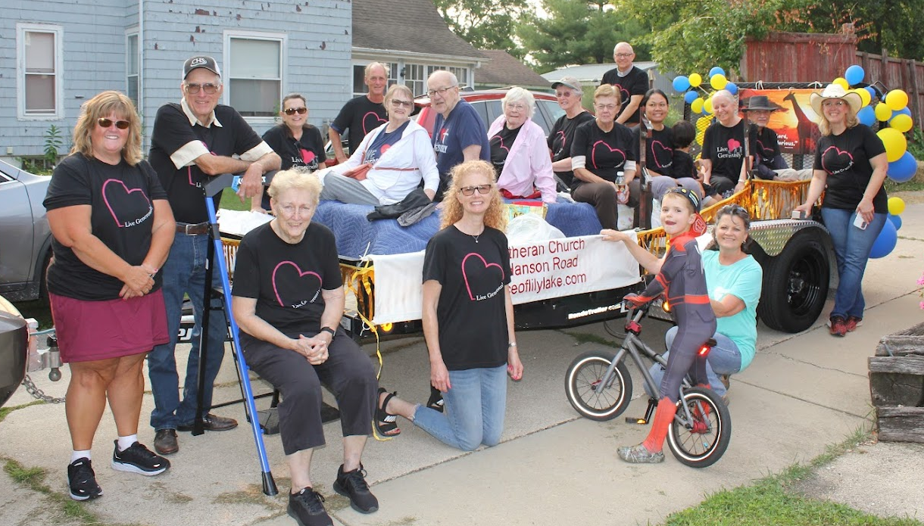

ELBURN DAYS FLOAT AND FLOATEES(?)
Thank you to Cathy Whiteside for heading this up.

