 | OCTOBER 2024
 | AMAZING GRACE  CONNECTIONS  Faith > Family > Community

Grace Lutheran Church of Lily Lake
5N600 Hanson Rd, St. Charles, IL 60175
Pastor David Mercurio

INDOOR Worship every Sunday
At 9:30 am with Communion
- Oct 6 – Worship and Sunday School (no coffee hour)
- Oct 13 – Worship with Coffee Hour celebrating Grace’s 130th year
- Oct 20 – Worship and Sunday School
- Oct 27 – Worship

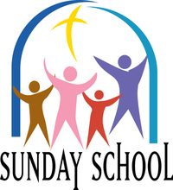
SUNDAY SCHOOL – FALL 2024

Fall Sunday School for 3 year olds – 13 year olds will meet every 1st and 3rd Sunday. Please see Janice Muncie, Pat Penfold or Marty Bradley to register your children if you did not do so last year.

A QUICK CONGREGATIONAL MEETING will take place in the sanctuary just after worship and prior to the celebration of Grace’s 130 years at the coffee hour on Sunday, October 13th. The meeting is to approve a change to the church bylaws which currently state that the annual meeting must be held in January. The Vision Team is recommending the bylaw be changed to state that the annual meeting must be held during January or February of each year. This is to accommodate putting together the annual report, finalizing the proposed budget and vacation schedules.
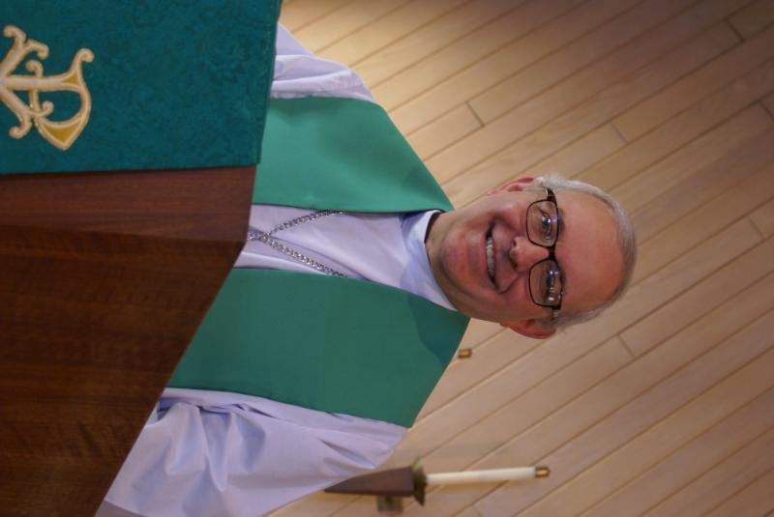
From PASTOR DAVID, October 2024

It’s the most, wonderful time, of the year-ELECTIONS!
With pollsters door knocking
And pundits all mocking
The media spreading its fear
It’s the most wonderful time, of the year

It’s the hap-happiest season of all
There’ll be parties for hosting
Opponents for roasting
With promises 50 feet tall
It’s the hap-happiest season of all

There’ll be much hot air blowing
Candidates crowing
And interviews threatening woe

We’ll hear scary ghost stories
And tales of the horrors of
Dead voters long, long, ago

It’s the most wonderful time, of the year

I hope you enjoyed that little parody. Seriously, though, as you exercise your free will and right to vote, please remember that no election will bring us any closer to utopia on earth. In fact, the only election that matters is the one Peter writes about:
Therefore, my brothers and sisters, make every effort to confirm your calling and election. For if you do these things, you will never stumble, and you will receive a rich welcome into the eternal kingdom of our Lord and Savior Jesus Christ.
AMEN
Pastor’s Hours: Tuesdays and Thursdays from 6 pm – 9 pm, and Sundays from 8:30 am for 3-4 hours and by appointment when requested.


Pastor Norm Nelson passed away on September 2nd.
Some sad news from Beth Nelson Smayda, the daughter of Pastor Norm and Joan Nelson. Norm passed away on Sept 2nd at the age of 98 at the Lexington Square Care Center. His Memorial Service will be on Oct. 12th at his long time church, Gloria Dei, in Downer’s Grove and his ashes will be brought to Grace Lutheran on Oct. 13th to be spread. A short ceremony will be held for this around noon – members are invited to attend. His obituary can be found online on the Adams, Winterfield and Sullivan funeral website. May he rest in peace at the feet of our Lord.


MANY THANKS AND PRAYERS TO THOSE WHO HAVE RECENTLY DONATED THEIR TIME AND TALENTS, including, but not limited to:

- Note from the Langsseth family: “Thank you! We thank God for you! Thank you for sending Cathy Whiteside and Kurt Redemann to visit my parents, Rev David and Carol Langseth, for bringing tons of love and good news about all the mission work Grace has continued to lead for 130 years! Thank you for sharing the vans full of donations for the refugees in Chicago. I love your witness to Christ and your new directory. You are in our prayers. We look forward to celebrating your 130th anniversary on October 13th and walking with Jesus and you in life. God bless you! With our thanks, prayers and love always, Anna Kari, Kristin, Hope, Emanuel, Xavier Johnson and Rev. David and Carol Langseth.
- We received a note from Chili Lindgren saying, “Thank you so much for making my BIG birthday so special. I am so grateful. God has blessed me with loving family and wonderful friends!”
- George and crew for coordinating and running the Oktoberfest.
- Trish and crew for coordinating and running our fall rummage sale.
- Sunday School crew.
- James Gwizdala for his piano prelude on September 15th. Great work James!

FINANCIAL MATTERS - OCTOBER 2024

Autumn is in the air, school sessions as well as Sunday School have begun. Your continued donations are a blessing to Grace and allow a variety of ministries to continue at Grace and help to serve our community.
- Our finances have held fairly steady (new boiler installed, a water softener installation completed (wiring issue was fixed by Ken Kusch), ComEd summer bills) – even with the slight downward summer giving months we usually experience.
- A new program “Parents Day Out – Pre-School” began in September. This program will be funded by the General Fund – with the goal of it being self-sustaining next year. Please look for highlights of this precious ministry in this newsletter and on our website and Facebook page.
- 130th year celebration at Grace (with extra mortgage principal gifts) and the rummage sale highlights and recaps will be in next months newsletter

Brief recap of August financials:
2024 2023
Aug 2024 Year-to-Date Year-to-Date

INCOME $ 12,839 $ 127,059 $ 116,980
EXPENSES $ 13,252 $ 116,322 $ 122,932
NET +/- $ - 413 $ 10,737 $ - 5,952

Pray for blessings upon Grace as we continue our mission and ministry, with goals and challenges for the last quarter 2024. ~ In Peace ~ Tricia Painter, Treasurer
VISION TEAM REPORT
Meeting was held on September 10th
- August meeting minutes and treasurer’s report were approved.
- We have welcomed a new member has joined – Nancy Burntnette.
- Parent’s Day Out has begun and is currently meeting on Wednesdays with five students. Registration is always open.
- A water softener has been installed. Cost was covered by the interest from our CD (which was recently renewed for 12 months at 5%).
- Suggestion was made to put together a new member packet. Dallas is working on this.
- Completion of the installation of the new boiler is getting close. No payment will be made to them until it is completed.
- Dallas and Kurt are working on repairing a leak in the pavilion roof.
- It was noted again that the parking lots will need resurfacing soon.

MISCELLANOUS INFORMATION
- The Finance Team is looking for volunteers to sign up as counters (counting our weekly offerings after worship) to have a rotating list of counters Please see Linda Smykowski or Tricia Painter for further details.
- The Worship Team is seeking additional volunteers to sign up to help run our power point during worship which brings the bulletin onto the TV screens in the sanctuary. Especially needed on the 1st and 3rd Sundays of the month. Please see Tricia Painter. If interested.
- If you know of someone who could benefit from having a PRAYER SHAWL, please let Twyla Strom know. We would like to share them with those in need.
- Spare BIBLES? If you have extra Bibles you are not using, please bring them to church as we are supporting a ministry that is sending Bibles to South Africa. Please leave them on the balcony steps on the 1st Sunday of the month.
- Our new website sign on is graceoflilylake.org (not .com)


This Photo by Unknown Author is licensed under CC BY-ND
Parents day out
A new ministry at grace

Our new Parents Day Out program, under the direction of Janice Muncie will begin on Monday September 9th. The program for children 3 – 5 years (potty trained only) will be open on Mondays and Wednesdays in Fellowship Hall from 9:15 am – 1:15 pm. Two teachers will be on site each day. The program will be using Christian materials. Costs and registration are now open. If you wish to register your child or volunteer to be a substitute teacher, please contact Janice at Janice.muncie@gmail.com.

UPCOMING SPECIAL DATES

LINE DANCING begins again on Wednesday, September 11th and continues on Wednesdays through December 15th from 6-7 pm in Fellowship Hall.
- October 4th and 5th – Fall Rummage Sale - see below for drop off times.
- Sunday, October 13th – CELEBRATE GRACE’S 130TH ANNIVERSARY during worship and coffee hour. Special guest Pastor Anna-Kari Langseth-Johnson. There will also be a short Congregational meeting to approve a bylaw change – increasing annual meeting time from January “through February.”
- Monday, October 18th – LIFELINE SCREENING available at Grace from 8am – 5pm. Contact Cathy Whitside to register and for more information, 630-605-1096.


OKTOBERFEST

Once again Grace will be hosting an Oktoberfest on September 28th from 5p- 8p. We’ll have an array of foods; pulled pork, Reams brats, Hot Dogs. Accompanied by sides; coleslaw, baked beans, tossed salad, Desserts galore, we guaranty there will be brownies and many other delectable sweets. We will have water, Lemon aide, Apple Cider, coffee and tea.
There will be games for young and old, bag toss, bounce house, bouncy balls.
Then of course a Hay Ride and a small fire for smores.
Watch for the sign up sheet in the Narthex for items to donate and times to volunteer.
George Theros

 ROAD RUNNERS TRIP 2024
Adventures in the Smokies!

The famous Road Runners have returned from their trip and its was wonderful according to participants. If you have Facebook you can view all the great phots they sent. They also stopped and saw Pastor Walker – what a blessing. Wonder where they will go next year?

SPECIAL MINISTRY INFORMATION:
Operation Christmas Child –Shoe Box Ministry: Need shoe boxes, toys, and more ideas can be found at https://www.samaritanspurse.org/what-we-do/operation-christmas-child/ Cathy Whiteside (630/605-1096) contact person@ Grace. Thank you to all helping with this ministry.
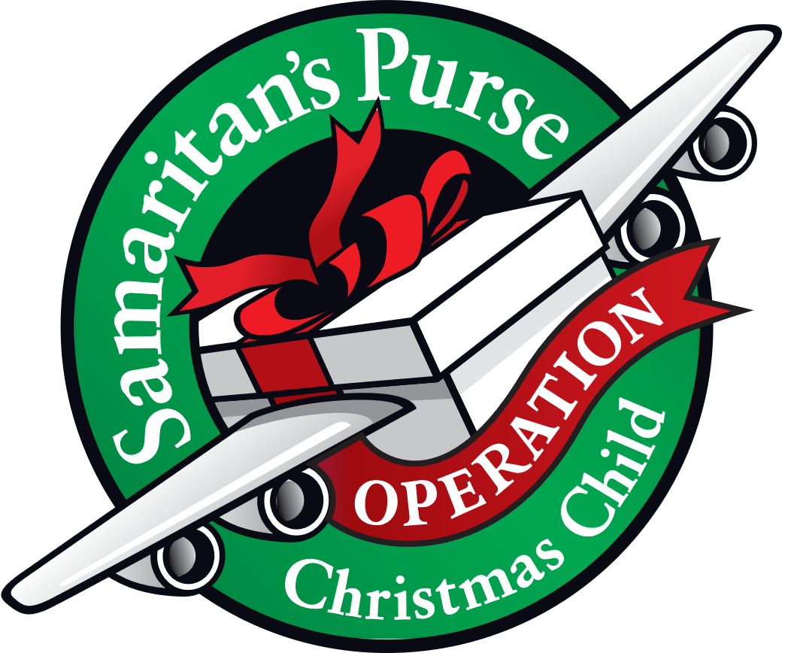
NEEDED: EMPTY SHOE BOXES
For:“Operation Christmas Child” Mission.
Please place shoe box donations in front entrance to the church. For more information:https://www.samaritanspurse.org/operation-christmas-child/mission- and-history
Bridge to Life Group’s Jesus Closet (homeless in Elgin): Items needed are backpacks, blankets, gym shoes, t-shirts, jeans, coats and socks. Please mark donated items to the attention of Cathy Whiteside (630/605-1096). Thank you for all the donations.
Clothing and miscellaneous items for the migrants in Chicago are being collected by Cathy Whiteside (630/605-1096) to be given to Pastor Anna-Kari Johnson for distribution in Chicago. Thank you to all who have donated in the past. Left overs from our Spring Rummage Sale were already passed on to this ministry in June.

NOISY OFFERING

Every Sunday we collect a “noisy offering” when you wish to empty your change purse or pockets. We are currently collecting for maintenance items, including our new boiler. Thank you.


REBECCA CIRCLE

The Rebecca Circle is continuing their tradition of sending a back-to-school remembrance to our college “kids”. Please see any Circle member with the address of your children or grandchildren, even if they are studying from home. We want them to know that Grace Lutheran is thinking and praying for them as they continue their education. We would like to get these sent by the third week of October, so look for the address forms on the “welcoming table”.


FALL RUMMAGE SALE DATES

October 4 & 5
Set up October 2 & 3

Donations being accepted: Tues: Oct 1 (varied hrs during day, 6pm-7pm) & Wed. Oct 2 – 10am-3pm)
Wed. - Oct 2 – set-up – volunteers anytime 10am – 4pm – varied times (pls bring you own lunch)
Thurs. - Oct 3 – set up – 10am - until late afternoon / when we are finished (pls bring you own lunch)
Fri. - Oct 4 – Sale: 9am – 4pm – volunteers needed by 8:30 and throughout the day (sandwich + salad fixin’s will be available)
Sat. - Oct 5 – Sale: 9am – 2pm – volunteers needed throughout the day ; ** 2pm Clean-Up (sandwich + salad fixin’s will be available)

Donations / Larger items to be dropped off Oct. 2 or 3 *various times noted above* – please contact us if you need assistance when dropping off - last donations accepted on Oct. 3 by 3pm to allow volunteers time to get your items set out – Thank you!

As a reminder: we cannot accept older TVs, no TV / ‘entertainment’ cabinets, sofas or mattresses. Items that are clean, vacuumed and in working order, with cords, accessories, etc. Ask yourself “would I buy this?” and if ‘no’, please pass this item on yourself (we don’t have the woman/manpower ).

Please contact any of us with any questions: Tricia Painter 708-624-0400 Linda Smykowski 708-309-3444 Cathy Whiteside 630-605-1096. Looking forward to a fulfilling autumn community sale!

COVID 19, FLU AND RSV SAFETY PROTOCOLS
We follow the recommendations of the CDC, ELCA and IL Department of Health.
If you wish to mask and social distance, please do so. Please do not come to church if you have symptoms of illness. If you do not feel comfortable worshipping with others, we invite you to join us for worship via our website, graceoflilylake.org

CONTACTS:
For emergencies, please contact the church office at 630-365-6751.
For prayer requests or other needs please call Kathy Hooey at 630-341-2293 or leave a message at the church office at 630-365-6751. Messages are checked daily at noon & 5 pm.

Information for the November newsletter will be due by October 25th – please send items to Marty Bradley at martybradley@mchsi.com. Thank you

NEW FIRE CIRCLE

Special thanks to Chance Anderson, Troop 80, St. Charles for his Eagle Project of a new fire circle for Grace. Chance's sister is a Scout in the girl's troop 946 here at Grace.
Completed 9/7/2024

