SEPTEMBER 2022, VOL. 33
 | AMAZING  GRACE  CONNECTIONS
Faith > Family > Community
Grace Lutheran Church of Lily Lake
5N600 Hanson Rd, St. Charles, IL 60175
Pastor David Mercurio

Worship indoors every Sunday at 9 am
with Communion
WORLDWIDE SEASON OF CREATION IS SEPTEMBER 1 – OCTOBER 4
Theme for 2022 is “Listen to the Voice of Creation”
Sunday, September 4th
Sunday, September 11th, ELCA God’s Work, Our Hands Sunday
Saturday, September 17th at 10:00 am – Pet Blessing Service in the
pavilion
Sunday, September 18th , Sunday School begins
Sunday, September 25th
(The nursery is available on Sundays for use by any parent when Sunday School is not in session.)

Sunday School Begins September 18th and will meet the first & third Sundays thereafter
Registration is requested
Two classes are planned if we have enough students:
- Ages 3 - 6 will meet during the entire worship service time.
- Ages 7 - 11 will meet at the beginning of the worship service and will come to the sanctuary for communion at the close of the service.
Please contact Marty Bradley, Kelly Diehl or Pat Penfold if you can assist as a teacher, substitute teacher or assistant. Thanks!
COVID-19 Safety Protocols
We follow the recommendations of the CDC, ELCA and the IL Department of Health. Face masks are recommended, but optional. We will continue to practice social distancing. .. If you don’t feel comfortable worshipping with others we invite you to join us virtually for worship via our website.

PASTORS MESSAGE
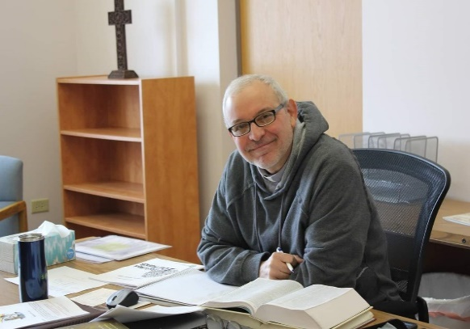
A Message from Pastor David
Children are returning to school, the leaves are starting to turn colors, the nights are getting cooler. Fall must be close. Jesus said, “Hypocrites! You know how to interpret the appearance of the earth and sky. How is it that you don’t know how to interpret this present time?” (Luke 12:56). By today’s standards, Jesus was considered rude, not “politically correct,” even harsh. But in fact, he was extremely loving and caring, because he knew that if he didn’t wake people out of their stupor, they would never repent and seek God’s kingdom.
Thankfully we live in a time of relative peace. But we need to stay focused and diligent. We need to interpret this present time spiritually. Jeremiah warns us, “Peace, peace, they say when there is no peace.” And so it is today as the world continues to turn away from and even against the living God. That is why we need to stay strong and unified and continue to be a source of light, love and peace in a world that is growing increasingly dark.
The Vision Team, the Worship Team and I are already working on programs and events for 2023 that will reinforce this goal. We are planning on traditional programs as well as considering many that are “outside the box.” To achieve any of them, we will need your time, your talents and, most of all, your unceasing prayers that God will continue to bless Grace Lutheran Church. To Him be the glory.
Pastor David
Pastor’s Hours at church
Tuesdays and Thursdays from 6 pm – 9 pm
Saturdays from 9 – noon Sundays from 8:30 am for 3-4 hours

JOIN US FOR A PET BLESSING SERVICE
Pastor will be holding a pet blessing service on Saturday, September 17th at 10am outside at the pavilion.
No reptiles please.

WORLDWIDE SEASON OF CREATION

Dear Sisters and Brothers in Christ, The Season of Creation is the annual Christian celebration to listen and respond together to the cry of Creation: the ecumenical family around the world unites to pray and protect our common home.
The Season “Celebration” begins on 1 September, the World Day of Prayer for the Care of Creation, and ends on 4 October, the Feast of St. Francis of Assisi, the patron saint of ecology beloved by many Christian denominations. This year we will unite around the theme, “Listen to the Voice of Creation.” The Psalmist declares,
“The heavens are telling the glory of God; and the firmament proclaims God’s handiwork. Day to day pours forth speech, and night to night declares knowledge…their voice is not heard; yet their voice goes out through all the Earth, and their words to the end of the world.” (19: 1-4)
During the Season of Creation, our common prayer and action can help us listen for the voices of those who are silenced. In prayer we lament the individuals, communities, species, and ecosystems who are lost, and those whose livelihoods are threatened by habitat loss and climate change. In prayer we centre the cry of the Earth and the cry of the poor. May this 2022 Season of Creation renew our ecumenical unity, renewing and uniting us by our bond of Peace in one Spirit, in our call to care for our common home.
And may this season of prayer and action be a time to Listen to the Voice of Creation, so that our lives in words and deeds proclaim good news for all the Earth. In God’s grace,
Members of the Season of Creation Advisory Committee
Including members of the Lutheran World Federation and the World Council of Churches of which the ELCA is member.

Creation sounds fill the air as well as calm and peace at times.
Beauty abounds all around us. God is always at work in His world.
This IS the day the Lord has made. Rejoice!

AUGUST VISION TEAM REPORT
The Vision Team meets on the second Tuesday of each month. If you have items you feel should be discussed by the team, please send them to Marty by the first Tuesday of the month.
- Discussed the need to keep our monthly shortfall in front of our members. Marty to address this periodically at worship. Stats for offerings received will be noted in each bulletin and newsletter. As always, thank you for your financial support as well as all the ways you serve Christ through Grace and in our community.
- Discussed the new building maintenance fund and which items are of priority concern. The Viision Team agreed that the annunciator panel and leak by the back lower door should be addressed first. The Garage roof has been replaced and doors and jambs have been refreshed and painted. The bell tower roof has been replaced. Special thanks to all who have donated to this ongoing fund.
- Cheyenne Watkins, our secretary, who has been working remotely, has officially resigned. We wish her the best and thank her for her service. Volunteers have been secured to cover the major items that she worked on. Thank to those volunteeers!
- Sunday School will begin on September for 3 -11 year olds.

In Christ, Marty Bradley
FINANCIAL MATTERS – September 2022
- Noisy Offering continues to be collected and our next goal is to help offset the expenses of having the (specialized) lightbulbs replaced in our sanctuary and the front and back parking lots, & possibly the rental cost of a lift to get to the high ceilings. As of July 2022, we have collected $410. We will graciously accept those heavy coins in your pocket - look for our “Noisy Offering” buckets for your donations & “Thank you”.
- Mid-year Giving statements were sent out mid-August (via email or USPS) – we apologize for this delay (computer issues!!). If you did not receive yours, please contact Cara Turner. Please review your statements and reflect on meeting your mid-year goals from your pledge for 2022, for Grace of Lily Lake; if you did not make a pledge to Grace, reflect on your commitment and support to Grace of Lily Lake. 2 Corinthians 9:6-8: Remember this, whoever sows sparingly will also reap sparingly, and whoever sows generously will also reap generously. Each of you should give what you have decided in your heart to give, not reluctantly or under compulsion, for God loves a cheerful giver. Unfortunately, in summer months, with vacations, etc., the giving receipts tend to decrease as we forget to make our contributions – please review, reflect, and ‘catch up’ now – as it will be easier than at the end of the year.
- Please note that we have needed to use money from our savings account to meet mortgage, salary and utility expenses during the summer months.

Brief recap on our July financials:
 |  |  |  | 2022 |  | 2021
 |  | July, 2022 |  | Year-to-Date |  | Year-to-Date
INCOME |  | $ 12,711.78 |  | $98,085.36 |  | $99,174.66
EXPENSES |  | $15,777.75 |  | $123,790.74 |  | $103,462.34
NET +/- |  | -$3,065.97 |  | -$25,705.38 |  | -$4,287.68
- Tricia is keeping track of non-monetary donations for goods and supplies that our members do not ask for/want reimbursement for. We are grateful for these donations, and ask that you submit any of your receipts to Tricia, so we are able to track the ‘extra costs’ for the many activities at Grace (you will keep your own receipts for tax purposes – these ‘donations’ are not reflected on your Giving statements.) We are hopeful to have a tally at year-end to report.

In Peace, Tricia Painter, Treasurer


This Photo by Unknown Author is licensed under CC BY-NC-ND

Getting to know
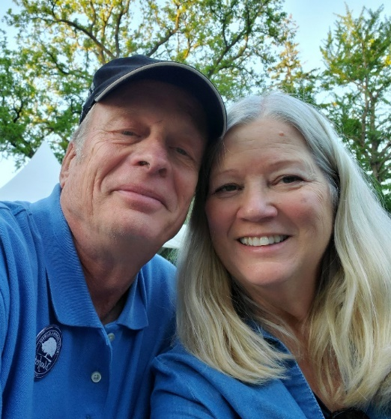
Greetings from Lee and Twyla Strom
Lee has been a member of Grace since his baptism. His parents, Elof and Edna Strom were members, as were their parents. Elof was the Sunday School Superintendent and Edna directed the choir for many years. One of Lee’s fondness memories is going to choir practice when he was young and laying under the pews in the balcony and listening to the pipe organ and his love of music stems from that. Lee has always held many hats in the work field. He is a farmer at heart and could grow about anything. He also was a Real Estate broker and then spent from 2006 – 2015 in Washington D.C. working for the Farm Credit Administration, under President George Bush and President Obama. Since 2015, he has been a partner in Open Prairie Ventures. On his “off hours” you can usually find him on the tractor helping in the veggie or tending to the sweet corn fields or in his workshop.
On July 16th of this year, we celebrated our 45th wedding anniversary. We were married at the United Church of Christ in Elburn where Twy was baptized and confirmed, and shortly after that she joined the Grace family. My roots are deep at Grace as my grandparents (Dave and Florence Nelson) attended Grace back in the 30’s, when they farmed on Reed Road and then my parents (Ruth and Alfred Anderson) when they lived in Lily Lake, in the early 40’s before moving to Elburn. After being a homemaker, I started Creative Beginnings Preschool in Elburn in 1992 and sold it in 2004 to help care for my mom. In 2014, I was asked to work at Conley Funeral Home and I’m still helping families through difficult times. When time allows, I love to have the grandkids over, be in my craft room at my sewing machine, or singing with my sisters, barbershop style!
We have three grown children, Derek who lives in Germany, and is a physics scientist and works at the Max Planck Institute for Physics, Amber (Brandon) Ballard who lives on Middleton Road and she oversees the Vet Tech program at Burlington Central High School, and Tyler (Jacalyn) Strom, who is Executive Director of Illinois Ag food Alliance.
We also have three wonderful grandkids who keep us busy and inform us on what is important, like always having desserts on hand and time to play games. Fredrika (Rika) is 10 and will be in 5th grade, Theodon (Teddy) is 9 and is a 4th grader, Eli is almost 6 and starts his kindergarten year with Rika and Teddy paving the way and watching out for him. All will be at Lily Lake school where Lee’s dad went in 1918, Lee is the 60’s, our kids in the 80’s and 90’s and now the grandkids. Traditions are strong!
Both of us have been involved at Grace in many ways throughout the years. We have taught Sunday School, sung in the choir, been a Vision Team member, leader of VBS, Worship Committee and been regular attending members. We are blessed to call Grace our home.


Autumn Rummage Sale Notes
In preparation for our autumn rummage sale, here are some preliminary notes:
**We need to be mindful of the Boy and Girl Scout troops that meet in our Fellowship Hall – please do not leave your donations right at the front door -- blocking walkway and fire escapes - we have been warned before by the FD. Thank you for your cooperation on this.
Donations we are not able to accept: items NOT in working order, older TVs (only flat screens), entertainment centers. Please consider if items are not in good shape, i.e. ask yourself “would I buy this?” – if not, please pass it along yourself before bringing it to Grace -- we simply do not have the manpower/nor hours to look through someone’s clutter. Thank you for your assistance & consideration.
Drop off donations: Sunday, Oct. 2 – after church service (**coffee hour also).
Tuesday, Oct. 4 – hours to be determined
Wednesday, Oct. 5 – 5pm-8pm
Thursday, Oct. 6 – donations accepted 9am – 3pm;
Thursday, Oct. 6 - 9am – 6/7pm? - set up all day -- volunteers needed
Friday, Oct 7 – sale hours are 9am – 4pm -- volunteers needed
Saturday, Oct 8 – sale hours are 9am – 2pm (**12noon is ½ price sale) - volunteers needed
** Please mark your October calendar for the Grace Autumn rummage sale: donations, set-up and clean-up. We look forward to the continued support and assistance from all of our volunteers – in whatever time allotments you are able. Many hands make the tasks ‘at hand’ come to fruition, please note where you can help! Sign-up sheets will be posted in mid-September. Please contact Tricia Painter with any questions: Email: trishe60@gmail.com ~ ~ Cell: Text/leave message: 708-624-0400


MANY THANKS AND PRAYERS TO THOSE WHO HAVE RECENTLY DONATED THEIR TIME AND TALENTS, including, but not limited to:

- Elburn Days parade. See article on page 8
- Cathy Lindquist, Linda Smykowski, Kurt Redemann and helpers for trimwork and painting of the doors on the garage
- George and Worship Team crew plus+ for setting up our outdoor worship area on summer Sundays
- Dottie Mantsch for her beautiful music, choosing of hymns, preludes and posltudes; a true blessing for our worship of the Lord
- Pastor Jane and Steve for their very special music and pulpit supply
- For those who have signed up to help with Sunday School – names to come
- Cathy Whiteside for her continued contact and taking donations to area ministries indluding clothing and food. (See Ministry News below)

If you wish to volunteer, please
contact Pastor or any Vision Team member.

POTTAWATOMIE HABITAT FOR HUMANITY
Grace Lutheran Representative is Nancy Corbage

News: This is the 25th anniversary of the Pottawatomie Habitat for Humanity Partnership – building homes for families in need of affordable housing in the Northern Fox Valley area. The latest build on Spuhler Drive in Batavia was just completed and are looking to start the next build on Stanton Drive in St. Charles. The partnership is asking all of us to join in their work in any of these four ways:
- Contribute funds
- Provide volunteers
- Help locate a concrete contractor
- Help find new property for new affordable houses
Contributions may be made on their fundraising page, www.chicagelandhabitat.org/pottawatomie or mailed to Habitat for Humanity of Northern Fox Valley, 56 S Grove Ave, Elgin, IL 60120.

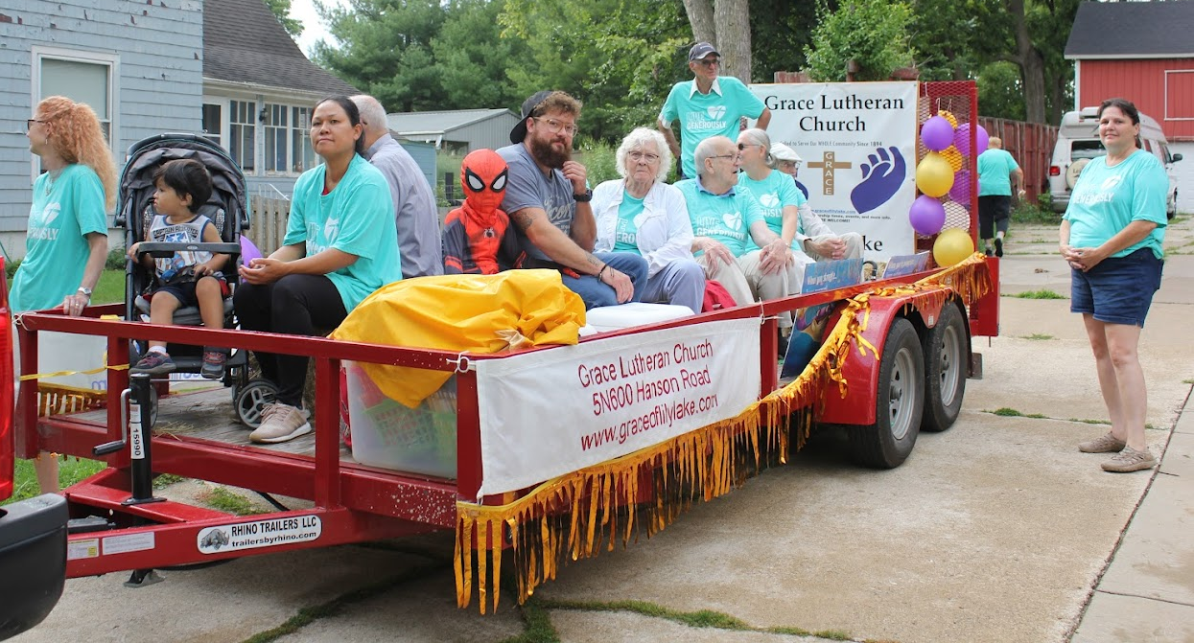
ELBURN DAYS PARADE 2022:
What an exciting time to be blessed with being part of the Elburn Days Parade. A lot of people lined the parade route, especially kids anxiously waiting to get candy and pencils. We had a sprinkling of rain before the parade started and then it was dry the rest of the time. Our energetic walkers ran out of pencils, candy, and brochures by the end of the parade (note to self, plan more for next year). Our Spiderman Hero (Odin Turner) was a big hit with the kids, and he got a lot of waves and cheers.


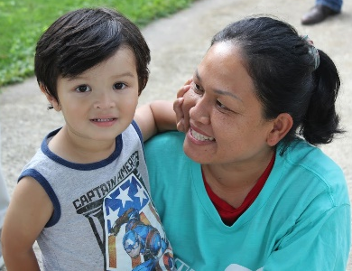
A big thank you to all the people involved in making our float entry in the Elburn Days Parade a success. Kelly Diehl provided his trailer and truck and John Verner drove the truck. People also helping with making the float happen are: Heidi & Mark Anderson (arranging trailer & truck and bales of hay to sit on), Bev Crosby (Cara’s sister), Kay Kinsel, Paul & Dottie Mantsch, , Pastor David, Piyamat & Dominick Mercurio, Janice Muncie, Karen Patterson, Kurt Redemann, Cara Turner, Norm Turner, Miles & Odin Turner, Tricia Painter and Cathy Whiteside.
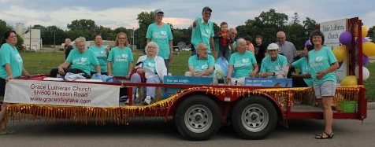
Cathy Whiteside’s house just happens to be on the street where the floats line-up. She hosted the float at her home, provided snacks, ham sandwiches (along with Paul Mantsch’s tasty homemade dill pickles). John Verner figured out that if he just waited until our spot in the parade came to Cathy’s driveway he could just pull out and join the parade (he coordinated this with the float that was scheduled right after our float). This saved everyone a lot of time and extra walking. A good time was had by all and there was talk about what to do for the 2023 Elburn Days Parade. Thank you, Lord, for blessing our time together and helping spread your Good News.
Dominick and Piyamat Mercurio

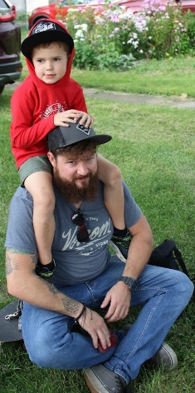

Odin and Miles Turner

MINISTRY NEWS
Many thanks to all who have donated to the following programs:
Homeless in Chicago: jeans, hoodies, sweat shirts, suitcases, back packs, bags and hand sanitizer.
Jesus’s Closet at Newlife Covenant Church Elgin IL: Clothing for the homeless.
Redeemer Fellowship Church in St. Charles: a free clothes closet once a month for those in need, including linens and blankets.
See Cathy Whiteside for more information and how you might be able to help.

Ongoing donations are welcome!

LAZARUS HOME UPDATE

Lazarus House serves men, women and children connected to the schools of Batavia, Geneva, St. Charles and western rural Kane County who are homeless or at risk of homelessness. It is the only emergency shelter serving central Kane County that is open around the clock, 365 days a year.
Grace currently contributes on 5th Sundays by making and delivering sandwiches to them.

LAZARUS HOUSE has just celebrated its 25th anniversary. Congratulations!

CONTACTS:
For emergencies please contact Marty Bradley, President, at 640-777-1074 or leave a message at the church office at 630-365-6751.
For prayer requests or other needs please call Kathy Hooey at 630-341-2293 or leave a message at the church office at 630-365-6751. Messages are checked daily at noon & 5 pm.

ELCA MISSION WEBSITES

LUTHERAN DISASTER RESPONSE:
https://www.elca.org/our-work/relief-and-development/lutheran-disaster-response
ELCA WORLD HUNGER APPEAL:
https://www.elca.org/Our-Work/Relief-and-Development/ELCA-World-Hunger
LUTHERAN WORLD RELIEF:
https://lwr.org/
REFUGEE ONE https://www.refugeeone.org/

Information for the October newsletter will be due by September 25th – please send it to Cathy Whiteside Cathy@imotay.com Thank you!

