 | SEPTEMBER 2024
 | AMAZING GRACE  CONNECTIONS  Faith > Family > Community
Grace Lutheran Church of Lily Lake
5N600 Hanson Rd, St. Charles, IL 60175
Pastor David Mercurio
INDOOR Worship every Sunday
At 9:30 am with Communion
- Sept 1 – Worship (no coffee hour)
- Sept 8 – Worship with Coffee Hour
- Sept 15 – Worship – RALLY SUNDAY – Sunday School starts
- Sept 22 – Worship
- Sept 29 – Worship

- September 1st through October 4th Christians around the world, including the Lutheran World Federation, celebrate the Season of Creation. Please see more information below.


SUNDAY SCHOOL – FALL 2024

Fall Sunday School for 3 year olds – 13 year olds will begin again on Sunday, September 15th and continue thereafter on every 1st and 3rd Sunday. Please see Janice Muncie, Pat Penfold or Marty Bradley to register your children if you did not do so last year.

A QUICK CONGREGATIONAL MEETING will take place in the sanctuary just after worship and prior to the celebration of Grace’s 130 years at the coffee hour on Sunday, October 13th. The meeting is to approve a change to the church bylaws which currently state that the annual meeting must be held in January. The Vision Team is recommending the bylaw be changed to state that the annual meeting must be held during January or February of each year. This is to accommodate putting together the annual report, finalizing the proposed budget and vacation schedules.
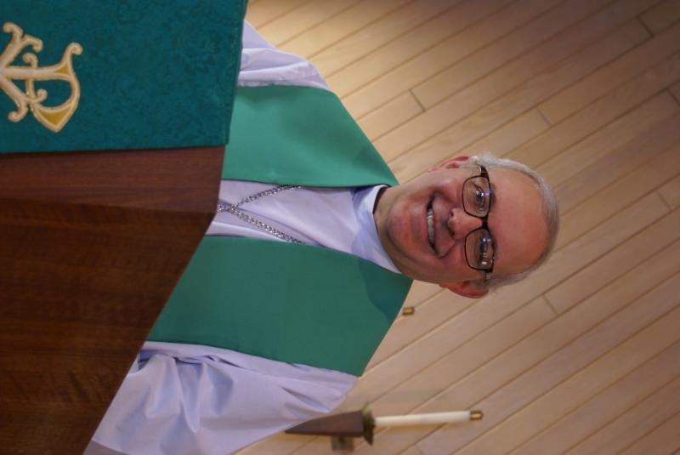
From PASTOR DAVID, September 2024

“If you’re going to give me directions, please don’t confuse me by using words like north, south, east, or west.” -Anonymous
As I have confessed in this newsletter before, I am somewhat of a You Tube addict. But I can’t help myself because it is such a fascinating window on the world, both past and present (and with the advent of AI, possibly the future?!). I have my regular channels I follow on topics such as theology, religion, geopolitics, music, nutrition, etc. But once in awhile I stumble across new insights and trends, some good, most bad.
The latest I found is a channel called “This is Why I Stay Home.” The creator of the channel provides a series of short clips featuring people exhibiting the most outrageous, aberrant behavior heretofore unimaginable. These are not immature youth hungry for attention or showing off their silliness. These are adults who are way outside the norm, people who have permanently disfigured themselves with tattoos, piercings, and implants to look like snakes and lizards; others who parade around and prefer to identify as dogs and cats; still others engaging in shrill screaming and zombie-like behavior in a public square. There are to date eight episodes of this program; I turned off the one I was watching after 5 minutes. It was truly shocking and depressing to how low we have sunk.
I mention this because, on the one hand, it makes me appreciate how Scripture is proven right when it says,
²⁸ Furthermore, just as they did not think it worthwhile to retain the knowledge of God, so God gave them over to a depraved mind, so that they do what ought not to be done. ²⁹ They have become filled with every kind of wickedness, evil, greed and depravity. They are full of envy, murder, strife, deceit and malice. They are gossips, ³⁰ slanderers, God-haters, insolent, arrogant and boastful; they invent ways of doing evil; they disobey their parents; ³¹ they have no understanding, no fidelity, no love, no mercy. (Romans 1)
But it also makes me delight in the grounding we have in Scripture. God shared His likeness with us in our love of beauty and truth and righteousness. Are we perfect? Absolutely not. Do we know when we have sinned? Yes. But through our faith, our sins are wiped away and our guidepost is the Holy Rock.
He will be the sure foundation for your times, a rich store of salvation and wisdom and knowledge; the fear of the Lord is the key to this treasure. (Isaiah 33)

Pastor’s Hours: Tuesdays and Thursdays from 6 pm – 9 pm, and Sundays from 8:30 am for 3-4 hours and by appointment when requested.


MANY THANKS AND PRAYERS TO THOSE WHO HAVE RECENTLY DONATED THEIR TIME AND TALENTS, including, but not limited to:

- Cathy Whiteside for hosting Graces’ Elburn Days parade float decorating and pre-parade meeting. See below for more information about all who helped. Photos last page.
- Everyone who helped put together the birthday coffee hour for Chili -Happy 90th.
- Vision Team members continuous work dealing with financial, building, ministry and all other issues.
- Barton family for donation of mulch and Kurt Redemann for spreading it
- David Russell (Scout dad) for installing a water softener in the boiler room Bags of solar salt (not pellets) will be needed – check with Kurt Redemann if you can donate a bag or two.
- Linda Smykowski – summer garden planting and upkeep - yum.
- Mowing of our church grounds – John Verner and Danny Lenert.
- All those who have assisting in helping with members’ special needs: hospital visits, rides, food, phone calls, prayers, etc.

FINANCIAL MATTERS –AUGUST 2024

Summer months are coming to an end, school sessions have begun. Your continued donations are a blessing to Grace and allow a variety of ministries to continue at Grace and help us serve our community.
- Our new boiler installation is nearing completion and thankfully before any winter temperatures are upon us. A church member has graciously gifted Grace with a $30,000 gift towards this boiler replacement. We have not received the final invoice for the remaining balance (~$19K) as of yet.
- The 11-month CD matured and earned interest of $1,681. Vision Team voted that the interest be transferred to our Building Maintenance Fund and was used towards a new water softener installation in the boiler room.
- Grace now has a renewed 12-month CD with the initial $35,000 investment @ 5% interest – matures Aug. 2025.
- The Building Maintenance Fund balance is $ 7,195. The Building Maintenance and Vision Teams review building and safety needs, outside of the regular maintenance services and any emergency repairs. If you wish to donate to this specific fund, please notate “Building Maintenance Fund”, so the donation will be designated accordingly.
- Noisy offerings are collected for special needs that arise.

Brief recap of July financials:
2024 2023
July 2024 Year-to-Date Year-to-Date

INCOME $ 12,787 $ 114,219 $ 106,056
EXPENSES $ 13,474 $ 102,737 $ 106,745
NET +/- $ - 687 $ 11,482 $ - 689

Pray for blessings upon Grace as we continue our mission and ministry, with goals and challenges for the second half of 2024. ~ In Peace ~ Tricia Painter, Treasurer
VISION TEAM REPORT
Meeting was held on August 13th
- Secretary’s minutes and treasurer’s reports were approved.
- Coming Vision Team meetings will be held at church at 6:30 pm on September 10th, October 8th, November 12th and December 10th
- Parents Day Out is continuing preparation for opening on September 9th. Budget was reviewed and discussed. Review of the program will be done after the first semester.
- The Vision Team voted to recommend to the congregation a change to the bylaws which state that the annual congregational meeting must be held in January. The change would be to state that the meeting must be held in January or February.
- Grace’s 11 month $35,000 CD was renewed for 12 months at 5%. Motion was made and approved to take the interest earned of $1,681 and move it to the building maintenance fund to cover the cost of the new water softener.
- Mortgage Team will be sending a letter out regarding the mortgage status asking for donations against the principal.
- Hurray, the new boiler has been installed along with a filtration system. The upstairs portion has been shut off as we have furnaces that cover that floor.
- Boy Scouts will be installing the new fire pit between Sept. 5 and Sept. 9.
- Line Dancing begins Sept. 11 and will run through Dec. 11.
- Fall rummage sale is October 4-5.
- October 13th coffee hour will be a celebration of our 130th anniversary.

MISCELLANOUS INFORMATION
- The Finance Team is looking for volunteers to sign up as counters (counting our weekly offerings after worship) to have a rotating list of counters Please see Linda Smykowski or Tricia Painter for further details.
- The Worship Team is seeking additional volunteers to sign up to help run our power point during worship which brings the bulletin onto the TV screens in the sanctuary. Especially needed on the 1st and 3rd Sundays of the month. Please see Tricia Painter. If interested.
- If you know of someone who could benefit from having a PRAYER SHAWL, please let Twyla Strom know. We would like to share them with those in need.
- Spare BIBLES? If you have extra Bibles you are not using, please bring them to church as we are supporting a ministry that is sending Bibles to South Africa. Please leave them on the balcony steps on the 1st Sunday of the month.
- Our new website sign on is graceoflilylake.org (not .com)


This Photo by Unknown Author is licensed under CC BY-ND
Parents day out
A new ministry at grace

Our new Parents Day Out program, under the direction of Janice Muncie will begin on Monday September 9th. The program for children 3 – 5 years (potty trained only) will be open on Mondays and Wednesdays in Fellowship Hall from 9:15 am – 1:15 pm. Two teachers will be on site each day. The program will be using Christian materials. Costs and registration are now open. If you wish to register your child or volunteer to be a substitute teacher, please contact Janice at Janice.muncie@gmail.com.

UPCOMING SPECIAL DATES

LINE DANCING begins again on Wednesday, September 11th and continues on Wednesdays through December 15th from 6-7 pm in Fellowship Hall.
- RALLY DAY and start of Sunday School, Sunday, September 15th (3 – 13
year olds) every first and third Sunday thereafter)
- Oktoberfest will be Saturday, September 28th from 5 – 8 pm. More information below.
- October 4th and 5th – Fall Rummage Sale - see below for drop off times.
- Sunday, October 13th – We will celebrate Grace’s 130th Anniversary during worship and coffee hour. Special guest Pastor Anna-Kari Langseth-Johnson. There will also be a short Congregational meeting to approve a bylaw change – increasing annual meeting time from January “through February.”


OKTOBERFEST

Once again Grace will be hosting an Oktoberfest on September 28th from 5p- 8p. We’ll have an array of foods; pulled pork, Reams brats, Hot Dogs. Accompanied by sides; coleslaw, baked beans, tossed salad, Desserts galore, we guaranty there will be brownies and many other delectable sweets. We will have water, Lemon aide, Apple Cider, coffee and tea.
There will be games for young and old, bag toss, bounce house, bouncy balls.
Then of course a Hay Ride and a small fire for smores.
Watch for the sing up sheet in the Narthex for items to donate and times to volunteer.
George Theros
 ROAD RUNNERS TRIP 2024
Adventures in the Smokies!
Registration for the September Roadrunner trip has begun. We will be leaving Grace on Sunday, September 15th and returning Saturday, September 21^{st.} Some places we’ll be visiting are Anakeesta: a new attraction in Gatlinburg, Dollywood, the Island in Pigeon Forge, The Biltmore in NC and Brushy Penitentiary. The estimated cost of this trip will be $1400-$1450. Registration forms will be in the Roadrunner mailbox in the church office or see Suzanne Girsch.

SPECIAL MINISTRY INFORMATION:
Operation Christmas Child –Shoe Box Ministry: Need shoe boxes, toys, and more ideas can be found at https://www.samaritanspurse.org/what-we-do/operation-christmas-child/ Cathy Whiteside (630/605-1096) contact person@ Grace. Thank you to all helping with this ministry.

NEEDED: EMPTY SHOE BOXES
For:“Operation Christmas Child” Mission.
Please place shoe box donations in front entrance to the church. For more information:https://www.samaritanspurse.org/operation-christmas-child/mission- and-history
Bridge to Life Group’s Jesus Closet (homeless in Elgin): Items needed are backpacks, blankets, gym shoes, t-shirts, jeans, coats and socks. Please mark donated items to the attention of Cathy Whiteside (630/605-1096). Thank you for all the donations.
Clothing and miscellaneous items for the migrants in Chicago are being collected by Cathy Whiteside (630/605-1096) to be given to Pastor Anna-Kari Johnson for distribution in Chicago. Thank you to all who have donated in the past. Left overs from our Spring Rummage Sale were already passed on to this ministry in June.

NOISY OFFERING

Every Sunday we collect a “noisy offering” when you wish to empty your change purse or pockets. We are currently collecting for maintenance items, including our new boiler. Thank you.

REBECCA CIRCLE

Rebecca Circle will meet on Tuesday, September 17th at 1 pm in Fellowship Hall to get right back to work.

CRUISE A LOVELY RIDE ON THE FOX RIVER with your friends from the Rebecca Circle. It has been rescheduled for Oct.15th, to enjoy a fall color cruise on the Fox River and a meal together at that time. We will, once again, share a delightful lunch at the Brunch Cafe before the cruise.


FALL RUMMAGE SALE DATES

October 4 & 5
Set up October 2 & 3
Drop off dates: Tues: Oct 1 (varied hrs during day, 6pm-7pm) & Wed. Oct 2 – 10am-2pm)
Wed. - Oct 2 – set-up – volunteers anytime 10am – 4pm – varied times (bring you own lunch)
Thurs. - Oct 3 – set up – 10am - until late afternoon / when we are finished (bring you own lunch)
Fri. - Oct 4 – Sale: 9am – 4pm – volunteers needed by 8:30 and throughout the day (sandwich + salad fixin’s will be available)
Sat. - Oct 5 – Sale: 9am – 2pm – volunteers needed throughout the day ; ** 2pm Clean-Up (sandwich + salad fixin’s will be available)
Donations are being accepted after church services Sept. 22 and 29. Larger items to be dropped off Oct. 2 or 3 *various times noted above* – please contact one of us below, if you need assistance when dropping off - last donations accepted on Oct. 3 by 2pm, to allow volunteers time to get your items set out – Thank you!
As a reminder: we cannot accept older TVs, no TV / ‘entertainment’ cabinets, sofas or mattresses. Items that are clean, vacuumed and in working order, with cords, accessories, etc. Ask yourself “would I buy this?” and if ‘no’, please pass this item on yourself (we don’t have the woman/manpower ).
Please contact any of us with any questions: Tricia Painter 708-624-0400 Linda Smykowski 708-309-3444 Cathy Whiteside 630-605-1096. Looking forward to a fulfilling autumn community sale!

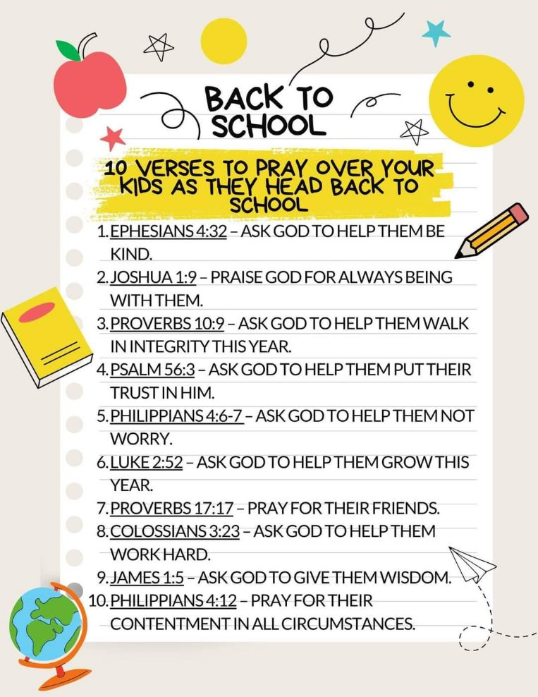

COVID 19, FLU AND RSV SAFETY PROTOCOLS
We follow the recommendations of the CDC, ELCA and IL Department of Health.
If you wish to mask and social distance, please do so. Please do not come to church if you have symptoms of illness. If you do not feel comfortable worshipping with others, we invite you to join us for worship via our website, graceoflilylake.org

CONTACTS:
For emergencies, please contact the church office at 630-365-6751.
For prayer requests or other needs please call Kathy Hooey at 630-341-2293 or leave a message at the church office at 630-365-6751. Messages are checked daily at noon & 5 pm.

Information for the October newsletter will be due by September 25th – please send items to Marty Bradley at martybradley@mchsi.com. Thank you


Season of Creation 2024: "To hope and act with Creation"
The theme and symbol for the Season of Creation 2024 are now available, with a theological reflection inspired by the Letter to the Romans, encouraging Christians around the world to prepare to experience the ecumenical season next September.
The theme for this year is "To hope and act with Creation". The annual Christian celebration is convened each year to pray and respond to the cry of Creation, between September 1st, the Feast of Creation, and October 4th, the Feast of St. Francis of Assisi.
This year, the symbol that will guide the season is "The first fruits of hope," inspired by Romans 8:19- 25. The times we live in demonstrate that we do not relate to the Earth as a gift from our Creator, but as a resource to be used. "Creation groans" (Rom 8:22) because of our selfishness and our unsustainable actions that harm it. However, Creation teaches us that hope is present in waiting, in the expectation of a better future (cf. Rom 8:20-21).
To hope in the biblical context does not mean to remain still and silent, but to groan, to cry out and to struggle actively for a new life in the midst of difficulties. Creation and all human beings are called to worship the Creator, working for a dynamic future from which the firstf ruits of hope can spring.
Visit the SeasonOfCreation.org website, where you will find the Religious Leaders' invitation message and the available resources

ELBURN DAYS PARADE

Many people were involved in making our float a success in the 2024 Elburn Days Parade. Participating were: Mark Anderson, Missy & Tom Barton, Marty Bradley, Trish Painter, Janice Muncie, Helen Gruber, Cathy Whiteside, Karen Patterson, Kurt Redemann, Cara Turner-Kusch, Miles Turner & Odin, Megan Brannen & Emmy & Ryder, Pastor David Mercurio & Piyamat & Dominick, John Verner, Piotr & Kelly Gwizdala & James & friend & Nathan & Claire, Josh & Marla Roach & Bethany & friend & Abby & Emma, & Vickie Linden. We all had a good time. We thank God for keeping us safe, even though some of us got wet. The candy was all handed out. A big thank you to Thrivent for financially supporting us in our work as a Thrivent Action Team for the parade. Apologies to any who may have been inadvertently not mentioned in our list of participants.
See photos below





