SWORD method Bible Study

What does it say?
Read the passage twice and summarize it in your own words.

Use the image of a sword to dive deeper, and draw out what the passage teaches.

God

Sin to avoid Example to
follow
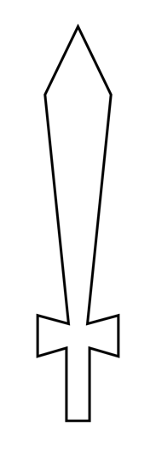

Man

What does it say about God?

What does it say about man?

Is there a sin to avoid?

Is there an example to follow?

What is the overarching lesson the passage teaches?

How will I apply it?

