ARCHIVES
Pastoral Gallery
This section honors the pastors who have led Second Missionary Baptist Church (SMBC) throughout its 160-year history, recognizing their faithful service and the achievements that have shaped SMBC’s ministry, membership, mission, and witness. It highlights each pastor’s unique contributions while demonstrating how their leadership built upon the foundation of those before them, strengthening the church and its impact on the community.

1st Pastor
Rev. Mason Burt (1866 - 1884)
In 1866, formerly enslaved believers moved from Wauhatchie (which is now Tiftonia) to Chattanooga, where the church was established. Rev. Mason Burt was the first pastor of Second Missionary Baptist Church and played a key role in organizing the church, then known as Pleasant Grove Baptist. Under Rev. Burts’s leadership, it became the city’s second African American Baptist church. As membership increased, he organized the church’s first building fund to support the growth. A devoted servant of God and the church, Rev. Burt dedicated his life to ministry and serving others. He was a U. S. Civil War veteran and passed away at age 72. Rev. Burt was laid to rest in Chattanooga National Cemetery on March 23, 1917.

2nd Pastor
Rev. John J. Sales (1885 — 1893)
Rev. John J. Sales led efforts to rebuild the church and position the entrance on 10th Street, then known as Leonard Street. He served until spring 1893, when he departed Chattanooga and led a group of 25 African Americans, primarily men, to Pueblo, Colorado.

3rd Pastor
Rev. Richard C. Richardson (1894 —1896)
Rev. Richard C. Richardson had the challenging responsibility of completing the rebuilding and remodeling efforts initiated under Rev. John J. Sales. During his tenure, the congregation changed the church’s name from Pleasant Grove to Second Baptist, reflecting its distinction as the second African American Baptist Church established in the city.
4th Pastor

Rev. Phillip H. Hughes (1896 — 1898)
While very little information is available about Rev. Phillip H. Hughes, he was known for his passion and interest in organizing church revivals. During one electrifying revival, more than 20 people were saved.

5th Pastor

Rev. W. H. Tilman (1898 — 1901)
Rev. Tillman served on both the Tennessee and Chickamauga Baptist Associations. He was also an educator in the Hamilton County School System and played an active role in educational organizations throughout the city.

6th Pastor
Rev. J. H. Johnson (circa 1901—1902)
Rev. J. H. Johnson, a powerful preacher, encouraged the members of Second to acquire additional property and build a parsonage for the church.

7th Pastor
Rev. Sam H. Johnson (circa 1902 —1903)
Under the leadership of Rev. Sam H. Johnson, the church achieved a significant milestone by becoming debt-free. This was a proud and joyful accomplishment for the congregation.

8th Pastor
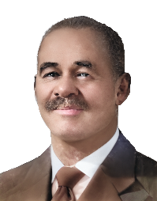
Rev. Hiram J. Johnson (circa 1904 —1908)
Rev. Hiram J. Johnson was a gifted evangelist whose ministry led to the addition of more than 200 new members. During his pastorate the church was formerly chartered and expanded through the acquisition of additional property. He also served as moderator of the North Chickamauga and Chattanooga Baptist Associations. He left Second in 1908 after accepting a call to Pastor Orchard Knob Baptist Church in Chattanooga.

9th Pastor
Rev. James Henry Mastin (1909 —1914)
During Rev. Rev. James Henry Mastin’s tenure, the church purchased its first piano, and he represented the congregation annually at the National Baptist Convention. In 1914, Rev. Mastin resigned after being called to pastor Union Hill Baptist Church in Detroit, Michigan.

10th Pastor
Rev. George K. Wilson (1914 – 1916)
Although his tenure at SMBC was brief, Rev. George K. Wilson earned a reputation as a gifted preacher. He left Second in 1916 after accepting a call to Pastor Carter Street Baptist Church in Chattanooga.

11th Pastor
Rev. H. K. Kennedy (1916 —1919)
Rev. Kennedy and his wife were the first residents of the new parsonage adjoining the church at Leonard and Elm Streets. Dedicated to the church’s success, Rev. Kennedy diligently did much of the labor to support the church financially.

12th Pastor
Rev. Edward F. Gouch (1919 – 1921)
Rev. Edward F. Gouch was a forward-thinking leader who advocated relocating the church, though many members initially opposed the idea. With the support of the civic leaders in the Black community, he helped the congregation recognize the benefits of the move. The church eventually voted to relocate and purchase property at 14th and Grove Streets. Although Rev. Gouch was called away before the project was completed, his leadership played a key role in setting the relocation in motion.

13th Pastor
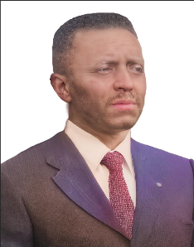
Rev. F. M. Hutchinson (1921 –1922)
Rev. F. M. Hutchinson became SMBC’s thirteenth pastor in 1921 during a time of uncertainty. He led preparations for the church’s relocation to 14th and Grove Streets and encouraged the congregation to focus on paying down the property debt. During the summer of 1921, members worshipped in tents, and by the fall, the completed basement served as the church’s new worship space.

14th Pastor
Rev. Hillmon Hannibal Hubbard (1922—1932)
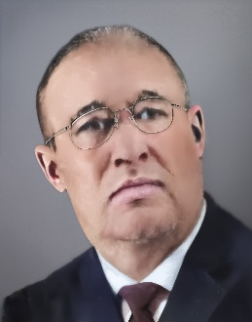
Rev. Hillmon Hubbard came to Second in 1922 with a working spirit and earned the reputation of being an effective leader. Under his pastorate and with the support of faithful members, the sanctuary at 14th and Grove Streets was completed in 1923. In 1932, Rev. Hubbard accepted a call to pastor Mt. Calvary Baptist Church in Knoxville, Tennessee.

15th Pastor
Rev. Samuel Pettigrue (1932 —1935)
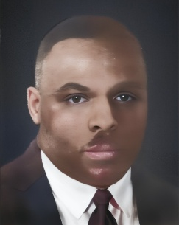
Rev. Samuel Pettigrue was a skilled organizer who strengthened lay ministry involvement. He developed and recognized several lay organizations including the Missionary Union, Baptist Training Union, and Baptist Young People’s Union at the local, district, and national levels.

16th Pastor
Rev. George W. Sandefur (1935 —1938)
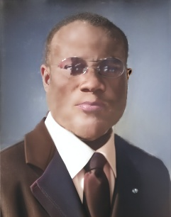
Rev. George W. Sandefur was an engaged civic leader who actively participated in the Negro Ministers Group and the Colored Ministers Alliance. He served as the Moderator of the 52nd Annual Session of the North Chickamauga and Chattanooga District Baptist Association and hosted a city-wide Baptist Young People’s Union Training School.

17th Pastor
Rev. Woodrow W. Taylor (1939 —1945)
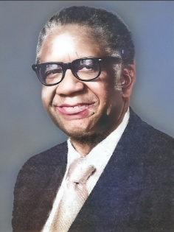
Rev. Woodrow W. Taylor, a protégé of Rev. Sandefur, was the pastor during the burning of the mortgage in 1941, a significant milestone in the church’s history. He later resigned in 1945 and formed Westside Baptist Church, marking Second’s first major split.

18th Pastor
Rev. Martin H. Ribbins (1945 — 1961)
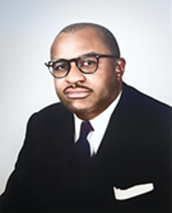
Rev. Martin Henry Ribbins, Sr., our eighteenth pastor, was a native of Memphis, Tennessee. He was respected as a gifted preacher, civic leader, organizer, and advocate for foreign missions. Passionate in his faith and community, he served as the Moderator of the Chattanooga Baptist District Association, a Trustee of Owen College, a member of the NAACP, and many other civic and religious organizations.
Following the launch of Chattanooga’s Urban Renewal project in 1957, many church members were forced to leave their homes on the west side of the city. In response, the first church bus was purchased to provide transportation to members for worship services and church events. The relocation of members also inspired Rev. Ribbins’ vision of building a new church. The congregation supported this vision by contributing to the building fund.
Sadly, his sudden death at the age of 53, prevented him from seeing the God-given vision fulfilled. He was laid to rest in Forest Hills Cemetery in Chattanooga on October 21, 1961.

19th Pastor
Rev. Edward N. Bates (1963 —1965)
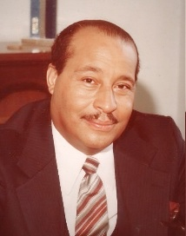
Rev. Edward N. Bates, a talented speaker, was called to serve as pastor on December 1, 1963. He led Second until 1965, when he resigned and formed The Greater Second Missionary Baptist Church. Some members followed him, marking the church’s second major split.

20th Pastor
Rev. Paul A. McDaniel (1966 — 2014)
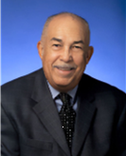
Rev. Paul A. McDaniel served 48 years, making him the longest tenured pastor in Second’s history. In 1975 under his faithful leadership, the church relocated from 14th and Grove to its current location at 2305 E. Third Street.
In 1977, Rev. McDaniel became the first clergy member permitted to serve as a delegate to the Tennessee Limited Constitutional Convention. He challenged Article IX of the Tennessee Constitution, which prohibited clergy from serving in state legislature. This battle ultimately reached the U.S. Supreme Court which unanimously ruled in his favor striking down Article IX.
During the mid-1980’s, the church expanded its facilities to include new classrooms, a nursery, chapel, multipurpose room, conference rooms, a commercial kitchen and administrative offices. In January 2000 the church celebrated the burning of the mortgage.
In 2002, Rev. McDaniel founded Second’s Evangelism School in partnership with the National Evangelism Movement of California. Guided by the theme “Disciples are Made, Not Born,” the tuition-free program served more than 17 local churches and graduated hundreds of participants and offered continued Bible training for graduates and new members.
Nationally, Rev. McDaniel served as an instructor and later as a supervisor in the National Baptist Convention, continuing this work until 2014. Locally he served on the Hamilton County Commission for five four-year terms. In 2010, the County Commission named an administrative building in his honor.
Rev. McDaniel retired on June 30, 2014, and served as Pastor Emeritus until his passing on August 22, 2021.

21st Pastor
Rev. Dr. Ernest L. Reid, Jr. (2015 – Present)
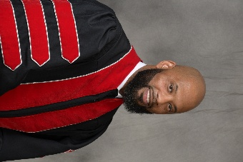
Rev. Dr. Ernest L. Reid, Jr., a native of Suffolk, Virginia, was installed as the twenty-first pastor in October 2015. A dynamic preacher and teacher of the Gospel of Jesus Christ, he has led the church into a new era of ministry growth.
From 2016 to 2019, he envisioned a stronger Second and led the congregation through plans for the church’s first major building renovation in more than 40 years. The renovations began in 2020 and included the sanctuary, vestibule, offices, youth room, restrooms, and technology upgrades throughout the church, Pastor Reid provided steady leadership as the church navigated the challenges and changes of the COVID-19 pandemic.
In 2022, with the support of SMBC, Pastor Reid went on his first foreign mission trip, teaching and preaching the Gospel in Kenya. Under his leadership, Second has seen increased membership growth, spiritual development, and expanded ministry initiatives including small-group Bible study and revitalized ministries.
Outside the church, Dr. Reid is a civic leader who is actively involved in the community, having served on the Hamilton County Partnership Network Advisory Board, The Urban League of Greater Chattanooga Board, and Chattanooga 2.0 Advisory Board. He also participated in the Harvard School of Business Young American Leaders Program. Additionally, he has contributed curriculum content for Lifeway Christian Resources and is a contributing writer for the Chattanooga News Chronicle, writing the column titled, “The Shepherd’s Voice.”
Pastor Reid continues to provide faithful leadership and vision for SMBC.

