
Making Disciples at Home through Teaching & Imitation

The Summer Family Guide

God’s Fruit of the Spirit

The fruit of the Spirit is listed in Galatians 5:22-23. It shares what someone looks like, acts like and serves like with Jesus living in them by faith. Take time to read through all of Galatians 5 to yourself and then share this Bible section with your child/ren. Look for opportunities to point out the various fruit aspects of the Spirit with your child/ren when you see them.

Note that the following items can be found at
trinitypeoria.com/children-s-ministry
Serving as Family Sheet
Kids in the Divine Service Sheet
Songs & Video Stories at the Trinity Jubilation YouTube channel

Jubilation at Church
Is on a summer Sabbath until late August

Trinity’s Jubilation in Your Home & at Church is your family’s opportunity to share God’s Word, mercy and life together in Jesus, making disciples at home with support from Trinity’s Family of God at church. If you have any questions or ideas about Jubilation and how we are operating it, please feel free to contact DCE Scott Rauch.

All Sorts of Items & Ideas to Use through the Summer

Bible Times
- Read right from your Bible with your child/ren about the Fruit of the Spirit and how they look in the Bible from these passages:
  - Galatians 5:22-23 – the actual list
  - 1 John 3:23 – all about God’s love in us
  - Psalm 47:1 – it’s about God’s joy
  - Philippians 4:7 – God’s peace is way beyond us
  - Ephesians 4:1-3 – patience is connected to love
  - Ephesians 2:4-7 – God is kind with us
  - Psalm 23:6 – God’s goodness follows around us
  - Psalm 26:3 – we walk in God’s faithfulness
  - Psalm 18:35 – God is gentle with us
  - 1 Corinthians 9: 24-27 – we are in control of our lives

Worship Liturgy Focus
Read the online K I D S-Worship sheet as a family.
Family Prayer Tent
Use the suggested Lord’s Prayer ideas.
Remembering Work Sheet
Use the sheet and have your family speak together Galatians 5:22-23 at various times throughout the summer. Post it on your refrigerator or somewhere else where everyone can see it often.

“Serving as Family”
Follow the suggestions found online.
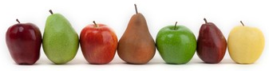
Psalm/Hymn/Spiritual Song
Find all the songs on the “Trinity Jubilation” YouTube channel.
- Fruit of the Spirit ~ Darren Winfield
- The Fruit of the Spirit ~ Sending Perfection
- Joyful Noise ~ FLAME feat. Lecrae & John Reilly
- Peace Be Still ~ The Belonging Co feat. Lauren Daigle
- Lord of All Hopefulness ~ Jon Dickerson
- Spirit, Grow Your Fruit in Us ~ Praise Him
Craft
Make the craft using the supplied items.
Activity Sheets
Make use of the various activity sheets provided in the bag all through the summer. Want more? Just Google Image “Fruit of the Spirit” and see what you come up with!
Extra Stuff
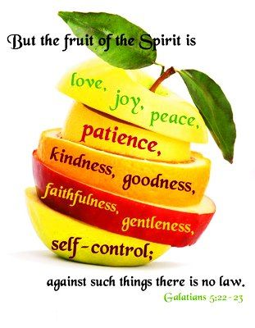
Your family’s bag has all sorts of extra stuff for your family to enjoy and use as the summer moves along.

Building Disciples at Church through
Word & Sacrament and Community

Summer Dates & Things to Do

June 14 & 28
14 & 28-Kids Library Book Day
14-Voters Bylaw Changes Discussion
28-Voters Meeting
July 5 TRINITY GOES TO THE BALLPARK!
Check with Pastor Matt or Cantor Peter for info.
July 19 “Splashin’ in the Son” Water Day
Right after the 10:45 service and includes a free lunch!
July 26 Movie Night
Come enjoy a family friendly movie with free popcorn & drink for everyone!
August 23
Jubilation Family Meeting

