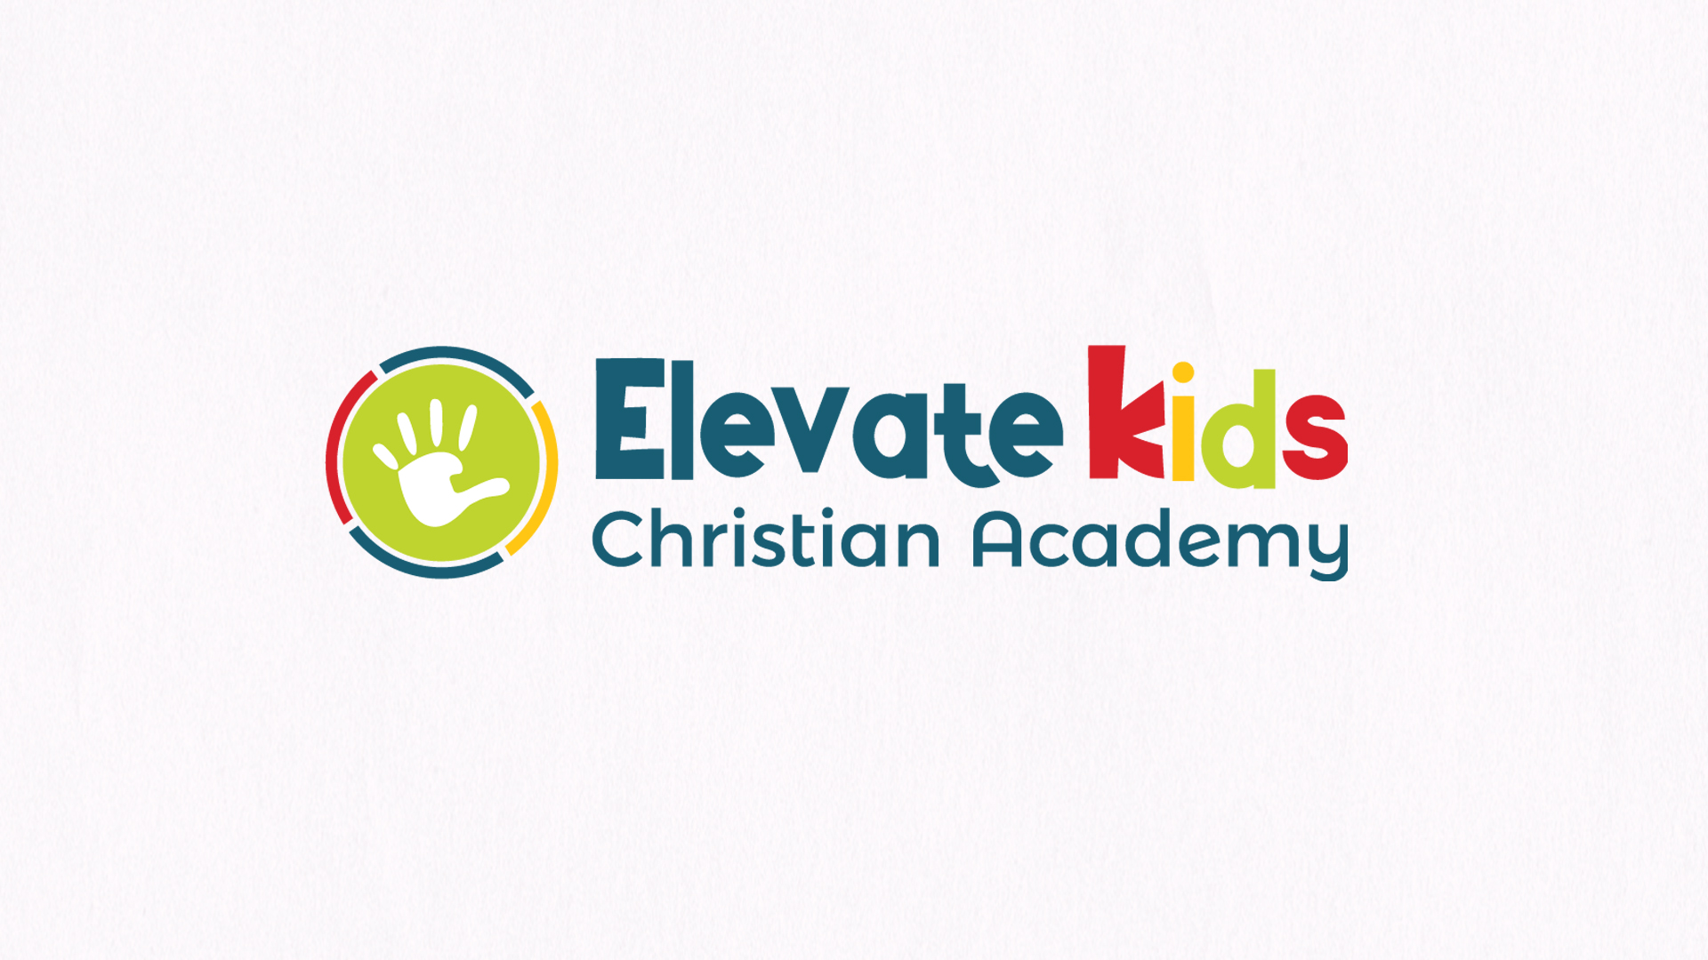

Elevate Kids Christian
Academy

Policy Handbook

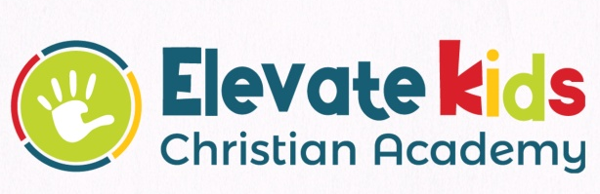
Elevate
Kids Christian Academy
Parent Handbook
1659 East 1400 South
Clearfield, UT.84015
ekca@elevation.cc

Dear Parents,

Thank you for choosing Elevate Kids Christian Academy. Our desire is to provide a quality learning environment for your child. Your child is very important to us and we strive to make our school a happy, positive, learning experience where your child can discover and grow.

You are very important to the success of this program. We maintain an open door policy for parents during school hours. This means that parents are always welcome to call or drop in to see their children. We would appreciate your taking into consideration our schedule when dropping in or calling, and remember that visitors usually cause children to react in an excited manner. If you call during the day, please be aware that we may be busy with the children and may not be able to answer the phone. If you would leave a message, we will call you back as soon as possible.
If you have talents or ideas you would like to share, we welcome your input.

This handbook is designed to acquaint you with the policies and procedures established by Elevate Kids Christian Academy. Please read and refer to this book often.

If you have any questions or concerns, please feel free to contact Michelle at (801)725-9282 or email at ekca@elevation.cc.

Many Blessings,

Michelle Farley
Director

NONDISCRIMINATORY POLICY AS TO STUDENTS
Elevate Kids Christian Academy (Office: 1659 East 1400 South, Clearfield, UT 84015) admits students of any religion, race, color, national and ethnic origin to all the rights, privileges, programs, and activities available to students at Elevate Kids Christian Academy. The school does not discriminate on the basis of religion, race, color, national and ethnic origin in administration of its programs or of its educational, admissions, or tuition policies.
Mission Statement for Elevate Kids Christian Academy
Elevate Kids Christian Academy is a non-denominational, evangelical Christian school, which strives to provide a quality academic education based on Christian principles. Elevate Kids Christian Academy is committed to leading students into a genuine relationship with Christ while providing an excellent academic program.
Statement of philosophy for Elevate Kids Christian Academy
Elevate Kids Christian Academy is a community of worship in Christ, open to growth towards fuller humanness through a living faith, hope, and love. The goal of this community is to create a Christian environment wherein the child learns to integrate secular knowledge with the life and the biblical teachings of Jesus Christ. Achievement of this goal will best be accomplished through mutual warmth and friendliness in an atmosphere of self-awareness and awareness of others.
In order to accomplish this stated purpose of the Elevate Kids Christian Academy:
- Opportunities for prayer and participation in the classroom.
- Students will develop the knowledge and understanding of their faith through participation in bible classes.
- Courtesy and respect for one another will be encouraged by word and example.
- Emphasis will be placed on developing self-discipline, responsibility, and love towards all people.
- The curriculum will be reviewed and updated periodically in order to assure the spiritual, intellectual, social, and physical growth of each child.

Partnership and Communication

We believe each child is a unique creation of God. Our goal and desire is to nurture your child in a positive, friendly atmosphere that promotes development of their intellect, confidence and self-worth.

Children learn and develop in different ways; through play, instruction, experience, and observation. Our goal is to draw on these various learning opportunities using,
a well-planned curriculum, hands on activities, and teacher-peer interaction.

Building a relationship with you, as parents, is central to the success of this program.
When a new family is accepted into our school, we like to be sure that we can share openly about any concerns or questions that may arise. It is important that there is a similar child care philosophy between the school and the parents. We welcome questions, feedback, or discussions of any kind that are oriented towards a positive outcome for the child(en). Sensitive issues will be discussed in private at a mutually beneficial time.

Personnel Requirements

All teachers must be either, certified or enrolled in a certification program through an accredited college or university in Early Childhood Education.

- All personnel must have a Tuberculosis skin test and be free from any other infectious diseases.
- All personnel must pass a criminal background investigation.
- Elevate Kids Christian Academy requires all employees to have a personal relationship with Jesus Christ.

Use of Building and Safety Procedures

Your children’s safety is very important to all of us at Elevate Kids Christian Academy. In order to insure your children’s safety while they are here we have adopted the following procedures:

- All staff will have background checks prior to employment.

- Check-in and check-out of all children and visitors.

- All visitors and staff members will wear visible I.D. tag.

- Classroom areas and children’s restrooms are off-limits to all non-Elevate Kids Christian Academy

- Staff are as will be clearly marked and partitioned (as necessary).
- No child will be left unattended at anytime.

Registration and Curriculum Fees

There are several forms the make up the Elevate Kids Christian Academy enrollment packet. This enrollment packet must completed and in our possession before we can assume the responsibility of caring for your child. This is to ensure that your child will get the very best care possible and satisfies the record keeping requirement of state licensing guidelines. All forms will be reviewed annually. If there are changes to any of the forms in the enrollment packet, please notify your director to update your records.

A registration/curriculum fee of $100.00 Preschool 3’s & $200 Pre-Kindergarten 4’s. This fee is non refundable and covers the cost of procuring curriculum, arts and other supplies needed during the period of enrollment.

Elevate Kids Christian Academy has a mandatory auto pay program. Enrollment is mandatory, although your account will not automatically be auto processed unless your account is not kept current or you have check auto pay as your primary source of payment. You may pay with a check, money order, or cash if you’re not comfortable with auto pay. If your account becomes delinquent in payment then you will be asked to sign up with auto pay.

Monthly Tuition Rates and Hours

Preschool 3’s (3-4 years) AM Class
Tuesday & Thursday.
8:30am-11:30am
Cost: $200.00 a month

Pre-Kindergarten (4-5 years)AM Class
Monday, Wednesday, Friday.
8:30am-11:30am
Cost: $250.00 a month

Pre-Kindergarten/Pre-School only items needed in the beginning of the year and throughout the School Year
- Backpack big enough to hold a folder and a change of clothes.
- Change of clothes in a zip lock bag labeled with your child’s name
- 2 Snack’s—crackers, cookies, fruit snacks, chips, cereal,(applesauce or fruit cups)(must contain enough for 15 to 30 servings) We share all snacks.
- 1 package of markers—washable Crayola Classic or any Washable markers 10 count
- 1 small set of Crayola water color paints
- 1 Water color set
- 8 glue sticks
- 1 package’s all-purpose paper cups—4 ounce or 5ounce
- 2boxes of Kleenex
- 2 packages of baby wipes
- 1 box Gallon size zip lock bags
- 1 small box of plastic spoons
- 1 bottle of Hand sanitizer

Personal Belongings

We prefer that children do not bring toys from home unless it is something that can be shared with the entire group (i.e. books, videos, etc.). Little ones have a difficult time sharing with others, and it is even harder with their own special toys. If toys are brought, please note that they may be put away, if they are the cause of disagreements among the children. Exceptions to this policy will be that a child may bring a favorite sleepy toy for naptime only, and toys may be brought for show and tell activities. We are not responsible for any loss or breakage of personal items. All personal items must be clearly marked with the child's name.

Clothing
All children are required to bring a backpack with an extra change of clothing, such as: light weight pants, shirt, under wear and socks in a one-gallon Ziploc. The Ziploc will be used to place soiled or wet clothing in.
Children should wear comfortable clothing that will allow them to be involved in activities planned each day. These clothes need to be easily removable to potty. Girl’s dresses need to have shorts underneath. No spaghetti straps or tank tops. If you chose to send your child in those items, your child must have on an over shirt or sweater. Shoes must be easy for children to remove (Slip-Ons or Velcro; No high top boots).
Payment Policy

Elevate Kids Christian Academy monthly tuition is prorated and based on the yearly tuition divided into 9 equal payments. Note: you are billed the full years tuition payment upon registration. You are expected to pay tuition in 9 equal payments.

Payment is due in advance of services. The amount due does not change when the Program is closed, nor is tuition discounted for holiday breaks, teacher workdays, inclement weather school closure due to flu or other infectious agents, if your child is ill or anything out of Elevate Kids Christian Academy’s control.

Each child’s slot in the Program is reserved for him or her only. Payment is due regardless of attendance.

Tuition payment is due, on or before the first day of the month. We accept many forms of payment including, major credit, debit cards, check, money orders, automatic debit of account or cash. You may also call you payment in over the phone to our main office. Please make checks out to Elevate Kids Christian Academy; please include your child’s name on the check in the memo.

A fee of $35.00 will be assessed for any returned checks. Late payments plus monthly tuition must be received on or before the first day of the month.

Elevate Kids Christian Academy reserves the right to impose a $25 dollar late fee payment penalty per month and/or to revoke at will the enrollment of any child whose account is past due. If tuition payment becomes a problem, please contact the Program Director so that a payment plan can be arranged and participation in the Program can continue.

If you withdraw your child, you must give the school director two weeks’ notice to receive any prorated tuition reimbursement.

Receipts and Credits

A monthly statement is issued to all families of Elevate Kids Christian Academy via email. A yearly statement for tax purposes is issued by Feb 1, also via email. Duplicate statements are available upon request for a $5.00 Fee.

Emergency Dismissal Procedures
Elevate Kids Christian Academy will be closed whenever the Davis County Public School System is closed or dismissed early due to inclement weather or whenever there is an unexpected event that impacts the safe use of our site. In the event of early dismissal we will contact the parents of any child/children that are in program.
Fire Drills
We are required by state law to do one fire drill per month at each location. We vary the time of day to help the staff and children prepare to evacuate the building quickly and safely. We will not do fire drills when the temperature is below 20 degrees or above 85 degrees.
Late Pick up Policy and Dismissal
Unless arrangements are made in advance, children must be picked up no later than 5 minutes after class ends.

A late fee of $1.00 per minute will be charged for a pickup after your child’s class ends. Please note: you will have three 10 minute grace periods per year.
Class Time’s End: Pre-school 3’s 11:30amTuesday, Thursday. Pre-Kindergarten 11:30am Monday, Wednesday, Friday.
An entry in the late pickup log will detail the time of pickup and the amount due. Late fees will be added to the child’s tuition bill. After the third occurrence of a late pickup, the ten minute grace period will be revoked. Continual late pickup may result in a child’s suspension or removal from the program.
The pre-school staff is unable to remain on site after 11:45 a.m. We will be happy to discuss special requests or exchanges of detailed information over the telephone or at a meeting scheduled during Program hours.
Parents must personally walk children into the school at the beginning of class (make sure the teacher knows your child is present). Please hold on to your child’s hand at all times in the parking lot until they are safely in the school or buckled into your vehicle. Please do not leave siblings in a running vehicle when picking up.

Your Child’s Adjustment:

Arrival

It is normal for your child to have some fears and misgivings about being away from you. Children need time to adjust to a new situation. Prepare your child for the changes as far in advance as possible. Discuss with your child any concerns and talk about some of the new people your child will meet and the things he or she will do in school. A cheerful good-bye kiss, a smile, and reassuring words are all that you need to do when dropping them off for school. Usually the child settles down shortly after the parent(s) leave. If your child continues to cry we will call you. Activities are offered to provide transition for your child at this time. Please do not sneak out when your child is not looking. Feel free to call anytime throughout the day if you have any questions or concerns.

Departures

Please be brief at pick-up times, as well. This is a time of testing, when two different authority figures are present (the parent and the provider). All children will test to see if the rules still apply. During arrival and departure, we expect parents to back up our rules. Please be in control of your child during pick up times.
Please leave your cell phones in your car so that the director, teachers and your child will have your undivided attention at pick up or drop off time. Drop off and pick up are not good times to discuss serious problems. Little ears and minds hear and understand everything. Your director can set up a time where the issues can be discussed in private.

Developmental/Curriculum
Our program is based on the ABEKA curriculum, which is phonics and number based. For more on ABEKAgotohttp://www.abeka.com/. Age appropriate activities are planned and implemented to further each child’s developmental growth. Throughout the year, every child’s developmental skills are assessed in the areas of: cognitive, language, physical and social.

Curriculum Outline
Early Phonics Physical Education
Early Math Cooking Music & Dance
Field Trips Developmental Play
Computers Seasonal
Music Programs Crafts
Bible Science
Guidance Policy
At Elevate Kids Christian Academy, discipline consists of positive guidance techniques, redirection, and thinking time (time-out). In extreme situation your child may be sent home for the day or expelled from school. The use of physical punishment is never permitted.

Supervision
Children enrolled at Elevate Kids Christian Academy will be properly supervised at all times, to ensure safety and security.

Exclusion Policy

A child will be excluded from school if one or more of the following conditions exist:

1. A child has a fever greater than 99.9 degrees.
2. Diarrhea, which is defined as an increased number of stools compared to the child’s normal pattern and with increased stool water.
3. Vomiting illness with two or more episodes in the previous 24 hours.
4. Rash with fever.
5. Infected eyes with discharge, until 24 hours after treatment by a physician.
6. Infestation (scabies, head lice, pinworms) until after first treatment with a medicated product.
7. Impetigo, until 24 hours after antibiotic treatment is started.
8. Strep throat, until 24 hours after antibiotic treatment is started.
9. Ring worm Infection, until after medication is started.
10. Chicken-Pox, until one week after the onset of rash or until all lesions have dried and crusted.

(Please contact school if child has contracted a contagious illness)

Illness
If a child shows signs of illness during school the parent or other emergency contact will be notified immediately and the child will be isolated from the class to prevent the possible spread of illness to other children.

Infection Control
All children are taught to wash their hands before eating and after toileting. This helps reduce factors that cause infection and disease.
Accidents or Acute Illness
In the event of an accident or acute illness, every effort will be made to notify the child’s parents and physician prior to treatment. If a situation requires immediate attention, 911 will be called and the child will be transported to the hospital by ambulance.
Health Policy
All children enrolled in Elevate Kids Christian Academy must satisfy the minimum immunization and routine physical examination requirements in accordance with the Utah Public Heath requirements. Documentation of the above must be on file at the child’s school.
Elevate Kids Christian Academy exclusion and reporting policies for communicable diseases are in conformance with the guidelines set by the Utah Department of Public Health. In the event of an outbreak of communicable disease or condition that is reportable to the Department of Health, a notice will be posted in the entry.
If a child becomes ill while attending the Program, a parent or emergency contact person will be notified. A child who is not feeling well should be picked up within one hour of notification. The Program will provide a rest mat and a quiet area while the child waits.
Children who attend Elevate Kids Christian Academy should be well enough to follow the normal routine of the Program. Children who have a contagious condition, eye ailment, head lice, rash, fever, vomiting, or diarrhea, may not attend the Extended Care Program, and must be fully recovered before returning to Elevate Kids Christian Academy.
Please report any changes of emergency contact information, employment, telephone numbers, or addresses to the Program Director as soon as they become available. Although this information will be kept confidential, it will be shared with appropriate staff members to facilitate communication with parents or guardians in emergency situations.

Medications & Allergies
Elevate Kids Christian Academy will dispense prescription and non-prescription medication only when the written permission of the child’s doctor and parent or guardian is on file at Elevation Kids Christian Academy office. If the prescription is a life sustaining medicine parents must provide permission and training. All medication administered by the staff of Elevate Kids Christian Academy must be current and in a pharmacy labeled container. An adult must bring the medication into the Program. Children are not allowed to transport medication. Expired medication will be returned to the families.
A medication request form is included in the Elevate Christian Academy registration information packet. Additional copies of the forms are available from the Program Director or from the teacher.

Pets

Animals are an important element of children's learning. Animals can instill in children a feeling of love, caring, nurturing and respect for nature. It is fun and entertaining for children to bring pets to show to their friends. Parents must check with their child's teacher at least one week before and may bring pets at the beginning of class or at the end, but no pets can remain during the entire class time. Yet, if there are any students with allergies to animals we will not allow them to visit.
These pets must be well groomed, children friendly, and current on all vaccinations. Dogs must be registered & licensed with the county where they live. Parents must notify the teacher if they are bringing a pet to school.
Animals may not come into the building with you during pick up or drop of child. All animals must remain outside of the school gate/ building and are not allowed on the premises.

Toys
Children may not bring toys, blankets, bottles or binkies, etc. to school. On Show And Tell Days they may bring certain items as designated by their teacher.

Snacks and Juice
All snacks are provided by parents and must be purchased in a store. Birthday and holiday snacks maybe brought by parents. Juices are provided by parents. No punch or sodas, please.

Parties and Celebrations
Holiday celebrations are an important part of children’s lives. At Elevate Kids Christian Academy, we celebrate holidays that focus on the love that God brought to mankind. Thanksgiving, Christmas, Valentines, and Easter are holidays used to remind children of that love. If you are interested in helping as a room parent with parties and other activities please talk to your teacher for more information.

Art

Art at Elevate Kids Christian Academy consists of one hanging craft, one bulletin board craft, one take home and one free art project. All bulletin board crafts and some art projects maybe held for the year books.

Safety Information

Emergency drills are held quarterly to acquaint your child with evacuation procedures. This may make quite an impression on your child the first time a drill is held. Your child will soon become accustomed to it and know what to expectand what to do. Complete emergency escape plan guidelines are available for your review upon request.

Field Trips and Outings

Fieldtrips are an excellent tool used to enhance and support the curriculum we offer at Elevate Kids Christian Academy. Due to liability concerns, all fieldtrips must have at least one adult accompanying the child. Since the school has no available bus or van, parents are expected to drive or make arrangements for child’s transportation. This is a great opportunity for parents and children to get to know each other better. If parents are not able to attend, a grandparent, aunt or uncle can be the child’s designated chaperone. Teachers will give sufficient advanced notification of fieldtrips schedules.

Winter Weather Watch

Green: Safe for to play outside 32* -45* must have coats on.
Yellow: 21*-30* Caution must where coats (Winter) - time limited to no more than 20 min outside with a 1 hour inside before being allowed out for another 20 min outside.
Yellow 13* -20* Caution Must where coats, gloves, hats (winter)… Time limited to 15 min outside play, with a 1 hour inside before being allowed out for another 15 min.
Red: 12* and lower Danger, No outside play
Summer Weather Watch

Green: 46*-89* Safe for to play outside.
Yellow: 90*-103* Cautiontime limited to no more than 20 min outside with a 1 hour inside before being allowed out for another 20 min outside. If shelter from the sun is provided and water is plentiful, time outside is limited to 4 hours before having to come in side for 1 hour in an area where temperatures are below 90*
Yellow 103*-109* Caution Time limited to 15 min outside play, must have shelter from sun and water. With 1 hour inside before being allowed out for another 15 min. inside temperatures must be below 90*
Red: *110 or higher Danger, No outside play.

