



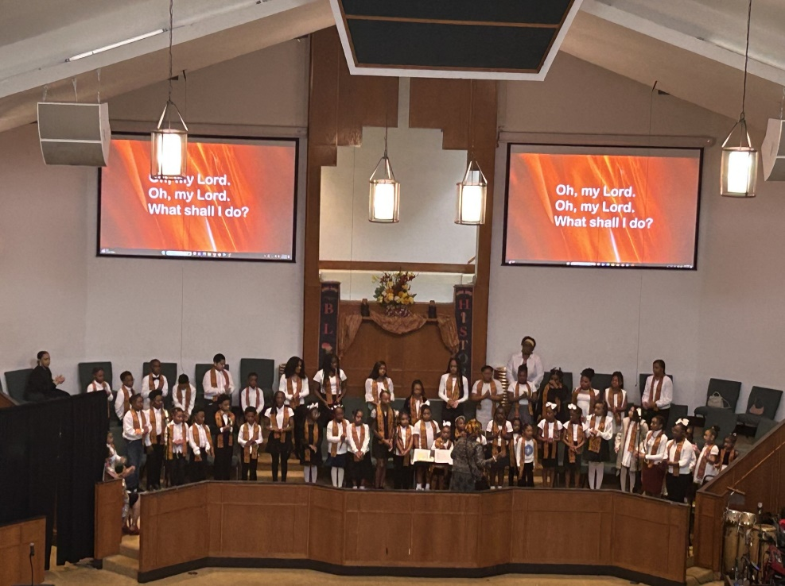

Progressive Baptist Church

Youth

Newsletter

July 2025

Pastor

Chad E. Nora

Children’s Choir: The Children’s Choir will rehearse on Monday, August 4th from 5:00- 6:00 p.m. Contact Sis. Cathie Durand, Director, via the Remind group below to join the choir. They will next minister on Sunday, August 10th during the 9:00 a.m. service.
Dance Like David Liturgical Praise Ministry and PBC Mime Ministry: The Jr. Troop (Elementary grades), Sr. Troop (Middle & High School grades) and Mime Ministry (boys ages 6-18) participated on program during Pastor Chad’s 2nd Anniversary program. The Sr. Troop will next rehearse on Fridays, August 8th and 15th at 6:00 p.m.
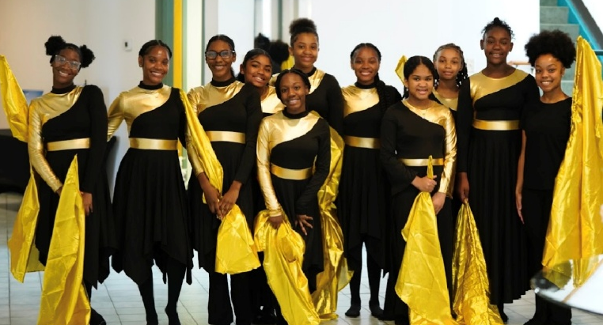
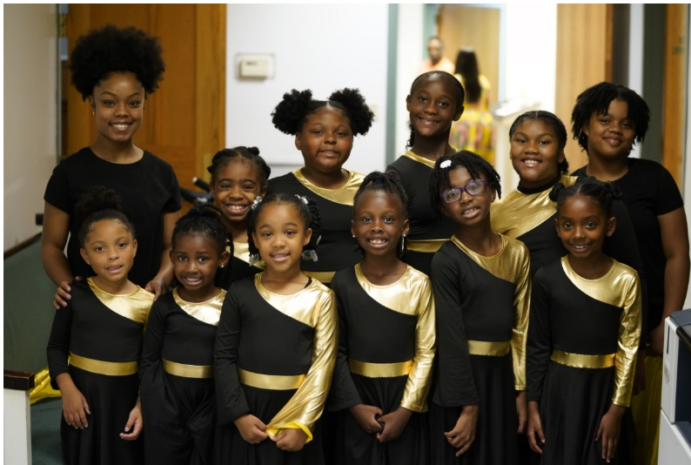
PBC Remind Groups: All messages can be sent via text to 81010. To join the Remind Group for PBC Youth, please text @98h24c. To join the group for Boys to Men (males ages 7-18 and adult male volunteers), text @pbcboy. To join the group for the Children’s Choir (ages 4-12), text@3693ca.

Youth Services: Youth services will be held in the
Community Center for Incredible Kids and Joshua Generation Youth on Sundays, August 10th, 17th, 24th and 31st with the Zippity Zoo Party for Incredible Kids to culminate the summer study of the Bible on August 17th. We will NOT have youth service in the morning for Joshua Generation teens on August 24th due to the 4x4 Service at 4:00 p.m.

Serve Sundays: On Sunday, July 27th, Middle and High school students served in a PBC ministry during the 9:00 a.m. service and returned at 4:00 p.m. for Joshua Generation Youth service in the sanctuary. The youth Praise Team sang at 4:00 pm while the Jr. Ushers assisted with seating. Min. Kevin Blane presented “Your Name Means Something” to the group. Youth Sis. Alaina Butler spoke about ACT Prep and Jr. Deacon Delvin Harrison, II spoke about College Scholarship application processes with his parents, Dr. Latonia Miller-Harrison and Bro. Delvin Harrison. The next Serve Sunday will be held on August 24th. The link to watch the presentations is listed below, along with the links for the Scholarship PowerPoint presentation and handout. https://youtu.be/UPAAVUs4C7Y?si=QsfbZzfqlpDkfO1mhttps://acrobat.adobe.com/id/urn:aaid:sc:US:9b4c0841-becf-45d0-be00-c0120047478f
https://acrobat.adobe.com/id/urn:aaid:sc:US:14d4ee49-3237-414e-8402-141b2e0681b3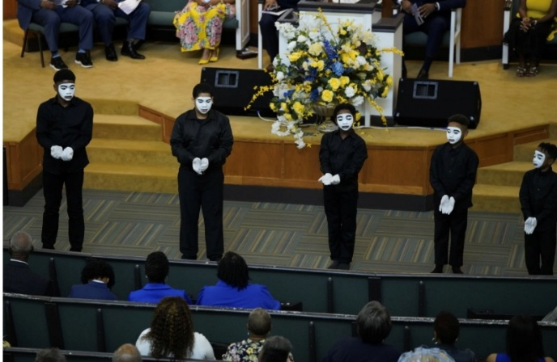
PBC Nursery: The PBC Nursery is open at 8:30 a.m. during Sunday services when there is youth service. Information about how to volunteer or register your 1-3 year old is available on the display tables in the church hallway. For additional information, please contact Sis. Shalanda Williams at 337-258-4994 or shay01@cox.net.
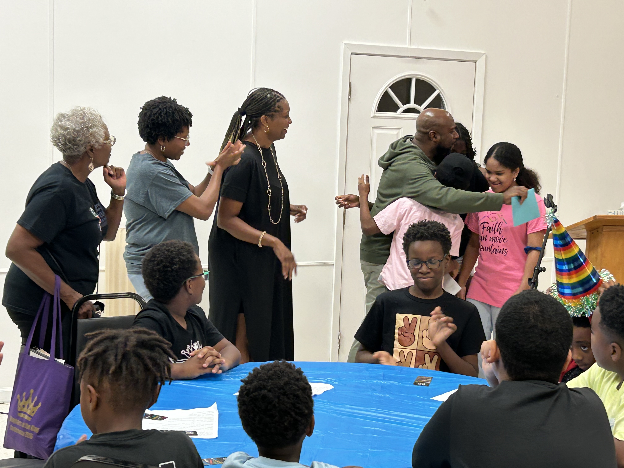

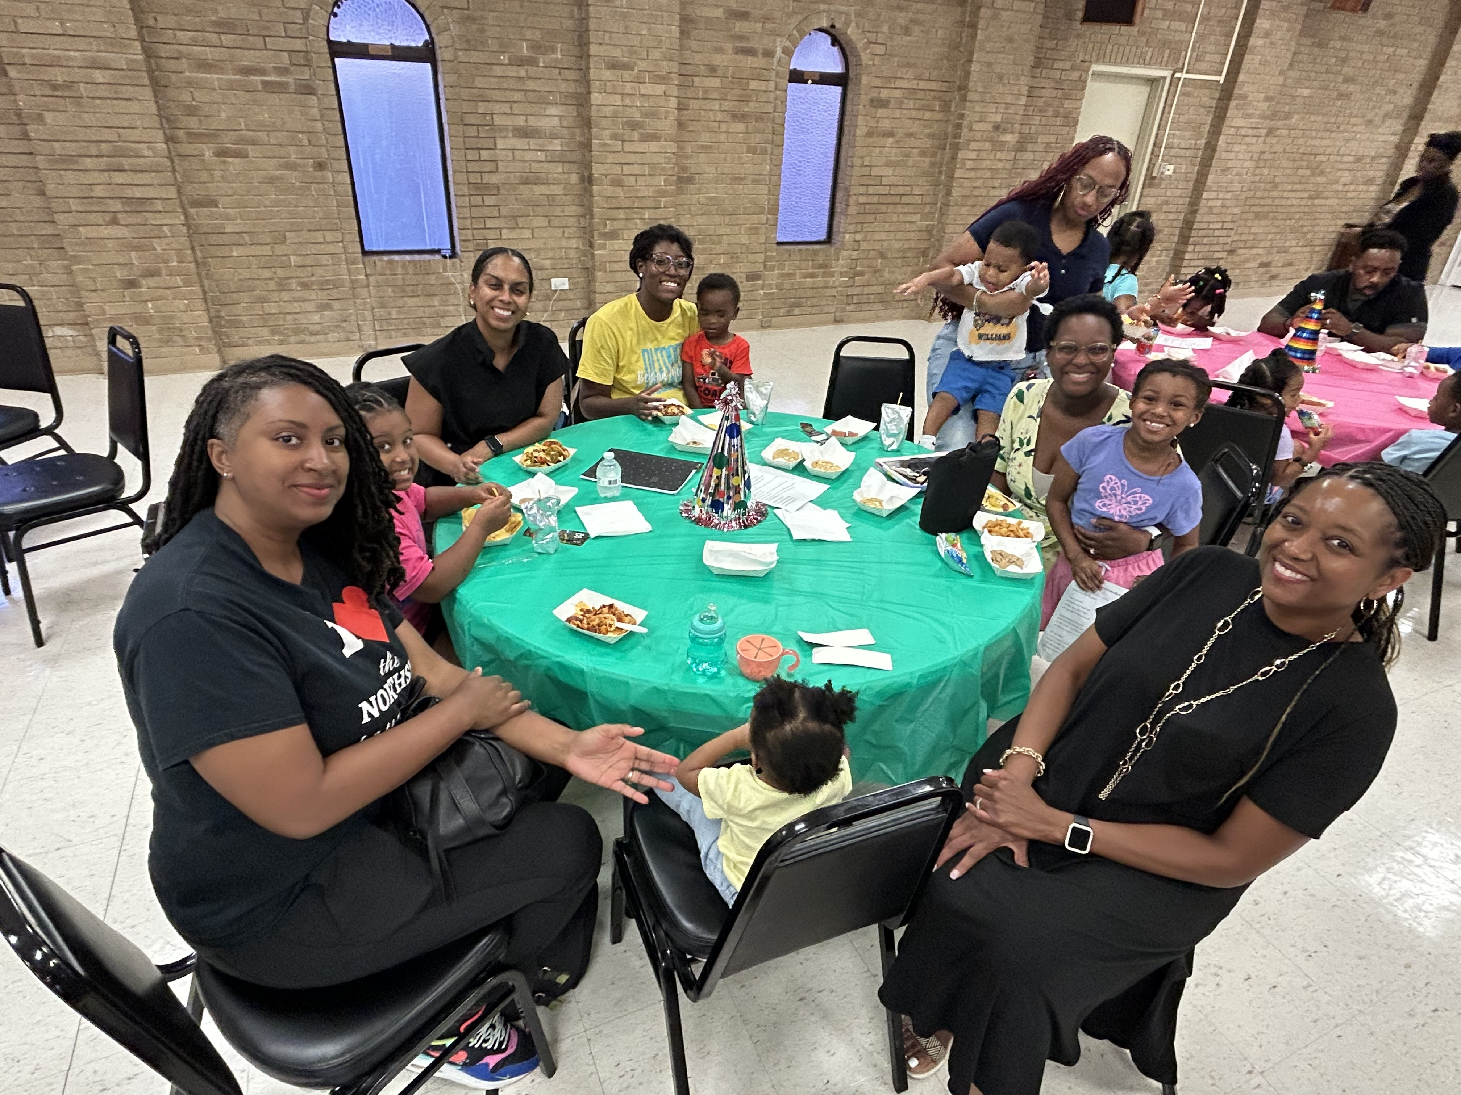

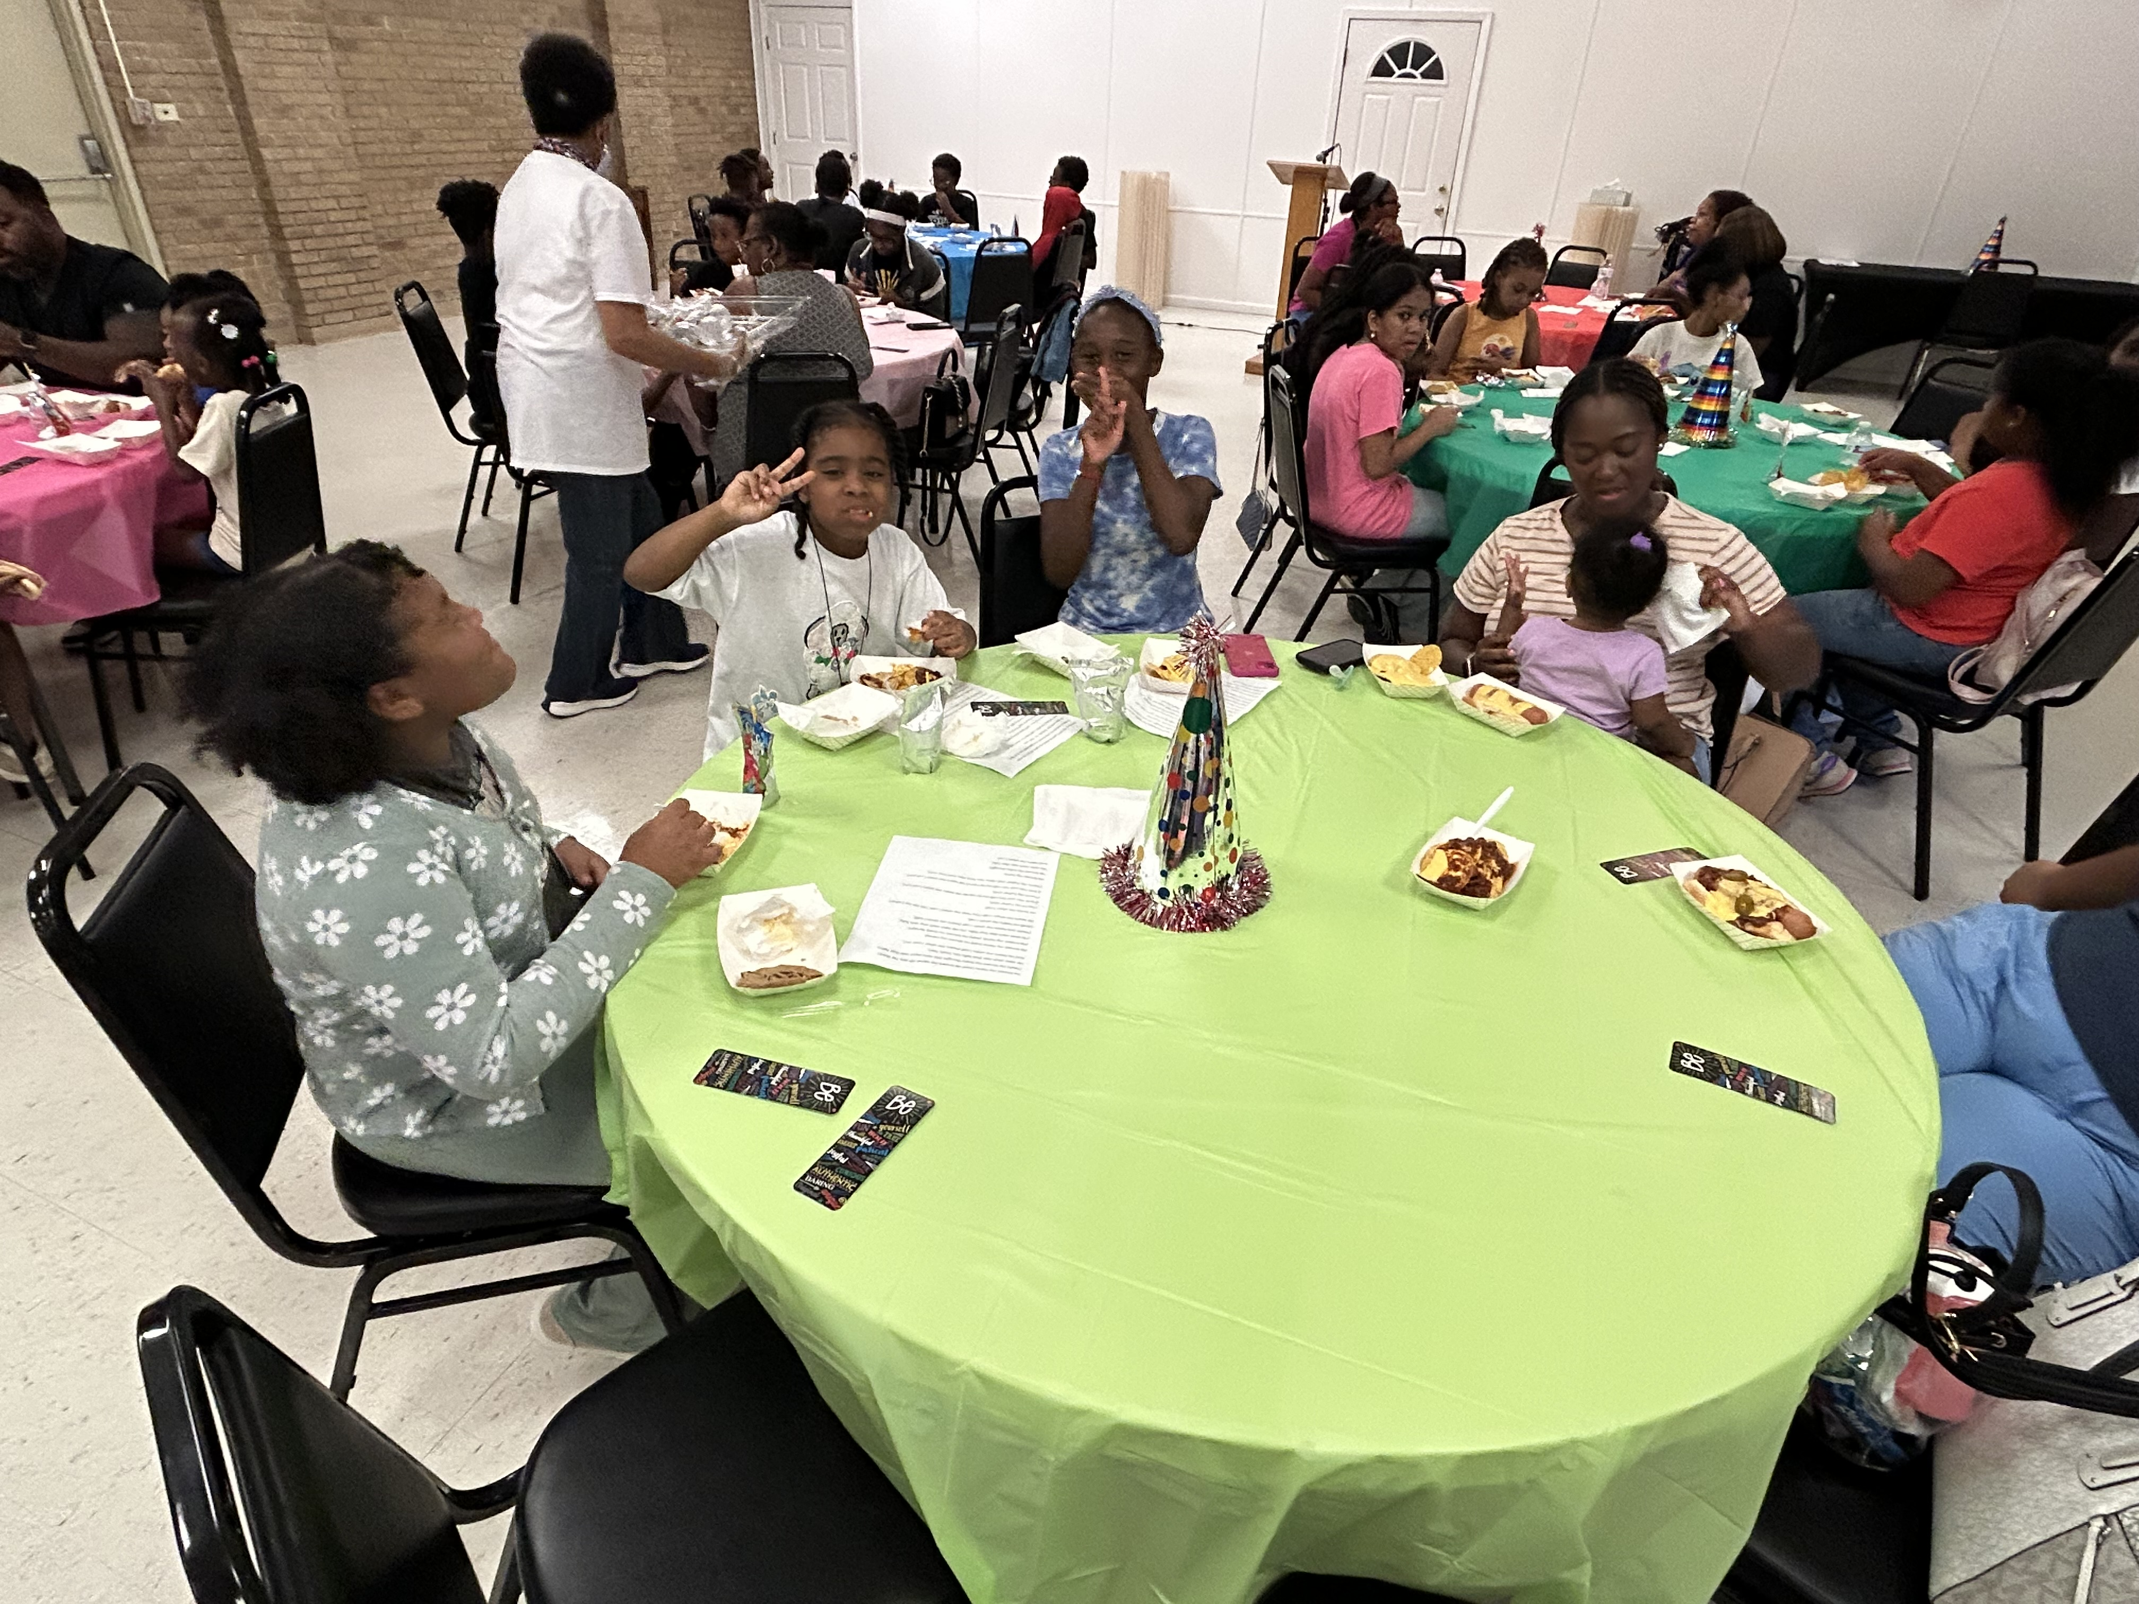
Pastoral Anniversary Social at Dave and Buster’s: PBC celebrated two years of Pastoral leadership with Pastor Chad and Lady Meredith on Saturday, July 19th . 45 youth and chaperones were in attendance.
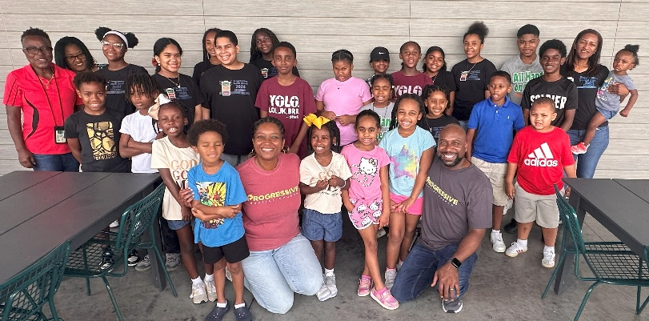
Choir Social with Pastor Chad and Lady Meredith:
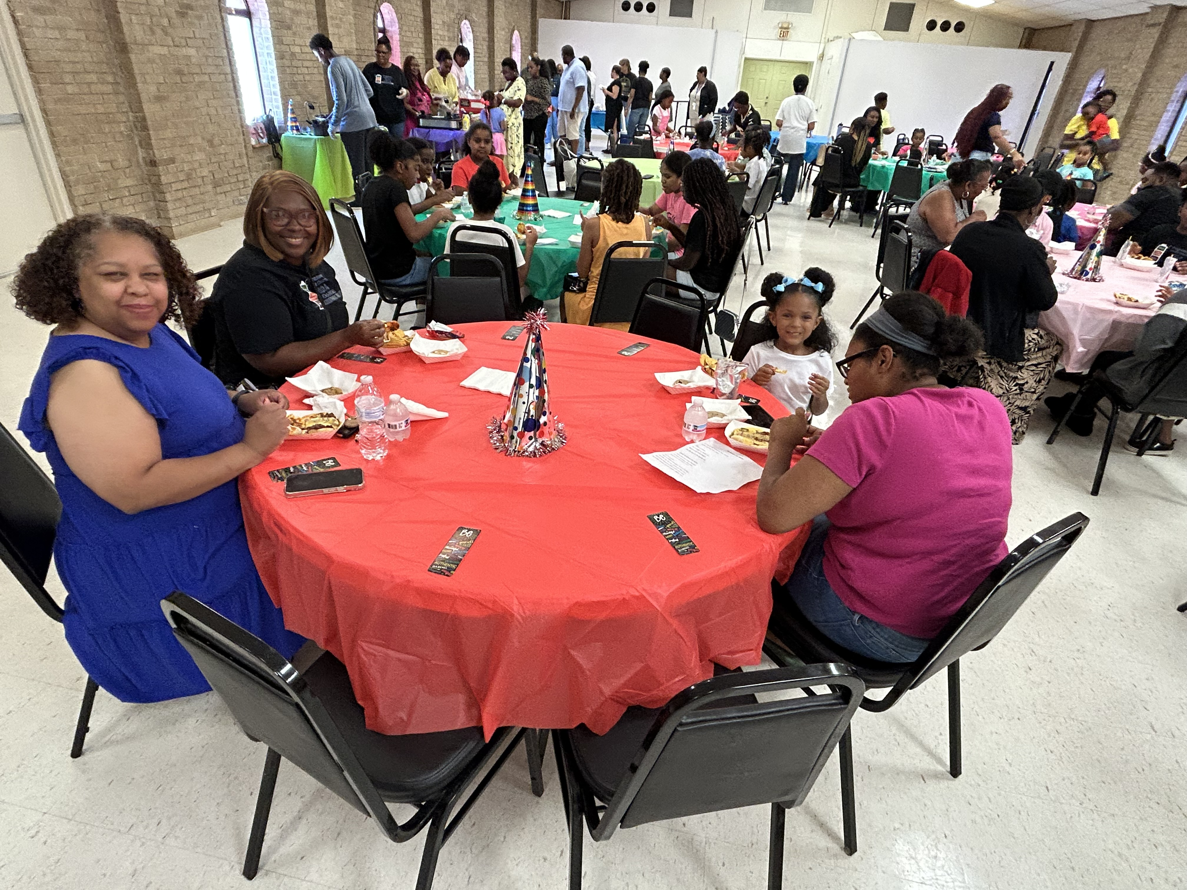
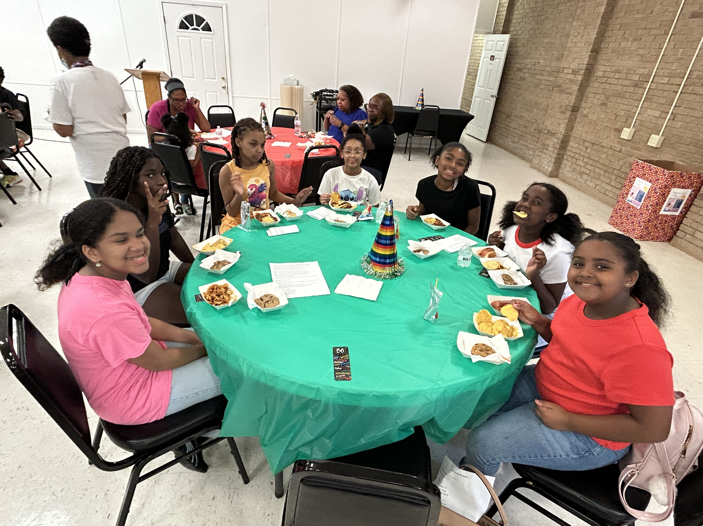
Kudos to You:
The Rideau Family had a lot to celebrate at the end of the school year. Vivienne made principals list with all A's at David Thibodeaux Middle School. Victor was recognized for outstanding leadership, honor roll and citizenship award and named student of the year at Cpl. Michael Middlebrook Elementary School.

