Paul & Ellen Byars
Missionaries to the Philippines
11 Nicanor Tomas, BF Homes, Phase 6-A, Paranaque City 1700 Philippines
Vonage Broadband Phone: 817-230-4090 E-mail: pdbyars@gmail.com

April – June 2026

Dear Pastor, Church and Friends,

Again the months keep rolling by, seemingly faster and faster. And the ministry activities and demands keep a fast pace as well. We are thankful for the blessings of seeing souls saved and victories won makes it all worthwhile.

The war in the Middle East has hit the Filipino people with higher fuel prices and the challenge of coping with the daily cost of living. But by the grace of God all mission works and daughter churches report good attendance and souls saved.

Our mission work in the Bicol region has been offered a 100 square meter (1,076 square feet) lot for a church building. This coming September I will go down and check on the offer and see what can be done.

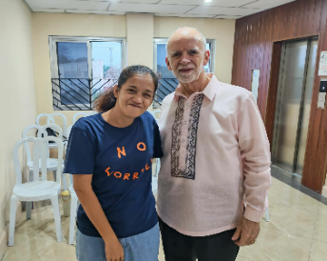
Our staff and some church members had been learning how to sign to the deaf. After passing the Sign Language Class, we began praying that the Lord would lead them to a deaf person in Tanza. The Lord answered their prayers and Kriza Marie came and attended the services. She trusted the Lord and has been faithful in attending. She has led us to many Deaf people in the area.
Recently she brought three others with her to church. We are praying that this will be a growing ministry in BBCTanza.
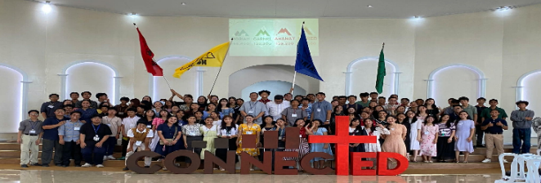
In May we hosted our own youth camp at our church facilities. For the two nights and three-day event. We had 106 registered campers.

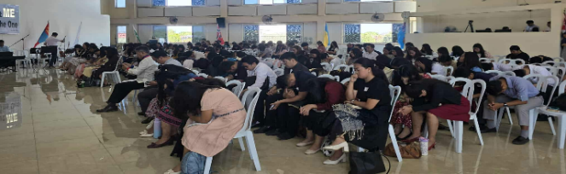
Our theme was CONNECTED and we saw 14 young people get Connected to Christ with the following decisions:
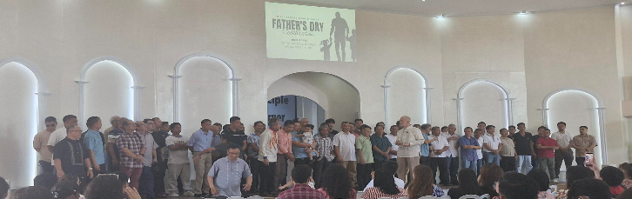
Bible College – 5; Bible Institute – 3; Baptism – 3; Missions – 2; Full time Ministry – 1.
In May and June, we honored our Mothers and Fathers.
What a joy to see so many mothers attending on Mother’s Day. God gave us 138 mothers and we had 62 fathers attended to celebrate with us.

For the 2nd quarter, the Lord blessed us with 31 professions of faith during the services. Over all in the soul winning ministry the Lord opened the hearts of 132. We are always excited to welcome first time visitors and this quarter we counted 70 joining with us. After our follow up and discipleship we had 10 obeyed in the waters of baptism with 9 transfer in.

On behalf of Ellen and I, we are so thankful for your partnership in the ministry in the Philippines.

May the Lord continue to bless you and may the works continue to expand.

Sincerely yours,

Paul and Ellen Byars

