
2026 VACATION BIBLE SCHOOL

Parents:

Our children are under a constant barrage of stories and ideas that conflict with Biblical teaching. They are almost daily taught, either directly or by inference, that there is no God, that evolution is our beginning, that there was no worldwide flood, and that Jesus was at best a very good and special man - but not God. All these are in stark contrast to the Bible.

Therefore, we at SSB have a sense of urgency to repeatedly teach about God, His Word, His creation, and that Jesus is the only begotten Son of God who came to die for sinful man. We believe we need to keep these truths before our children else they be consumed by false teaching and reject this only Savior of mankind - Jesus!

DATES: JULY 6-9, 2026
TIME: 6:30 – 8:30 PM
STUDENT AGES: AGE 3 (only if well potty trained) thru students who completed 5th GRADE.
COST: None

REGISTRATION: We don’t require pre-registration, but we appreciate it. Our contact info is below. Check-in begins Monday at 6:15 pm.

THEME: VBS this year is about the God choosing and changing us—God Can Change Me! Children this year will be taught about how Jesus came to find and change us, how God offers salvation, and that anyone can be saved.

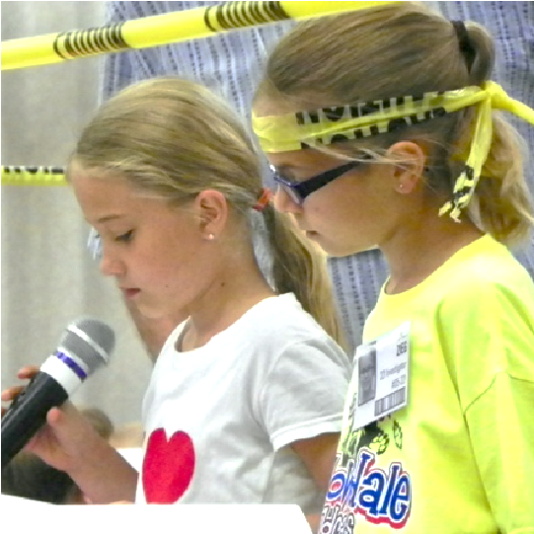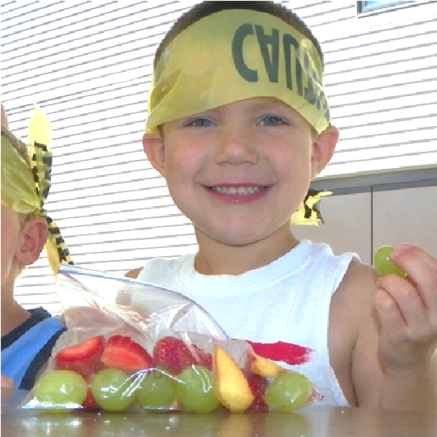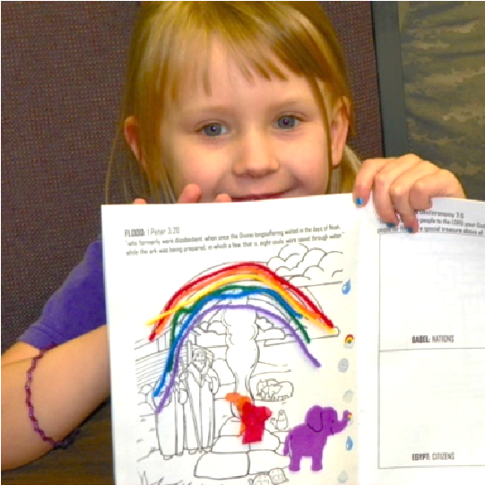

address: Standing Stone Bible Church w 321 South Highway 6 w Gretna, NE 68028 website: www.standingstonebible.church
email: standingstonebiblechurch@gmail.com phone: 402.332.3044
 VBS REGISTRATION | July 6-9, 2026 | 6:30-8:30 p.m.
Standing Stone Bible Church w Gretna, NE w 402.332.3044
www.standingstonebible.church w standingstonebiblechurch@gmail.com

Child’s Name | Age | Birthday  01-01-01 | Grade this fall | Meds/Allergies

Address: ___________________________________________________

City/State/Zip: _______________________________________________

Phone #: ___________________________________________________

The minors listed above have my permission to participate in all Standing Stone Bible Church VBS activities except as noted below. In the event that I cannot be reached in an emergency, I hereby give permission to the physician selected by Standing Stone Bible Church staff to secure and administer treatment, including hospitalization, for my child as named above.

Comments/Info:______________________________________________________________
__________________________________________________________________________

Emergency Names and Phone Numbers:

- _______________________________________________________________________

- _______________________________________________________________________

- _______________________________________________________________________

Printed Name of Parent or Legal Guardian: ______________________________________________

Signature of Parent or Legal Guardian: _________________________________________________

Today’s Date: _______________________

*IMPORTANT: This must be filled out entirely and accurately in order for your child to attend.

