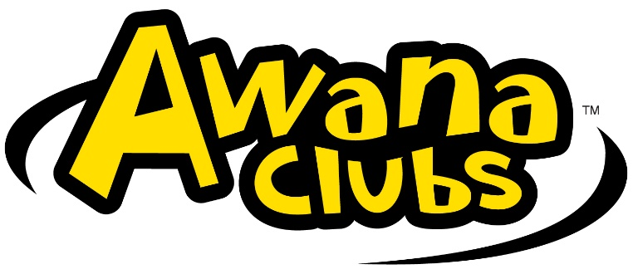
Southside Club Members Uniform Order Form
AWANA clubbers will be asked to wear uniforms to club each week. Points will be given to clubbers for wearing uniforms.

Please complete order form and turn in to the Awana office.

Clubber Name: ______________________________________________
Telephone Number _______________________

Quantity | Uniform | Size | Price | Total
 | Puggles T-shirt – light blue (2 yr olds)  Sizes 2T, 3T, 4T, 5T/6T |  | $13.00
 | Cubbie Vest – royal blue (3-4 yr olds)  Sized Med (5), Lg (6), XL (8), 2X (10) |  | $15.00
 | Sparky Vest – red (Kindergarten – 2nd Grade)  Sized Med (8), Lg (10),  XL (12), 2X (14), 3X (16) |  | $15.00
 | T&T Adventure & Challenge Jersey (Grade 3-6)  Y-Sm (10), Y-Med (12), Y-Lg (14),  A-Sm, A-Med, A-Large, A-XL, 2X, 3X |  | $20.00

