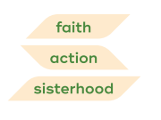
October, 2022 Newsletter First-Centenary United Women in Faith
PRESIDENT’S MESSAGE
Happy Fall to Everyone,

We had a very successful UWF Sunday on September 11. There was participation in both the Traditional service and the Vine. In the traditional service, Donna Palmer and Beth Peacock gave brief talks about our mission and how to get involved in the work of UWF. In the Vine a short video presentation about UWF was shown, and Caroline Archer spoke. We had several women who indicated they were interested in learning more about UWF. Our new banners were displayed at tables in the Vine Lobby and the Narthex with information. Thank you to those who helped at the tables, greeted, and participated in the service!
In this newsletter you’ll find information about our small groups and how to get involved.

As the end of November nears, our treasurer, Sally Richardson will be completing the pledge to missions from our Unit of UWF. It is important that she has received our money before the end of November when our books are closed for the year. Thank you for your continued support!

In December we are planning to have our installation of officers for 2023, a Memorial Service for those who passed away during the last year, and Beth Green will be presenting a program for us. She was with us several years ago and was enjoyed by all those in attendance. We are working on plans to have a dinner meeting, and more information will be forthcoming. You are invited to bring spouses and guests. The tentative date is

There will be other opportunities for service as December rolls around and other needs are identified. Be sure to keep checking on the UWF link on the website for what's happening.

Blessings,
Martha Payne
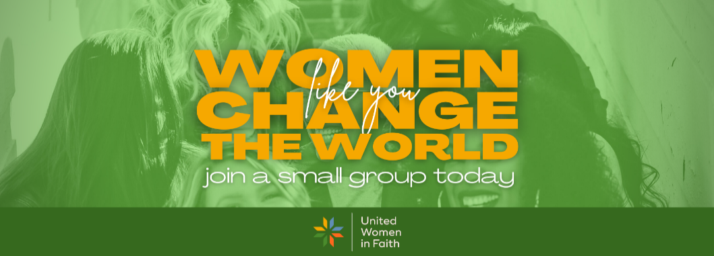
WOMEN LIKE YOU CHANGE THE WORLD
Put your talents, energy and ideas to work. You’ll find flexible opportunities for spiritual growth and ways to act for social justice, support your community, live your faith and enrich your life RIGHT HERE AT FIRST-CENTENARY UNITED WOMEN IN FAITH in our small groups/Circles.
Existing UWF groups
BOOK CLUB This is a group of interdenominational women who meet to discuss books on religious topics/Bible study with authors ranging from some of faith's most liberal writers to more traditional theologians. They meet 8 weeks in the fall and 8 weeks after Christmas.
CALEB Chattanoogans in Action for Love Equality and Benevolence Our UWF unit is a member of this community organization. CALEB has 3 areas on which members focus: Criminal Justice Reform, Economic Mobility, and Education Reform. General meetings are on the 2nd Thursday of each month. Each task force has a schedule for working meetings.
CHRIS BOWLES CIRCLE The Chris Bowles Circle focuses on Bible study and discussion. It meets in the Prigmore Room on the 4th Tuesday at 6:30 p.m. from March through October.
HEARTS AT WORK CIRCLE This group is not currently active. It’s mission has been to provide bread or food for members. It is a hands-on ministry and can be configured in a number of ways. In the past the group coordinated with Congregational Care to determine needs and has met only as needed.
MARTHA AND MARY CIRCLE This Circle describes its activities as Bible study and creatively demonstrating concern for others. Meetings are in Mohney Hall at 10:30 a.m. every 3rd Monday, except in July and December.
SUSANNAH WESLEY CIRCLE The Susannah Wesley Circle meets in the homes of members, with programs and discussion of various topics. Members share food and fellowship at 6:30 on the 4th Monday of each month.
WINDMILL CIRCLE This group meets to meditate and pray in the Kate Lyle West Chapel. Schedule tbd.
WOMEN TOGETHER SHARING A CUP This is a group of women from F-C and other local churches. The focus is on getting to know each other and sharing common goals. Each meeting has a socialization component and a presentation on a community mission or program. They donate needed supplies/materials. We meet every other month on Saturday, from 10-12, currently at F-C.
Potential UWF groups
Group A This group would access media from United Women in Faith (uwfaith.org) to deepen faith, and hear from leaders and missions around the U.S. and the world. Meeting schedule tbd.
*FAITH TALKS Downloadable podcasts suitable for discussion groups.
*RESPONSE Downloadable podcasts from Response magazine, suitable for discussion starters.
*VOICES FROM THE FIELD Webinars, accessible for viewing after the event, suitable for discussion groups.
For each of the * groups you can sample at Podcasts | United Women in Faith (uwfaith.org)
Group B This group would have access to Amplify Media through First-Centenary’s subscription. There are hundreds of choices, usually with video/leader’s guide/book for each choice.
To preview go to Topics | Amplify Media
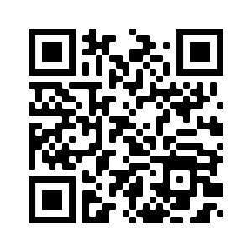
Submit your choices by using this QR Code or responding by email dsbpsych@gmail.com or phone 423 653 3663 and one of our UWF leaders will respond to you.
Is there something missing? Please share any ideas you have for other kinds of small groups.

SCENIC SOUTH DISTRICT ANNUAL MEETING

SATURDAY OCTOBER 29, 10 A.M.

VIRTUAL

(SEE SEPARATE EMAIL)

Holston UWF 2022 Theme

Live in Peace…Build up One Another.

Our new logo represents the past, present and future of our organization. The symbol refers to our Christian roots. The multicolored pieces of the cross coming together represent the diversity we aim for and the inward and outward reflection we engage in as women of faith. The typography is solid, modern and bold, showcasing our power to support the causes in which we invest.
New Mission Statement: United Women in Faith seeks to connect and nurture women through Christian spiritual formation, leadership development, creative fellowship, and education so that they can inspire, influence and impact local and global communities

