MONTANA DINOSAUR DIG
AUGUST 16-17, 2024, Glendive Dinosaur & Fossil Museum, Glendive, MT
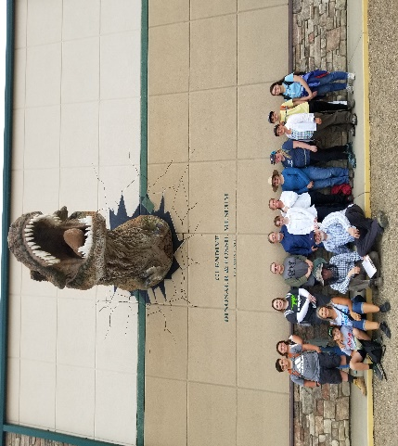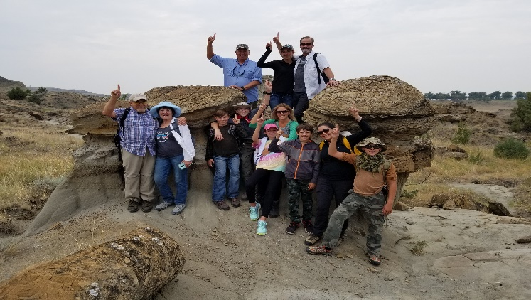
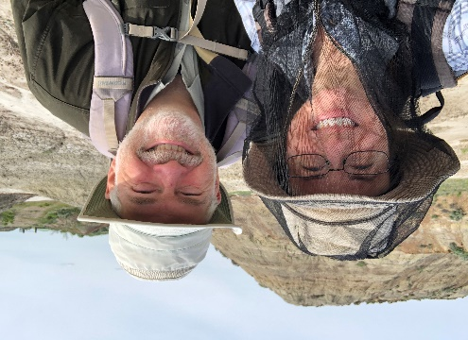
COME JOIN US! AN ADVENTURE OF A LIFETIME!
DISCOVER DINOSAURS BURIED IN THE GENESIS FLOOD
DATE: August 16-17, 2023 – FRIDAY AND SATURDAY, THURSDAY/SUNDAY TRAVEL DAYS - MUST REGISTER mikemueller@bresnan.net or call 406-531-8297
AGES: 12 YEARS AND UP - LIMIT 30 PEOPLE - FIRST COME, FIRST SERVE!
COST: $75/person - PROVIDE YOUR OWN TRAVEL, LODGING, MEALS – Event Co-hosted by Institute for Biblical Authority and Glendive Dinosaur & Fossil Museum
LOCATION: GLENDIVE DINOSAUR & FOSSIL MUSEUM, GLENDIVE, MT
For information call Mike Mueller, Institute for Biblical Authority, 406-531-8297
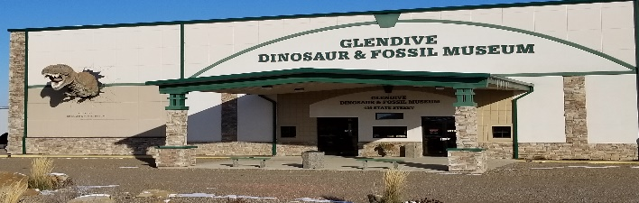
SCHEDULE
Thursday Aug 15 – Travel Day to Glendive, Provide your own transportation
Friday Aug 16 - Read FOSSIL DIG CHECKLIST prior to trip to prepare for your adventure. Go to creationtruth.org or IBA777.org
7:30 AM - Meet at GDFM – Travel to Dig Site at 8 AM – Fill out waivers - Excavate Fossils for 3 hours with Tommy Lohman, Field Paleontologist, GDFM - Bring outdoor clothing, water, dress to hike/hiking shoes, snacks 11:30 Return to GDFM
Noon – Lunch on your own, pack a lunch or eat at local diner
1:30 – 3:30 PM – Meet at GDFM - Museum Tour – Robert Canen, Museum Director, Tommy Lohman, GDFM Field Paleontologist, and possibly Melanie Richard
Dinner on your own
7-8 PM – Presentation TBD by Tommy Lohman, Glendive Dinosaur & Fossil Museum Location – Glendive Museum Auditorium- Optional
Saturday Aug 17
8 AM – 11:30 AM - Meet at GDFM – Fossil Preparation Workshop in Fossil Prep Lab Building
Lunch – 11:30-1:30 - Lunch on your own, pack a lunch or eat at local diner
2:00-3:30 – Meet at GDFM – Biblical Worldview Panel Discussion Q&A Presentation with Tommy, Robert, and possibly Melanie Richard
3:30- 5:00 Time for follow up Museum Visit and Gift Shop on your own
Dinner on your own -Evening On Your Own – Suggest visiting Makoshika State Park outside Glendive
Sunday Aug 18 – Travel Home Day or Visit Historic Medora, ND, Theodore Roosevelt National Park, or Makoshika State Park, outside Glendive, MT
Accommodations/Diners – Go to creationtruth.org and see area map. Local motels Comfort Inn 406-365-6000, Holiday Inn Express 406-377-3300, LaQunta 406-377-7300
Glendive Dinosaur and Fossil Museum Information – 406-377-3228 or go to creationtruth.org

