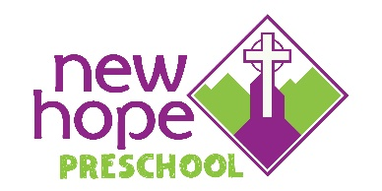
**** Registration Instructions: Please keep this page! ****
Registration Dates
*Completed registration forms can be dropped off or mailed, but NOT prior to the below registration dates.
January 6 – January 22, 2026
- Currently enrolled families
- Alumni families
- New Hope Church families
January 27, 2026
- Open to the Community

Registration Confirmation/Fee/Additional Paperwork
Confirmation Letter: Once the registration form and fee are received, a confirmation of enrollment or waitlist letter will be mailed to the address on the registration form, typically by mid-March.
Registration Fee: There is an $85.00 per child ($125 per family), non-refundable, registration fee, that is due upon submission of registration form. Registration forms cannot be considered without the registration fee.
May 2027 Tuition
The May 2027 tuition is due on or before May 5, 2026. This payment indicates your commitment to enroll for the 2026-2027 school year and is non-transferrable and non-refundable. Cash or check payments are accepted. Checks should be payable to New Hope Preschool.
**If registering AFTER May 5, 2026, this tuition payment is due upon enrollment in the program. Therefore, both the registration fee AND the May 2027 tuition payment will be due.
Enrollment Paperwork: An emailed invitation to the Playground App will be sent once the May 2027 tuition has been received (usually by the end of May). It is through this app that paperwork will be completed.
Currently enrolled families only: If you already pay your tuition via the Playground App, the May 2027 tuition will be automatically deducted from your account.

Monthly Tuition Rates 2026-2027
2 days: $275 3 days: $330 4 days: $385

