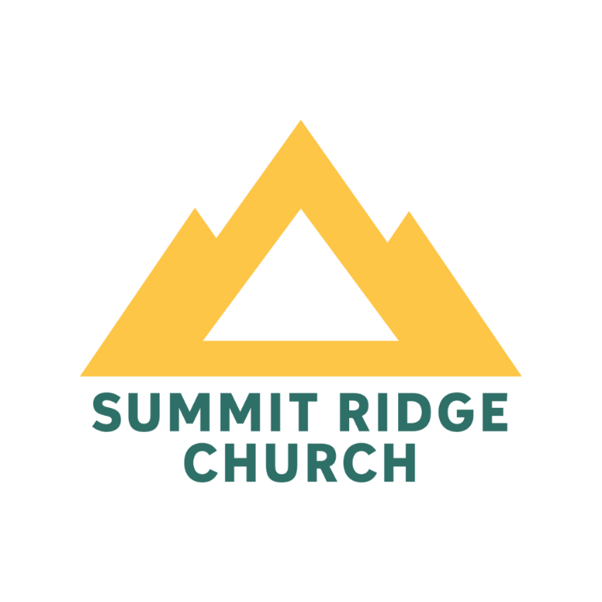
Discovering Summit Ridge Church
Membership Class

Table of Contents
Table of Contents 1
Welcome Letter 2
The Summit Ridge Story… How we began 3
The Gospel: Our Foundation 4
The Gospel: 4
Summit Ridge Purpose Statement 5
Disciple Making 5
Our Vision: 6
Our Process: 7
Reaching Our Neighbors & Nations: 8
Summit Ridge’s Global Values & Vision 9
Gospel-Centered Compassion: 9
God-sized Faith: 9
Strategic Focus: 9
Clear and Effective Communication: 9
Church-wide Engagement: 9
Summit Ridge’s Global Mission: 9
Symbols of Salvation 10
Statement of Faith 10
Our Beliefs 10
Ways to Connect: 21
What is Church Membership? 22
Why Commitment is Important 22
Where is it in the Bible? 23
The Membership Process 24
Summit Ridge Membership Covenant 25

Welcome Letter

Dear Friend of Jesus Christ,

I want to thank you for taking time out of your busy schedule to discover more about Summit Ridge Church. And thank you too for considering Summit Ridge as your church home. Know that this membership class is really for you to discover more about the church, who we are, what God is doing, and where we are going – it’s about what makes us tick. If God is so leading you, we would love for you to join with us as we seek to make much of Jesus Christ, and while we seek to impact our community for Him.
We are a simple church. We have a heart to see you know Christ and to grow in your relationship with Him. We offer you an opportunity to touch others’ lives and point them to Christ. We offer you a chance at making an impact in the world, allowing God to use you in ways far beyond you ever dreamed. We want you to meet with God, to have a deep love of Him and we want to help you connect with others. We commit to loving you forward as best as we can. We, as the church, want to come alongside you in times of joy and in times of struggles. We aren’t perfect, no church is. But we do strive to love like Jesus did. All in all, we want to make disciples and grow disciples.
I am amazed as the pastor of this church the variety of great people God has brought into our lives. We serve professional workers, homemakers, many military folks and people of different ethnicities and income levels. It is fantastic! So many people in Las Vegas are alone, with families in other places in the country. So we have a close family type atmosphere. This is best experienced in any of our small groups and through ministries.
We would be honored to have you join our family. Pray about it, consider it, let the Holy Spirit lead you. If membership is something you feel compelled to do, then after the class, fill out the forms and return them to us and I or another elder of the church will talk with you and pray with you. Following that we will welcome you into our church family as an official member. There’s no strings attached. No secret handshake. Just a family of people who love Jesus and are striving to make much of Him in our lives.
Come along for the journey.
In His Grip,

Senior Pastor John Caprine
Summit Ridge Church

The Summit Ridge Story… How we began

Summit Ridge Church is an evangelical Bible church that was started in September of 2000. At that time over 85 couples and individuals were committed to invest monthly to Mission to America (now known as Missions Door) so that Paul and Jean Biggers could move to Las Vegas to launch a new church.

In November of 2007 SRC sent Paul Biggers into a new role as coaches to church planters where they moved to Colorado. At that time SRC called John Caprine as the new senior pastor. Over the years we’ve seen the ministry grow in multiple ways from people, staff and discipleship.

From the very beginning we chose to align ourselves with the Venture Church Network.

What is the Venture Church Network?
- Venture Church Network is a network of churches, empowered by the Lord and mobilized by passionate spiritual leaders, reaching the Southwest with the Gospel through healthy, reproducing congregations.

- Venture Church Network of churches and their leaders share six that keep us “spot on” whether cultural winds are gentle, blustery or at gale force. Venture Church Network partners are Bible-centered . . . Gospel-focused . . . Mission-driven . . . Grace-infused . . . Relationally-committed . . . Culturally-inclusive. These six values solidly anchor our vision to what’s close to God’s heart and vision. And our conservative, biblical, long-standing faith commitments as expressed in the Connection Statement of Faith keep us and our partners on a steady course.

- Venture Church Network is a family of churches not a denomination. No ecclesiastical authority is exercised over any affiliated church.

What are the advantages of affiliating with the Venture Church Network?
- It allows us to identify with other Christians who are known for their commitment to the Bible.
- It allows our church to be autonomous AND accountable.
- It provides support for our church through resourcing, leadership and partnerships.

The Gospel: Our Foundation

Here is how we see it:
He created us for His glory (Isaiah 43:7). He predestined us to be His children for His glory (Ephesians 1:6). He appointed us to live for His glory (Ephesians 1:12). Whether you eat or drink or whatever you do, do all to the glory of God (1 Corinthians 10:31). "From Him and through Him and to Him are all things. To Him be glory forever. Amen" (Romans 11:36).

The Gospel:
Simplified:
The Gospel is the good news that Jesus Christ, the Righteous One, died for our sins and rose again, eternally triumphant over all His enemies, so that there is now no condemnation for those who believe, but only everlasting joy to be shared with God in heaven. (1 Corinthians 15:1-4; 1 Thessalonians 5:9-10; 1 Peter 3:18; John 3:16; Romans 3:23, 6:23)

Explained:
A good way to summarize this good news is to biblically unpack the words: God, Man, Christ, Response.
- God. God is the creator of all things (Gen. 1:1). He is perfectly holy, worthy of all worship, and will punish sin (1 John 1:5, Rev. 4:11, Rom. 2:5-8).
- Man. All people, though created good, have become sinful by nature (Gen. 1:26-28, Ps. 51:5, Rom. 3:23). From birth, all people are alienated from God, hostile to God, and subject to the wrath of God (Eph. 2:1-3).
- Christ. Jesus Christ, who is fully God and fully man, lived a sinless life, died on the cross to bear God’s wrath in the place of all who would believe in Him, and rose from the grave in order to give His people eternal life (John 1:1, 1 Tim. 2:5, Heb. 7:26, Rom. 3:21-26, 2 Cor. 5:21, 1 Cor. 15:20-22).
- Response. God calls everyone everywhere to repent of their sins and trust in Christ in order to be saved (Mark 1:15, Acts 20:21, Rom. 10:9-10).

Summit Ridge Purpose Statement

Summit Ridge Church exists to Glorify God, To make much of Jesus Christ in all that we do.
We glorify Jesus by: Loving God, Loving others, and Serving the world.

Disciple Making

Matthew 28:19 – 20, “Therefore go and make disciples of all nations, baptizing them in the name of the Father and of the Son and of the Holy Spirit, (20) and teaching them to obey everything I have commanded you. And surely I am with you always, to the very end of the age.”
These verses tell us about disciple making.
1. Helping people - We have to initiate and be intentional—because we are to “go” and “make” disciples (vs.19).
2. Trust - Disciple making is about repentance and conversion with the accent on grace—baptizing them in the name of the Father and of the Son and of the Holy Spirit” (vs.19).
3. Follow - Disciple making is about obedience and sanctification (increasing holiness)—“teaching them to obey everything I commanded you” (vs. 20).
4. Jesus - He is the object and focus in discipleship; disciples are to become His “apprentices” and “live life” as He would live—“make disciples” (vs. 19).
With these four components from Matthew 28 in mind, we define disciple making this way:
Discipleship is helping people to trust and follow Jesus.
A disciple is following Jesus,
being changed by Jesus and committed to the mission of Jesus.

Our Vision:

We recognize that God is for us, but it isn’t about us – it’s about Him – and we live to make much of Jesus with our whole church body. We exist to make Him known.
[Matthew 22:37-38; Philippians 1:6, 9-11; Zephaniah 3:17; 2 Corinthians 5:14-15]

While growing in fellowship to the Lord and obedience to Him, we value godly sorrow over our sin so that we can walk more closely to Him while listening to the Holy Spirit’s promptings.
[Hebrews 13:21; 2 Corinthians 7:9-10]

It is our growth, hunger and thirst for righteousness that makes us distinct from others who do not follow Him.
[Colossians 1:4-6, 9-10, 21-23, 28-29; 2 Corinthians 2:14-16]

It is our commitment to loving Jesus and making much of Him that drives us to love others around us through all of life, and in equipping our church to encourage people toward Jesus through intentional discipleship.
[Romans 15:5-6; 2 Corinthians 1:3-7; John 13:34-35; 1 Corinthians 16:13]

We believe that people will love Jesus so much that they will abandon inherent selfishness for engaging in God-inspired work. They will think globally, they will care for the lost, they will sacrifice above the norm, they will break the mold of status quo for the sake of Jesus’ mission.
[Acts 2:42-47; Hebrews 10:32-36]

This is the community of Summit Ridge Church – loving the Lord in every way possible and loving others from that joy found in the Lord.
[Romans 15:13; Hebrews 10:24-25]

Our Process:

At Summit we aim to keep things simple in order to focus on what’s most important – making much of Jesus by making disciples who make disciples. So we encourage everyone who is a part of Summit to engage in the following three areas:
- Church
- Discipleship
- Neighbors & Nations
That’s it, plain and simple.

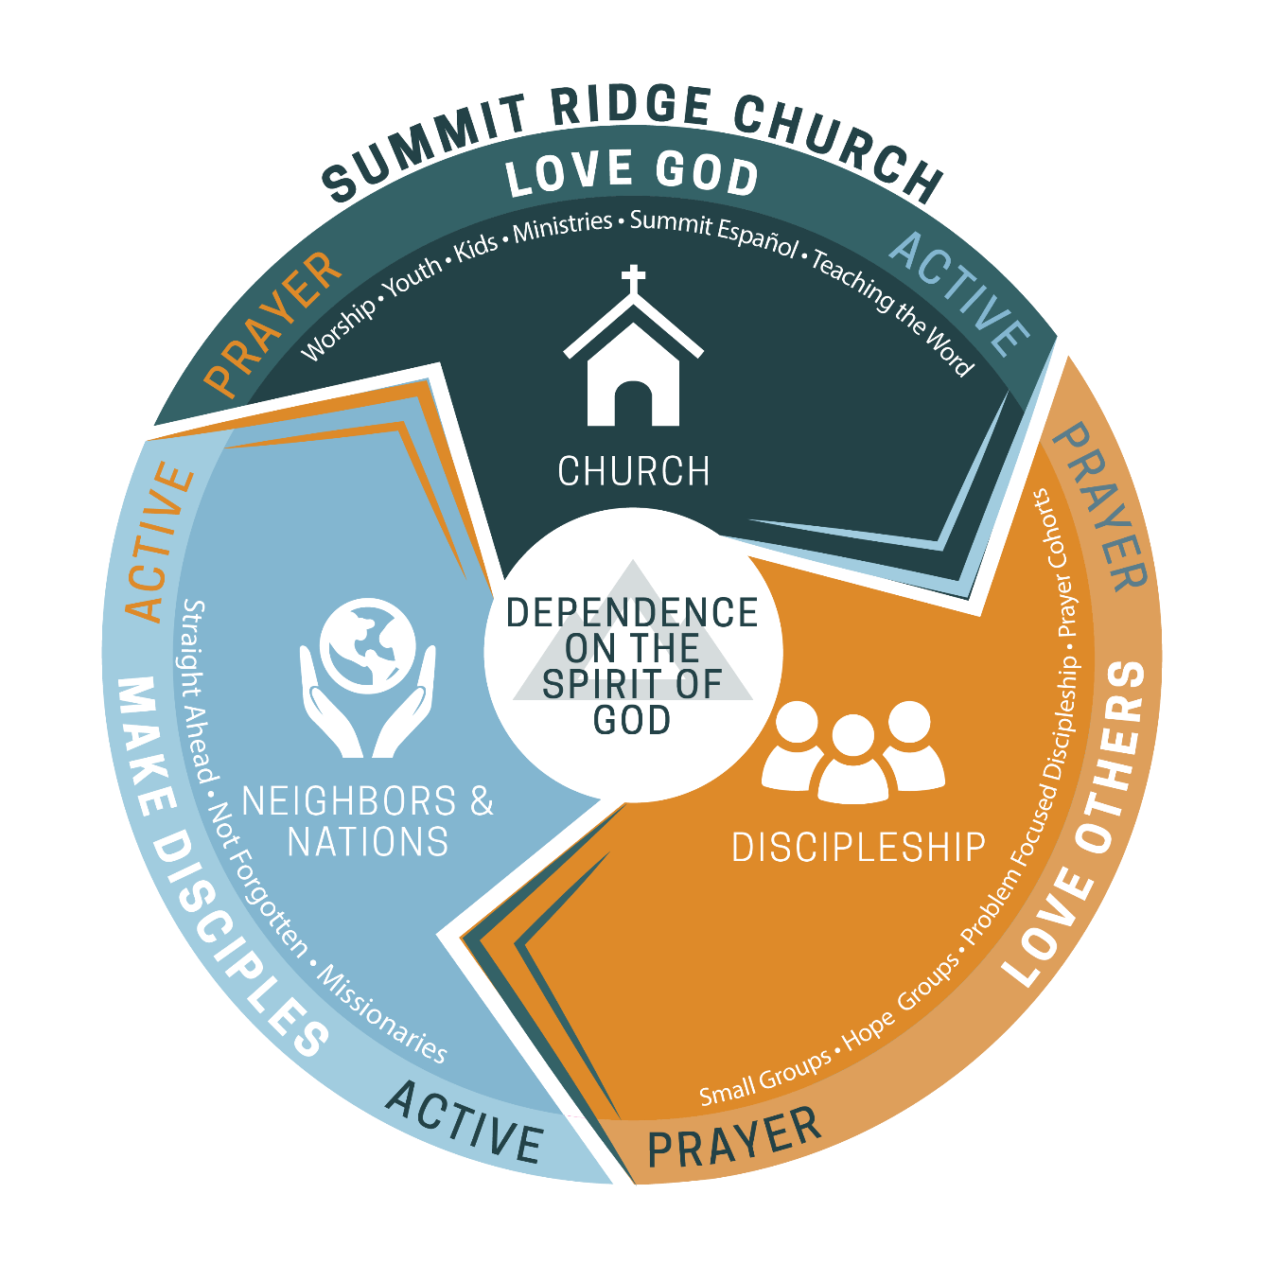

A Healthy Discipleship Path:

There is not a one-size-fits all when it comes to discipleship. We are all at different places in our journey with different experiences and perspectives. To help those at Summit to grow in maturity and knowing more fully the joy of living wholly for Christ we offer a path that is intended to meet us where we are. Our primary area of discipleship is through our small groups. We also offer encouragement through various support groups as well as one-on-one discipleship to speak to specific areas where one may be stuck or paralyzed in being able to grow. We believe God’s Word has spoken into these very hard places of life and He wants to help us find health and freedom.
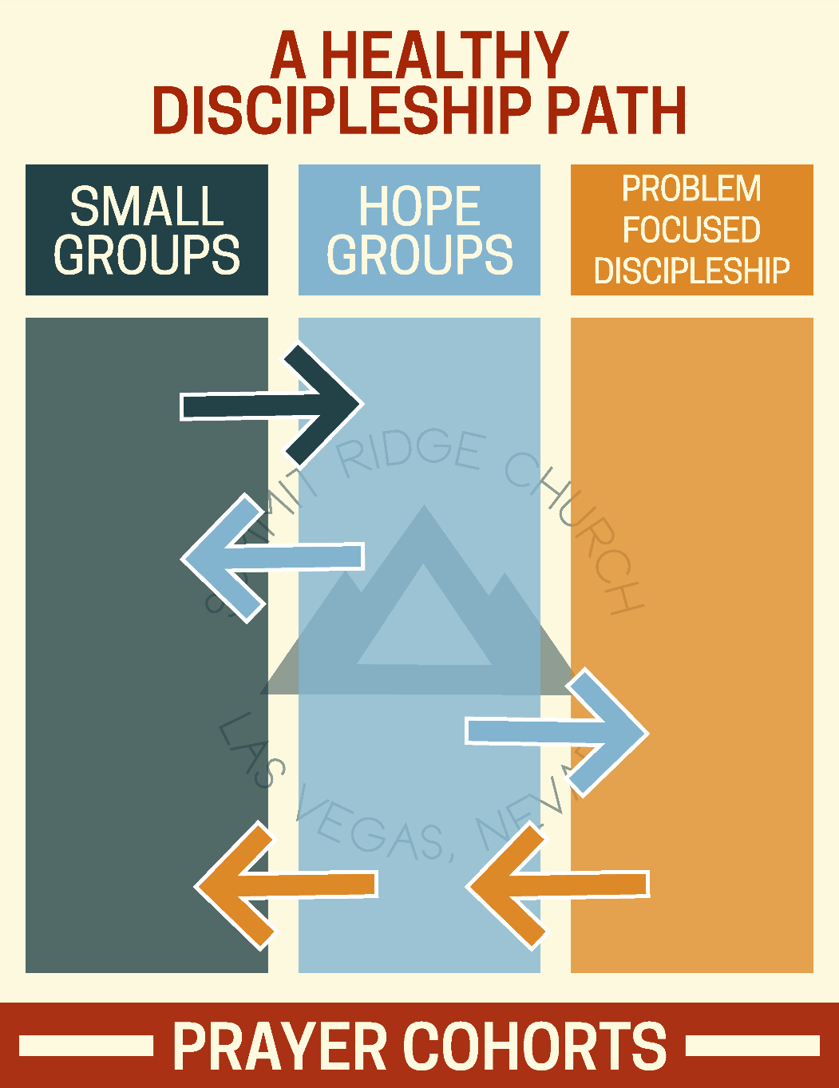

Reaching Our Neighbors & Nations:
Mark 16:15, “Go into all the world and proclaim the gospel to the whole creation.”

Summit Ridge’s Global Values & Vision

Gospel-Centered Compassion: We will tirelessly make much of Christ by proclaiming the hope of the Gospel to our Neighbors and Nations.
God-sized Faith: Rooted in the Word and soaked in expectant prayer, we will take extraordinary and uncomfortable actions in obedience to God’s purpose for SRC that can only be attributed to Him and His power.
Strategic Focus: Through proactive and consistent focus, we will develop, serve, and come alongside missionaries and organizations to build long-term relationships that increasingly propel the Gospel.
Clear and Effective Communication: Celebrating what God has done, we will continually communicate our missions vision and direction, inspiring SRC to engage in His purposes for our church.
Church-wide Engagement: We will equip SRC to pray, send, and go to reach our Neighbors and Nations. We will develop clear opportunities to engage our church to declare the Gospel.

Summit Ridge’s Global Mission:

Our global mission is to make much of Jesus by developing disciple-making disciples of our neighbors and the nations, propelling the Gospel to lost and forgotten peoples.

We believe we are called to fulfill Mark 16:15. So we want to engage in what God has for us because we believe there is nothing greater and satisfying than living out God’s purpose for us.
So we want to be about making Him known, both to our neighbors and the nations. We would love for you to be a part of that too. Here are ways we are currently making Him known that you can engage in:

- Sending a family from Summit to the Middle East
- Supporting a couple with Wycliffe to translate the Bible into people’s heart languages
- Sending teams/Going to Iquitos, Peru with Not Forgotten to help kids practically get off the streets and make Him known
- Military families, our own contacts and…
- Numerous local outreach opportunities

Symbols of Salvation

At Summit Ridge Church we practice two ordinances, or ceremonies, as a church – Baptism and Communion.
We believe that water baptism is commanded by Jesus (Matthew 28:19-20) and it is a practice that has been practiced throughout the church era (Acts 18:8). Baptism also demonstrates that one is a Believer (1 John 2:3; Luke 6:46). When one participates in baptism it is symbolic of Christ’s death, burial and resurrection (1 Corinthians 15:3 – 4; Colossians 2:12). Baptism also symbolizes the new life of a Christian (2 Corinthians 5:17; Romans 6:4). Baptism makes a statement: Baptism is a public declaration that you are a follower of Jesus Christ. Baptism is an outward expression of an inward commitment made to Jesus Christ.
At Summit Ridge, it is a membership requirement that every member must have been baptized following conversion, even if they were “confirmed” as a child.
The other ordinance we practice is communion, also called “The Lord’s Supper”. We typically participate in communion twice a month (1st & 3rd Sunday’s) during our worship services. We see it as a simple act of remembrance of what Jesus did for us on the cross (1 Corinthians 11:23 – 26). Communion is a symbol of the death of Christ in which He took our payment for sin. We believe that anyone who is a Christian, a follower of Jesus Christ, can participate in communion. One does not need be a member of Summit Ridge to participate in communion.

Statement of Faith

Our Beliefs
This statement of faith does not exhaust the extent of our beliefs. The Bible itself, as the inspired and infallible Word of God that speaks with final authority concerning truth, morality, and the proper conduct of mankind, is the sole and final source of all that we believe. For purposes of Summit Ridge Church’s faith, doctrine, practice, policy, and discipline, our Elder team is Summit Ridge Church’s final interpretive authority on the Bible’s meaning and application.

The Scriptures
We believe that the entire Bible is inspired, (i.e. “God breathed”), of God and that holy men of God “were moved by the Holy Spirit” to write the very words of Scripture. We believe that this divine inspiration extends equally and fully to all parts of the sacred writings – historical, poetical, doctrinal, and prophetical – as appeared in the original manuscripts. We believe that the whole Bible (66 books) in the originals is, therefore, without error. We believe that all the Scriptures center around the Lord Jesus Christ in His person and work in His first and second coming. We believe that Scripture contains all of the words of God that He intended His people to have at every stage of redemptive history, and that it contains all of the words needed for salvation and for trusting and obeying Him completely. Therefore, there is nothing that needs to be added at any time to complete the whole of God’s Word. We also believe that all the Scriptures were designed for our practical instruction. (Romans 15:4, 1 Corinthians 2:13, 2 Timothy 3:16-17; 2 Peter 1:21, Luke 24:27, 44; Acts 17:2-3; 18:28; 28:23)

The Godhead
We believe that the Godhead eternally exists in three persons – the Father, the Son and the Holy Spirit – and that these three are one God, having precisely the same nature, attributes, and perfections, and worthy of precisely the same homage, confidence, and obedience. We believe that there are also varying roles within the Godhead and yet each Person of the Trinity is equal in unity and are one. (Genesis 1:26 ; Deuteronomy 6:4; Matthew 28:18-19; Mark 12:29; John 1:1,14; Acts 5:3-4; 2 Corinthians 13:14; Hebrews 1:1-3)
The Doctrine of God
We believe in one God the Father, Almighty, living and eternal, who has manifested Himself in many ways through many attributes. He has revealed Himself as:
  - Independent – God is completely free of needing mankind or the rest of creation to make Him any more complete, whole or happy. His existence and character are not dependent on anyone or anything else. Nevertheless, all of His creation can glorify Him and bring Him glory. (John 17:5, 24; Exodus 3:14; Isaiah 43:7)

  - Unchangeable – God is immutable in His being, purposes, and promises, yet God does act and feel emotions, and He acts and feels differently in response to different situations. He is both infinite and personal. God does not change His mind to the extent of changing anything that would be contrary to the rest of His character (Malachi 3:6; James 1:17)

  - Eternal – God is eternal, He has no beginning (He was before there was time, Psalm 90:2; Revelation 1:8), end, or succession of movements in His own being. He sees all time equally vivid and yet He sees events in time and acts within time. (Psalm 90:4; Isaiah 45:21)

  - Omniscient – God fully knows Himself and all things actual, (all things that exist) and possible, (all things that can happen) in one simple and eternal act. (1 John 3:20; Psalm 139:1-12; Psalm 90:4)

  - Other Attributes: God is love (1 John 4:8; Romans 5:8); He is Holy (Psalm 99:9; 1 Peter 1:16); He is true, meaning: He is the true God, all His knowledge and words are both true and the final standard of truth. (John 17:3; James 1:17; Numbers 23:19); He is a God of peace, meaning: In God’s being and His innumerable actions He is separate from all disorder and confusion, yet He is continually active in innumerable well-ordered, fully controlled, simultaneous actions (1 Corinthians 14:33; Philippians 4:9); God is righteous, meaning that He always acts in accordance with what is right and is Himself the final standard of what is right (Deuteronomy 32:4; Romans 9:20,21); A God of wrath, meaning He intensely hates all sin (Romans 1:18; Hebrews 3:11); Jealous, meaning He continually seeks to protect His own honor (Exodus 34:14; Isaiah 48:11); God is omnipotent, which means He is able to do all of His holy will (Isaiah 46:9-10; Luke 1:37; Matthew 19:26); and He is wholly glorious (Psalm 24:10; Revelation 21:23).

Of God and Creation: God the Father was intimately involved in the creation process. He created everything, visible and invisible, in the span of six days, and He created it from nothing, ex nihilo. Creation is distinct from God but it is always dependent upon Him. His creation was, and is, for the express purpose of bringing glory and joy to Himself, (Isaiah 43:7, Ephesians 1:11, 12). He works apart from having any need of what He created, (Acts 17:24, 25). (Genesis 1:1; Nehemiah 9:6)

The Person of Jesus Christ
We believe that Jesus Christ is the Son of God, being the second Person of the Trinity – fully human and yet fully God, (John 8:58; Matthew 10:40). Jesus is eternal, He was pre-existent of all other human beings, not just prior to His human birth, (John 1:1; Colossians 1:16). He is one in essence with God the Father and with God the Holy Spirit. Jesus Christ chose to become incarnate, taking upon Himself humanity, (John 1:14; Philippians 2:7). Christ’s humanity was conceived by the Holy Spirit in the womb of the virgin Mary, (Matthew 1:18-25; Luke 1:35).
Jesus Christ was completely divine, being God and was completely human, He held both natures at the same time, not lessening one over the other or separating the two natures. While Jesus took on the role of a servant, (Philippians 2:5-8), He voluntarily self-limited His divine attributes and subjected Himself to God the Father, (John 8:28-29; Matthew 26:39). We believe that Jesus, although completely human, was completely sinless, (2 Corinthians 5:21; Hebrews 7:26). Although tempted in every way that all other humans are, (Hebrews 4:15) He was yet without sin.
We believe that Jesus Christ willingly went to the cross where He was crucified and died, giving up His spirit, (Luke 23:33, 46; Matthew 27:50). Jesus, following His death, was buried in a tomb and then rose from the grave, victorious, on the third day in a resurrected body, (Matthew 27:57-60; 28:1-10; Luke 24:1-9; John 20:19-29). He then appeared to multiple people for a remaining forty days, (Acts 1:3-9), before He ascended into heaven where He now sits at the right hand of God, (Philippians 2:9-11; Acts 7:55-56; Rom. 8:34). Jesus Christ will return again, as the rightful King, and in power and glory to bring judgment on the earth and establish His kingdom, (Acts 1:10-11; Revelation 19:11-21; Micah 5:4).

Salvation Only Through Christ
We believe that, owing to universal death through sin (Romans 3:23; 6:23), no one can enter the kingdom of God unless born again; and that no degree of reformation however great, no attainments in morality however high, no culture however impressive, no baptism or other ordinance however administered, can help the sinner to take even one step toward heaven. A new nature imparted from above, a new life implanted by the Holy Spirit through the Word (John 1:1), is absolutely essential to salvation, and only those thus saved are children of God. We believe, also, that our redemption has been accomplished solely by the blood of our Lord Jesus Christ, who was made to be sin and was made a curse for us, dying in our place; and that no feeling, no good resolutions, no sincere efforts, no submission to the rules and regulations of any church can result in salvation. (Ephesians 2:8,9; Titus 3:5; John 3:16, 18; 14:6; 15)

The Extent of Salvation
We believe that when an unregenerate person exercises saving faith in Christ, which is illustrated and described as such in the New Testament, these being; he passes immediately out of spiritual death into spiritual life, and from the old creation into the new, being justified freely by grace, accepted before the Father as Christ, His Son, is accepted, loved as Christ is loved, having his place and portion linked to Him and one with Him forever. Though the saved one may have occasion to grow in the realization of his blessings and to know a fuller measure of divine power through the yielding of his life more fully to God, he is, as soon as he is saved, in possession of every spiritual blessing and absolutely complete in Christ. (John 5:24; Acts 13:39; Romans 5:1; 1 Corinthians 3:21-23; Ephesians 1:3; 1 John 5:11-12)

Sanctification
We believe that sanctification, which is a setting-apart unto God, is threefold. It is already complete for every saved person because his position toward God is the same as Christ's position. Since the believer is in Christ, he is set apart unto God in the measure in which Christ is set apart unto God. We believe, however, that he still struggles with habit patterns and vestiges from his former sin nature, which cannot be eradicated in this life. Therefore, while the standing of the Christian in Christ is perfect, (one is declared righteous, i.e. justified), his present state is no more perfect than his experience in daily life.
There is, therefore, a progressive sanctification wherein the Christian is to "grow in grace," and to "be changed" provided that the believer submits to the power of the Holy Spirit. We believe also that the child of God will yet be fully sanctified in his state as he is now sanctified in his standing in Christ when he shall see his Lord and shall be "like Him." (John 17:17; 2 Corinthians 3:18; 7:1; Ephesians 4:24; 5:25-27; 1 Thessalonians 5:23; Hebrews 10:10, 14, 12:10)
We believe that he is called with a holy calling, to walk not after the flesh, but after the Spirit, and to live in the power of the indwelling Spirit that he will not fulfill the lust of the flesh. But the flesh with its fallen, Adamic nature, which in this life is never eradicated, being with us to the end of our earthly pilgrimage, needs to be kept by the Spirit constantly in subjection to Christ, or it will surely manifest its presence in our lives to the dishonor of our Lord. (Romans 6:11-13; 8:2, 4, 12-13; Galatians 5:16-24; Ephesians 4:22-24; Colossians 2:6-10; 1 Peter 1:14-16; 1 John 1:4-7; 3:5-9)

Eternal Security
We believe that, because of the eternal purpose of God toward the objects of His love, because of His freedom to exercise grace toward the meritless on the ground of the propitiatory blood of Christ, because of the very nature of the divine gift of eternal life, because of the present and unending intercession and advocacy of Christ in heaven, because of the immutability of the covenants of God, because of the regenerating, abiding presence of the Holy Spirit in the hearts of all who are saved, those once saved shall be kept saved forever. We believe, however, that God is a holy and righteous Father and that, since He cannot overlook the willful disobedience of His children, He will, when they persistently sin, chasten them and correct them in infinite love; but having undertaken to save them and keep them forever, apart from all our human merit, He, who cannot fail, will in the end present every one of them faultless before the presence of His glory and conformed to the image of His Son. (John 5:24; 10:28; 14:16-17; 17:11; Romans 8:28-39; Ephesians 1:11-14; Hebrews 7:25; 1 John 2:1-2; 5:13; Jude 24)

Assurance
We believe it is the privilege of all who are born again by the Spirit through faith in Christ as revealed in the Scriptures, to be assured of salvation from the very day they take Him to be their Savior; and that this assurance is not founded upon any fancied discovery of their own worthiness or fitness, but wholly upon the testimony of God in His written Word, exciting within His children love, gratitude, and obedience. (Luke 10:20; Romans 8:1; 2 Corinthians 5:1, 6-8; 2 Timothy 1:12; Hebrews 10:22, 23; 1 John 5:13)

The Person of the Holy Spirit
The Holy Spirit pre-existed with God, (Genesis 1:2, 26), and is equal with God the Father and with God the Son, being the third person of the Trinity and possessing all of the attributes of Deity. The Holy Spirit is divine, (Acts 5:3-4; Matthew 28:19), and yet has attributes of a person, (a will – 1 Corinthians 12:11; intelligence – Isaiah 11:2; emotion – Ephesians 4:30). The Holy Spirit actively works in both creation, salvation and in sanctification. His purpose and work is to convict mankind of sin, righteousness, and judgment, (John 16:8-11); to regenerate such as He enables to repent of their sins and believe on the Lord Jesus Christ; to sanctify, (Romans 15:16), strengthen, (Romans 8:26), teach, (John 14:16), lead, (Romans 8:14), and comfort the believer, (John 14:16-17); to glorify the Lord Jesus Christ. He is indeed, holy, (Leviticus 11:44; Isaiah 6:3-7).
His Work in Creation: The Holy Spirit was not only involved in the creation of the universe, (Genesis 1:2-3), but He is actively involved in the giving of life, (Romans 8:2), through the regeneration of humans, (John 3:3-6).
His Work in Salvation: The Holy Spirit is active in the process of salvation for every believer. He is the One who convicts people of their sins, (John 16:7-11) and He is the One who converts, (1 Corinthians 2:11-14; Galatians 3:3). We believe that it is only because of His working that anyone can come to a personal relationship with Christ Jesus, becoming a child of God, (Romans 8:15-16, 30). It is at the point of salvation that the Holy Spirit will then indwell the believer, (Romans 8:9; 1 Corinthians 3:16), being baptized by Him, (1 Corinthians 12:13), sealing them for the day of redemption, (Ephesians 1:13; 4:30). It is because of the Holy Spirit, and through Him alone, that one is justified, once and for all, (Titus 3:5; John 1:12-13). We believe that once a person believes and is indwelled by the Holy Spirit that they are baptized by Him therefore sealing them for eternity.

Mankind, Created and Fallen
We believe that mankind was originally created in the image and after the likeness of God, and thereafter fell through sin, consequently losing spiritual life, becoming dead in trespasses and sins and subject to the power of the devil. We also believe that this spiritual death, or total depravity of human nature, has been transmitted to the entire human race, the Man Christ Jesus alone being excepted; and hence that every child of Adam is born into the world with a nature which not only possesses no spark of divine life, but is essentially and unchangeably evil apart from divine grace. (Genesis 1:26-27; 6:5; Psalms 14:1-3; 51:5; Jeremiah 17:9; Romans 3:10-19; 8:6-8; Ephesians 2:1-3; 1 John 3:8)

Human Sexuality
We believe that God wonderfully and immutably creates each person as male or female. These two distinct, complementary genders together reflect the image and nature of God. (Gen 1:26-27.) Rejection of one’s biological sex is a rejection of the image of God within that person.
We believe that all human life is sacred and created by God in His image. Human life is of inestimable worth in all its dimensions, including pre-born babies, the aged, the physically or mentally challenged, and every other stage or condition from conception through natural death. We are therefore called to defend, protect, and value all human life. (Ps. 139.)
We believe that the term “marriage” has only one meaning: the uniting of one man and one woman in a single, exclusive union, as delineated in Scripture. (Gen 2:18-25.) We believe that God intends sexual intimacy to occur only between a man and a woman who are married to each other. (1 Cor 6:18; 7:2-5; Heb 13:4.) We believe that God has commanded that no intimate sexual activity be engaged in outside of a marriage between a man and a woman.
We believe that any form of sexual immorality (including adultery, fornication, homosexual behavior, bisexual conduct, bestiality, incest, and use of pornography) is sinful and offensive to God. (Matt 15:18-20; 1 Cor 6:9-10.)
We believe that God offers redemption and restoration to all who confess and forsake their sin, seeking His mercy and forgiveness through Jesus Christ. (Acts 3:19-21; Rom 10:9-10; 1 Cor 6:9-11.)
We believe that every person must be afforded compassion, love, kindness, respect, and dignity. (Mark 12:28-31; Luke 6:31.) Hateful and harassing behavior or attitudes directed toward any individual are to be repudiated and are not in accord with Scripture nor the doctrines of Summit Ridge Church.
We believe that men and women are spiritually equal in position before God but that God has ordained distinct and separate spiritual functions for men and women in the home and the church. The husband is to be the leader of the home and men are to be the leaders (pastors and elders) of Summit Ridge Church. (Galatians 3:28; Colossians 3:18; 1 Timothy 2:8-15; 3:4-5, 12)

The Doctrine of Angelology
Angels are created, spiritual beings who do not have physical bodies and are considered heavenly beings. Angels show the greatness of God and His plan for us, (Psalm 148:2; Hebrews 1:14). They carry out the will of God, (Luke 1:11-19; 2 Chronicles 32:21), and they are examples for mankind, (Isaiah 6:3). Angels are immortal, (Luke 20:36), and have great power, (Psalm 103:20). Angels also minister to humans, (Hebrews 13:2; Daniel 6:22; Acts 12:7-11), as well as announce judgment and execute judgment to unbelievers, (Revelation 8 – 11; Genesis 19:13, Exodus 12:13, 23). Angels are also given the great task of directly glorifying God, (Revelation 4:8; 5:11-12), crying, “Holy, holy, holy is the Lord God Almighty, who was and is and is to come!”.

Satan and Demons
We believe that Satan and his demons are not only real, but alive, and active today in the world to bring dishonor to God and against His will. Satan is a created angelic being that was at one time one of the greatest of angelic beings (Ezekiel 28:12-19). He became prideful and believed that he could take the place of God (Isaiah 14:14) and it was then that he turned to unrighteousness and was cast out of his position in heaven along with a large number of angels, now known as demons, who followed Satan. Satan is the leader of the demonic realm and gives them orders and directions (Matthew 12:24). He and his forces are actively working in the lives of unbelievers and believers to do acts of evil, turn people away from the gospel and do the will of Satan as opposed to the will of God. Nevertheless, Satan and his forces have limited power and limited authority. They are still within the confines of what God allows, for God is ultimately sovereign (Job 1:12; 2:6; James 4:7). Satan’s end, and that of his demons, will be final, ending in being thrown into the Lake of Fire for eternity (Revelation 20:10).

The Church, A Unity of Believers
Definition of the Church: We believe the Church is the community of all true believers for all time (John 3:4, 36; 6:28-29; 11:25-26; Ephesians 1:22-23; 5:25). It is applied to a group of believers at any level, ranging from a very small group meeting in a private home to all true believers in the universal church (Acts 9:31; 1 Corinthians 12:28).
The Purposes of the Church: We believe that the purpose of the church is fourfold, (1) It is a ministry to God through worship (Colossians 3:16), (2) It is a ministry to believers through the nurture they should receive (Ephesians 4:11-13), (3) It is a ministry to the world through evangelism and acts of mercy and kindness (Matthew 28:18-20; Luke 6:35-36), (4) and lastly it is to keep each of these purposes in balance with each other.
(Acts 2:42-47; Romans 12:5; 1 Corinthians 12:12-27; Colossians 3:14-15)

The Ordinances
We believe that water baptism and the Lord's Supper are the only ordinances of the church and that they are a testimony for the church in this age.
(Matthew 28:19; Luke 22:19-20; Acts 10:47-48; 16:32-33; 18:7-8; 1 Corinthians 11:26)
Baptism:
We believe that baptism is an outward expression of an inward experience that has already taken place through faith in Jesus Christ as Savior and Lord. A Believer can be baptized immediately following ones profession of faith in Jesus Christ and baptism is to be done as an act of obedience to Jesus’ teachings. We believe that the Bible teaches in the emersion of water for baptism.
(Romans 6:3-5; Acts 2:37-38, 41; 8:12-13, 25-39; 18:8; Matthew 3:16; 28:19; 1 John 2:3; Mk. 1:9-11)
Lord’s Supper:
We believe that the Lord’s Supper is for a believer as an act of worship that takes the form of participating in a ceremonial meal of eating bread and drinking wine (or juice) that symbolizes the body of Christ and the blood of Christ and His sacrifice on a believers behalf. We believe the Lord’s Supper has three levels of meaning for its participants: (1) It has a past reference to Christ’s death. (2) It has a present reference to our corporate feeding on Him by faith, with implications for how we treat our fellow believers. And (3) It has a future reference as we look ahead to Christ’s return and are encouraged by the thought of it.
(1 Corinthians 11:20-29; Matthew 26:26-29; Mark 14:22-25; Luke 22:17-20)

The “Means of Grace”
We believe that the means of grace are any activities within the fellowship of the church that God uses to give more grace to Christians. There are numerous means of grace that are available to believers through their active involvement in the church. For instance, the preaching of God’s Word (Romans 1:16; 2 Timothy 3:16), baptism (Matthew 28:19), communion (1 Corinthians 11:23-26), prayer (Ephesians 6:18; Hebrews 4:16), worship (John 4:23-24), church discipline (Matthew 18:15-20; 1 Timothy 5:20), giving (2 Corinthians 8:5; 9:6-12), spiritual gifts (1 Peter 4:10), fellowship (Acts 2:42; Hebrews 10:24-25), evangelism (Matthew 28:19-20; Romans 10:14, 15), and personal ministry to individuals (Colossians 3:16; Ephesians 4:29; Hebrews 10:24-25; Acts 4:34). All of these means of grace occur within the fellowship of the church. Those who neglect the fellowship of the church willfully cut themselves off from all of these means of grace and thereby cut themselves off from most of the ordinary means that the Holy Spirit uses to bring blessing to His people.

The Christian's Service
We believe that divine, enabling gifts for service are bestowed by the Spirit upon all who are saved. While there is a diversity of gifts, each believer is energized by the same Spirit, and each is called to his own divinely appointed service as the Spirit sovereignly determines. We believe also that today some are especially called of God to be evangelists, pastors and teachers, and that it is to the fulfilling of His will and to His eternal glory that these shall be sustained and encouraged in their service for God. (Romans 12:6-8; 1 Corinthians 12:4-11; Ephesians 4:11-13)
We believe that, wholly apart from salvation benefits which are bestowed equally upon all who believe, rewards are promised according to the faithfulness of each believer in his service for the Lord, and that these rewards will be bestowed at the judgment seat of Christ after He comes to receive His own to Himself. (1 Corinthians 3:9-15; 9:18-27; 2 Corinthians 5:10)

Worship
We believe that worship is the activity of glorifying God in His presence with our voices and hearts (Colossians 3:16; Ephesians 5:17-20). It is a direct expression of our ultimate purpose for living, “to glorify God and to fully enjoy him forever.” When we enter into genuine worship for God: We delight in God (Psalm 27:4; 73:25; Luke 24:52-53), God delights in us (Zephaniah 3:17), we draw near to God (Hebrews 4:16), God draws near to us (James 4:8), God ministers to us (Hebrews 4:16; Ephesians 5:19), and unbelievers know that they are in God’s presence (1 Corinthians 14:24, 25).

Giving
We believe that every Christian, as a steward of that portion of God's wealth entrusted to him, should give to support his local church financially. We believe that God has established the principle of giving whereby Christians should give regularly and cheerfully to the support of the Church, the relief of those in need, and the spread of the gospel. (Genesis 14:20; Proverbs 3:9-10; Acts 4:34-37; 1 Corinthians 16:2; 2 Corinthians 9:6-7; Galatians 6:6; Ephesians 4:28; 1 Timothy 5:17-18; 1 John 3:17)

Spiritual Gifts in the Church
We believe that there is one baptism of the Holy Spirit that occurs at the time a person is born again, placing that one into the body of Christ. We believe that the gifts of the Spirit (Romans 12:6-8; 1 Corinthians 12:8-10; 29-30; Ephesians 4:11) are given to believers according to the Will of God for the purpose of building up the Church. He gives them in various ways and at various times (1 Corinthians 12:4-6).
We believe that during the foundational era of the Church (i.e., the time of Christ and the Apostles) God gave special manifestations of the overtly supernatural and miraculous gifts (e.g., tongues, healings, miracles) as “signs” that witness to the validity of those bearing new canonical revelation (2 Corinthians 12:12; Hebrews 2:3-4). Beyond the foundational era, God in His sovereignty may grant any spiritual gift and work miraculously for the benefit of His Church at any time. However, we hold that "sign gifts" are not normative for the church today.

The Great Commission and Missions
We believe that it is the explicit message of our Lord Jesus Christ to those whom He has saved that they are sent forth by Him into all the world even as He was sent forth of His Father into the world. We believe that, after they are saved, they are divinely reckoned to be related to this world as strangers and pilgrims, ambassadors and witnesses, and that their primary purpose in life should be to make Christ known to the whole world. We believe that God has given the church a great commission to proclaim the gospel to all nations so that there might be a great multitude from every nation, tribe, ethnic group, and language group who believe on the Lord Jesus Christ. As ambassadors of Christ we must use all available means to go to the foreign nations and preach the gospel of Jesus Christ. (Matthew 28:19-20; Mark 16:15; Luke 24:46-48; John 17:18; 20:21; Acts 1:8; 2 Corinthians 5:18-20; Romans 10:14-15)

The Blessed Hope
We believe that the next great event in God’s prophetic program will be the coming of the Lord Jesus Christ in the air to receive unto Himself His church -- consisting of all Christians who have died as well as those who are alive when He comes. This special event, which is often referred to as the Rapture (the “catching up”) is the blessed hope for which Scripture instructs us to be constantly looking (John 14:1-3; 1 Corinthians 15:51-58; Philippians 3:20; 1 Thessalonians 4:13-18; Titus 2:11-14).

Tribulation on Earth
We also believe that the Rapture of the church will be followed by a seven year period of tribulation during which the righteous judgments of God will be poured out on the earth (Daniel 9:24-27; Matthew 24:1-29; 25:14-30; Revelation 6-19).

The Second Coming of Christ
We believe that the period of great tribulation on the earth will be climaxed by the return of the Lord Jesus Christ to the earth as He went, in person on the clouds of heaven, with power and great glory to introduce the millennial age, to bind Satan and place him in the abyss, to lift the curse which now rests upon the whole creation, to restore Israel to her own land and to give her the fulfillment of God's covenant promises. At that time the whole world will be exposed to the knowledge of God. (Deuteronomy. 30:1-10; Isaiah 11:9; Ezekiel 37:21-28; Matthew 24:15-25, 46; Acts 15:16-17; Romans 8:19-23; 11:25-27; Revelation 20:1-3)

Our Future Hope

It is clear the particulars concerning End Times have been greatly debated since the Church’s beginning. We acknowledge that Christians throughout history have reached different conclusions while trying to remain faithful to Scripture.

We believe in the following non-negotiable, orthodox, beliefs:

We believe in the personal, glorious, and bodily return of our Lord Jesus Christ. He will sit as the final Judge and defeat both Satan and his demons, condemning them eternally to hell. We believe in the bodily resurrection of both the justified and the unjustified — the unjustified to judgement and eternal conscious punishment in hell, and the justified to eternal joy in the presence of Him who sits on the throne. On that day, in the new heavens and the new earth, the redeemed in Christ will be glorified through His suffering, obedience and triumph. All of creation will be purged of sin and its wretched effects will be forever banished. We find our hope in the promises of Scripture, that God will make all things new and dwell with humanity. He will wipe away every tear. Death, grief, crying and pain will be no more. We will be His people and He will be our God — Emmanuel fully enjoyed (Rev. 21:3-5)!

(John 14:1-3; 1 Corinthians 15:51-58; Philippians 3:20-21; 1 Thessalonians 4:13-18; Galatians 3:28; Matthew 24; Revelation 19-21; Isaiah 11:9-10; Romans 11; 2 Thessalonians 1:7-10; Jude 6-7)

Additional Footnote

We believe the following verses are foundational to keep in mind as we express our understanding of the richness of God’s Word and various ways we understand His Word applied to our church. As one has said: “Unity in essentials, liberty in incidentals, and in all things charity [love].”

Romans 14:19 says, “So then, let us pursue what promotes peace and what builds up one another.”
Ephesians 4:15 – 16, “But speaking the truth in love, let us grow in every way into Him who is the head—Christ. From Him the whole body, fitted and knit together by every supporting ligament, promotes the growth of the body for building itself up in love by the proper working of each individual part.”
Colossians 1:28, “We proclaim Him, warning and teaching everyone with all wisdom, so that we may present everyone mature in Christ.”

Ways to Connect:

One of the questions we get regularly is, “how do I connect?” Good news, there are many ways to connect here at Summit to help you be a part of the family – that’s really important to us. Below are some of the more common ways to connect into the community at Summit:
- Church services (and Spanish service)
- Small Groups
  - We have multiple groups that run on a trimester basis. This is the best place to get to know others and be discipled.
- Ministry
  - Greeting/Hospitality, Children’s (soon we hope), Worship, Sound/slides/technology, Youth, Small Groups
- Missions
- Social media to stay up-to-date (Newsletters, Website, Facebook, Instagram, YouTube…)

What is Church Membership?
Membership is a covenant between committed Christ-followers and the leadership of Summit Ridge Church.
The weight of entering into a covenant may be diminished in our culture where promises are made casually and broken vows are the norm; however, we use the language intentionally to communicate that a Membership is to be entered into with sobriety and commitment. This commitment goes two ways. Should you choose to become a member, you are acknowledging that you desire to be held to a higher degree of responsibility by church leadership. In choosing to become a member, you are also receiving the promise of counsel, service, aid, prayer, teaching, and guidance from the leadership.
You can see that membership is not a status symbol or a social club that you get to join. You do not get a t-shirt or a parking space. You should not enter into membership because you have been around for a while and figure it is the next step or “something you should do.” Nor should you enter into membership simply to say, “Summit Ridge is my church.” That is part of it, but membership is more than that. It is an informed commitment to the doctrine and vision of Summit Ridge, a willing submission to the leadership of the church, and an intentional embrace of your role in the Body of Christ and the Mission of the Church.

Why Commitment is Important

No one will ever grow in the church if they leave as soon as things get hard.
Summit Ridge Church is committed to making disciples of Jesus Christ who live out the implications of the Gospel rather than just giving it lip service. This means that we strive to help you grow in maturity and holiness. This also means that sometimes you will be challenged by things you hear from the pulpit or from across a table. Sometimes you will be called to step outside of your comfort zone, and sometimes decisions will be made that do not align with your preferences. You will, inevitably, experience some kind of conflict.
Your first inclination may be to bail as soon as you get uncomfortable. Past experience may tell you that the slightest conflict equals the end of relationship. If all you are doing is dating the church without investment or commitment, you may be tempted to simply move on as soon as the initial fondness starts to fade. After all, there’s another church down the road. But just like in the covenant of marriage, growth happens when we stay true to our commitment, address sin and conflict, and allow ourselves to be challenged and stretched. That is where sanctification happens. That is where disciples are made. That is also where real joy is found.

Pastor Matt Chandler put church commitment well when he said:
If you view church as some sort of…buffet, then you severely limit the likelihood of your growing into maturity. Growth into godliness can hurt. For instance, as I interact with others in my own local body, my own slothfulness in zeal is exposed, as is my lack of patience, my prayerlessness, and my hesitancy to associate with the lowly (Rom. 12:11-16). Yet this interaction also gives me the opportunity to be lovingly confronted by brothers and sisters who are in the trenches with me, as well as a safe place to confess and repent. But when church is just a place you attend without ever joining, like an ecclesiological buffet, you just might consider whether you’re always leaving whenever your heart begins to be exposed by the Spirit, and the real work is beginning to happen.
Commitment is also necessary because partners have an important role to play.
The church has a blemished track record of allowing members to become observers and consumers while pastors/elders and staff are looked upon to provide services and “do ministry”; however, at Summit Ridge Church we are committed to equipping members to do the work of the ministry (Ephesians 4:12) and to operate in their gifts so that the church grows into a mature, healthy body (Ephesians 4:15-16). Pastors cannot meet every need in the church, nor can they single-handedly impact our community, but a committed, proactive body of disciples of Jesus Christ is a powerful force for the Kingdom. It is what God desires for us and from us.

Where is it in the Bible?
- Throughout Old Testament history, God made a clear distinction between His people and the world (see Lev. 13:46, Num. 5:3, Deut. 7:3).
- Christ says that entering the kingdom of God means being bound to the church “on earth” (Matt. 16:16-19; 18:17-19). Where do we see the church on earth? The local church.
- The New Testament explicitly refers to some people being inside the church and some people being outside (1 Cor. 5:12-13). This is much more than a casual association.
- The church in Corinth consisted of a definite number of believers, such that Paul could speak of a punishment inflicted by the majority (2 Cor. 2:6).
- Not only does the New Testament speak of the reality of church membership, but its dozens of “one anothers” are written to local churches, which fill out our understanding of what church membership should practically look like.

Our Membership Process

The Summit Ridge Membership process is simple. We solely want to assess two things: 1) Are you a Christian? 2) Do you understand what it means to be committed to this particular local church? To help you and to help us along this path, our membership process involves five steps:
- Attend a Membership class.
- Fill out the Membership Application.
- After your application is completed, one of your pastors/elders will contact you to set up an interview. This interview is not a test or an overly formal meeting that you should be scared or intimidated by. Rather, it is an opportunity for you to discuss your partnership in this ministry, ask any questions you have, and receive any necessary spiritual direction or care.
- Affirm and sign the Covenant.
- Be notified by the elder team of approval.

Summit Ridge Membership Covenant

Members of Summit Ridge Church commit to these Biblical areas:

To LOVE God
To LOVE others
To SERVE the church

“Having trusted in Jesus Christ as my Savior, having been baptized, and being in agreement with the Summit Ridge statement of faith, their purpose and process of making much of Jesus Christ, with prayerful consideration I am led to unite with the Summit Ridge Church family. In doing so, I wholeheartedly commit myself to God and to the other members to do the following:
- Passionately Pursue my LOVE of God:

…By intentionally looking for ways to grow in Christ and spend time in His Word and prayer
…By encouraging other Believers around me to do the same
…By living a Godly life through the power of the Holy Spirit

(Matthew 22:37; Hebrews 10:25; 13:15-16; 1 Peter 1:13-23; 1 Thessalonians 5:17; 2 Timothy 3:16-17)

- To Seek to LOVE Others in a way that honors God:

…By praying for my church body
…By refusing to gossip but instead to build up
…By acting in grace and truth toward others
…By warmly welcoming those who visit
…By inviting others to attend with you
…By standing with the leaders

(Matthew 22:39; Romans 15:5-7; 1 Peter 1:22; Ephesians 4:29; 1 Thessalonians 1:2; Philippians 1:27)

- To SERVE the church in whatever ways I can:

…By attending regularly
…By giving faithfully
…By discipling others
…By serving in at least one of the ministries
…By encouraging others to engage in the Great Commission

(1 Peter 4:10; Ephesians 4:11 – 12; Philippians 2:3-5; Hebrews 10:24-25; 1 Corinthians 16:2; Leviticus 27:30; 2 Corinthians 9:7; Proverbs 3:9-10; Matthew 28:19-20)

As representatives of Summit Ridge Church, we commit to you, the member, to seek the Lord in every area of our church, to seek to love you by intentionally shepherding you, by praying for you and by holding each other accountable to follow Jesus. We commit to serving you in whatever ways we can.

“Obey your leaders and submit to them, for they are keeping watch over your souls, as those who will have to give an account. Let them do this with joy and not with groaning, for that would be of no advantage to you.” Hebrews 13:17

Matt Chandler, “Is Church Membership Biblical” 9 Marks ejournal Vol. 8, Issue 3, May/June 2011

