
The Scriptures Inspired

Foundations for Faith Overview
We were never meant to do life alone—especially as followers of Jesus. Disciples grow best in community. Jesus himself modeled this concept by gathering a small group of followers to live and minister alongside Him every day. Even now when believers gather to seek God, relationships are forged, iron-sharpening discussions happen, and genuine accountability can develop.

During the next several sessions, you will journey together through foundational truths—or doctrines—of the Bible. Don’t let the word doctrine put you off. It simply refers to a teaching that comes from Scripture. Our doctrine impacts our decisions more than we might realize. For example, if we have a doctrinal belief that God heals, we are more likely to pray in faith, see Him deliver others from sickness, and experience our own healing. If we don’t believe in healing, we will not expect it or pray for it, and we may even speak out against it. The experiences we have as we follow Jesus largely depend on our doctrine.

The Book of Acts describes a group of Jews in Berea (17:10–15) who, like us, were seeking to better understand Scripture’s most foundational doctrines. After hearing Paul and Silas’s gospel message, they searched the Scriptures every day on their own to verify and fully understand the truth. The result? Many people believed the good news of Jesus and were changed for eternity. As you study Scripture and discuss doctrine together, may the Holy Spirit do the same for you.

SESSION OVERVIEW


Foundation 1: WE Believe the Bible is the verbally inspired and only infallible (incapable of being wrong) and authoritative (having authority over beliefs and conduct) written Word of God (2 Timothy 3:15–17; 2 Peter 1:21).

The Bible is not outdated or irrelevant. In fact, it’s quite the opposite! God’s Word reveals God’s truth, and it shines the light in our spirit, showing us the stark reality of who we are. It also illuminates our path, showing us who we can become as we are transformed by our loving Heavenly Father. 2

Every other doctrinal truth your group will discuss over the other sessions—from sin and salvation to healing and heaven—comes straight from the pages of the Bible. So first things first. Today’s session explores the bedrock of all we believe: God’s Word is inspired by the Holy Spirit, is incapable of being wrong, and has complete authority over what we believe and how we behave.

NOTE: Foundations for Faith covers so much important information that you may need to break some sessions into two parts in order to cover all the vital teaching provided.

ENGAGE
Welcome
Take this time to welcome everyone, introduce new group members, learn names, and thank everyone for coming. Your friendliness here can create a comfort level that encourages participation later.

Question
Do you have any special letters, cards, emails, or texts that you keep to read again and again? Why are those messages important to you?

Introduction
Many people view the Bible as nothing more than a rule book from God. While it’s true the Bible includes critical guidelines for God’s people, it is much more than a list of dos and don’ts. The words of Scripture were recorded by people, but they were inspired by God himself. We cannot overstate the importance of this truth. How God accomplished this miracle assured that He fully engaged and gave space for the unique personality, skills, vocabulary, and experiences of each author to be expressed while superintending in such a way that every word was just as God intended.

WHAT WE BELIEVE
Foundation for Faith: The Scriptures Inspired
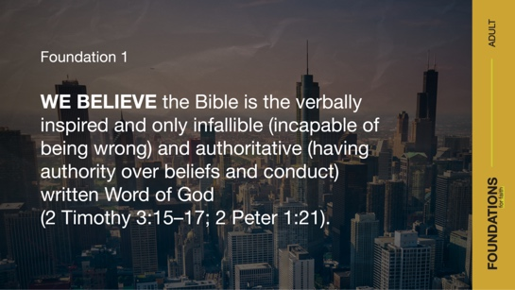

Foundation 1: WE Believe the Bible is the verbally inspired and only infallible (incapable of being wrong) and authoritative (having authority over beliefs and conduct) written Word of God (2 Timothy 3:15–17; 2 Peter 1:21).

Even more than we would treasure a message from a close friend or loved one, we should treasure these words from our Heavenly Father. Today, we can read His message to us compiled in a book we call the Bible. It is the Word of God, written to us.

Watch
Let’s watch this video about today’s foundational truth.



CONSIDER WHAT THE BIBLE SAYS
God’s Word Speaks to Us



The Bible is full of information about our life and how we should live it.

- Show the Consider Slide 1B as you read the bulleted items.

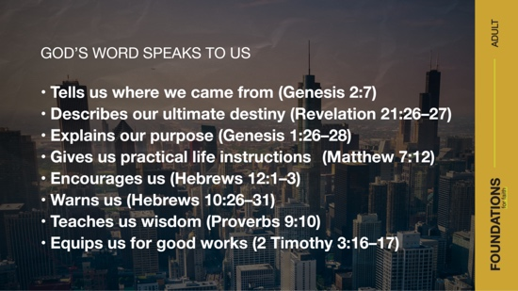

The Bible:
- Tells us where we came from (Genesis 2:7)
- Describes our ultimate destiny (Revelation 21:26–27)
- Explains our purpose (Genesis 1:26–28)
- Gives us practical life instructions (Matthew 7:12)
- Encourages us (Hebrews 12:1–3)
- Warns us (Hebrews 10:26–31)
- Teaches us wisdom (Proverbs 9:10)
- Equips us for good works (2 Timothy 3:16–17)

The Bible also says a lot about itself. As you’ll see in the Scriptures we’re about to read, the Bible’s trustworthiness is confirmed by its content. Though it was written by more than forty authors over about fifteen hundred years, its message is remarkably consistent. From Genesis to Revelation, prophecies were given and fulfilled, people’s hearts were changed by the truth, and the steady character of our God is displayed.

God’s Word Is Perfect



Read Psalm 19:7–8.

God’s Word is infallible, which means “incapable of error.” This is why it’s important for people to never change the divine message of Scripture (Proverbs 30:5–6). Any human attempt to add or subtract would create imperfection in God’s perfect truth.

One way God’s Word confirms its infallibility is through prophecy and fulfillment. For example, Isaiah 7:14 contains a prophecy about Jesus’ birth that was fulfilled about seven hundred years later in Matthew 1:18–24. This is just one of hundreds of Old Testament prophecies fulfilled during Jesus’ life and ministry.

Question
Why is it significant that Old Testament prophecies are fulfilled in the New Testament?

Question
How can seeing prophecies fulfilled in Scripture increase our trust in the Bible as a whole?

God’s Word Is Inspired

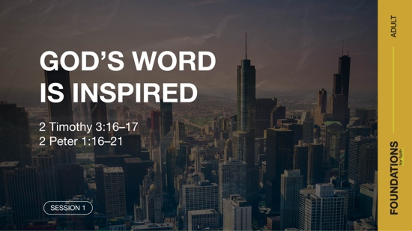

Read 2 Timothy 3:16–17; 2 Peter 1:16–21.

In relation to God’s Word, the term inspired means that the Holy Spirit moved the human writers of the Bible to perfectly record the words containing God’s intended message. When Paul wrote that Scripture is “inspired by God,” he used a word that literally means “God-breathed.” Much like a musician breathes into an instrument to produce a melody, God breathed into the biblical authors to produce His Word. His breath inhabits every verse, every story, and every concept.

It was a long process to get from God-breathed inspiration to the completed collection of books we call the Bible—also known as the canon (meaning measurement or standard). Each book in our Bible had to meet certain standards or requirements set by ancient Jews and early Christians at key points in history. These leaders recognized the text contained in the sixty-six books in our Bible could be trusted as an authentic message from God to all His followers for all time.

Even after the content of the Bible had been established, it wasn’t accessible to many people because the Scriptures were primarily written in Hebrew (Old Testament) and Greek (New Testament). Translating the Bible into other languages required lifetimes of work. Not only did scholars collect and compare ancient manuscripts, but they also analyzed each one to faithfully recreate the original documents. Translators then applied their expertise to transform these ancient messages into text that modern readers could understand.

It’s no exaggeration to say that people gave their lives (even through martyrdom) so we could have full access to the Bible. Because of their diligent efforts, we can understand, believe, and share the Word of God.

Question
Based on 2 Timothy 3:16–17, what are five ways the inspired Scriptures are useful for us?

Question
The New Testament word for breath can also be translated as spirit. What might this say about the concept of Scripture being God-breathed?

Question
How can believing that the Scriptures are inspired by God affect how you use the Bible?

Read 2 Peter 1:16–21.

At Jesus’ transfiguration—the “experience” Peter mentioned in verse 19—Peter, James, and John had heard God say, “This is my dearly loved Son, who brings me great joy” (verse 17; Matthew 17:1–6). They had witnessed Jesus’ divinity for themselves. Experiencing the majesty of the transfiguration of Jesus—the One prophets had written about—gave Peter “even greater confidence” in the rest of Old Testament prophecy. The messages of Scripture didn’t come from human ideas or understanding but from the Holy Spirit himself.

Question
How can believing the Bible is inspired by God give you confidence as you read it?

Question
What are some of the dangers of not relying on the truth of God’s Word or allowing it to change us?

God’s Word Is Consistent

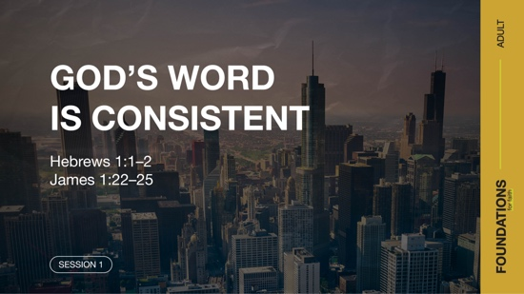

Read Hebrews 1:1–2; James 1:22–25.

Whether through the Old Testament prophets or through the passed down teachings of Jesus, it’s consistently clear that God wants to speak to people through His Word. The core way He continues to speak universal truth for everyone is through the Bible. Because He never changes (Numbers 23:19; Malachi 3:6; James 1:17), neither does the truth of His Word (Psalm 119:89; Isaiah 40:8). The Bible’s truth is perfectly consistent. It never wavers in its message of a relational God in pursuit of His people. God continually speaks to us from His Word, and this is why it’s important to engage with it regularly.

Question
What does it mean to truly listen to God’s Word? Based on James 1:22–25, what should happen next?

Question
What’s something God has spoken to you through His Word?

Question
How would you put the Bible’s consistent, central message in your own words?

God’s Word Is Life-Changing

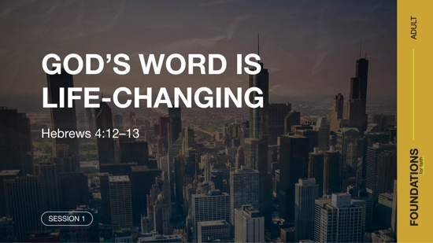

Read Hebrews 4:12–13.

The living Word of God shines the light of truth in the darkest corners of our mind and heart, revealing what we really think and what we really want. Reading His Word allows us to understand how God sees us and realize our need for a Savior. Only then can we receive God’s mercy and stand before Him unashamed. That is the life-changing power of the Word of God.

Question
Based on the Scriptures we’ve read so far, what are some of the components that make God’s Word so powerful?

Question
In what ways can God’s Word change a person’s life?

Question
If you’re comfortable, share about a time when the Bible clarified your thoughts or desires. How did this lead you to change?

God’s Word Became Human

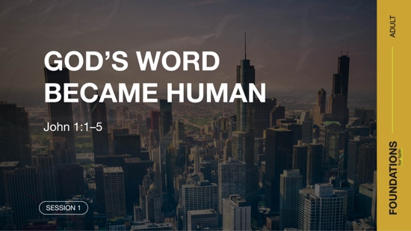

Read John 1:1–5.

The first few verses of John’s Gospel describe Jesus as the Word, or the ultimate expression of God’s message to humanity. Jesus not only spoke the Word of God, but He was the Word in human form (John 1:14). Through Him, we can better understand who God is and how we should relate to Him. When we engage with the Word, we engage with God himself.

Question
How does viewing Jesus as the Word impact your view of God’s desire to communicate with people?

Question
What similarities do you see between how Jesus is described in John 1 as the Word and what you know about Scripture?

REFLECT
God Speaks through Scripture
God desires a relationship with each of us. From creation to this moment, across all generations, He has consistently spoken to His people. How privileged we are to have access to His uniquely authoritative, collected words in the Bible! It teaches us the truth about humanity and the world around us, both visible and invisible. It provides a firm foundation for our faith. And it illustrates God’s unfailing love and perfect holiness.

Hearing God’s audible voice may be rare today, but He is always speaking to us through the Bible. Martin Luther, a key figure in church history, once said, “Let the man who would hear God speak, read Holy Scriptures.”3 As Pentecostals, we know that the Holy Spirit also speaks in other ways, but God’s written Word is the ultimate and authoritative expression of His communication in all times and places.

LISTEN TO GOD
The goal of Foundations for Faith is not only to better understand God’s Word, but also to pause and listen to what God is saying to us about His Word. Over the next few moments, silently reflect on the following questions.

Personal Reflection Questions

Record your answers to the following questions.

Question
What truths from God’s Word do you have the most trouble believing or receiving? Why?

Question
What truths from God’s Word have been the most transformative or meaningful in your life? Why?

Activate
Followers of Jesus are meant to do more than just stick to a list of rules. Instead, we’re called to the adventure of growing in a personal relationship with our Savior. As we know from our human relationships, one way of getting to know someone better is by being a good listener. Part of listening to God is reading and meditating on His Word. As you read God’s Word this week, remember to stop and listen to what the Holy Spirit is saying to you.

Challenge
God has spoken to us through His written Word, the Bible. He also spoke through His Son Jesus, the Word that became human. God calls us to learn and obey His message to us. The more we study the Scriptures, the more complete our view of God will be and the deeper our relationship with Him will grow.

Take time this week to go through the What We Believe section below and do the devotions. This will add insight for this foundational truth. Listen to God’s Word as the Spirit speaks with you and gives instruction and purpose for living.

Prayer Requests
Note any requests from the group, and remember to pray for them during the week.

WHAT WE BELIEVE
Foundation for Faith: The Scriptures Inspired

Foundation 1: WE Believe the Bible is the verbally inspired and only infallible (incapable of being wrong) and authoritative (having authority over beliefs and conduct) written Word of God (2 Timothy 3:15–17; 2 Peter 1:21).

The Scriptures of the entire Bible are inspired of God. The Holy Spirit moved the original writers of the Bible to fully record exactly what He wanted them to record—even down to their word choices. In doing this, He did not set aside their intellect, experience, or vocabulary, but powerfully engaged it for His purposes. This explains how there is diversity in the manner that each author wrote, but each text remains equally inspired by God. Regardless of a variety of authors, our Bible is infallible and authoritative. Because God is perfect, His Word cannot be wrong, and it has the final say over what we believe and how we behave.

And so, we believe that (1) the Scriptures are God’s Word and way of revealing himself to humankind, (2) they are infallible (never wrong), and (3) they are the divinely authoritative guide for our faith, belief, and way of living (1 Thessalonians 2:13; 2 Timothy 3:15–17; 2 Peter 1:21).

The Significance of This Foundation
If we don’t agree that all Scripture is given by inspiration of God (2 Timothy 3:16) and is therefore authoritative, we have no dependable standard on which to base our lives. Instead of having a guide that is fixed and reliable, everything becomes relative and uncertain. However, since God does not change as do the shifting shadows (James 1:17), we can be certain that His truth also remains steadfast, enduring all time, generations, and cultures.

Endnotes

To read the full, official version of the Statement of Fundamental Truths, visit ag.org/beliefs/statement-of-fundamental-truths
2 Portions of this session are adapted from Bible Engagement Project Adult Learn © 2021 by The General Council of the Assemblies of God, 1445 N. Boonville Ave., Springfield, Missouri 65802. Used by permission of the publisher.
3 Ewald M. Plass, What Luther Says (Saint Louis, MO: Concordia, 2006), 62.
Day 1—God’s Word Is Inspired
Before you begin each devotion, spend some time in prayer—praising God, offering requests, and asking for Him to speak to you through His Word.

Foundation 1: WE Believe the Bible is the verbally inspired and only infallible (incapable of being wrong) and authoritative (having authority over beliefs and conduct) written Word of God (2 Timothy 3:15–17; 2 Peter 1:21).

Read 2 Timothy 3:16–17.

In group time, we explored how the Bible is inspired. Much like a musician breathes into an instrument to produce a melody, God breathed into the biblical authors to produce His Word. He inspired every verse, every story, and every concept.

LISTEN to God through His Word
Question
What does it mean to you that God’s Word is inspired?

LEARN from God’s Word
Question
How do these verses reinforce our foundational truth that the Scriptures are inspired?

LIVE God’s Word
Question
What is one area of your life right now where God’s Word can teach, correct, or equip you? Take time to look up what the Bible says about that area.

Day 2—God’s Word Is Perfect
Before you begin each devotion, spend some time in prayer—praising God, offering requests, and asking for Him to speak to you through His Word.

Foundation 1: WE Believe the Bible is the verbally inspired and only infallible (incapable of being wrong) and authoritative (having authority over beliefs and conduct) written Word of God (2 Timothy 3:15–17; 2 Peter 1:21).

Read 2 Peter 1:20–21.

In group time, we looked at how the Bible is infallible or perfect. It’s incapable of error. One way God’s Word confirms its infallibility is through prophecy and fulfillment. Here is just one of hundreds of Old Testament prophecies fulfilled in the Bible. In Acts 2:4–6 after Jesus’ followers were first baptized in the Holy Spirit, Peter reminded the crowd that the prophet Joel had predicted this would happen hundreds of years before. (See Acts 2:14–18.) People were baptized in the Holy Spirit exactly as the Scriptures said—and this prophecy continues to be fulfilled today!

LISTEN to God through His Word
Question
Is it significant to you that prophecies in the Bible have been fulfilled as proof that the Bible is true and infallible? Why or why not?

LEARN from God’s Word
Question
How do these verses reinforce our foundational truth that the Scriptures are inspired?

LIVE God’s Word
Question
The prophets proclaimed God’s message as the Holy Spirit moved them. What is the message God wants you to share with someone?

Day 3—God’s Word Speaks to Us
Before you begin each devotion, spend some time in prayer—praising God, offering requests, and asking for Him to speak to you through His Word.

Foundation 1: WE Believe the Bible is the verbally inspired and only infallible (incapable of being wrong) and authoritative (having authority over beliefs and conduct) written Word of God (2 Timothy 3:15–17; 2 Peter 1:21).

Read Psalm 119:105.

In group time, we looked at how the Bible was written by more than forty writers over about fifteen hundred years, yet its message is remarkably consistent. That’s because God inspired what they wrote in order to teach us through His Word. We looked at how the Bible teaches us many things. For example, it:
- Tells us where we came from (Genesis 2:7);
- Describes our ultimate destiny (Revelation 21:26–27);
- Explains our purpose (Genesis 1:26–28);
- Gives us practical life instructions (Matthew 7:12);
- Encourages us (Hebrews 12:1–3);
- Warns us (Hebrews 10:26–31);
- Teaches us wisdom (Proverbs 9:10); and
- Equips us for good works (2 Timothy 3:16–17).

LISTEN to God through His Word
Question
What is one area in the list above that you would like God to speak to you about?
Read that verse or verses and note what it says to you.

LEARN from God’s Word
Question
How do these verses reinforce our foundational truth that the Scriptures are inspired?

LIVE God’s Word
Question
As we read God’s Word, it will change us. Reflect on how God has used His Word to guide you in the past. What do you need His guidance for now?

