
The One True God

Foundations for Faith Overview
We were never meant to do life alone—especially as followers of Jesus. Disciples grow best in community. Jesus himself modeled this concept by gathering a small group of followers to live and minister alongside Him every day. Even now when believers gather to seek God, relationships are forged, iron-sharpening discussions happen, and genuine accountability can develop.

During the next several sessions, you will journey together through foundational truths—or doctrines—of the Bible. Don’t let the word doctrine put you off. It simply refers to a teaching that comes from Scripture. Our doctrine impacts our decisions more than we might realize. For example, if we have a doctrinal belief that God heals, we are more likely to pray in faith, see Him deliver others from sickness, and experience our own healing. If we don’t believe in healing, we will not expect it or pray for it, and we may even speak out against it. The experiences we have as we follow Jesus largely depend on our doctrine.

The Book of Acts describes a group of Jews in Berea (17:10–15) who, like us, were seeking to better understand Scripture’s most foundational doctrines. After hearing Paul and Silas’s gospel message, they searched the Scriptures every day on their own to verify and fully understand the truth. The result? Many people believed the good news of Jesus and were changed for eternity. As you study Scripture and discuss doctrine together, may the Holy Spirit do the same for you.

SESSION OVERVIEW
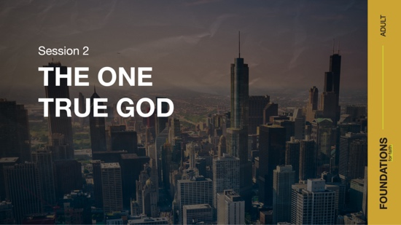

Foundation 2: WE Believe there is one God, eternally existent in three Persons: God the Father, God the Son, and God the Holy Spirit (Deuteronomy 6:4; Matthew 28:19; John 14:16–17).¹

The entirety of human history is littered with deity worship. From idols representing false gods to media superstars to even oneself, everyone has someone or something they worship. But the Bible reveals that there is only One who deserves our allegiance—the one true God. The Bible reveals who God is, who we are, and how we can have a relationship with Him. Throughout His Word, we find an array of His interactions with men and women, through which He chose to reveal himself to us. He is the eternal One who began our existence; He has revealed himself through His handiwork, Word, and Son; He is the only One powerful enough to be our Savior, and He is the One who we were made to worship. Given those truths, we must respond by deciding whether or not we will embrace Him as our one true God. ²

NOTE: Foundations for Faith covers so much important information that you may need to break some sessions into two parts in order to cover all the vital teaching provided.

ENGAGE
Welcome
Take this time to welcome everyone, introduce new group members, learn names, and thank everyone for coming. Your friendliness here can create a comfort level that encourages participation later.

Question
Have you ever purchased a product that wasn’t what you thought it was or didn’t do the job you expected it to do? What was your reaction?

Introduction
When given the chance, we choose real over fake any day of the week. Advertisers understand this, so they market their products accordingly. Food packaging boasts “real” ingredients, and clothing manufacturers claim “genuine” materials. Nobody wants a knockoff—we want the real thing!

Yet, when it comes to faith, people sometimes don’t realize they’re settling for a cheap substitute for the one true God. Some people choose to have faith in positive thoughts, energy fields, hope, their gut, their skills, and their finances. As Christians, we must make the one true God first in our life no matter what.

Question
What are some examples of cheap imitations people worship today instead of God?

Rather than embrace imitations, we have the opportunity to serve the real God, who is the Creator and Judge of everything.

WHAT WE BELIEVE
Foundation for Faith: The One True God
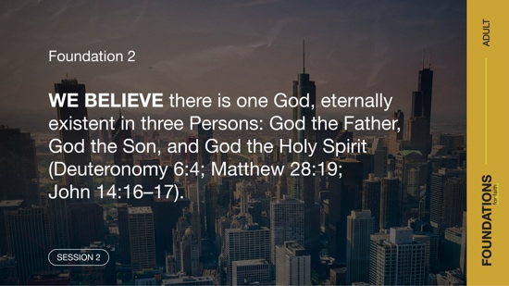

Foundation 2: WE Believe there is one God, eternally existent in three Persons: God the Father, God the Son, and God the Holy Spirit (Deuteronomy 6:4; Matthew 28:19; John 14:16–17).

We’ll unpack the pieces of that statement in this session. In today’s Bible readings, we’ll discover that He is the one true God, He’s the eternally existent Creator of all things, He has revealed himself to people, and He is the exclusive Redeemer—the One who restores people to right relations with himself. And as the one true God, He alone is to be worshipped. For now, let’s talk through a few questions.

Question
Do you believe that God still makes himself known to people today? Why or why not?

Question
Why do you think some people choose to reject that there is one true God?

Watch
Let’s watch this video about today’s foundational truth.



CONSIDER WHAT THE BIBLE SAYS
NOTE: There are many supporting Scriptures in this session. These are listed for further study, but not intended to be read aloud during a typical group time.

There Is One True God
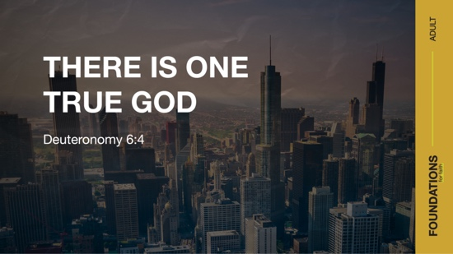

Read Deuteronomy 6:4.

Before diving into a few Bible stories that illustrate today’s foundation, here are some descriptions that Scripture offers about who God is. The Bible reveals a God who is
- full of mercy (Psalm 145:8–9),
- loving (John 3:16),
- compassionate (2 Corinthians 1:3), and
- holy (Leviticus 11:44–45; 1 Peter 1:16).

God is the Judge of people and their sins (Romans 2:5–6), but He also extends forgiveness to those who confess their sins (1 John 1:9).

Question
What are some other ways you would describe God’s activity and nature?

God has revealed far more about himself than could ever fit in this session. But one of the key things He revealed is in Deuteronomy 6:4. God revealed himself as a single Being. Christians serve only one God. That truth is a starting point for understanding that we don’t serve multiple gods and reject anything else that has been labeled as a god.

Throughout the Old Testament Scriptures, clues and hints can be found that this one God interacts with creation as three Persons. This truth is more clearly revealed in the New Testament Scriptures. Our one God exists in three Persons: Father, Son, and Holy Spirit (Matthew 28:19; Luke 3:21–22). The term used to express the truth of one God in three Persons is called the Trinity. That may be hard to comprehend. Nonetheless, it’s important to understand that whether Scripture is describing the Father, Jesus, or the Holy Spirit, the Bible is pointing to the one true God. (More information about the Trinity is in the “What We Believe” section later in this session.)

Question
Some statistics estimate that almost a third of people claim to be Christian. Do you think all those people really believe that our God is the one and only true God? Why or why not?

God Is Eternal

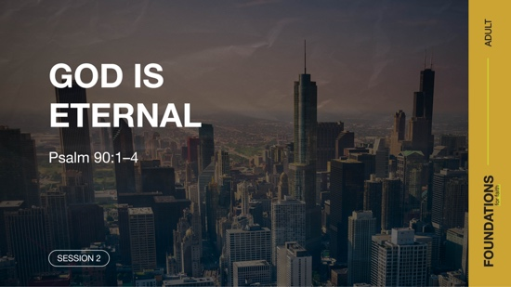

Read Psalm 90:1–4.

Remember in math class when you had to draw a line and the teacher instructed you to add arrows to both ends of your line? The arrows were a way to represent that the line goes on in both directions with no end. Trying to grasp the concept of an unending line is similar to coming to the understanding that God is eternal. He just always was, is, and will be (Revelation 1:8).

Unlike humans, God is infinite—He has no end or beginning. Trying to wrap our brain around the truth that God always has and always will exist is like trying to figure out what you would do if you were given a trillion dollars. If we’re honest, most of us struggle with numbers that get into that many digits.

In almost all literature and media, gods and godlike beings are portrayed with limitations or a weakness. Granted, the storyline needs a way to make it possible for such characters to be overcome. But perhaps this is also a subtle insight into the struggle humans have with truly accepting that there is an eternal God.

The eternal God existed before the “beginning” of everything we know (Genesis 1:1). He is the Creator of all things. He designed the course of the natural world (Ecclesiastes 1:4–7) and defined the role of human beings (Genesis 1:26–28). Contrary to many worldviews, God is still present and active in this world. Jesus taught this when He spoke of God the Father feeding the birds and decorating the fields with beautiful flowers to teach people of God’s care for them (Matthew 6:25–33). We can trust our eternal God to always be active and present in our world and life.

Question
How would you answer someone who doubts that an infinite God could or would care about finite beings?

Question
Accepting that God is the Creator, what responsibility do we as created beings have to our Creator?

God Reveals Himself to People

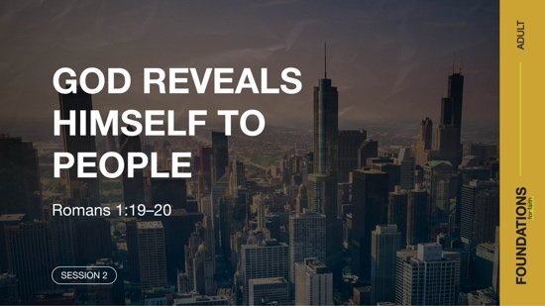

Read Romans 1:19–20.

How can finite people know and experience the eternal one true God? God reveals himself to people through creation. This is often referred to as natural or general revelation. That means it is information that is available to everyone. The majesty of nature reflects the glory of God. The wonder of its design also points to a Creator. Despite the natural evidence of God, most people choose not to recognize Him or offer the worship He deserves (Romans 1:21–23).

Question
Why do you think some people reject the existence of God even though creation reveals His existence?

Read Hebrews 1:1–3.

In addition to natural revelation, God has also chosen to speak to people over the course of history. This is referred to as special revelation. God has made himself known as He spoke messages through men and women, and given people dreams and visions. His laws and decrees gave insight into His character and a path for people to interact with Him. Much of what He has revealed has been captured for us in God’s Word, the Bible. His Word also became human in Jesus Christ who became the ultimate means by which God revealed himself to people.

Question
How do God’s efforts at making himself known reflect that He cares about us?

God Is the Exclusive Savior of Humanity

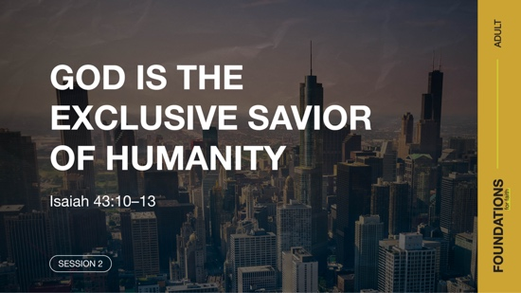

Read Isaiah 43:10–13.

Have you ever taken a placebo, a substitute for an actual medicine? Did it work for you, or did you continue to suffer from what ailed you? At times, the mind and body can do amazing things when a person is convinced that something is true. This is why placebos sometimes work, even though they are not the real medicine.

Now consider the reality that there is only one true God. While some people may believe salvation comes from other sources, and perhaps see some benefits in life from that belief, the reality is that God is the exclusive Savior. Both the Old and New Testaments are clear that God is the only one who restores people to right relationship with himself. When Jesus came, He boldly made the claim that no one comes to Father except through faith in Him (John 14:6). The apostles also boldly proclaimed that salvation is only possible through faith in Jesus (Acts 4:12).

There’s an old expression: You can’t get blood from a turnip. Similarly, it is foolishness to think salvation, entering a right relationship with God, can come from a false god. Don’t be fooled by imitations or alternatives. Only God is the real deal.

Question
Why do you think some people find the statement that salvation is only found in faith in the one true God offensive?

Question
How would you answer a friend who holds to the idea that there are many paths to God and salvation?

Only the One True God Is to Be Worshipped



Read Psalm 96:1–10.

We worship things that we ascribe worth to. God, more than anyone or anything else, is worthy of worship. As our Creator and Savior, He deserves displays of our honor and reverence. Anything vying for our worship is nothing more than a so-called god or idol. Those who trust in them face eternal disappointment and loss. The valuable things in this world may afford someone comfort and privilege, but they offer no hope when death comes, as it does for all people. Fame can also fade away as quickly as it comes. Rather than worship false gods, valuables, or famous people, let’s give worship to the One to whom it is due—the one true God. He alone is to be worshipped.

Question
Do you think it’s possible for a person to worship someone or something other than God without being aware they are doing so? Why or why not?

Question
Why do you worship God?

REFLECT
God Is the One True God
So, what do we do with the fact that there is only one true God who reveals himself to humanity in three Persons: Father, Son, and Holy Spirit? We either choose to believe it and act accordingly or we don’t. Some people will argue that belief is unreasonable, a leap of faith. Yet so much of what we do in life, to some degree, is acting on faith. You have faith that there’s a pilot in the cockpit with your best interest in mind while you’re flying in a plane. You have faith that your laundry soap will clean your clothes rather than destroy them. The reality is that society couldn’t function without some faith.

It’s also not unreasonable to believe there is one true God. The wonders of creation testify to it. The reliability and inerrancy of the Scriptures are grounds for belief in the God who reveals himself to people. And so many intangibles, including the witness of the Holy Spirit in our spirit and the way our life is changed when we put our faith in Christ, help to make faith in the one true God a reasonable step of faith. Perhaps these words from Hebrews 11:6 make more sense now: “And it is impossible to please God without faith. Anyone who wants to come to him must believe that God exists and that he rewards those who sincerely seek him.”

As to the complaint that it is arrogant to claim only our God is the one true God in light of the other religions of this world, may God help us not to be prideful. Instead, let’s share the reason for our hope in our God with gentleness and respect (1 Peter 3:15–16). The Bible acknowledges that enemies exist, including the devil and false gods. But in the end, every entity in all creation will yield to God and confess that He is the Lord (Isaiah 45:23; Romans 14:11).

LISTEN TO GOD
The goal of Foundations for Faith is not only to better understand God’s Word, but also to pause and listen to what God is saying to us about His Word. Over the next few moments, silently reflect on the following questions.

Personal Reflection Questions

Record your answers to the following questions.

Question
How are you displaying your worship of the one true God in your daily life?

Question
How would you explain your decision to put your faith in God as Savior and Lord to a non-Christian?

Activate
It’s not enough to simply acknowledge that there is one true God. Every believer must also choose to submit to Him as the Lord of their life. Some think of this as a one-time decision. But the choice to make God the Leader of your life happens moment by moment. It is made up of numerous life choices and deciding to make them according to what you believe is His will.

Challenge
As significant choices and options occur this week, be intentional about trying to allow God to be Lord over your life. If there’s time, pause and pray before deciding. Let your life reflect that He is your one true God.

Also, take time this week to go through the personal devotions and “What We Believe.” Read through the Scriptures listed and listen to God’s Word as the Holy Spirit speaks to you.

Prayer Requests
Note any requests from the group, and remember to pray for them during the week.

WHAT WE BELIEVE
Foundation for Faith: The One True God

Foundation 2: WE Believe there is one God, eternally existent in three Persons: God the Father, God the Son, and God the Holy Spirit (Deuteronomy 6:4; Matthew 28:19; John 14:16–17).

God has revealed himself as having always existed without any outside cause or agent bringing Him into being (Revelation 1:8). He is the Creator of heaven and earth (Genesis 1:1) and the One who redeems, saves, and rescues people from sin and its painful consequences (Isaiah 43:11). God has further revealed himself as a single Being (Deuteronomy 6:4), consisting of three interrelated Persons: Father, Son, and Holy Spirit (Matthew 28:19; Luke 3:22). This concept of one God or Being of three Persons is called the Trinity.

The terms Trinity and Persons as related to the Godhead are not found in the Scriptures, but they are in harmony with Scripture. Read the passages below for a deeper understanding of this concept.
- There is one God: Deuteronomy 6:4; Isaiah 44:6, 24
- The Father is God: John 17:3; 1 Corinthians 8:6
- The Son (Jesus) is God: John 20:28; Colossians 2:9; Hebrews 1:8
- The Holy Spirit is God: Acts 5:3–4; Hebrews 3:7–11
- The Father is eternal: 1 Chronicles 16:36; Malachi 3:6
- The Son is eternal: Colossians 1:15–17; Hebrews 1:2, 10–12
- The Holy Spirit is eternal: Job 33:4; Psalm 104:30; Hebrews 9:14
- Three distinct Persons: Matthew 28:19; 2 Corinthians 13:14; Ephesians 4:4–6

The Significance of This Foundation
Recognizing God as the one true God is necessary for developing a proper relationship with Him. Understanding His nature is important for relating to Him in the most appropriate way. It is contrary to the clear statement and meaning of Scripture to speak of the Father, Son, and Holy Spirit as three gods or as three modes in which the one God has revealed himself. Through the centuries, such misguided teachings have created division and devastation in the Church. Though the concept of a “three in one” Trinity has no parallel in the human world, it is absolutely scriptural and essential to a proper understanding of the multifaceted nature of God.

(Numerous other Scripture references support the nature of the one true God and the relationship between the three Persons, including: Zechariah 14:9; Matthew 1:21–23; 11:25–27; 28:19; Luke 1:35; John 1:1–2, 14, 18, 29, 49; 5:17–30, 32, 37; 8:17–18; 14:16–17; 15:26; 17:11, 21; Acts 2:32–36; Romans 1:1–4, 7; 14:11; 1 Corinthians 1:24; 15:24–28; 2 Corinthians 13:14; Philippians 2:8–9; Hebrews 1:1–13; 7:3; 12:2; 1 Peter 1:3; 3:22; 1 John 1:3–4; 2:22–23; 3:8; 4:1–5, 10, 14; 2 John 3, 9; Revelation 1:13, 17; 4:8–11; 5:6–14; 7:9–10.)

Endnotes

To read the full, official version of the Statement of Fundamental Truths, visit ag.org/beliefs/statement-of-fundamental-truths
2 Portions of this session are adapted from Bible Engagement Project Adult Learn © 2021 by The General Council of the Assemblies of God, 1445 N. Boonville Ave., Springfield, Missouri 65802. Used by permission of the publisher.

Day 1—There Is One True God
Before you begin each devotion, spend some time in prayer—praising God, offering requests, and asking for Him to speak to you through His Word.

Foundation 2: WE Believe there is one God, eternally existent in three Persons: God the Father, God the Son, and God the Holy Spirit (Deuteronomy 6:4; Matthew 28:19; John 14:16–17).

Read Deuteronomy 6:4.

In our group time, we learned that there is one God revealed in three Persons: God the Father, God the Son, and God the Holy Spirit. This can be hard to understand, but the doctrine of the Trinity is clearly present in Scripture. God is three Persons in perfect relationship with one another, sharing the same essence and substance, and completely unified as one God. We do not worship many gods or even three gods, but one true God.

LISTEN to God through His Word

Question
In John 17:20–23, Jesus prayed that His followers would be as united as He is with the Father. How can the Trinity be a model for how you can be united with other believers?

LEARN from God’s Word

Question
How does the Deuteronomy passage you read reinforce our foundational truth that there is one true God?

LIVE God’s Word

Question
If someone is struggling to believe there is only one true God, what would you say to them?

Day 2—God Is Eternal
Before you begin each devotion, spend some time in prayer—praising God, offering requests, and asking for Him to speak to you through His Word.

Foundation 2: WE Believe there is one God, eternally existent in three Persons: God the Father, God the Son, and God the Holy Spirit (Deuteronomy 6:4; Matthew 28:19; John 14:16–17).

Read Revelation 1:8.

The Bible makes it clear that God is eternal; He has always existed (Genesis 21:33; Psalm 90:2; John 17:5). The universe has a beginning and an end, but God doesn’t. This can be difficult to comprehend, because as finite humans we have a short lifespan in this world. Not only is God eternal, but He knew the end from the very beginning (Isaiah 46:10). God’s eternal nature is a certainty upon which we can build our faith.

LISTEN to God through His Word

Question
How does God’s eternal nature and knowledge give you confidence to trust His promises?

LEARN from God’s Word

Question
How do these verses reinforce our foundational truth that there is one true God?

LIVE God’s Word

Question
What are some areas of your life where you need to trust that God has an eternal plan? How can you demonstrate your trust in God in those areas today?

Day 3—God Is the Exclusive Savior of Humanity
Before you begin each devotion, spend some time in prayer—praising God, offering requests, and asking for Him to speak to you through His Word.

Foundation 2: WE Believe there is one God, eternally existent in three Persons: God the Father, God the Son, and God the Holy Spirit (Deuteronomy 6:4; Matthew 28:19; John 14:16–17).

Read John 3:16; 14:6.

Because there is only one true God, the only way for salvation is the path that He made available. Salvation only comes through Jesus Christ (Acts 4:12; 1 Timothy 2:5). God paid a high price to offer us the gift of salvation through Jesus’ work on the Cross, making Jesus the only option we have for eternal life.

LISTEN to God through His Word

Question
What are some ways you can express your gratitude to Jesus for the price He paid for your salvation?

LEARN from God’s Word

Question
How do these verses reinforce our foundational truth that there is one true God?

LIVE God’s Word

Question
Who is someone in your life who needs to hear about God’s offer of salvation in Christ Jesus? How could you share the good news with that person?

