
The Fall of Man

Foundations for Faith Overview
We were never meant to do life alone—especially as followers of Jesus. Disciples grow best in community. Jesus himself modeled this concept by gathering a small group of followers to live and minister alongside Him every day. Even now when believers gather to seek God, relationships are forged, iron-sharpening discussions happen, and genuine accountability can develop.

During the next several sessions, you will journey together through foundational truths—or doctrines—of the Bible. Don’t let the word doctrine put you off. It simply refers to a teaching that comes from Scripture. Our doctrine impacts our decisions more than we might realize. For example, if we have a doctrinal belief that God heals, we are more likely to pray in faith, see Him deliver others from sickness, and experience our own healing. If we don’t believe in healing, we will not expect it or pray for it, and we may even speak out against it. The experiences we have as we follow Jesus largely depend on our doctrine.

The Book of Acts describes a group of Jews in Berea (17:10–15) who, like us, were seeking to better understand Scripture’s most foundational doctrines. After hearing Paul and Silas’s gospel message, they searched the Scriptures every day on their own to verify and fully understand the truth. The result? Many people believed the good news of Jesus and were changed for eternity. As you study Scripture and discuss doctrine together, may the Holy Spirit do the same for you.

SESSION OVERVIEW

Foundation 4: WE BELIEVE man and woman were created good and upright in the image of God. However, sin entered the world by their voluntary disobedience leading to humankind’s separation from God both physically and spiritually (Genesis 1:26–27; Romans 5:12–19).¹

God gave Adam and Eve a great start to life. The two of them lived in a beautiful garden, created for them by God. They enjoyed a perfect relationship with each other as well. However, out of their own selfish desires, they chose sin over their relationship with God. This resulted in shame and separation.

The serpent brought the temptation, but Adam and Eve chose to participate in the sin. Like Adam and Eve, we are tempted by a real enemy. It’s up to us whether we will then engage in the sin or not. We cannot say, “The devil made me do it” and assume that relieves us of guilt. As we discuss this foundation, note how the enemy’s mission has not changed since the first recorded sin. He uses a similar approach in our lives as well. Fortunately for us, God had a plan of restoration. This plan involved forgiveness through His Son Jesus who paid the price for the sins of all humanity.

NOTE: Foundations for Faith covers so much important information that you may need to break some sessions into two parts in order to cover all the vital teaching provided.

ENGAGE
Welcome
Take this time to welcome everyone, introduce new group members, learn names, and thank everyone for coming. Your friendliness here can create a comfort level that encourages participation later.

Question
What’s the top rule from your childhood that you either broke or were often tempted to? What about it made it so enticing?

Introduction
Today, we’re going to continue our journey through the foundations of faith in the Bible. Last time we were together, we discussed the deity of Jesus as God. Today we’re going back to the beginning of the Bible, to the Book of Genesis, to look at the fall of man when sin began.

WHAT WE BELIEVE
Foundation for Faith: The Fall of Man
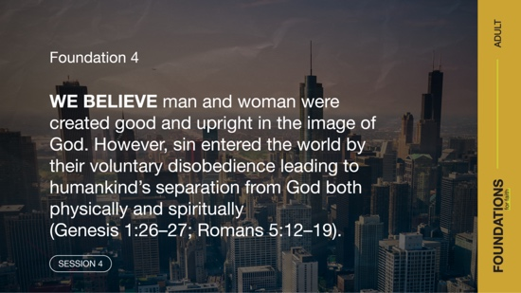

Foundation 4: WE BELIEVE man and woman were created good and upright in the image of God. However, sin entered the world by their voluntary disobedience leading to humankind’s separation from God both physically and spiritually (Genesis 1:26–27; Romans 5:12–19).

Maybe you’ve come across someone who believes they’re a good person and that alone should get them into heaven. Or maybe you’ve come across someone who believes a loving God wouldn’t send anyone to hell, regardless of their sins. How would you respond to these people? How does people’s choice to sin affect us today? Feel free to follow along in your Bible or in a Bible app as we explore what the Word of God says about the origin of sin in humanity.

Watch
Let’s watch this video to focus in on today’s foundational truth.

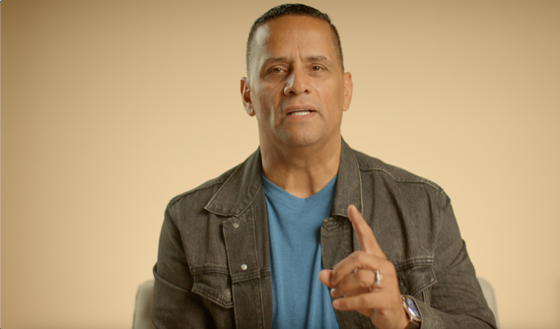

CONSIDER WHAT THE BIBLE SAYS
The first two humans, Adam and Eve, not only had each other, but they enjoyed an ideal relationship with God. They were planted in the place and with the person He designed specifically for each of them. It was the life He wanted for them. We don’t have all the details about how God connected with them, but we know He came so near that they could hear Him walking (Genesis 3:8) and could talk with Him (Genesis 3:10). Humans and God were close. Even the nature of human creation, in God’s image and likeness (Genesis 1:26–27), made them close. But one aspect of that image is moral freedom and a free will. Humans could choose to disobey God, and this is exactly what happened. That choice created a downward spiral of problems for them and for every generation since then.

Question
What do you think it would be like to live close enough to God to hear Him walk and talk, as Adam and Eve did?

Good People Were Tempted to Sin

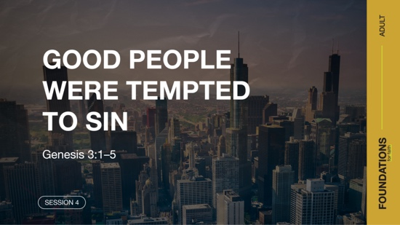

Read Genesis 3:1–5.

We don’t know how much time had elapsed after Adam and Eve were created before the serpent came on the scene to tempt them. Note that the serpent didn’t tell them to do anything. He certainly didn’t tell them to sin. Read the passage again carefully if you’re questioning this. He simply questioned what God had said—His Word. Does this tactic sound familiar to you? It’s still happening to us today.

The devil subtly tempts us with sin, often by making us question who God is and what He has said. The devil plants doubt and then begins to build on that doubt. And it’s not just our spiritual enemy at work. There are lots of human voices pushing us to question God’s Word. But His instructions are the foundation for right living and belief.

Question
What stands out to you about the serpent’s opening question and response to the woman?

With his opening question, the serpent planted doubt by questioning God’s instructions. He also misrepresented God’s instruction by expanding it to include all the trees. Then, with his response, the serpent directly questioned the goodness and trustworthiness of God.

Question
How does Satan continue to use this tactic to tempt people?

Adam and Eve Chose Sin



Read Genesis 3:6–13.

Following the serpent’s conversation with Eve, she noticed the fruit. Then she chose to sin by taking the fruit and eating it. Despite knowing God’s will and instructions, she chose to do
otherwise—she sinned. But sin didn’t stop there. She invited Adam to take part in the sin as well. Then their lives began to unravel. The same is true for us today. When we choose to sin, we often take others into sin with us. Most likely, someone has invited you to sin with them. Why do people do this? Maybe they believe it justifies their own sin.

Question
How would you define sin to a person with no Christian background?

Question
Is all sin obvious to everyone? Explain.

Question
Based on the verses you read, where did Adam seem to be during this encounter?

The tree was beautiful, the fruit looked delicious, and the wisdom it would give seemed appealing. The attractiveness of the fruit overcame the desire to obey God. Note the steps involved from the beginning of this temptation to the choice to sin.

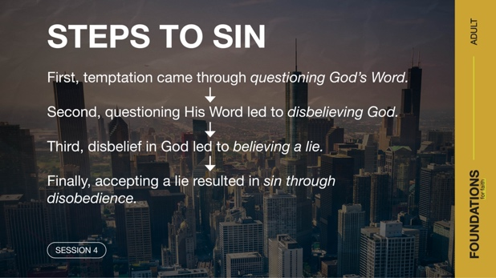

The results of Adam and Eve’s disobedience were immediate—a damaged relationship with God and each other. Before sin, they were satisfied in their perfect relationship with God, and they felt no shame. When sin entered their lives, they immediately felt shame—the feeling of knowing something was inherently wrong with them. Their shame was so strong that when they heard God’s voice, they hid from Him. But it was as useless to hide from God then as it is today.

Question
What are some ways that sin unravels people’s lives today?

Question
What part does shame still play when we give in to temptations?

Sin Brought Separation



Read Genesis 3:23–24.

Sin results in separation and broken relationships—both with God and others. Adam and Eve hid from the same God they had previously walked and talked with. When confronted with their disobedience, they didn’t take responsibility. Instead, they started pointing fingers. Adam blamed Eve, and Eve blamed the serpent. And in the end, all three suffered consequences (Genesis 3:14–19).

As a result of their sin, Adam and Eve were banished from the Garden and lost the special relationship they had with God. This also meant that they no longer had access to the tree of life (Genesis 3:22). Sin had led to death, just as it still does today (Romans 3:23). Thankfully, God offers a solution to the problem of sin and separation from Him.

Question
How does sin still bring separation to a person’s relationship with God?

Question
How might sin affect our relationships with others?

Sin Is Overcome through Jesus



Read Romans 5:8–11.

In the next session, we’ll discuss in more detail the salvation that Jesus offers. Yet it seems important to at least touch on it briefly. Adam and Eve’s disobedience brought the first sin into the world, but humanity has consistently followed their lead. Jesus’ sacrifice alone has the power to restore our relationship with God and overcome the sin problem.

Question
How do the verses you read say God demonstrated His love for us?

Question
What was restored through the death of Jesus on the Cross?

Just as we once chose sin, we can now choose an eternal relationship with Him. Without Jesus’ sacrifice, we could never be reconciled with God.

Question
What’s one thing you learned today that you could share with someone to help them avoid sin?

REFLECT
Sin Enters Our Life through Disobedience
Let’s consider the main idea for this session. Shame and separation from God and others are the result of our sin. While we may deserve the consequences of our sins, God has offered a solution. He sent His Son Jesus to sacrifice His life and restore our relationship with God.

Sin is a problem for every human, and we can’t overcome it on our own. But we should be encouraged because there is remedy—the sacrificial work of Jesus Christ! This should motivate us to share this good news with those in our life who need to hear it.

LISTEN TO GOD
The goal of Foundations for Faith is not only to better understand God’s Word, but also to pause and listen to what God is saying to us about His Word. Over the next few moments, silently reflect on the following questions.

Personal Reflection Questions

Record your answers to the following questions.

Question
Do you have sin in your life that is currently separating you from God? If so, what do you think will be the impact of that sin—on yourself and others?

Question
Are you willing to make things right between you and God? Why or why not?

Activate
Followers of Jesus are not meant to simply memorize and follow a list of rules. Instead, we’re called to the adventure of developing a personal relationship with our Savior. From our human relationships, we know one way of getting to know a person is by being a good listener.

Challenge
In your personal devotions and prayer time this week, try to incorporate additional listening time. During that time, be open to areas where God may want to bring correction to your life. Even if you’re not sinning, there are always adjustments to be made that lead to being a better follower of Jesus.

Prayer Requests
Note any requests from the group, and remember to pray for them during the week.

WHAT WE BELIEVE
Foundation for Faith: The Fall of Man

Foundation 4: WE BELIEVE man and woman were created good and upright in the image of God. However, sin entered the world by their voluntary disobedience leading to humankind’s separation from God both physically and spiritually (Genesis 1:26–27; Romans 5:12–19).

God said, “Let us make human beings in our image, to be like us.” From the beginning, humans were patterned after God’s goodness. However, by voluntary transgression, those humans fell and incurred—for all generations—both physical death and spiritual death, which is separation from God. Jesus’ ministry on earth demonstrated His desire for people to repent and the importance of turning from our sinful way of thinking.

The Significance of This Foundation
All of us sin because we are sinners. As a result of Adam and Eve’s sin, we are born with a sin nature (Psalm 51:5). Because of our sin, we are destined to physical and spiritual death (Romans 5:12). For this reason, we all must be born again (John 3:7), receiving what God’s Son Jesus did on the Cross for us. The only way to receive salvation from our sin is through His death (1 Timothy 2:5; 1 John 2:2). Some reject this foundational truth and believe that people can be good enough to deserve or earn heaven on their own merits. Scripture reveals that is far from the truth. The actual truth is, all humans need salvation and no one can experience salvation except through Jesus (John 14:6; Acts 4:12).

Endnote

To read the full, official version of the Statement of Fundamental Truths, visit ag.org/beliefs/statement-of-fundamental-truths

Day 1—Adam and Eve Chose Sin
Before you begin each devotion, spend some time in prayer—praising God, offering requests, and asking for Him to speak to you through His Word.
Foundation 4: WE Believe man and woman were created good and upright in the image of God. However, sin entered the world by their voluntary disobedience leading to humankind’s separation from God both physically and spiritually (Genesis 1:26–27; Romans 5:12–19).

Read Genesis 3:6–13.

Adam and Eve knew God’s commands, but they made a willing choice to disobey Him. When Eve sinned, her first instinct was to encourage Adam to join her in her rebellion against God. Sin not only affects us, but also those around us who can get drawn into our sins. Sin damages people’s relationships with God and with others.

LISTEN to God through His Word

Question
What effects of sin do you see in these verses?

LEARN from God’s Word

Question
How could a person’s sin affect others?

LIVE God’s Word

Question
What results has sin had in your own life?

Day 2— Sin Brought Separation
Before you begin each devotion, spend some time in prayer—praising God, offering requests, and asking for Him to speak to you through His Word.
Foundation 4: WE Believe man and woman were created good and upright in the image of God. However, sin entered the world by their voluntary disobedience leading to humankind’s separation from God both physically and spiritually (Genesis 1:26–27; Romans 5:12–19).

Read Genesis 3:22–24; Romans 3:23.

Adam and Eve’s sin resulted in a distance between people and God that didn’t exist before. It also hurt people’s relationships with each other. Fear and shame replaced perfect love. Isolation replaced perfect relationships. Life was replaced by eventual death. Rather than taking responsibility and repenting, Adam and Eve blamed each other, the serpent, and even God. Sin’s consequences are severe, and continue to impact people today.

LISTEN to God through His Word

Question
How did Adam and Eve’s sin affect their relationships with God and each other?

LEARN from God’s Word

Question
Why do you think Adam and Eve chose to blame others rather than repent of their sin? Do you think anything might have been different if they had?

LIVE God’s Word

Question
What effects does sin have in the world today?

Day 3— Sin Is Overcome through Jesus
Before you begin each devotion, spend some time in prayer—praising God, offering requests, and asking for Him to speak to you through His Word.
Foundation 4: WE Believe man and woman were created good and upright in the image of God. However, sin entered the world by their voluntary disobedience leading to humankind’s separation from God both physically and spiritually (Genesis 1:26–27; Romans 5:12–19).

Read Genesis 3:14–15; Romans 5:8.

Even though Adam and Eve rejected Him, God had a plan to save them. God’s plan would cost Him greatly, but He loved Adam and Eve so much that He was determined to undo the results of their rebellion and reestablish right relationships with His children. Even as God pronounced judgment, He promised that one of Eve’s descendants would reverse the effects of sin. That promise is found in the prophetic words of verse 15. This promise would be fulfilled in the life, death, and resurrection of Jesus Christ.

LISTEN to God through His Word

Question
What evidence do you see in these verses that God loves His children?

LEARN from God’s Word

Question
How did God offer Adam and Eve hope for the future?

LIVE God’s Word

Question
What evidence of God’s love do you see in your life?

