
The Salvation of Man

Foundations for Faith Overview
We were never meant to do life alone—especially as followers of Jesus. Disciples grow best in community. Jesus himself modeled this concept by gathering a small group of followers to live and minister alongside Him every day. Even now when believers gather to seek God, relationships are forged, iron-sharpening discussions happen, and genuine accountability can develop.

During the next several sessions, you will journey together through foundational truths—or doctrines—of the Bible. Don’t let the word doctrine put you off. It simply refers to a teaching that comes from Scripture. Our doctrine impacts our decisions more than we might realize. For example, if we have a doctrinal belief that God heals, we are more likely to pray in faith, see Him deliver others from sickness, and experience our own healing. If we don’t believe in healing, we will not expect it or pray for it, and we may even speak out against it. The experiences we have as we follow Jesus largely depend on our doctrine.

The Book of Acts describes a group of Jews in Berea (17:10–15) who, like us, were seeking to better understand Scripture’s most foundational doctrines. After hearing Paul and Silas’s gospel message, they searched the Scriptures every day on their own to verify and fully understand the truth. The result? Many people believed the good news of Jesus and were changed for eternity. As you study Scripture and discuss doctrine together, may the Holy Spirit do the same for you.

SESSION OVERVIEW
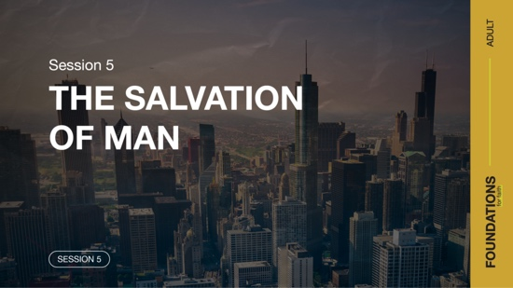
Foundation 5: WE BELIEVE the only means of being cleansed from sin is through the precious blood of Christ. We receive access to that by having faith in Jesus, repentance, and regeneration by the Holy Spirit for personal salvation (Luke 24:47; John 14:6; Romans 8:16;
Titus 3:5).¹

Asking someone how a person can spend eternity with God generates a variety of responses. Answers may include because they believe in God, how they treated others, how good they were, or whether they attended and participated in church. Others may even offer the idea that there isn’t a sure way due to so many religions or that everyone goes to heaven because a loving God would never send anyone to hell.

The truth is people choose whether they want to spend eternity with God or be separated from Him. Just as people make a choice to sin or not, we all make our own decision on whether we accept what Jesus did for us by paying the price for our sin. So, exactly how do we find salvation? We must once again turn to the Scriptures for guidance. They are foundational to living a full life. The Bible reveals Jesus’ offer of salvation to us and how we can come to Him and enter into an eternal relationship.

Maybe you’ve questioned how someone is truly saved or perhaps you’ve wondered if you are saved and will enter heaven. According to the inspired Scriptures, we can answer both questions.

NOTE: Foundations for Faith covers so much important information that you may need to break some sessions into two parts in order to cover all the vital teaching provided.

ENGAGE
Welcome
Take this time to welcome everyone, introduce new group members, learn names, and thank everyone for coming.

Question
Have you ever been rescued from something? What happened?

Introduction
Believe it or not, we all need to be rescued. To be rescued often requires some type of sacrifice or heroic act. Perhaps you almost drowned and required CPR, or you began to choke and had to have someone perform the Heimlich maneuver. Whether we know it or not, we’ve all needed rescue at least once. Every person is at a loss when it comes to being able to find enteral life on their own. We all need to be rescued.

Today, we’re going to discuss how someone can be spiritually rescued. Being rescued means we can be at peace in our relationship with God, knowing that we will be with Him for all eternity. This was the primary reason Jesus came to earth. His mission was to show us the Father and take on our sin. Because He did this, our sin can be forgiven.

WHAT WE BELIEVE
Foundation for Faith: The Salvation of Man
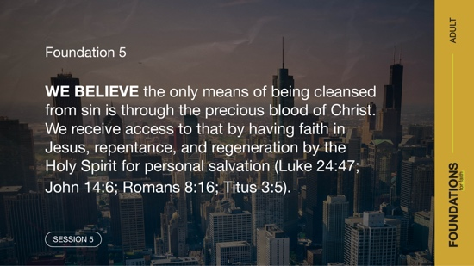
Foundation 5: WE BELIEVE the only means of being cleansed from sin is through the precious blood of Christ. We receive access to that by having faith in Jesus, repentance, and regeneration by the Holy Spirit for personal salvation (Luke 24:47; John 14:6; Romans 8:16;
Titus 3:5).

Every person can be restored to fellowship with God through salvation, available only through the sacrificial death of Jesus and guaranteed through His resurrection. As we’ll see, this requires us to choose to put our complete trust in Jesus. It’s not enough simply to have some knowledge about who Jesus is or what He did. Knowing something doesn’t necessarily mean someone accepts it or puts their trust in it. Nicodemus is one example. He knew a lot about God, but when he spoke to Jesus in John 3, he still didn’t really understand the salvation that would be provided through Jesus.

Question
Did you grow up knowing about salvation? If not, how did you first find out about it?

Watch
Let’s watch this video to focus in on today’s foundational truth about salvation.



CONSIDER WHAT THE BIBLE SAYS
We all come to Jesus offering only our sinful life. Our sin has separated us from God. Humanity needed to be rescued from sin. Salvation is received through repentance toward God and faith in the Lord Jesus Christ (Hebrews 10:19–20). But what did Jesus’ act of rescue look like? Let’s check it out.

Jesus Was the Sinless Sacrifice

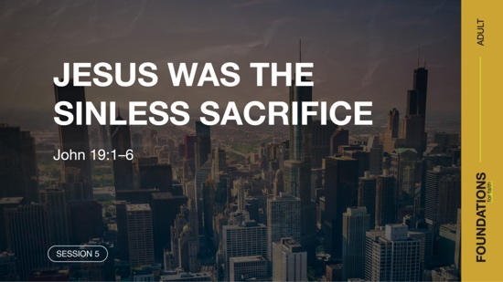

Read John 19:1–6.

Before this passage, Jesus had been arrested and questioned by the Jewish religious leadership. All their accusations fell short. But they hated Jesus so much that they made up criminal charges, bribed people to make false claims, and dragged Him off to the local Roman governor, Pilate. The Jews had no legal right to execute someone, so they needed to involve the Roman government to accomplish their evil plot. Even Pilate knew that Jesus had done nothing wrong, let alone a crime deserving death.

Question
Was there ever a time that you felt you were unfairly accused by others, either from a distance or by someone close to you? How did this make you feel?

Question
Why do you think the religious leaders hated Jesus and wanted Him to be executed?

Jesus revealed truth that contradicted the religious leaders’ beliefs, and He threatened their position and power. Several times Jesus had exposed their sinful behavior. Jesus had never sinned with His actions, His words, or even His motives. This is important for you and me because His perfect, sinless life is the only thing that could be sacrificed to atone for our imperfect, sinful life, restoring us to a right relationship with God.

Jesus’ popularity inspired the religious leaders to try to catch Him in a sneaky way. Rather than publicly arresting this beloved Teacher and risking outrage from the crowds, they plotted to seize Him at night. To do this, they needed someone close to Jesus to betray His location. They paid one of His disciples, Judas, to be the informant. Their attempt at secrecy in the death of Jesus was a massive failure. His death is one of the most well-known executions in human history.

Question
What might Jesus have been thinking as He endured the mocking, beating, and crucifixion?

Read John 19:16–20.

Jesus was executed between two criminals, as if He were a criminal himself. Crucifixion was a horrible death marked by extreme pain, humiliation, and suffering. It was reserved for the worst of criminals. The public display of a crucifixion served as a warning to other potential criminals.

It’s fitting that Jesus died between two sinners because Jesus was dying for sinners. Years later, the apostle Paul would write that Jesus became the offering for our sin, so we could be made right with God (2 Corinthians 5:21). Jesus willingly chose to be sacrificed in our place.

Question
What about the scene of Jesus’ death on the Cross is most impactful for you?

Question
What does knowing that Jesus willingly endured the Cross say to you about His love for people?

Question
How should knowing Jesus died for us change how we live for Him?

Jesus Was the Final Sacrifice

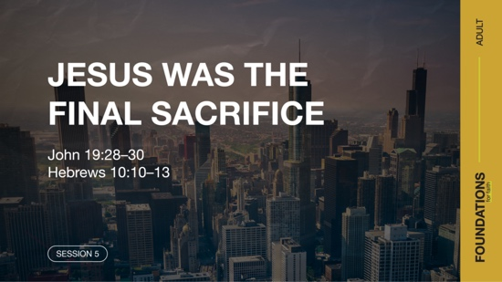

Read John 19:28–30; Hebrews 10:10–13.

In the first verses, Jesus was just moments from death. His mother, His disciple John, and some others were standing nearby, knowing that He would soon give up His life. With His dying breath, Jesus said, “It is finished!” (John 19:30). The Perfect Sacrifice had been given. No more sacrifices would be needed for our sin. Jesus paid it all.

Question
What did Jesus mean when He said, “It is finished!”?

It’s worth noting that Jesus did not say, “I am finished.” If you know the rest of the story, He was far from finished. Jesus said, “It is finished” because the work He had come to do was finished, but even more so, His sacrificial work for our redemption was finished.

Question
Why do some people try to add their own efforts or works to Jesus’ perfect sacrifice for salvation?
Nothing was lacking in Jesus’ sacrifice. God sacrificed himself, through His only Son, to rescue us! There is nothing you and I need to do or can do in addition to what Jesus accomplished for us to be saved.

Question
How would you explain to someone how they can be saved?

We come to Jesus with faith and trust in who He is and what He did for us in His death. Then we commit to follow Jesus as the Lord and Leader of our life. Our new life as a saved person begins when we believe in what Jesus did for us and put Him in charge of our life (Romans 10:9). That moment of salvation begins a lifelong journey of repentance, which means turning toward God and His will and away from a life that displeases Him. Just like salvation is a beginning rather than the end of our story as one of Jesus’ followers, His death wasn’t the end of His amazing story.

Jesus Conquered Death

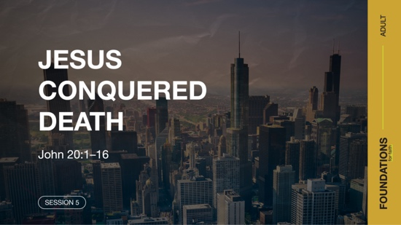

Read John 20:1–16.

After Jesus’ death, His body was laid in a tomb. A few days later, Mary Magdalene went to the tomb to handle some burial preparations for the body and was shocked to find that Jesus’ body was gone. After leaving to tell some others the news, she came back to the tomb and was overcome with emotion. Can you sense her love, loyalty, and commitment to Jesus in this moment? Jesus had delivered her from demons. She was among the women who traveled with Jesus and His disciples, financially supporting His ministry.

It’s likely that neither she nor the rest of Jesus’ followers truly expected Him to rise from the dead—although He had spoken of it several times. How often we, too, miss what Jesus is speaking to us! He shows us many things through His Word and yet we question if it’s really Jesus speaking. The Resurrection shows that Jesus overcame death, and it’s the proof that He has the power to do the same for us. He’s not only taken our sin away, but He’s taken away the eternal consequences of our sin.

Question
Why might it have been difficult for Mary and others to believe that Jesus was alive following His crucifixion?

Question
How would you explain the significance of Jesus being raised from the dead in your own words?

The Resurrection is central to the Christian faith. You can’t talk about the Cross without the Resurrection (1 Peter 1:3). Not only does the Resurrection show the immense power of Jesus Christ, but the Resurrection also proves that Jesus was who He claimed to be. Later, more than five hundred witnesses testified to the Resurrection (1 Corinthians 15:3–6). One day, all followers of Jesus will be also raised as He was (1 Corinthians 6:14).

Question

Why do you think people who know what Jesus did and the promise of what He offers still reject Him?

REFLECT
Jesus Is the Perfect Sacrifice
Jesus said no one could take His life from Him, but He would voluntarily sacrifice it (John 10:18). As He was beaten, whipped, and mocked, it may have looked like He was an unwilling victim. At the Cross, it seemed that He was being killed by Roman soldiers. Instead, Jesus was a willing sacrifice who chose the moment He gave up His spirit. He chose to die for you and me. The Jewish leaders, Pilate, and the soldiers played their roles, but ultimately Jesus chose to be the Perfect Sacrifice.

LISTEN TO GOD
The goal of Foundations for Faith is not only to better understand God’s Word, but also to pause and listen to what God is saying to us about our foundation for faith. Over the next few moments, silently reflect on the following questions.

Personal Reflection Questions

Record your answers to the following questions.

Question
Are you sure of your salvation? If not, what’s standing in the way of you turning to Jesus for salvation today?

Question
What’s been the most significant change in your life after receiving Jesus’ gift of salvation?

Question
What sacrifices might you need to make in response to the sacrifice Jesus made for you?

Activate
The sacrifice of Jesus on the Cross must be more than just a moving story to us. His sacrifice requires something of all who believe. You and I don’t deserve to be alive and filled with hope for eternity, but we are. And that must change how we live.

Challenge
In light of Jesus’ sacrifice, what is one thing He is asking you to sacrifice? You may need to give up a bad habit, end an unhealthy relationship, or give a gift to your church or a ministry. Identify one sacrifice you can make this week—and make it. Don’t do this to attempt to earn God’s love or even to prove your love for God. Do it because God’s love is freely yours. Let your worshipful response be one of sacrifice.
Take time this week to go through the personal devotions and the “What We Believe” section below. This will add insight for this foundational truth of salvation. Listen to God’s Word as the Holy Spirit speaks to you and gives instruction and purpose for living out this truth in your life as well as sharing it with others.

Prayer Requests
Note any requests from the group and remember to pray for them during the week.

WHAT WE BELIEVE
Foundation for Faith: The Salvation of Man
Foundation 5: WE BELIEVE the only means of being cleansed from sin is through the precious blood of Christ. We receive access to that by having faith in Jesus, repentance, and regeneration by the Holy Spirit for personal salvation (Luke 24:47; John 14:6; Romans 8:16;
Titus 3:5).

Salvation is deliverance from spiritual death and enslavement by sin in this life and the promise of eternal life in the next. God provides salvation for all who believe and accept His free offer of forgiveness. Our only hope of redemption from our fallen sinful state is through the blood of Jesus Christ, God’s Son—blood that was shed as Jesus died on the Cross (an account recounted by four of His contemporaries: Matthew [chapter 27], Mark [chapter 15], Luke [chapter 23], and John [chapter 19]).

In response to placing faith in God and accepting His freely given salvation, a person experiences the washing of regeneration (or spiritual rebirth), the renewing work of the Holy Spirit, and is declared righteous (right with God). Regeneration, renewal, and justification (justified, or made right with God) are words describing what happens at salvation. At the moment of salvation, a person becomes heir to God’s promised hope of eternal or everlasting life (Luke 24:47; John 3:3; Romans 10:13–15; Ephesians 2:8; Titus 2:11; 3:5–7).

The Significance of This Foundation
The death and resurrection of Jesus guaranteed our salvation. Jesus’ life was the perfect sacrifice (Hebrews 4:15)—and only sacrifice (1 John 2:2)—to bring about this salvation. He was sent to provide a way for us to inherit eternal life. This eternal life can come only through Jesus (John 14:6), so all who believe in Him will gain eternal life (John 3:15–16). There is no other way for us to be saved (Acts 4:12). As a result, we can be confident that the one true God has made a way for our eternal salvation.

Endnote

To read the full, official version of the Statement of Fundamental Truths, visit ag.org/beliefs/statement-of-fundamental-truths

Day 1—Jesus Was the Sinless Sacrifice
Before you begin each devotion, spend some time in prayer—praising God, offering requests, and asking for Him to speak to you through His Word.
Foundation 5: WE BELIEVE the only means of being cleansed from sin is through the precious blood of Christ. We receive access to that by having faith in Jesus, repentance, and regeneration by the Holy Spirit for personal salvation (Luke 24:47; John 14:6; Romans 8:16;
Titus 3:5).

Read John 19:4-6; 2 Corinthians 5:21; Titus 3:5.

In group time, we talked about how Jesus died for our sins, even though He was not guilty of any sin himself. Jesus was the only Person who ever died that did not deserve death. This is because sin leads to death (Romans 6:23) and every human, except Jesus, has sinned (Romans 3:23). Even the Roman governor Pilate declared that Jesus was innocent. But because He was innocent, He was able to take the penalty for sin and become the sinless sacrifice for our sins.

LISTEN to God through His Word

Question
Why is it important that Jesus was not guilty of any sin?

LEARN from God’s Word

Question
How did Jesus’ death benefit all of humanity?

LIVE God’s Word

Question
How can you show gratitude for Jesus’ selfless sacrifice for your sins?

Day 2— Jesus Was the Final Sacrifice
Before you begin each devotion, spend some time in prayer—praising God, offering requests, and asking for Him to speak to you through His Word.
Foundation 5: WE BELIEVE the only means of being cleansed from sin is through the precious blood of Christ. We receive access to that by having faith in Jesus, repentance, and regeneration by the Holy Spirit for personal salvation (Luke 24:47; John 14:6; Romans 8:16;
Titus 3:5).

Read Hebrews 10:10–13; John 14:6.

In group time, we discussed how Jesus finished the work needed to offer salvation with His death on the Cross. In the Old Testament, priests constantly offered sacrifices for the sins of the people. But because Jesus was the perfect sacrifice, His death provided once for all time everything necessary to provide salvation from sin. Our forgiveness from sin is not based on what we do, but what He has already done. He is the only path to salvation and eternity in heaven.

LISTEN to God through His Word

Question
How was Jesus’ sacrifice different from the Old Testament sacrifices?

LEARN from God’s Word

Question
Why is Jesus the only way that people can be saved?

LIVE God’s Word

Question
How does Jesus’ once-for-all sacrifice give you assurance of your salvation?

Day 3— Jesus Conquered Death
Before you begin each devotion, spend some time in prayer—praising God, offering requests, and asking for Him to speak to you through His Word.
Foundation 5: WE BELIEVE the only means of being cleansed from sin is through the precious blood of Christ. We receive access to that by having faith in Jesus, repentance, and regeneration by the Holy Spirit for personal salvation (Luke 24:47; John 14:6; Romans 8:16;
Titus 3:5).

Read 1 Corinthians 6:14; 1 Peter 1:3–5.

The story of Jesus does not end with His death on the Cross. The resurrection of Jesus Christ is proof of His identity and power. When Christians remember the empty tomb, their response should be offering praise to God for the amazing gift He gave. Jesus’ resurrection provides assurance to His followers that one day we will also be raised from the dead to be with Him forever.

LISTEN to God through His Word

Question
What did Jesus’ resurrection prove?

LEARN from God’s Word

Question
How can we be confident that Jesus rose from the dead?

LIVE God’s Word

Question
What hope does Jesus’ resurrection provide for His followers?

