
The Ordinances of the Church

Foundations for Faith Overview
We were never meant to do life alone—especially as followers of Jesus. Disciples grow best in community. Jesus himself modeled this concept by gathering a small group of followers to live and minister alongside Him every day. Even now when believers gather to seek God, relationships are forged, iron-sharpening discussions happen, and genuine accountability can develop.

During the next several sessions, you will journey together through foundational truths—or doctrines—of the Bible. Don’t let the word doctrine put you off. It simply refers to a teaching that comes from Scripture. Our doctrine impacts our decisions more than we might realize. For example, if we have a doctrinal belief that God heals, we are more likely to pray in faith, see Him deliver others from sickness, and experience our own healing. If we don’t believe in healing, we will not expect it or pray for it, and we may even speak out against it. The experiences we have as we follow Jesus largely depend on our doctrine.

The Book of Acts describes a group of Jews in Berea (17:10–15) who, like us, were seeking to better understand Scripture’s most foundational doctrines. After hearing Paul and Silas’s gospel message, they searched the Scriptures every day on their own to verify and fully understand the truth. The result? Many people believed the good news of Jesus and were changed for eternity. As you study Scripture and discuss doctrine together, may the Holy Spirit do the same for you.

SESSION OVERVIEW
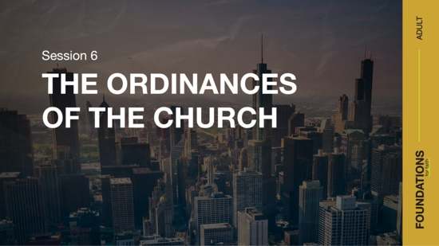

Foundation 6: WE BELIEVE that the Bible directs all believers to participate in water baptism by immersion and in Holy Communion (Matthew 28:19; Romans 6:4;
1 Corinthians 11:26).¹

When we think of church, it’s easy to be instantly drawn to the building where we attend. However, in God’s design, the church isn’t the building we gather in. Instead, the church has everything to do with the people who are gathered there. In essence, the biblical church is not a building that we go to, but a family of believers we belong to.
As part of God’s family, it’s important that we follow His commands. Two of these commands are water baptism and Communion. Jesus demonstrated both by being baptized in water and by leading a meal with His disciples that established the practice of Communion.

Being baptized shows our obedience to Jesus. After His resurrection, Jesus commanded His followers to baptize those who become new followers (Matthew 28:19). On the Day of Pentecost, Peter passed on that command by commanding new believers to be baptized (Acts 2:38). Sharing in Communion is another way that we obey Jesus (Luke 22:19), and it should be a part of our life as a church family (Acts 2:42).

Water baptism and Communion are called ordinances of the Church. They are practices that are ordered by Jesus for all members of His Church. They are not just rituals, but meaningful symbols that represent our identification with Jesus.

NOTE: Foundations for Faith covers so much important information that you may need to break some sessions into two parts in order to cover all the vital teaching provided.

ENGAGE
Welcome
Take this time to welcome everyone, introduce new group members, learn names, and thank everyone for coming.

Question
What do you enjoy most about going to church? Why?

Introduction
People attend church for many reasons. Besides the Bible directing us to gather with other Christians (Hebrews 10:25), people also appreciate the sermons, worship, prayer, fellowship with other believers, seeing friends, going as a family, and more. Another key reason for attending church is to celebrate all that God has done and is doing.

As the Church, we have much to celebrate. A core element we celebrate is the mercy and grace of God through the work of Jesus on the Cross. We also celebrate the hope of an empty tomb and the power of a resurrected Savior. Nothing brings these elements to the forefront quite like Communion and water baptism. These are called ordinances—prescribed practices that we follow. These two practices were both modeled and commanded by Jesus himself and were regularly observed in the Early Church.

WHAT WE BELIEVE
Foundation for Faith: The Ordinances of the Church
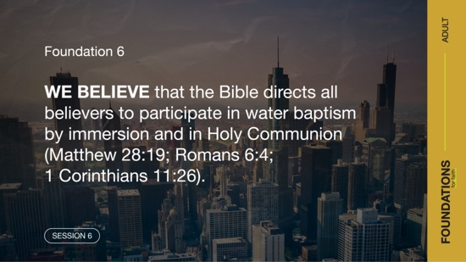

Foundation 6: WE BELIEVE that the Bible directs all believers to participate in water baptism by immersion and in Holy Communion (Matthew 28:19; Romans 6:4;
1 Corinthians 11:26).

Both Communion and water baptism are important ways we remember all that Jesus has done for us through His death and resurrection.

Watch
Let’s watch this video to focus in on today’s foundational truth.

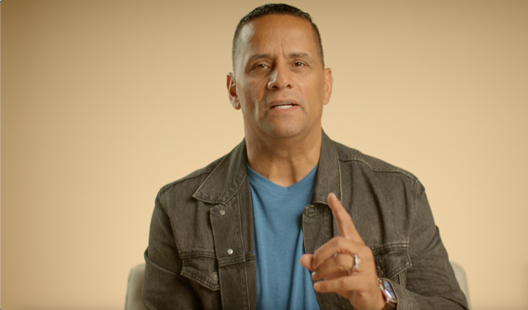

CONSIDER WHAT THE BIBLE SAYS
We may live in the most self-centered society in history. Everything seems to be about us: “Discover and create yourself,” “Be true to yourself,” “Satisfy yourself.” Water baptism and Communion push against many of those human values. These ordinances remind us that we’re part of something bigger. Being part of the Church also reminds us that life is not just about us, but about the One who created us to be part of His family.

Water baptism is an act of obedience to God. It’s also a symbol of dying to self in order to fully identify with Christ. We exchange what we want for ourself for what God wants for us. God wants us to be in a life-giving relationship with Him and others.

Communion is a reminder of the tremendous sacrifice Jesus made for our salvation and healing. It’s also a symbol that His sacrifice provides a way for us to share in the benefits of His work for us.

Question
What does water baptism mean to you?

An Outward Symbol of an Inward Change



Read Acts 16:11–15.

This event took place at the beginning of Paul’s second missionary journey. He was traveling the known world, sharing the good news of Jesus with anyone who would listen. Philippi was a Roman colony filled with mostly Gentiles (non-Jews). Lydia was a businesswoman who had gathered with some other women at a riverbank. As she listened to Paul sharing the gospel, the Lord opened Lydia’s heart and she believed! This was her moment of conversion, the time when she accepted the gift of salvation Jesus provided by His sacrificial death on the Cross.

Question
What do you notice about God’s role in Lydia’s conversion?

Question
What do you notice about Paul’s role in Lydia’s conversion?

After her conversion, Lydia agreed to be baptized in water. This pattern in the New Testament never changes: first salvation, then water baptism. Water baptism doesn’t earn salvation. It’s an act that announces to the world that you have accepted the gift of salvation. It’s an outward expression of an inward change. Without hesitation, Lydia and her family were baptized in water.

Question
Do you think we make water baptism as important today as it was in the New Testament? Why or why not?

Question
What brought you to the decision to be baptized?

Question
Does anyone have a special story or detail from your baptism that you would like to share?

A Symbol of Our Union with Christ

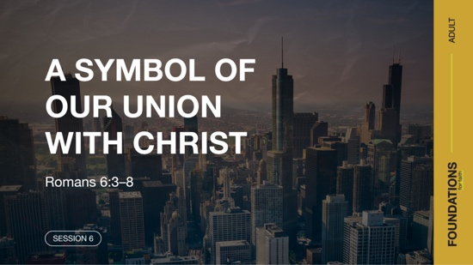

Read Romans 6:3–8.

The Book of Romans is a letter written by the apostle Paul. In this passage, Paul emphasized our coming together with Christ. We’re united with Jesus in His life, death, and resurrection. Water baptism is a visible symbol of that relationship.

Question
How would you describe what it means to be united with Jesus?

By going under the water in baptism, believers identify with Christ’s death and burial. This is one reason we practice water baptism by immersion. The person you used to be in your sin, selfishness, and slavery to sin dies. In coming out of the water, the believer identifies with Christ in His resurrection. Because of Jesus, we have new life in Him, and we find ourself free from sin’s rule over us.

Question
What do you think it means for our old, sinful self to be crucified?

Question
How can water baptism help you share your faith and your personal salvation story with friends and family who don’t know Jesus?

Communion Focuses Our Heart on Jesus

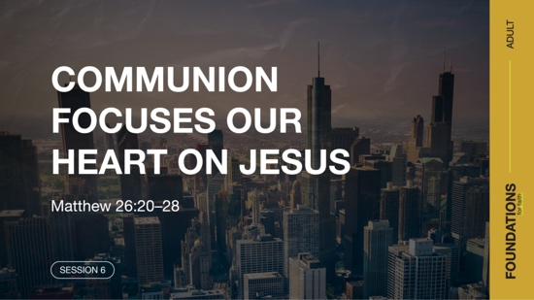

Depending on your faith background, your Communion experiences may vary. The disciples also had a unique experience by being a part of the event that set the pattern for Communion, led by Jesus himself! They were the first to understand the meaning and importance of taking Communion together.

Question
What do you remember about either your first Communion or a memorable Communion experience?

Read Matthew 26:20–28.

Just before these verses, Jesus instructed His disciples to prepare the meal to celebrate Pass-over. This annual Jewish holiday celebrated the Israelites’ deliverance from Egyptian slavery. It reminded them how God had spared the Israelites who applied a lamb’s blood to their doorposts. God had commanded them to do this before the death angel would strike the firstborn son in every Egyptian family (Exodus 12:23).

Jesus shared the bread and cup with His disciples, focusing their hearts on what was most important. He informed them that soon His body would be broken, and His blood would be poured out. Just as the lamb’s blood on the doorframe at the first Passover prevented physical death (Exodus 12:13), Jesus is the Lamb of God who allows everyone the opportunity to escape spiritual death (John 1:29). His death, burial, and resurrection bring wholeness to everyone who believes.

Question
How does sharing in Communion help us focus on our relationship with God?

Jesus used this shared meal to point toward His work on the Cross, and it does the same for us today. Jesus took on himself the punishment that our sin deserves (Romans 3:23–26; 1 John 2:2). And although they likely didn’t know it at the time, the disciples were taking part in a meal that generations of Jesus’ followers would repeat to remember His sacrifice.

Question
Why is it important for believers to remember Jesus’ sacrifice?

In his letter to the Corinthian church, the apostle Paul looked back at Jesus’ sacrifice, teaching that such a sacrifice compels us to examine ourself.

Read 1 Corinthians 11:23–31.

Paul’s recounting of the Last Supper reminds us that the attitude we bring to this sacred activity matters. It begins with an often-repeated word in relation to Communion—remembrance. Remembering the gift of Jesus’ death for us is humbling. And remembering the relationship we have as a result should draw us closer to Him.

The attitude recalibration doesn’t stop with remembering. Paul urged those taking Communion to look at their own life. The purpose of Jesus’ death, burial, and resurrection was to set us free from sin and death. It’s wrong when we bring sin with us to this time of remembrance. This should challenge us to examine our heart and ensure that we continue to take account of our personal sin and allow His forgiveness to transform us.

Question
Why is it important that we examine our life each time before we take Communion?

Read 1 Corinthians 10:16–17.

This additional passage from Paul’s letter to the church at Corinth reinforces the importance of unity with other believers. When we look closely at the word communion, we can see “common union.” Our faith is the common bond that joins us together. When we focus together on Jesus’ death, burial, and resurrection, we’ll love and serve others better.

Question
What difference might it make if the Church experienced a stronger spirit of unity?

REFLECT
We Celebrate Water Baptism Together
New life in Jesus doesn’t end when we pray for salvation. The New Testament gives us a pattern to follow—water baptism always follows salvation. Water baptism shows others our choice to connect with God. This symbolic act of obedience is both personal and public. It’s an important way of going public with our faith. It’s also a great moment to worship God with our church family, encourage new believers, and celebrate new life in Jesus!

We Share Communion Together
Communion shouldn’t be just a ritual. It’s an act of intentional worship that believers should share together. It unites our heart with God and with each other around the redemptive work of Jesus on the Cross. Communion reminds us of God’s great love for us and the price Jesus paid to give us spiritual freedom, wholeness, and eternal life. For those who are saved, Communion is a celebration!

LISTEN TO GOD
The goal of Foundations for Faith is not only to better understand God’s Word, but also to pause and listen to what God is saying to us about His Word. Over the next few moments, silently reflect on the following questions.

Personal Reflection Questions

Record your answers to the following questions.

Question
How would you explain the importance of water baptism to someone else?

Question
Carefully examine your heart. Do you know of any sin you need to confess to God before you take Communion the next time?

Activate
Have you been baptized in water? If you’re a Christian, then what are you waiting for? Water baptism is an important next step after salvation. It’s an act of obedience to God. It’s spiritually significant and a public declaration of your new life in Christ.

When was the last time you shared Communion? While Communion is something you typically participate in at church, you don’t have to wait for your pastor to determine the time and frequency of this act of worship. You can also take Communion as often as you like with other believers and remember together Jesus’ amazing gift.

Challenge
If you’re a Christian who has never been baptized in water, talk to a Christian friend, pastor, or church leader about it as the next step on your faith journey. It will be a special moment for you and for your church family!

If you have been baptized in water, find a time to celebrate Communion with a small group of believers. This could be as small as a few friends or family members. Use bread or crackers as the symbol of Jesus’ body. Use grape juice as the symbol of His blood. After you have gathered these elements, read 1 Corinthians 11:23–26 before taking Communion, and then spend some time in prayer together.
Take time this week to go through the personal devotions and the “What We Believe” section below. This will add insight for this foundational truth. Listen to God’s Word as the Spirit speaks to you and gives instruction and purpose for living.

Prayer Requests
Note any requests from the group and remember to pray for them during the week.

WHAT WE BELIEVE
Foundation for Faith: The Ordinances of the Church

Foundation 6: WE BELIEVE that the Bible directs all believers to participate in water baptism by immersion and in Holy Communion (Matthew 28:19; Romans 6:4;
1 Corinthians 11:26).

The ordinance of baptism by immersion in water (not sprinkling) is commanded in the Scriptures (Mark 16:16). All who repent and believe on Jesus Christ as their personal Savior and Lord are to be so baptized. This act of baptism symbolically declares to everyone that the old sinful nature and lifestyle of the baptized believer died with Christ at salvation. A new spiritual being has been raised with Christ through His resurrection to live a new life (Matthew 28:19; Mark 16:16; Acts 10:47–48; Romans 6:4).

The Lord’s Supper or Communion, consisting of bread and the fruit of the vine (grape juice), is a memorial of Christ’s suffering and death (1 Corinthians 11:26). In eating and drinking the symbols of Christ’s suffering and death, the believer expresses their awareness that through salvation they have been made right with God and share the divine nature of eternal life through our Lord Jesus Christ (2 Peter 1:4). The ordinance also looks forward to Christ’s second coming
(1 Corinthians 11:26) as a reminder to proclaim the Lord’s death “until he comes!”

The Significance of This Foundation
Water baptism and Communion are not simply religious customs. Water baptism embodies the central message of the Christian faith. It’s a one-time event in which the new believer announces publicly that they are now a child of God who has identified with Jesus Christ and His death, burial, and resurrection. Communion embodies the central message of the Christian faith. The Early Church celebrated Communion often (Acts 2:42–46). It reminds us of our free salvation through the suffering, death, and resurrection of Jesus Christ and should be observed often throughout our life.

Endnote

To read the full, official version of the Statement of Fundamental Truths, visit ag.org/beliefs/statement-of-fundamental-truths

Day 1—An Outward Symbol of an Inward Change
Before you begin each devotion, spend some time in prayer—praising God, offering requests, and asking for Him to speak to you through His Word.

Foundation 6: WE BELIEVE that the Bible directs all believers to participate in water baptism by immersion and in Holy Communion (Matthew 28:19; Romans 6:4;
1 Corinthians 11:26).

Read Matthew 28:19; Acts 16:13–15.

In our group time we looked at Lydia’s conversion to Christianity. God worked on Lydia’s heart while Paul preached the gospel, and Lydia responded by believing Paul’s message. In the New Testament church, when people accepted Christ, they were baptized in water. Salvation always came first. Water baptism is the outward proclamation to the world of what God did internally. Like rings at a wedding, water baptism is an outward sign of the commitment Christians have made to follow Jesus.

LISTEN to God through His Word

Question
What connection does Jesus make between becoming a disciple, one of His followers, and being baptized in water?

LEARN from God’s Word

Question
How would you put in your own words the relationship between water baptism and being saved?

LIVE God’s Word

Question
How would you explain to a friend the importance of being baptized in water?

Day 2— A Symbol of Our Union with Christ
Before you begin each devotion, spend some time in prayer—praising God, offering requests, and asking for Him to speak to you through His Word.

Foundation 6: WE BELIEVE that the Bible directs all believers to participate in water baptism by immersion and in Holy Communion (Matthew 28:19; Romans 6:4;
1 Corinthians 11:26).

Read Romans 6:3–8.

We discovered how water baptism connects believers to Jesus’ death and resurrection. Baptism by immersion in water is a terrific illustration of the work Jesus Christ does in our heart at salvation. Our sinful old self dies and is buried with Christ, and then God gives each believer a new life by the power of His Spirit. This also points believers toward their future resurrection from the dead.

LISTEN to God through His Word

Question
How does baptism by immersion illustrate the work Jesus does in a believer’s heart?

LEARN from God’s Word

Question
What promise of ultimate hope for Christians is reflected in water baptism?

LIVE God’s Word

Question
How can your new life in Christ be demonstrated to others this week?

Day 3— Communion Focuses Our Heart on Jesus
Before you begin each devotion, spend some time in prayer—praising God, offering requests, and asking for Him to speak to you through His Word.

Foundation 6: WE BELIEVE that the Bible directs all believers to participate in water baptism by immersion and in Holy Communion (Matthew 28:19; Romans 6:4;
1 Corinthians 11:26).

Read 1 Corinthians 11:23–26.

We connected communion with the Jewish celebration of Passover—the remembrance of God’s miraculous salvation of the children of Israel from slavery. Communion reminds believers of Jesus’ sacrifice on the Cross and the price He paid to defeat sin and death. During Communion, each believer should examine their heart for sin and for issues that might separate them from other believers. Finally, Communion also looks forward to the day when Jesus returns, and all believers gather with Him for a celebratory meal (Revelation 19:6–9).

LISTEN to God through His Word

Question
How do the two elements of Communion remind us of Jesus’ death?

LEARN from God’s Word

Question
How does Communion celebrate the unity of believers with each other and with Christ?

LIVE God’s Word

Question
Why is a regular reminder of Jesus’ sacrifice valuable to your daily walk with Him?

