
The Baptism in the Holy Spirit and
the Initial Physical Evidence

Foundations for Faith Overview
We were never meant to do life alone—especially as followers of Jesus. Disciples grow best in community. Jesus himself modeled this concept by gathering a small group of followers to live and minister alongside Him every day. Even now when believers gather to seek God, relationships are forged, iron-sharpening discussions happen, and genuine accountability can develop.

During the next several sessions, you will journey together through foundational truths—or doctrines—of the Bible. Don’t let the word doctrine put you off. It simply refers to a teaching that comes from Scripture. Our doctrine impacts our decisions more than we might realize. For example, if we have a doctrinal belief that God heals, we are more likely to pray in faith, see Him deliver others from sickness, and experience our own healing. If we don’t believe in healing, we will not expect it or pray for it, and we may even speak out against it. The experiences we have as we follow Jesus largely depend on our doctrine.

The Book of Acts describes a group of Jews in Berea (17:10–15) who, like us, were seeking to better understand Scripture’s most foundational doctrines. After hearing Paul and Silas’s gospel message, they searched the Scriptures every day on their own to verify and fully understand the truth. The result? Many people believed the good news of Jesus and were changed for eternity. As you study Scripture and discuss doctrine together, may the Holy Spirit do the same for you.

SESSION OVERVIEW

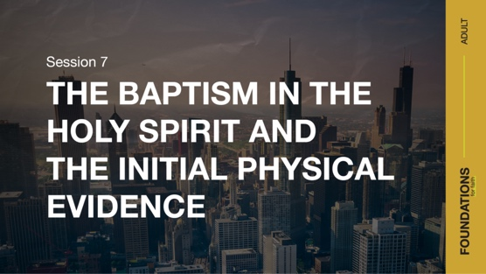
Foundation 7: WE BELIEVE that the baptism in the Holy Spirit is given to believers who ask for it. This experience is distinct from and subsequent to the experience of new birth. Spirit baptism gives believers power to live and serve God and gifts to fulfill the mission of the Church. With the baptism in the Holy Spirit comes experiences such as an overflowing fullness of the Spirit, a deepened reverence for God, an intensified consecration to God and dedication to His work, and a more active love for Christ, for His Word, and for the lost (Luke 24:49; Acts 1:4, 8; 2:4).

Foundation 8: WE BELIEVE that the first sign a believer has been baptized in the Holy Spirit is that he or she has spoken in a language that was not learned and was given by the Holy Spirit (Acts 2:4; 1 Corinthians 12:4–10, 28).¹

When thinking of God, often the Father or Jesus comes to mind. The ideas of God as our Heavenly Father and Jesus as our Savior are fairly easy to grasp concepts. But Scripture tells us that there is a third Person of the Trinity whose activity in our life is just as vital—the Holy Spirit.

In this session, we’ll look at the first account of people being baptized in the Holy Spirit. Jesus told His disciples that it was good that He went away because if He didn’t, the Advocate—the Holy Spirit—would not come (John 16:7). This alone tells us that Jesus considered it vital to our spiritual health to have this work of the Holy Spirit active in our life.

God also saw fit to ensure that we would have proof of Spirit baptism in our life. This initial physical evidence is speaking in tongues. This, too, is validated in several places in the Bible.²

NOTE: Foundations for Faith covers so much important information that you may need to break some sessions into two parts in order to cover all the vital teaching provided.

ENGAGE
Welcome
Take this time to welcome everyone, introduce new group members, learn names, and thank everyone for coming.

Question
What are some ways the Holy Spirit helps Christians?

Introduction
In today’s Bible text, we’ll look at the first time Jesus’ followers were baptized in the Holy Spirit. Jesus promised this incredible gift when He returned to heaven because He knew His followers would need the Holy Spirit’s help to fulfill His mission. After His followers were baptized in the Holy Spirit on a Jewish holiday called Pentecost, their lives were forever changed. This same gift is available for us today.

WHAT WE BELIEVE
Foundation for Faith: The Baptism in the Holy Spirit and the Initial Physical Evidence

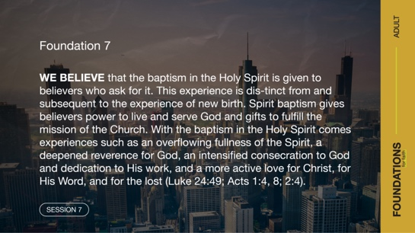
Foundation 7: WE BELIEVE that the baptism in the Holy Spirit is given to believers who ask for it. This experience is distinct from and subsequent to the experience of new birth. Spirit baptism gives believers power to live and serve God and gifts to fulfill the mission of the Church. With the baptism in the Holy Spirit comes experiences such as an overflowing fullness of the Spirit, a deepened reverence for God, an intensified consecration to God and dedication to His work, and a more active love for Christ, for His Word, and for the lost (Luke 24:49; Acts 1:4, 8; 2:4).
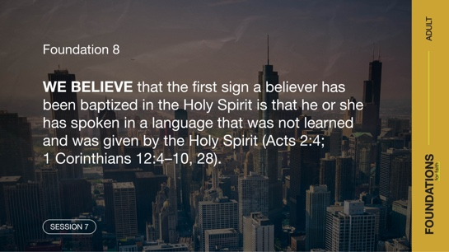

Foundation 8: WE BELIEVE that the first sign a believer has been baptized in the Holy Spirit is that he or she has spoken in a language that was not learned and was given by the Holy Spirit (Acts 2:4; 1 Corinthians 12:4–10, 28).

Watch
To get started, let’s watch this video to focus in on today’s foundational truths about the baptism in the Holy Spirit and the initial physical evidence of that baptism.

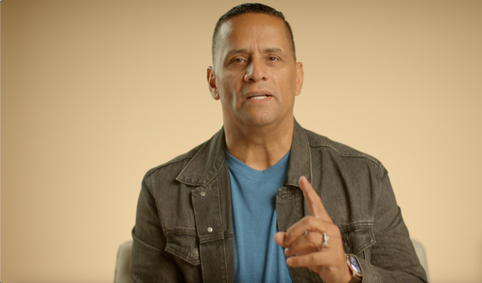

CONSIDER WHAT THE BIBLE SAYS
The Promise of the Baptism in the Holy Spirit

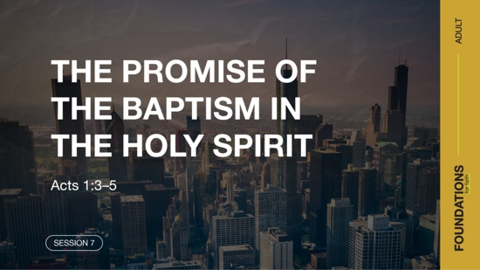

Even though Jesus was fully God, while He lived on earth He chose to limit himself and live as a human (Philippians 2:6–8). So instead of using His own status as God, He relied on the power of the Holy Spirit for everything He did. He chose to depend on the Holy Spirit to set an example for His followers. That included being filled with the Holy Spirit before beginning His ministry (Luke 3:21–22).

So, before Jesus returned to heaven, He gave His disciples an important assignment to go and make more disciples (Matthew 28:19). But Jesus knew that His followers needed the Holy Spirit to fulfill this mission. His followers couldn’t minister as effectively exclusively in their own strength. Let’s look at what He promised to them.

Read Acts 1:3–5.

Jesus made the baptism in the Holy Spirit a priority for His followers. He commanded His disciples to wait in Jerusalem until they had received the Holy Spirit. This waiting literally delayed the spread of the good news about Jesus’ resurrection to the world. At the time when His disciples would be most excited to share what they had witnessed, Jesus told them to wait.

Question
What does Jesus’ instruction to wait in Jerusalem for the baptism in the Holy Spirit say to you about how important He thought it was?

Question
What was your first thought when you heard about the baptism in the Holy Spirit?

The Provision of the Baptism in the Holy Spirit
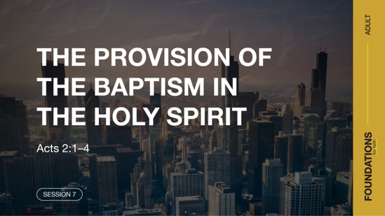

Read Acts 2:1–4.

Imagine what it would have been like to be there for this incredible moment! Jesus’ followers heard the sound of a mighty windstorm. Something like flames appeared over their heads. Then when everyone was filled with the Holy Spirit, they spoke in languages they didn’t know, which we call speaking in tongues. The baptism in the Holy Spirit was worth the wait!

Question
According to Acts 2:4, how many of them were filled with the Holy Spirit?

No one was left out! After waiting together, they all received the gift of the Holy Spirit. Some things about the baptism in the Holy Spirit were unique to that day. In the remainder of Acts, we don’t read about the sound of wind or the flamelike appearance again. The only part of this event that was consistently repeated when others were filled with the Holy Spirit was speaking in tongues (Acts 10:44–46; 19:1–7). In Acts 10:45–46, Scripture even indicates that speaking in tongues was how these early Jewish Christians recognized that the Gentile Christians had received the baptism in the Holy Spirit.

Question
Why do you think God chose to give us proof that someone has been baptized in the Holy Spirit?

Some people are confused when it comes to speaking in tongues. For those seeking Holy Spirit baptism, speaking in tongues is the first physical sign that they’ve received this gift from God. But it’s not our goal. Instead, our goal should be to give God more control of our life and to receive more from Him.

The timing of our baptism in the Holy Spirit is ultimately up to God. Sometimes He baptizes people in the Holy Spirit immediately when they ask. And sometimes people wait to be baptized in the Holy Spirit just like Jesus’ first followers. If that describes you, try not to be so focused on the experience and the evidence of speaking in tongues that you miss the goal—more of God in your life. Keep asking and keep waiting.

While speaking in tongues is the initial, physical sign that someone has received the baptism in the Holy Spirit, that’s not all the Baptism involves. Praying in tongues can become a part of your personal prayer time; it can bring you closer to God and allow the Holy Spirit to guide your prayers.

Question
What may be some personal benefits to the Holy Spirit empowering you to pray in tongues?

The Purpose of Being Baptized in the Holy Spirit

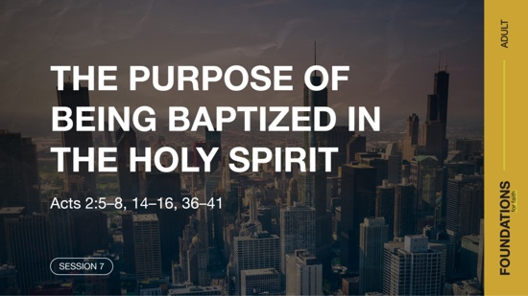

In Acts 1:8, Jesus explained that a primary purpose of the baptism in the Holy Spirit is to empower us. With that power, we can be His witnesses in ways we never could have in our own strength. Let’s look at how this power was given to Jesus’ followers immediately after being baptized in the Holy Spirit.

Read Acts 2:5–8, 14–16, 36–41.

Jesus’ followers were baptized in the Holy Spirit during the Jewish holiday of Pentecost when people from many places were visiting in Jerusalem. Amazingly, they heard these Jewish believers proclaiming the things God had done in their native languages! After that miraculous event, Peter did as Jesus had commanded His followers to do (Matthew 28:19). He shared the good news about Jesus with courage! The result was a message that went straight to the hearts of those who heard it, and about three thousand new followers of Jesus were added that day.

Question

Would someone here quickly share about the change in their boldness to witness after being baptized in the Holy Spirit?

While there isn’t time to get into the details in this session, the baptism in the Holy Spirit opens the door to many other gifts that can be given to serve His Church. One example is the gift of tongues (1 Corinthians 12:4–10, 28). The gift of tongues is the same in essence as speaking in tongues when baptized in the Spirit, but the gift is different in purpose and use. The gift of tongues, when paired with the gift of the interpretation of tongues, is meant to strengthen the whole church (1 Corinthians 14:5). The Holy Spirit also gives believers power to live for God, serve Him, and become more like Jesus.

Question

How could being baptized in the Holy Spirit empower someone in their daily life?

REFLECT
The Results of the Baptism in the Holy Spirit
There is no limit to the number of things the Holy Spirit can do in the life of a believer after a person is baptized in the Holy Spirit. The Bible offers some examples of how being baptized in the Spirit affects our life as a follower of Jesus. Here are a few ways the Holy Spirit enables us to live as witnesses.
- We are filled with power. (Luke 24:49; Acts 1:8)
- We live a life of overflowing fullness of the Spirit. (John 7:37–39)
- We experience a deepened reverence for God. (Acts 2:43; Hebrews 12:28)
- We have an intensified dedication to God and His work. (Acts 2:42; 4:8–10)
- We have a more active love for Jesus, for His Word, and for the lost. (Matthew 28:18–20)
- We can possess a supernatural boldness to share God’s Word. (Acts 4:31)
- We live a life of thanks and deeper concern for others. (Ephesians 5:18–21)
- We minister in the gifts of the Spirit. (1 Corinthians 12:4–11).

LISTEN TO GOD
The goal of Foundations for Faith is not only to better understand God’s Word, but also to pause and listen to what God is saying to us through His Word. Over the next few moments, silently reflect on the following questions.

Personal Reflection Questions

Record your answers to the following questions.

Question
If you’ve not yet been baptized in the Holy Spirit, what is preventing you from seeking this gift?

Question
If you are baptized in the Holy Spirit, how often do you pray in tongues or feel the Spirit’s guidance in your life? Are these areas in your life that God may want to increase?

Question
Who is a Christian you know who may need to hear that Spirit baptism is for them regardless of their faith background?

Activate
Aim to open your life to every aspect of the Holy Spirit. The key is to keep seeking all God has for you. As He does wonderful things in your life, don’t let that lead you to comparing yourself with others. We shouldn’t think any less of those who have not yet been baptized in the Holy Spirit. Even Jesus’ disciples had to wait to be baptized in the Holy Spirit. We also should never think that being baptized in the Holy Spirit makes us better than any other believer. The Holy Spirit simply makes us far better than we would’ve been without Him.

Challenge
Take time this week to seek the Holy Spirit and all that He has for you. If you’re not baptized in the Holy Spirit, ask (again) for God to fill you. If you have been baptized, take time to pray in your prayer language. Allow the Holy Spirit to pray through you for what’s on His heart.

You may also want to read through the “What We Believe” section below and do the devotions in the app. Listen as the Holy Spirit speaks to you and gives guidance and purpose for living.

Prayer Requests
Note any requests from the group, and remember to pray for them during the week.

WHAT WE BELIEVE
Foundation for Faith: The Baptism in the Holy Spirit and the Initial Physical Evidence

Foundation 7: WE BELIEVE that the baptism in the Holy Spirit is given to believers who ask for it. This experience is distinct from and subsequent to the experience of new birth. Spirit baptism gives believers power to live and serve God and gifts to fulfill the mission of the Church. With the baptism in the Holy Spirit comes experiences such as an overflowing fullness of the Spirit, a deepened reverence for God, an intensified consecration to God and dedication to His work, and a more active love for Christ, for His Word, and for the lost (Luke 24:49; Acts 1:4, 8; 2:4).

Foundation 8: WE BELIEVE that the first sign a believer has been baptized in the Holy Spirit is that he or she has spoken in a language that was not learned and was given by the Holy Spirit (Acts 2:4; 1 Corinthians 12:4–10, 28).

The Significance of These Foundations
Embracing the baptism in the Holy Spirit is a major focus of the Pentecostal movement. Jesus felt it necessary to tell His disciples that His going away and giving them the Holy Spirit was good. The Holy Spirit, the third Person of the Trinity, empowers us to do the works of Jesus. We shouldn’t think of the baptism in Holy Spirit as some sort of merit badge or reward. Rather, we should understand how the Holy Spirit enables us to live on earth, as we share the good news of Jesus with a hurting world. Just as the disciples had much to learn about Jesus during His time on earth, we have much to learn about the Holy Spirit.

We should also remember that speaking in tongues is not the destination; rather, tongues are the first sign that we have been baptized in the Holy Spirit. God gave us a sign as security in knowing that we are baptized, and we can now focus on His mission and minister in the power of the Spirit.

Endnotes

To read the full, official version of the Statement of Fundamental Truths, visit ag.org/beliefs/statement-of-fundamental-truths
2 Portions of this session are adapted from Bible Engagement Project Adult Learn © 2021 by The General Council of the Assemblies of God, 1445 N. Boonville Ave., Springfield, Missouri 65802. Used by permission of the publisher.

Day 1—The Promise of the Baptism in the Holy Spirit
Before you begin each devotion, spend some time in prayer—praising God, offering requests, and asking for Him to speak to you through His Word.
Foundation 7: WE BELIEVE that the baptism in the Holy Spirit is given to believers who ask for it. This experience is distinct from and subsequent to the experience of new birth. Spirit baptism gives believers power to live and serve God and gifts to fulfill the mission of the Church. With the baptism in the Holy Spirit comes experiences such as an overflowing fullness of the Spirit, a deepened reverence for God, an intensified consecration to God and dedication to His work, and a more active love for Christ, for His Word, and for the lost (Luke 24:49; Acts 1:4, 8; 2:4).

Foundation 8: WE BELIEVE that the first sign a believer has been baptized in the Holy Spirit is that he or she has spoken in a language that was not learned and was given by the Holy Spirit (Acts 2:4; 1 Corinthians 12:4–10, 28).

Read Acts 1:4–5, 8.

Jesus commanded His disciples to remain in Jerusalem and not begin sharing the gospel widely until they received the Spirit’s baptism. He knew that the baptism in the Holy Spirit would equip them to accomplish the mission He had assigned. As a result, the Spirit gave the disciples boldness to preach about Jesus in spite of overwhelming persecution. For believers today, the baptism in the Holy Spirit provides the same power for witnessing.

LISTEN to God through His Word

Question
What effects did Jesus say the Spirit’s baptism would have on the disciples?

LEARN from God’s Word

Question
Why did Jesus think that the baptism in the Holy Spirit was important?

LIVE God’s Word

Question
How can the Holy Spirit give you power to share the gospel with others?

Day 2—The Provision of the Baptism in the Holy Spirit
Before you begin each devotion, spend some time in prayer—praising God, offering requests, and asking for Him to speak to you through His Word.
Foundation 7: WE BELIEVE that the baptism in the Holy Spirit is given to believers who ask for it. This experience is distinct from and subsequent to the experience of new birth. Spirit baptism gives believers power to live and serve God and gifts to fulfill the mission of the Church. With the baptism in the Holy Spirit comes experiences such as an overflowing fullness of the Spirit, a deepened reverence for God, an intensified consecration to God and dedication to His work, and a more active love for Christ, for His Word, and for the lost (Luke 24:49; Acts 1:4, 8; 2:4).

Foundation 8: WE BELIEVE that the first sign a believer has been baptized in the Holy Spirit is that he or she has spoken in a language that was not learned and was given by the Holy Spirit (Acts 2:4; 1 Corinthians 12:4–10, 28).

Read Acts 2:38–39.

Everyone who believes in Jesus should seek the gift of the baptism in the Holy Spirit. In these verses, Peter made it clear that God’s gift of the Holy Spirit was not limited to Jews, but to people of all races and all generations. God has no favorites. He makes His good gifts available to all His children.

LISTEN to God through His Word

Question
What qualifications does Peter list in Acts 2:38 for someone to receive the baptism in the Holy Spirit?

LEARN from God’s Word

Question
Do you think some people feel as if their background disqualifies them from being baptized in the Holy Spirit? Why or why not?

LIVE God’s Word

Question
What advice would you give someone who is curious about the baptism in the Holy Spirit?

Day 3—The Purpose of the Baptism in the Holy Spirit
Before you begin each devotion, spend some time in prayer—praising God, offering requests, and asking Him to speak to you through His Word.
Foundation 7: WE BELIEVE that the baptism in the Holy Spirit is given to believers who ask for it. This experience is distinct from and subsequent to the experience of new birth. Spirit baptism gives believers power to live and serve God and gifts to fulfill the mission of the Church. With the baptism in the Holy Spirit comes experiences such as an overflowing fullness of the Spirit, a deepened reverence for God, an intensified consecration to God and dedication to His work, and a more active love for Christ, for His Word, and for the lost (Luke 24:49; Acts 1:4, 8; 2:4).

Foundation 8: WE BELIEVE that the first sign a believer has been baptized in the Holy Spirit is that he or she has spoken in a language that was not learned and was given by the Holy Spirit (Acts 2:4; 1 Corinthians 12:4–10, 28).

Read Galatians 5:22–23.

The Holy Spirit not only gives us power to share our faith, but He also helps us to become more like Jesus. These verses are just a few of the qualities the Holy Spirit can help to grow in your life. If you have extra time, look at what God’s Word says about these other ways the Holy Spirit helps us:
- We are filled with power. (Luke 24:49; Acts 1:8)
- We live a life of overflowing fullness of the Spirit. (John 7:37–39)
- We experience a deepened reverence for God. (Acts 2:43; Hebrews 12:28)
- We have an intensified dedication to God and His work. (Acts 2:42; 4:8–10)
- We have a more active love for Jesus, for His Word, and for the lost. (Matthew 28:18–20)
- We can possess a supernatural boldness to share God’s Word. (Acts 4:31)
- We live a life of thanks and deeper concern for others. (Ephesians 5:18–21)
- We minister in the gifts of the Spirit. (1 Corinthians 12:4–11).

LISTEN to God through His Word

Question
Which of these ways the Holy Spirit helps us is easiest for you? Which is the most difficult?

LEARN from God’s Word

Question
How would you summarize why the baptism in the Holy Spirit is so important for believers?

LIVE God’s Word

Question
How has the baptism in the Holy Spirit affected your life?

