
Sanctification

Foundations for Faith Overview
We were never meant to do life alone—especially as followers of Jesus. Disciples grow best in community. Jesus himself modeled this concept by gathering a small group of followers to live and minister alongside Him every day. Even now when believers gather to seek God, relationships are forged, iron-sharpening discussions happen, and genuine accountability can develop.

During the next several sessions, you will journey together through foundational truths—or doctrines—of the Bible. Don’t let the word doctrine put you off. It simply refers to a teaching that comes from Scripture. Our doctrine impacts our decisions more than we might realize. For example, if we have a doctrinal belief that God heals, we are more likely to pray in faith, see Him deliver others from sickness, and experience our own healing. If we don’t believe in healing, we will not expect it or pray for it, and we may even speak out against it. The experiences we have as we follow Jesus largely depend on our doctrine.

The Book of Acts describes a group of Jews in Berea (17:10–15) who, like us, were seeking to better understand Scripture’s most foundational doctrines. After hearing Paul and Silas’s gospel message, they searched the Scriptures every day on their own to verify and fully understand the truth. The result? Many people believed the good news of Jesus and were changed for eternity. As you study Scripture and discuss doctrine together, may the Holy Spirit do the same for you.

SESSION OVERVIEW
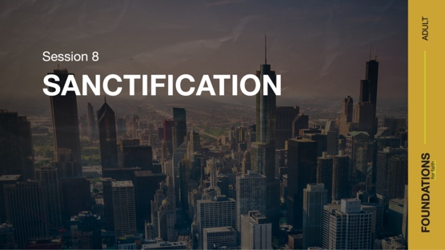

Foundation 9: WE BELIEVE in the sanctifying work of Jesus at salvation to dedicate us to God and the power of the Holy Spirit by whose indwelling the Christian is enabled to live a holy life (Romans 12:1–2; Galatians 5:16–25; 1 Peter 1:15–16).¹

The word sanctification can be an intimidating one for sure. So this session will help to define it in a way that your group can handle. Let’s look at a more technical definition first. Sanctification initially occurs at salvation and is a positional declaration that a believer is holy, and it is a progressive, lifelong process of separating from evil, as believers continually draw closer to God and become more Christlike. A simple way of saying it would be to use the word separation—separation from sin and separation to God. It’s in sanctification that we become more like Jesus.

We experience sanctification throughout our life as we follow Jesus. The Bible is an important tool in this journey. Every verse, story, example, and parable guides our sanctification. Through the Scriptures we listen, learn, and live as closer followers of Jesus. The longer we serve Jesus, the more our sanctification should increase. It’s not a one-time event, rather a progressive work in our life.

NOTE: Foundations for Faith covers so much important information that you may need to break some sessions into two parts in order to cover all the vital teaching provided.

ENGAGE
Welcome
Take this time to welcome everyone, introduce new group members, learn names, and thank everyone for coming.

Question

Who is the holiest person you’ve ever known? What makes you think of that person as “holy”?

Introduction
People sometimes feel intimidated when we talk about sanctification. After all, who among us can claim to have reached the level of holiness that God expects of us—or that we might expect of ourself? Sanctification does not mean we are perfect. Instead, it calls for a lifetime of growth toward being more like Jesus. Another way to explain what it means for us is to separate from unholiness. The idea of sanctification is to do all we can, with the help of the Holy Spirit (2 Corinthians 3:18), to live righteously for our holy Lord.

WHAT WE BELIEVE
Foundation for Faith: Sanctification
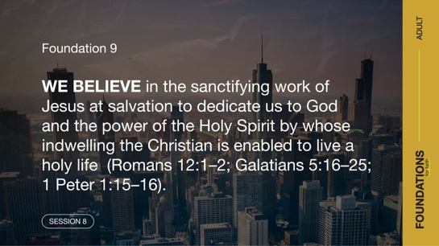
Foundation 9: WE BELIEVE in the sanctifying work of Jesus at salvation to dedicate us to God and the power of the Holy Spirit by whose indwelling the Christian is enabled to live a holy life (Romans 12:1–2; Galatians 5:16–25; 1 Peter 1:15–16).

Question
Why do you think sanctification is so challenging for Christians?

Because part of sanctification is an ongoing work, we never arrive at a point of perfection in this life. We should always be doing our best to become more like Jesus, but we don’t need to make that effort on our own. As with every other part of the believer’s life, the Holy Spirit works in us to bring us into the holiness God wants for us.

Watch
Let’s watch this video to focus in on today’s foundational truth.

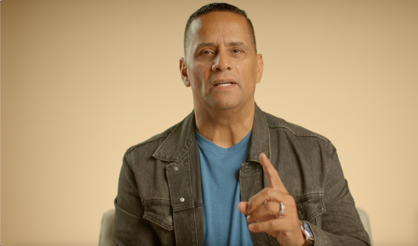

CONSIDER WHAT THE BIBLE SAYS
Before getting into our discussion on sanctification, let’s define a few terms connected to salvation that often get confused. These definitions will help us better understand what Jesus does, did, and is doing in our life.
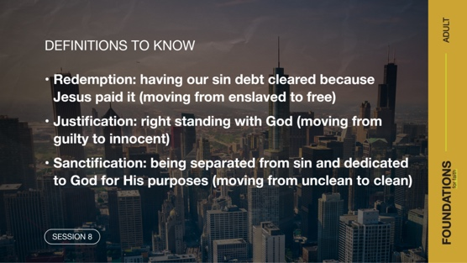
- Redemption: having our sin debt cleared because
Jesus paid it (moving from enslaved to free)
- Justification: right standing with God (moving from guilty to innocent)
- Sanctification: being separated from sin and to God for His purposes (moving from unclean to clean)

In 1 Corinthians 6:11, Paul connected all of these when he wrote, “Some of you were once like that. But you were cleansed [redeemed]; you were made holy [sanctified]; you were made right [justified] with God by calling on the name of the Lord Jesus Christ and by the Spirit of our God.” This verse shows us how God, Jesus, and the Holy Spirit brought about change in our life. We were cleansed, or forgiven; made holy, or sanctified; and made right, or justified.

While our redemption and justification are received at salvation, sanctification is both a salvation event as well as a process that continues for the rest of the believer’s life. It’s through sanctification that we are separated from sin and set apart for God. Salvation is just the first step as we become more and more separated from sin and more like Jesus.

There’s a Battle Going On
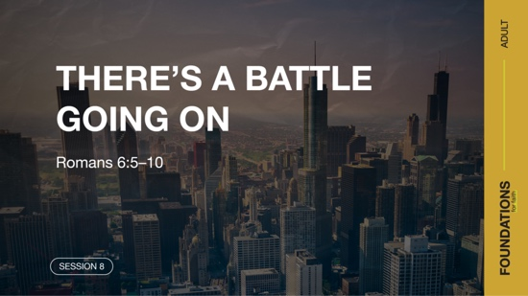

Read Romans 6:5–10.

Though we are born again and even have the Holy Spirit in us, there’s still a battle going on. Before we trusted in Jesus, we didn’t concern ourself with this battle. Most of us continued to sin and thought little of the consequences or of how God viewed our sin. Something changed in us when we placed our trust in Jesus. We no longer viewed God or sin the same way. Yet, we find ourself still struggling with sin today.

Here's the good news! The fact that you are in a struggle indicates the Holy Spirit is at work in your life. You’re walking through this process of sanctification. You’re in the process of moving from unclean to clean.

Question
What do you think it means to be united with Christ in His death?

Question
How does our being crucified with Christ bring about the process of sanctification in our life?

Sanctification calls us to live out what Christ did in our life. As He gave His life through death, we give our life by committing it to Him. None of us can, through our own willpower, live in a way that pleases God. However, through daily living the truths of Scripture as the Holy Spirit helps us, we become more like Jesus and live holy just as He is holy.

Question
Since we are no longer slaves to sin (verse 6), does this mean we won’t ever sin again? Explain.

Question
How has the Holy Spirit helped you in your struggle with sin?

The Struggle with Sin
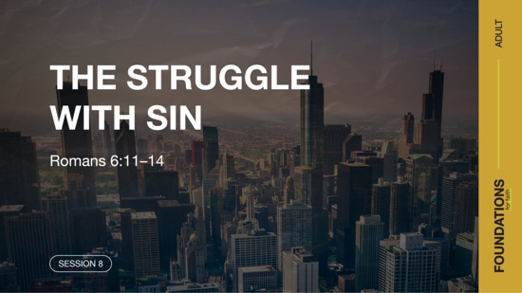

Read Romans 6:11–14.

Paul addressed our struggle with sin. In a commanding tone, he urged us to not let sin control the way we live. In other words, even though we still sin, we don’t let it control how we live. This is the tension we live in, as we move forward in our sanctification. We are growing in our ability to defeat sin, but occasionally sin does win a battle. Yet we must not allow our sin to control us.

We are in a spiritual battle. Our sin nature wars against our spirit and our desire to stand clean before God. Each day, as we obey and yield ourself to the process of sanctification, we can claim a victory. With each victory we grow closer to being holy. It’s a lifetime process, only complete when we enter heaven for eternity.

Question
Why do you think committed followers of Jesus continue to struggle with sin?

Question
What’s your response when sin wins a battle in your life?

The word instrument can also be rendered as weapon. It wouldn’t be wrong to read verse 13 again using the word weapon in place of instrument. Don’t let the weapon of sin destroy you or your relationship with God.

Question
How does reading the verse with the word weapon change your attitude about this struggle?

The Work of the Holy Spirit
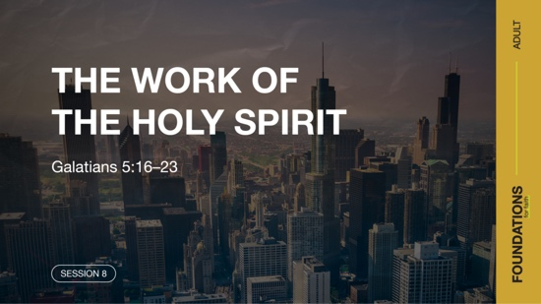

Read Galatians 5:16–23.

There are no shortcuts to living a sanctified life. Each day is an opportunity to allow the Holy Spirit to work further in us. This is more than having daily devotions. It is actively listening to, learning from, and living for God. In the part of his letter to the churches of Galatia that you just read, Paul described the two forces at work in each of us: the Holy Spirit and our own sinful nature. Sanctification requires letting go of our sinful nature and letting the Holy Spirit replace it with the image of Jesus.

Question
What’s the outcome of allowing the Holy Spirit to guide our life?

Question
Do you ever feel like these two forces are battling in your life? Explain.

Question
Have you ever become frustrated with your struggle to live a sanctified life? What did you do?

Following Paul’s challenge to Christ-followers to be led by the Holy Spirit, he gave examples of the behaviors produced by the two forces he described earlier. Following our sinful nature produces very different things than being guided by the Holy Spirit. As we grow in sanctification, the fruit of the Spirit should naturally be produced and widen the gap between us and our sinful desires. Also, the good news is that it’s not us that produces this fruit. It’s the Holy Spirit who produces it in our life. Our part in the process is resisting sin as He enables and being open to His work in our life.

Question
What aspect of the fruit of the Spirit do you feel you most need to grow in?

Question
What effect does it have on your life to know the Spirit of God is at work in your life?

Victory over Our Sin
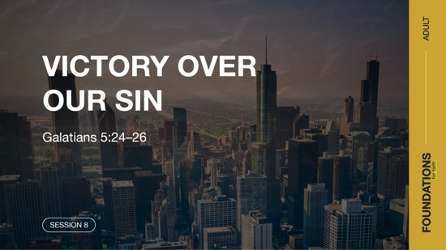

Read Galatians 5:24–26.

Paul finished this portion of Scripture with a challenge to us. We are to crucify our sinful desires and passions. Because our passions are crucified on a cross, they no longer live. Sanctification implies a death to our desire to sin in order to bring us new life. Our desire for sin has been replaced with a passion for Jesus and His work. As we grow in our faith regarding what Jesus has done for us, we are less likely to return to our sinful desires.

Question
What do you think it means to crucify your passions on the cross?

Question

How do we follow the Spirit’s leading in every part of our life?

Question
What are some godly passions you didn’t care about before but do now?

We are all in different places on our sanctification journey with Jesus. One person may be a new follower, and others may have walked with Jesus for years. It would be easy to compare our walk with someone else’s. This only leads to discouragement, and some may give up on their progress. It is important that we motivate others toward acts of love and good works (Hebrews 10:24).

REFLECT
Growing in Sanctification
God desires a vibrant, growing relationship with each of us. It’s been said that if we’re not growing, we’re dying. Maybe it could also be said that if we aren’t changing, we aren’t growing. Growth demands change. Change includes allowing the Holy Spirit to transform us to be more like Jesus, but we must also do our part.

As we read the Bible and set aside time for prayer, worship, and fellowship, we are challenged to change and grow. The foundation of sanctification involves continually surrendering our life to Jesus and becoming more like Him. We can’t do this on our own. We need the Spirit of God freely operating in our daily life to continue our sanctification.

LISTEN TO GOD
The goal of Foundations for Faith is not only to better understand God’s Word, but also to pause and listen to what God is saying to us about His Word. Over the next few moments, silently reflect on the following questions.

Personal Reflection Questions

Record your answers to the following questions.

Question
What sinful desire(s) in your life do you struggle to overcome?

Question
What truth (or truths) from today’s discussion helps you believe you can overcome sin? Explain.

Activate

Sanctification is not about memorizing and following a list of rules. Instead, we’re called to the adventure of developing a personal relationship with our Savior. This includes spending time in God’s presence. As we open God’s Word, listen to what the Spirit of God is speaking to us and obey, we begin to take on more characteristics of Christ.

Challenge
Take time this week to carefully read through the verses on sanctification in the “What We Believe” section and do the personal devotions on the app. This will add insight for this foundational truth. Listen to God’s Word as the Spirit speaks to you and gives you instruction and purpose for living.

Prayer Requests
Note any requests from the group and remember to pray for them during the week.

WHAT WE BELIEVE
Foundation for Faith: Sanctification
Foundation 9: WE BELIEVE in the sanctifying work of Jesus at salvation to dedicate us to God and the power of the Holy Spirit by whose indwelling the Christian is enabled to live a holy life (Romans 12:1–2; Galatians 5:16–25; 1 Peter 1:15–16).

Sanctification is all about being set apart to and for sacred purposes. Thus, sanctification is not solely the idea of being separated from something. It also implies being separated to something. Only by the power of the Holy Spirit can we live the holy life God desires (1 Peter 1:15–16).

The Significance of This Foundation
Sanctification is the process of disconnecting from a sinful lifestyle and turning to God with all our heart, soul, mind, and strength (Mark 12:30). Without understanding this process, we attempt to live as followers of Jesus in our own strength. But we can’t live in holiness on our own. Nor does God desire that we attempt to do so. He gave us His Holy Spirit to help us overcome sin and the power to fulfill our purpose. As we grow in our holiness, we begin to take on the image of Jesus in our speech, attitudes, and lifestyle.

Sanctification is realized in the believer by identifying with Christ in His death and resurrection and by continually offering every aspect of our life to the power of the Holy Spirit. Sanctification then produces a changed life that is different from the world. Because of Jesus’ love and His giving His life for us, we can live set apart (Galatians 2:20). As we work to display our salvation, God is also working in us. He gives us the desire and power to live in a way that pleases Him (Philippians 2:12–13).

Endnote

To read the full, official version of the Statement of Fundamental Truths, visit ag.org/beliefs/statement-of-fundamental-truths

Day 1—The Struggle with Sin
Before you begin each devotion, spend some time in prayer—praising God, offering requests, and asking for Him to speak to you through His Word.
Foundation 9: WE BELIEVE in the sanctifying work of Jesus at salvation to dedicate us to God and the power of the Holy Spirit by whose indwelling the Christian is enabled to live a holy life (Romans 12:1–2; Galatians 5:16–25; 1 Peter 1:15–16).

Read Romans 6:11–14.

Sanctification happens instantly when a Christian accepts Jesus, but it also happens over a lifelong journey as Christians become more like Him each day. Paul’s teaching on sanctification represents the real-life experiences of every believer. Sin is no longer a Christian’s master, yet the temptation to sin remains a constant threat. Believers are set free from slavery to sin and face a choice: return to their sin or enjoy their newfound freedom from sin in Christ.

LISTEN to God through His Word

Question
What does it mean to be “dead to the power of sin”?

LEARN from God’s Word

Question
How has Jesus Christ made you alive to God?

LIVE God’s Word

Question
What does it look like to give yourself completely to God?

Day 2— The Work of the Holy Spirit
Before you begin each devotion, spend some time in prayer—praising God, offering requests, and asking for Him to speak to you through His Word.

Foundation 9: WE BELIEVE in the sanctifying work of Jesus at salvation to dedicate us to God and the power of the Holy Spirit by whose indwelling the Christian is enabled to live a holy life (Romans 12:1–2; Galatians 5:16–25; 1 Peter 1:15–16).

Read Galatians 5:16–23.

Paul described a war within a Christian. The sinful nature within every human pushes them toward evil. Pushing the other direction is the Holy Spirit, who lives inside every believer. The direction a person goes will determine the fruit produced in his or her life. Being guided by the sinful nature produces the types of things listed in verses 19–20. But those guided by the Holy Spirit along the journey of sanctification allow the Holy Spirit to produce the fruit of the Spirit instead (verses 22–23).

LISTEN to God through His Word

Question
Describe the differences between the products of the sinful nature and those of the Spirit.

LEARN from God’s Word

Question
How can we ensure that the Holy Spirit’s desires gain victory over our sinful desires?

LIVE God’s Word

Question
What evidence of sanctification do you see in your life?

Day 3— Victory over Our Sin
Before you begin each devotion, spend some time in prayer—praising God, offering requests, and asking for Him to speak to you through His Word.
Foundation 9: WE BELIEVE in the sanctifying work of Jesus at salvation to dedicate us to God and the power of the Holy Spirit by whose indwelling the Christian is enabled to live a holy life (Romans 12:1–2; Galatians 5:16–25; 1 Peter 1:15–16).

Read Galatians 5:24–26.

As believers, our sinful nature must be put to death. Its death allows new life in Christ to flourish as we become more and more set apart for God’s purposes. Our new life in Christ should affect every aspect of life. Being a Christian isn’t about our behavior in church alone, but also at work, school, with family, and even when alone. The Spirit wants to lead every part of our life. As we follow Him, we grow in sanctification and become more like Jesus.

LISTEN to God through His Word

Question
What does it mean to live by the Spirit?

LEARN from God’s Word

Question
How can we put to death our sinful nature?

LIVE God’s Word

Question
In what areas of your life do you need to follow the Spirit’s leading more closely?

