

LEADER OVERVIEW
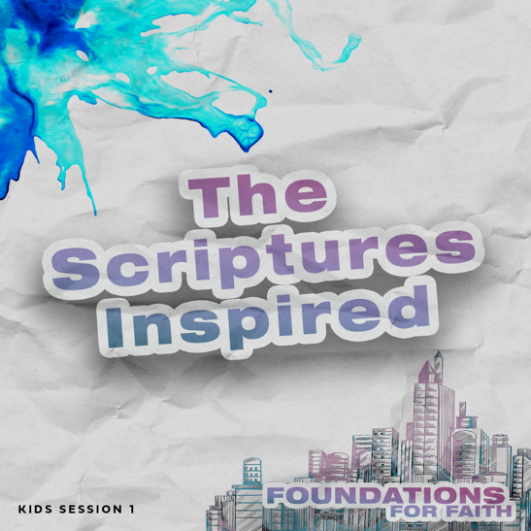
Foundations for Faith is designed to teach kids what we believe and why. These sessions cover core teachings—
or doctrines—that come from the Bible. Today’s session
focuses on:

Foundation 1: The Bible is God’s Word and His plan for me. God gave people the words to write so we can know Him. The Bible is completely true and is the final authority on what we should believe and how we should live.

In this session, kids will discover that the Bible is God’s message for each of us. God inspired more than forty writers to communicate His message, and every word is true. The Bible shares that God’s plan for our life is knowing and obeying Him.

Bible Lesson | Faith Fact
God Gives the Ten Commandments  Exodus 19:1–8; 20:1–4; 32:15–16 | We believe that . . .  The Bible is God’s Word and His plan for me.
Faith Verse
Your word is a lamp to guide my feet and a light for my path.
Psalm 119:105 (NLT)

First time leading Foundations for Faith Kids?
Passing on what we believe to kids is important, so pray and invite God to guide you as you prepare and present this session. Then read through the session and consider how to best present it to the kids you lead. Always start with the Large Group teaching. Then add extra Small Group Activities if you have time. Some of the activities are designed for older or younger students, so consider which ones will best fit your group.

To find out more about all the resources available to help you lead and promote Foundations for Faith Kids, check out the Foundations for Faith Kids Overview.

PREPARING FOR THE SESSION
You Will Need | Getting Ready
Large Group  - Bible  - Scissors  - Flashlight  - Worship songs (Song options: “Too Good to Not Believe” Lyrics Video by Cody Carnes, Brandon Lake; “Prize” Lyrics Video by The Belonging Co; “This I Believe (The Creed)” Lyrics Video by Hillsong Kids  - For groups not using a phone or tablet only, add:  - Projector or TV  - Laptop  - Foundations for Faith Countdown Video  - Faith Fact Slide  - Bible Lesson Video  - Teaching Point Slides 1–3  - Pages to Print:  - Game Page  Small Group Activities  - Ball  - Bible  - Flashlights, two per group  - Bibles, one per team  - Pencils or pens, one per kid  - Scissors, one per kid  - Glue sticks, one per two kids  - Crayons or markers  - Faith Verse Slide  - Pages to Print:  - Faith Fact Fun Pages  - Faith Verse Journal Page  - 4 Questions Pages  - Activity Page A and/or B | Large Group  - Download videos and slides if needed.  - Select worship song(s) and have them ready to play.  - Print the Game Page and cut apart slips, enough for one slip per kid.  Small Group Activities  - Print the Faith Fact Fun Pages, one set per kid plus an extra for sample.  - Download the “Books of the Bible” song from JumpStart3.  - Optional: Make a sample Books of the Bible Craft to show the group.  - Print the Faith Verse Journal Page, one per kid.  - Print and cut apart the 4 Questions Pages, one set per group. Keep questions and answers separate.  - Choose how to use this activity: Simple matching, Concentration-style find the pairs, etc.  - Print copies of Activity Page A and/or Activity Page B, one per kid.

LARGE GROUP (45 Minutes)

INTRODUCTION

Countdown Video
- Play the Foundations for Faith Countdown Video. Encourage kids to say the Faith Facts with the video.
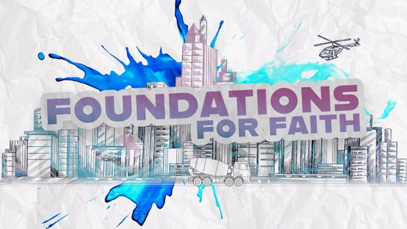

Welcome
Welcome, everyone! It’s great to see you today. I hope what we talk about today will inspire you to live for God like never before! We’ll look at what God wants us to know and believe about Him, His plan for us, and the future of the world. I’m so excited! We’ll have fun and learn a lot. Most of all, you’ll build a foundation for your faith based on God’s Word, the Bible.

Today, we’ll find out more about the Bible and how we can know for sure that it’s from God. (Hold up the Bible.) Did you know some people don’t believe the Bible is true? Raise your hand if you know someone like that. (Group response)

Faith Fact

God gave us the Bible to show us what to believe and how to live. We believe that . . . The Bible is God’s Word and His plan for me. That’s our Faith Fact. Can anyone guess what image represents today’s Faith Fact? (Allow responses.) It’s the Bible, of course!
- Show the Faith Fact Slide.
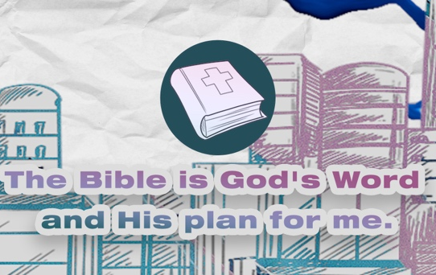

Let’s say today’s Faith Fact again. I’ll start the Faith Fact by saying, “We believe that . . .” That’s your cue to finish the phrase with me. Let’s try it. We believe that . . . The Bible is God’s Word and His plan for me. Great! This time let’s add some actions. When you say, “God’s Word,” hold your hands in front of you like an open book (demonstrate). Then when you say, “His plan for me,” place your hands over your heart (demonstrate). Ready? We believe that . . . The Bible is God’s Word and His plan for me. Let’s say that one more time. We believe that . . . The Bible is God’s Word and His plan for me. I think we’re ready to jump into today’s session.

GAME | Telephone
You Will Need | Getting Ready
- Scissors  - Game Page, enough for one slip per kid | - Print the Game Page and cut apart slips, enough for one slip per kid.

Can anyone guess how many people wrote all the books in the Bible? (Allow responses.) God used about forty people to write the Bible! They were regular people like you and me, but God gave each of them exactly what He wanted us to know. Everything they wrote points to God and His plan for us. There’s no way a group of people who mostly didn’t talk together or copy each other could do that. Let’s play a game to show how we can know these people didn’t just write on their own. God inspired them.
- If you have a large group, you can divide the group into teams for this activity.

We’ll play Telephone. I’ll whisper a sentence to the first person. Then, that person will whisper it to the next person and so on until we get to the very last person. Wave your hand, (name of last kid). (Pause while the kid waves.) Let’s see if my message makes it all the way through correctly.
- Whisper to the first kid: All Scripture is inspired by God and is useful to teach us what is true.
- Wait until everyone has passed on the message.

Now, let’s see what happened to my message as you passed it on.
- Call on the last kid to repeat the message.
- If the last kid got the message right, play again with a more difficult message.

Wow! We had a hard time passing on just one sentence. I think it’s because the message had to be repeated by so many people. I’m glad God didn’t only expect people to pass on what they knew about Him by talking to other people. Instead, God gave His message to each writer. That means He inspired them. Then, they wrote down God’s truth for us. Let’s try this game again in a different way to show you the difference God as author of the Bible makes.
- Hand out a slip from the Game Page directly to each kid.
- Optional: Whisper to each kid individually: “The Bible is God’s Word and His plan for me.”

Now, when I say, “Go,” I want everyone to shout at the same time the message you got. Ready? Go! (Group response) That was great! Give yourselves a hand. (Pause for clapping.) Everybody got the message right that time. Why is that? (Allow responses.) You all got the same message from one person—me! That’s a lot like God’s Word. All the Bible writers got their message directly from God. That’s the only way all the words written by so many people over hundreds of years could work together to share God’s message. That’s why We believe that . . . The Bible is God’s Word and His plan for me. I’m glad God chose to give His message to you and me in the Bible.

WORSHIP

God gave us the Bible, so we could get to know Him better. Thinking about how wise He is really makes me want to worship Him. Who is ready to worship God with me today? (Group response) Let’s worship Him right now!
- Lead the kids in singing one or two praise songs. See options at the beginning of the session.

Prayer
What an incredible time of worshipping together! When we sing about God, His truth sticks in our mind and heart. Let’s pray and ask God to show us even more truth from His Word.

Dear God, we love to worship You. Please get our heart and mind ready to learn more about You and Your Word now. Thank You for the truth You have given us in the Bible. Help us to read it, learn it, and live it every day. Amen.

BIBLE LESSON | God Gives the Ten Commandments
You Will Need | Getting Ready
- Bible  - Flashlight  - Teaching Point Slides 1–3 | - Download the Teaching Point Slides 1–3.

Today, we’ll look at what the Bible says to discover more about why We believe that . . . The Bible is God’s Word and His plan for me. To get us started, let’s watch this video.

Video Introduction
- Play the Bible Lesson Video.

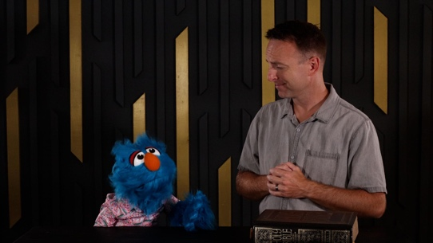

That video really set us up for our Bible lesson today! Jeremy had a lot to say about God’s Word—how it’s inspired and infallible. But I sure hope you didn’t let Hank confuse you! It’s amazing how God can show us His plan for our life through His Word. Let’s look at how God did that for Moses and the Israelites.

Teaching Time
Have you ever received a letter or card in the mail addressed just to you? (Group response) Did you know the Bible is sort of like that? It’s like a lot of letters that God had other people write down just for us. Let’s go back thousands of years ago to find out more.

God’s people, the Israelites, were slaves in the country of Egypt. They were treated terribly, and they couldn’t escape. Then, God sent a man named Moses to help the Israelites get out of Egypt. They started traveling to the special land God had promised to give them. Because the Israelites were God’s people, they needed to learn how to live the way God wanted them to. God sent them a special message to share His plan for them. Let’s read God’s Word to find out what happened. Turn to Exodus 19:1–8.
- Keep Large Group time moving along by having an adult read the verses aloud.

God wants to connect with His people.
- Show the Teaching Point 1 Slide.
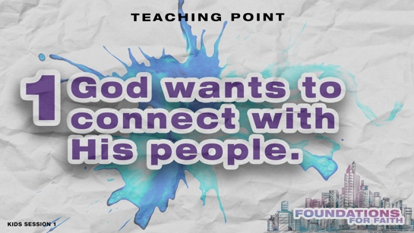

- Read Exodus 19:1–8.

Wow! God truly wanted to connect with His people. Just think about how God delivered the Israelites from Egypt. They had seen Him part the sea so they could walk through on dry ground. Now, God wanted them to be His treasure among all the people on earth. How would you respond to that? (Group response) I’d shout yes! That was their answer, too. They promised to obey God and His Word.

Here’s the incredible part! God told Moses to get everyone ready because He would do something amazing in three days. The third morning started with what seemed like a big storm. Can you make the sound of thunder by tapping your feet on the floor? (Group response) Now, let’s add three loud claps of lightning. (Group response) Excellent! Then, a big cloud came down, and there was a loud blast from a trumpet (demonstrate). Can you make a super loud trumpet sound? (Group response) Okay. I think it’s starting to feel like we’re right there with them.

A few days later, Moses led everyone to a special mountain. They were going there to be in God’s presence! The mountain shook because God was there. Then, Moses spoke. God answered, and His voice sounded like thunder. Tap your feet on the floor again a few times. (Group response) Wow! What one word describes how the Israelites were probably feeling in that moment? (Allow responses.) I think I would have felt _______.

They were in the presence of the one and only, all-powerful God. He didn’t do all of this to scare them. God wanted to let them know that He could be close to them, so, He connected with them and gave them His special message. Let’s find out what God said.

2. God’s Word gives His plan for us.
- Show the Teaching Point 2 Slide.
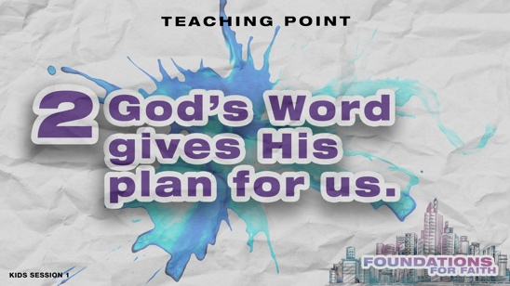

- Read Exodus 20:1–4.

We just read some of what God said that day thousands of years ago while Moses was on the mountain. Isn’t it incredible that the Bible tells us that? (Group response) We read just a small part of God’s instructions. Can any of you can tell me how many specific rules God gave to Moses that day? If you think you know, show me by holding up that many fingers. Ready? Go! (Group response)

Ten is the right answer! Does anyone know what we call these ten rules? (Group response) The Ten Commandments not only helped the Israelites know how to live for God, but they can help you and me know how to live for God, too. If you had been there with Moses, do you think you could remember everything God said to you and never forget it? (Group response) I know I couldn’t! I think God knew that too because He had the perfect solution.

3. God’s Word shows us the best way to live.
- Show the Teaching Point 3 Slide.
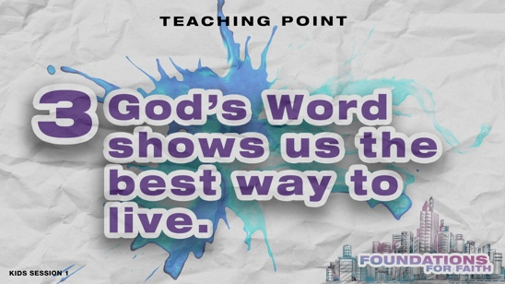

- Read Exodus 32:15–16.

God wanted His people to remember His words of instruction, so what did He do? (Group response) He made sure His words were written down. God gave these rules to live by on stone tablets so they could be remembered forever. We know what those words were because people wrote them down for us. God inspired Moses and around forty others to write His message to us in the Bible. We don’t have to wonder how God wants us to live. We just need to read His Word and live how it tells us to. That’s why We believe that . . . The Bible is God’s Word and His plan for me.

OBJECT LESSON | Flashlight
You Will Need | Getting Ready
- Bible  - Flashlight | No prep is needed for this activity.

God’s Word is so powerful! Psalm 119:105 tells us that it’s like a lamp that guides our feet and a light that shows God’s path for us.
- Turn on the flashlight and place it in your open Bible. Then close the Bible pages around it.
- Dim the lights in the room.

This verse reminds us that God wants His Word to shine brightly in our life. Let’s take time to talk to God and to listen for Him to speak to us about that.

PRAYER AND RESPONSE
You Will Need | Getting Ready
- Bible with flashlight inside | No prep is needed for this activity.

- Consider playing a worship song softly in the background while kids pray.

When we hear and read God’s Word, we should respond. Today, we talked about why We believe that . . . The Bible is God’s Word and His plan for me. Let’s reflect on that. I want you to close your eyes and quietly talk to God.
- Pause after each direction to give kids time to respond in prayer.

Begin by giving God thanks for the Bible. Ask God to guide you as you read His Word. Tell Him that you want to read it, memorize it, and follow it.
- Hold up the Bible with the flashlight inside.

Now, let’s listen to God. He may want to show you if you need to follow Him more closely in some way. Listen for the Holy Spirit to speak to your mind and heart. After a few minutes, I’ll close in prayer.
- Pause to allow the Holy Spirit to speak to kids. Then, close in prayer.
Dear God, thank You for loving us and wanting to be close to us. We want to hear Your voice and follow You with our whole heart. We love You. Amen.

When we listen to God like this, we should expect Him to talk to us. Sometimes He will speak to us, but not always. How many of you felt like you heard God say something to you? (Group response)
- Optional: Have kids tell an adult what God said to them. You may want to share what kids heard from God when appropriate. For example, someone may hear God say, “Be nicer to your mom; she loves you.” After sharing that out loud, other kids may realize God is speaking to them, too.

God wants to speak to us when we pray and when we read His Word. I’ve loved learning more about God and the Bible with you. We believe that . . . The Bible is God’s Word and His plan for me. I hope you believe that, too.

Optional: Salvation Prayer
If kids don’t know Jesus as their Savior, consider sharing about salvation. See the Salvation Guide.

DISMISSAL
Got more time? Choose one or more Small Group Activities to reinforce what kids are learning.

The Bible is God’s Word, and it’s filled with God’s messages for us today! No matter how much we read it, study it, and memorize it, there’s always something new to learn about God and His plans for us.

Faith Fact Recap
- Show the Faith Fact Slide.

I’ve had a lot of fun learning about God’s Word with you today. One truth we need to remember always is our Faith Fact. We believe that . . . The Bible is God’s Word and His plan for me. I’m so glad you came today! I can’t wait to see you next time.
- Send home the Activity Page(s) and Journal Page, if used.
- Tell everyone the date and time for the next session.
- Remind parents that there are Family Devotions available on the app.

SMALL GROUP ACTIVITIES

Choose one or more of these activities to extend kids’ learning as time allows. All activities are led by a small group leader.

GROUP CONNECTION | Talk about It
You Will Need | Getting Ready
- Bible  - Ball | No prep is needed for this activity.

We’ve talked about how We believe that . . . The Bible is God’s Word and His plan for me. God sharing His instructions with Moses and the Israelites is a great example of how much He wants to connect with you and me. He wants to make sure we get His message and His plan for our life.
- Have the kids sit on the floor in a circle.

(Hold up the Bible.) Let’s talk more about God’s Word, the Bible. Think about your answer to each of these questions. Then, choose one to share with the group.
- What was your favorite part of the Bible story we read today?
- What is your favorite Bible story?
- If God were still writing the Bible today, would you want a story from your life to be included? Why or why not?

I’ll go first and answer one question. Then, I’ll roll the ball to someone to answer next. We’ll roll the ball until everyone has had a time to share. (Answer a question and then roll the ball.)

Prayer Time

Let’s pray together now. Who has a prayer need that you’d like the group to pray for?
- Have kids share and pray for each other’s prayer requests.
- Keep track of kids’ prayer requests and review them each time you meet.

Today, we’ve talked a lot about how We believe that . . . The Bible is God’s Word and His plan for me. So, I’d like us to pray a special prayer about that. (Place the Bible in the center of the group.) Everyone, reach out and touch the Bible with me.
- Have kids repeat this prayer after you.

Dear God, thank You for Your Word. I am grateful for this gift to me. I will read Your Word. I will trust Your Word. I will obey Your Word. I will treasure Your Word. I want You to guide me through Your Word. Please let the Bible help me find the right path through the maze of life. I want to live for You my whole life. Amen.

GAME | Flashlight Relay
You Will Need | Getting Ready
- Flashlights, one per team  - Bibles, one per team | No prep is needed for this activity.

Today we’ve talked about a very important foundation for our faith. We believe that . . . The Bible is God’s Word and His plan for me. The Bible can show us God’s plan for us. God compares it to a light for our path.
- Stand up the Bible at the end of the relay area.

Let’s play Flashlight Relay. We’ll divide into two teams. Each team will get a flashlight. The goal is to keep your team’s light shining on the Bible the entire time. When it’s your turn, you’ll shine the light on the Bible until you get close enough to touch it with your hand. Then here’s the tricky part. You have to keep your team’s light on the Bible as you walk backward all the way back to your team. Then carefully hand the flashlight to the next person while still keeping it shining on the Bible. Do you think you can do that? (Group response) Let’s play.
- Coach the kids through a practice run. Then play the game.

That was a challenging game! Always remember that no matter what decision you are facing, God’s Word can show you how to live. That’s why We believe that . . . The Bible is God’s Word and His plan for me.

FAITH FACT ACTIVITY | Books of the Bible Craft and Song
You Will Need | Getting Ready
- Scissors  - Glue sticks  - Faith Fact Fun Pages, one set per kid plus an extra for sample | - Print the Faith Fact Fun Pages, one set per kid plus an extra for sample.  - Download the “Books of the Bible” song from JumpStart3.  - Optional: Make a sample Books of the Bible craft to show the group.
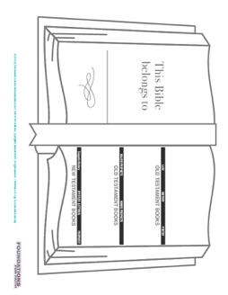

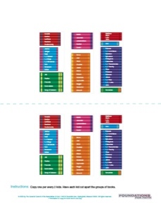
Guess how many books there are in the Bible? (Group response) There are sixty-six books in all. Let’s look more closely at how the Bible is put together.
- Hand out a copy of the Faith Fact Fun Pages, scissors, and a glue stick to each kid.

You can see that the Bible is divided into two parts or Testaments. What are they? (Allow responses.) The Old Testament starts with God’s creation of the world and everything in it. Does anyone know what big event the New Testament starts with? (Allow responses.) That’s right, Jesus’ birth!

Now, look at the extra page with the books of the Bible grouped together. Cut them out and glue them in the correct order. As we work, let’s listen to the “Books of the Bible” song and sing along together. Let’s see if we can learn the names of all the books in the whole Bible.
- Sing the “Books of the Bible” song together as kids work on the craft.

FAITH VERSE JOURNAL
You Will Need | Getting Ready
- Pencils or pens, one per kid  - Faith Verse Journal Page, one per kid  - Faith Verse Slide | - Print copies of the Faith Verse Journal Page, one per kid.

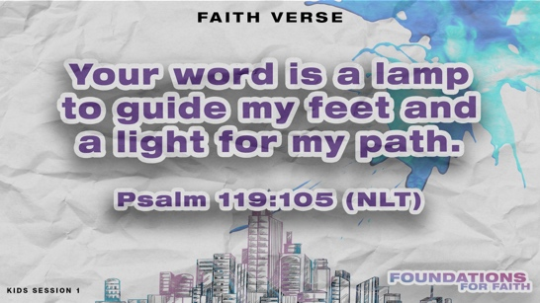
- Optional: Show the Faith Verse Slide.

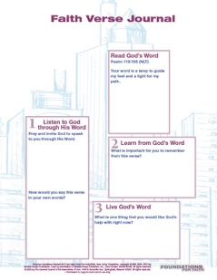
God’s Word is so powerful! Psalm 119:105 tells us:
Your word is a lamp to guide my feet and a light for my path.
Psalm 119:105 (NLT)

God wants to speak to us through His Word. Let’s look at today’s Faith Verse and see what He might want to say to us through it.
- Hand out the Faith Verse Journal Page and pencils. Guide kids through the activity.

4 FAITH QUESTIONS
You Will Need | Getting Ready
- Scissors  - 4 Questions Pages, one set per group | - Print and cut apart the 4 Questions Pages, one set per group. Keep questions and answers separate.  - Choose how to use this activity: Simple matching, Concentration-style find the pairs, etc.
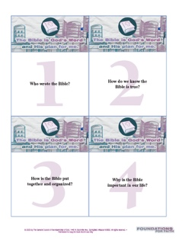
Who’s ready for a challenge? (Group response) Today, we’ve learned a very important foundation for our faith. We believe that . . . The Bible is God’s Word and His plan for me. Let’s find out what more we need to know about that. [Answers: 1=C, 2=D, 3=A, 4=B]
- Proceed with the activity you chose using the 4 Questions Pages cards.
- Discuss what’s written on each card as time allows.

ACTIVITY PAGE A | Coloring Page (A simpler activity for younger kids)
You Will Need | Getting Ready
- Crayons or markers  - Activity Page A, one per kid | - Print copies of Activity Page A, one per kid.

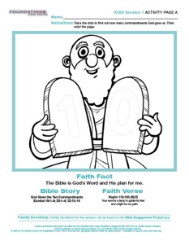
In our Bible story, God gave His Word to Moses and the Israelites. What do you remember from the story? (Allow responses.)
- Hand out the Activity Page A and crayons or markers to each kid.

Do you remember how many special rules God gave His people in the verses we read today? (Group response) Trace over the dots on the stone tablets Moses is holding to see if you’re right. Then, color the picture.

ACTIVITY PAGE B | Bible Translation Challenge
You Will Need | Getting Ready
- Pencils, one per kid  - Activity Page B, one per kid | - Print copies of Activity Page B, one per kid.
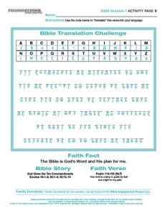
Can anyone guess how many languages the Bible was originally written in? (Allow responses.) The writers God chose wrote parts of His Word in three different languages. The first part of the Bible, the Old Testament, was written in mostly Hebrew and a little Aramaic. Then, the New Testament was written in Greek. Hundreds of years later, the Bible was translated into our language so that we could read it on our own.

Translators of the Bible need to know Hebrew, Aramaic, and Greek to make sure God’s message is translated correctly into our language. Our Activity Page lets us practice what it would be like to translate a Bible passage.
- Hand out a copy of the Activity Page B and a pencil to each kid.

On your page is a verse from the Bible. Your job is to use the alphabet code to figure out what it says. Let’s see if you can translate it to see what God wants to say to us.

To read the full, official version of the Statement of Fundamental Truths, visit ag.org/beliefs/statement-of-fundamental-truths

