

LEADER OVERVIEW
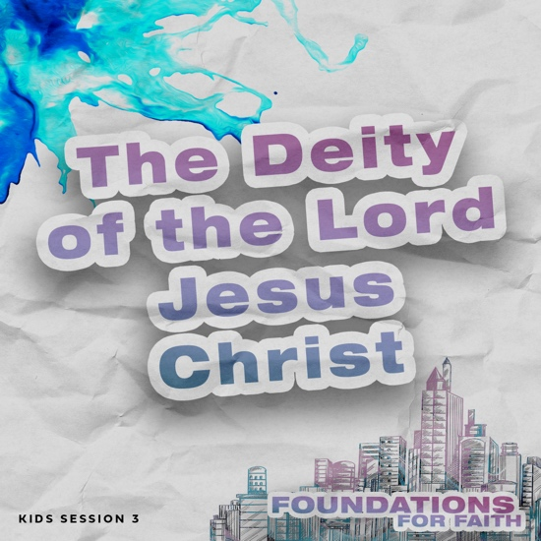
Foundations for Faith is designed to teach kids what we believe and why. These sessions cover core teachings—
or doctrines—that come from the Bible. Today’s session focuses on:

Foundation 3: Jesus is God the Son. The Bible tells us that He was born to Mary, a virgin, and His Father is God. Jesus never sinned, and He did many miracles. He died on the Cross for our sins and came back to life. Now He is in heaven with God the Father.

In this session, kids will discover that Jesus is not like
anyone else who has ever lived. As Thomas declared after Jesus came back to life, Jesus is God. He has always existed. His earthly birth, life, death, and resurrection were all for a special purpose—to bring us back into right relationship with God the Father. One day Jesus will return so we can live with Him forever.
Bible Lesson | Faith Fact
Thomas Declares Jesus Is God  Matthew 1:21–23; John 20:24–29;  Acts 1:9–11 | We believe that . . .  Jesus is God.
Faith Verse
In the beginning the Word already existed. The Word was with God, and the Word was God.
John 1:1 (NLT)

First time leading Foundations for Faith Kids?
Passing on what we believe to kids is important, so pray and invite God to guide you as you prepare and present this session. Always start with the Large Group teaching. Then add extra Small Group Activities if you have time. Some of the activities are designed for older or younger students, so consider which ones will best fit your group.

To find out more about all the resources available to help you lead and promote Foundations for Faith Kids, check out the Foundations for Faith Kids Overview.
PREPARING FOR THE SESSION
You Will Need | Getting Ready
Large Group  - Bible  - Worship songs (Song options: “Too Good to Not Believe” Lyrics Video by Cody Carnes, Brandon Lake; “Prize” Lyrics Video by The Belonging Co; “This I Believe (The Creed)” Lyrics Video by Hillsong Kids  - For groups not using a phone or tablet only, add:  - Projector or TV  - Laptop  - Foundations for Faith Countdown Video  - Faith Fact Slide  - Bible Lesson Video  - Teaching Point Slides 1–3  - Bible Lesson Slides A and B  - Prayer Response Slides 1–3  - Pages to Print:  - Object Lesson Page  Small Group Activities  - Bible  - Balloons, one per team  - Floor-safe tape  - Pencils or pens, one per kid  - Scissors, one per kid  - Crayons or markers  - Faith Verse Slide  - Pages to Print:  - Faith Verse Journal Page  - 4 Questions Pages  - Activity Page A and/or B  - Optional: Answer Page B | Large Group  - Download videos and slides if needed.  - Select worship song(s) and have them ready to play.  - Print the Object Lesson Page.  Small Group Activities  - Blow up the balloons.  - Tape start and finish lines for the game.  - Print the Faith Verse Journal Page, one per kid.  - Print and cut apart the 4 Questions Pages, one set per group. Keep questions and answers separate.  - Choose how to use this activity: Simple matching, Concentration-style find the pairs, etc.  - Print copies of Activity Page A and/or Activity Page B, one per kid.

LARGE GROUP (45 Minutes)

INTRODUCTION

Countdown Video
- Play the Foundations for Faith Countdown Video. Encourage kids to say the Faith Facts with the video.


Welcome
Hi, everyone! I sure look forward to seeing you each time we get together. Let’s start by praising God out loud for forty-five seconds. You can thank God for creating you and for sending Jesus. You can also thank Him for His Holy Spirit being with you. You can even thank Him that Jesus died for your sins. You can say, “I love You, Jesus.” You can say, “Praise God.” There are so many things to say. Close your eyes, and let’s praise Him. (Pause while kids respond.)

Praising God is a great way to start our time together today. Are you ready to make another amazing discovery in God’s Word? (Group response) We’ll talk today about another important truth of our faith. It’s one of the most important things you could ever know and believe.

Faith Fact
Our Faith Fact today is We believe that . . . Jesus is God. Can anyone guess what image represents today’s Faith Fact? (Allow responses.) Those are good guesses. Because this is such an important truth, the image shows the words.
- Show the Faith Fact Slide.
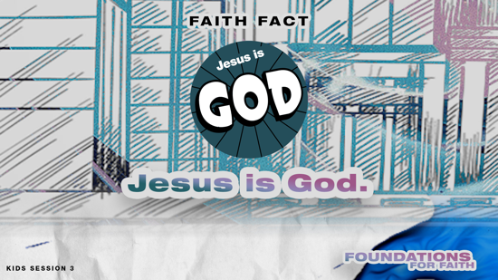

What do we mean when we say that Jesus is God? Well, there has never, ever been another person like Jesus. He never sinned, which means He never said or did anything wrong. He died on the Cross to pay for our sins. He rose from the dead and then went back to heaven to be with God. Someday, He will come back and rule on earth as King. He isn’t just a person who lived on earth. Jesus is God. Let’s say our Faith Fact again together with some actions. For the name “Jesus,” we’ll do the sign for Jesus in American Sign Language (demonstrate touching your middle finger to the palm of the opposite hand) to represent the nail holes in His hands. When you say, “God,” point up with both pointer fingers. Let’s try it. We believe that . . . Jesus is God. Now let’s shout it boldly. We believe that . . . Jesus is God. Great job!

GAME | Believe It or Doubt It
You Will Need | Getting Ready
- No supplies are needed for this activity. | - No prep is needed for this activity.

Not everyone believes that Jesus is God. Some people doubt because He lived on earth like you and me. I thought we’d play Believe it or Doubt it. I’ll read some statements. If you believe it, you’ll run and touch the wall to your right. (Point to wall.) If you doubt it, you’ll touch the wall to your left. (Point to wall.) Let’s get started.
- Tomatoes are fruits, not vegetables. (Yes, tomatoes have seeds and grow from flowers.)
- Owls can move their eyes to look around. (No)
- The Bible is God’s Word. (Yes)
- Unicorns are real. (No)
- Lions tiptoe when they walk. (Yes)
- Bananas were the first food eaten in space. (No, applesauce)
- There is one true God. (Yes)
- A very hot day can make train tracks bend. (Yes)
- The earth is flat. (No)
- A giraffe can use his tongue to clean his ears. (Yes)

Was it easy for you to figure what you believe and doubted in that game? (Group response) We’ll learn so much about Jesus today. I can’t wait to find out more about why We believe that . . . Jesus is God. But first, let’s worship Him.

WORSHIP

Here’s something you may not know about Jesus yet. The Bible tells us that someday, every person everywhere will understand that Jesus is the King. That will be an incredible day! I’m glad we don’t have to wait to worship Him. We can do that together now by singing.
- Lead the kids in singing one or two praise songs. See options at the beginning of the session.

Prayer
It’s awesome to worship Jesus with you! Let’s continue to focus in on Him as we pray together.

Dear Jesus, we love You so much! Help us to listen closely today to what the Bible tells us about You. Take away any doubts that anyone has that You are God. Amen.

BIBLE LESSON | Thomas Declares Jesus Is God
You Will Need | Getting Ready
- Bible  - Bible Lesson Slides A and B  - Teaching Point Slides 1–3 | - Download Bible Lesson Slides A and B and Teaching Point Slides 1–3.

Today, we’ll look at what the Bible says to discover why We believe that . . . Jesus is God. To get us started, let’s watch this video.

Video Introduction
- Play the Bible Lesson Video.
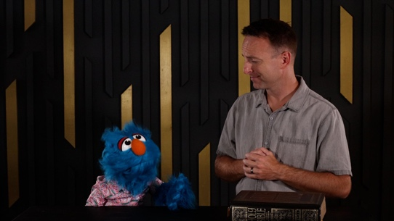

I sure hope you know more than Hank did about the holidays when we remember Jesus! That video really got us ready for our Bible lesson today. Let’s look at God’s Word to find out more about why We believe that . . . Jesus is God.

Teaching Time
We’ll see that the Bible talks about Jesus being there in the very beginning when the world was created. (Hold up the Bible.) The last verses of the Bible talk about Jesus, too. We can learn the most about Jesus in the Gospels, which are four books all about Him—Matthew, Mark, Luke, and John. Let’s turn to John 20 and begin there.
- Keep Large Group time moving along by having an adult read the verses aloud.

Jesus is God.
- Show the Teaching Point 1 Slide.
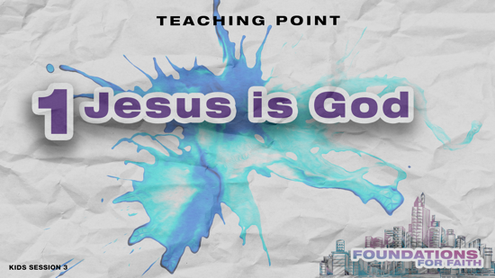

Have you ever been looking at something so closely that you couldn’t see the bigger picture? (Group response) Let’s try to guess what this zoomed in picture could be. What do you think the full picture shows? (Allow responses.)
- Show the Bible Lesson Slide A—zoomed in picture.
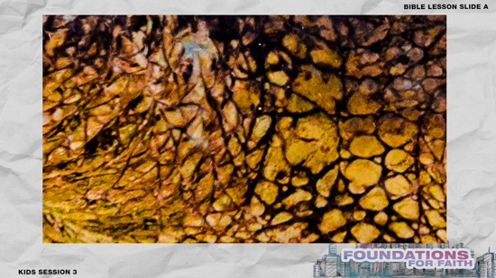

When you are so focused on one thing, it can be easy to miss the bigger picture! That same thing happened to one of Jesus’ disciples. The disciples had spent about three years living with Jesus every day. They had seen Him do miracles and heal the sick. They knew He was a very special person, but they also had some wrong ideas about who they thought Jesus should be. They didn’t always see the bigger picture. When Jesus died and they saw Him raised from the dead, most of them were able to see the bigger picture. But, not everyone could see it.
- Read John 20:24–29.

Who didn’t believe what the other disciples were telling him? (Group response) Thomas was the only one of Jesus’ disciples who hadn’t seen Jesus after He was raised from the dead. He was confused and full of doubt about who Jesus was. Thomas told the other disciples that he wouldn’t believe unless he saw Jesus himself. Let’s go back to our picture, so you can see for yourself what it is.
- Show the Bible Lesson Slide B—zoomed out picture.
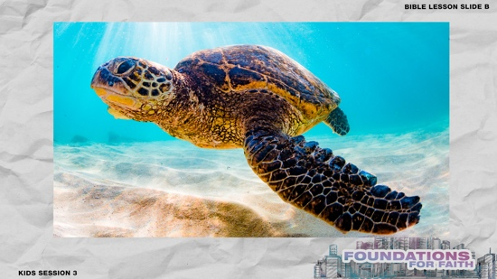

Did you get it right? (Group response) The same thing happened to Thomas. Eight days later, Jesus appeared to him. Jesus allowed Thomas to see and do everything he needed to believe. Thomas immediately saw the bigger picture, and he responded with a confession of who Jesus is, “My Lord and my God.” Thomas declared that Jesus is God.

Jesus isn’t just a good person who lived a long time ago. He isn’t just the long-awaited Messiah. He is God! Those who lived with Him learned that Jesus was God. That’s why We believe
that . . . Jesus is God.

2. Jesus is “God with us.”
- Show the Teaching Point 2 Slide.
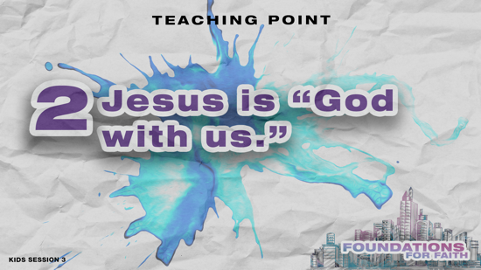

What about other people who were alive then? Could they see who Jesus was? People were puzzled by Jesus, but God had given them lots of clues about Jesus before He was born just like I gave you a clue about the picture. Let’s look at one of them.
- Read Matthew 1:21–23.

In these verses, it’s an angel talking to Joseph, who was going to marry Mary. What did the angel tell Joseph to call the baby? (Group response) Do you know what the name Jesus means? It means “the Lord saves.” It’s the Lord our God who saves us. Do you remember what the angel said right after the name Jesus? He said that Jesus “will save his people from their sins.” So, if the Lord God saves and if Jesus is going to save His people, then that means Jesus is God!

Then, Matthew quoted the Book of Isaiah, which was written hundreds of years before Jesus was born. Isaiah was a prophet who said that people would call the baby a special name—Immanuel. That means “God is with us.” Although not everyone realized at the time, God was living among them. His name was Jesus. That’s why We believe that . . . Jesus is God.

3. Jesus died, came back to life, and is now in heaven.
- Show the Teaching Point 3 Slide.
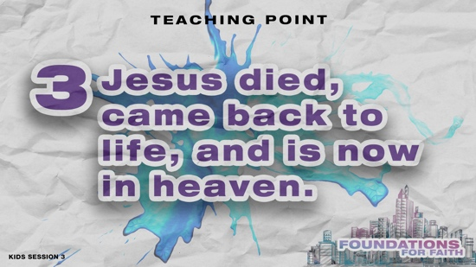

It’s amazing to think that God came to earth and many people didn’t realize it. Jesus could have used the opportunity to get famous, rich, or powerful. Jesus didn’t come to earth for any of that. Does anyone know why Jesus came to earth? (Allow responses.) He came to be the Savior of the world. To save people from their sins, Jesus lived a perfect life and gave His life by dying on the Cross. He made it possible for us to spend forever with God.

We know Jesus didn’t stay dead in the grave. Three days later He rose again. Jesus appeared to many of His disciples and many other people after His resurrection. He wanted people like Thomas to believe in Him. Do you think Jesus is still living on earth today? (Group response) Let’s see what the Bible says happened to Jesus a while after His resurrection.
- Read Acts 1:9–11.

After Jesus died and rose from the dead, He returned to heaven. His closest disciples were with Him when it happened. Now, Jesus is in heaven. We are awaiting the time when He will return so that we can be with Him forever. Jesus defeated death. He is alive, and now He is in heaven. That’s why We believe that . . . Jesus is God.

OBJECT LESSON | Walk through Paper
You Will Need | Getting Ready
- Scissors  - Object Lesson Page | - Print the Object Lesson Page.

Wow! Jesus did what seemed to be impossible, but nothing is impossible for Him because He is God. Sometimes it’s hard for us to understand how something so impossible could happen. Do you want to see me do something that seems impossible? (Group response)
- Show the blank side of the Object Lesson Page.

Some people thought Jesus was just a good man kind of like this is just a piece of paper. Do you think I can walk through this piece of paper? (Group response)
- Turn the page over and cut the paper on the lines as you say the next sentences.

Situations may seem impossible, but Jesus is God. He can do the impossible! If we put our trust in Jesus, we will see Him do the impossible. Now, do you think I can walk through this paper? (Group response)
- Open the paper into a large ring, put it over your head, and push it down your body until you have walked through the paper.
- Option: You may want to use one of the kids to walk through the paper.

PRAYER AND RESPONSE
You Will Need | Getting Ready
- Prayer Response Slides 1–3 | - Download the Prayer Response Slides.

- Consider playing a worship song softly in the background while kids pray.

When we hear and read God’s Word, we should respond. Today, we learned that Jesus is God. Let’s respond with a call and response using the words of Thomas in our Bible story, “My Lord and My God.” I’ll make a statement about Jesus, and you will shout in response, “My Lord and My God.”
- Show the Prayer Response Slides, one at a time.
- Read each statement and pause for kids to respond.
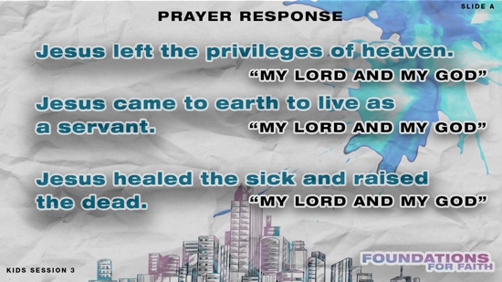

Jesus left the privileges of heaven. (Pause for response.)

Jesus came to earth to live as a servant. (Pause for response.)

Jesus healed the sick and raised the dead. (Pause for response.)

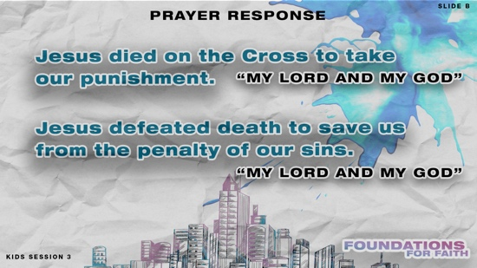

Jesus died on the Cross to take our punishment. (Pause for response.)

Jesus defeated death to save us from the penalty of our sins. (Pause for response.)

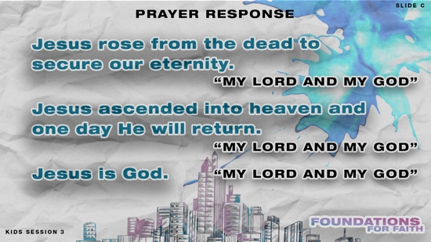
Jesus rose from the dead to secure our eternity. (Pause for response.)

Jesus ascended into heaven and one day He will return. (Pause for response.)

Jesus is God. (Pause for response.)

- Close in prayer.

Dear Jesus, thank You for coming to earth and living among us! We declare that You are God and that You do the impossible. We ask You to help us with our impossible situations. Amen.

Optional: Salvation Prayer
If kids don’t know Jesus as their Savior, consider sharing about salvation. See the Salvation Guide.

DISMISSAL
Got more time? Choose one or more Small Group Activities to reinforce what kids are learning.

I’ve had a great time learning more about Jesus as God with you today. (Hold up the Bible.) God’s Word has so much to teach us about what we believe and why. I hope you’ll choose to spend time reading the Bible every day. That’s one way to learn more about Jesus.

Faith Fact Recap
- Show the Faith Fact Slide.

Speaking of Jesus, let’s say our Faith Fact together and do the actions. We believe that . . . Jesus is God. One more time. We believe that . . . Jesus is God. Awesome! See you next time!
- Send home the Activity Page(s) and Journal Page, if used.
- Tell everyone the date and time for the next session.
- Remind parents that there are Family Devotions available on the app.

SMALL GROUP ACTIVITIES

Choose one or more of these activities to extend kids’ learning as time allows. All activities are led by a small group leader.

GROUP CONNECTION | Talk about It
You Will Need | Getting Ready
- No supplies are needed for this activity. | - No prep is needed for this activity.

We’ve been talking about how We believe that . . . Jesus is God. Our actions with our Faith Fact begin with us representing the nail holes in Jesus’ hands on our hands. Do that with me now. (Group response) That’s the same thing Jesus’ disciple Thomas needed to see and do to believe that Jesus is God. Then, Thomas declared that Jesus was God. What’s one thing you discovered about Jesus today? Think about your answer for a moment. Then, we’ll take turns sharing.
- Pause while kids think and then take turns sharing their answer.

Prayer Time

Let’s pray together. Who has a prayer need that you’d like the group to pray for?
- Have kids share and pray for each other’s prayer requests.
- Keep track of kids’ prayer requests and review them each time you meet.

Because Jesus is God, we can talk to Him in prayer. He’s listening to us. Let’s talk to Jesus now.
- Have kids repeat this prayer after you.

Dear Jesus, I want to serve You. I want to follow You. Help me to believe in You always. Help me to tell others about You, especially if they have doubts. I want others to know how much You love them. Amen.

GAME | Toss Across Relay
You Will Need | Getting Ready
- Balloons, one per team  - Floor-safe tape | - Blow up the balloons.  - Tape start and finish lines for the game.

One of the ways we know that Jesus is God is because He was present at the beginning before the earth was created. One day, He’ll take us home to live with Him. Let’s play a game about that. We’ll break up into two teams. Each team will get a balloon to represent Jesus. We’ll see if your team can make it from the start line to the finish line, which is our home in heaven, without dropping the balloon. Each team will spread out in a line across the space and toss the balloon to the next person on their team. If your team doesn’t reach all the way to the finish line, then each team member will need to run to the end of the line after they toss the balloon.

One more thing. You need to spell out your part of the Faith Fact, saying one letter each time someone hits the balloon. J–E–S–U–S–I–S–G–O–D. Then, when you get your balloon all the way to the end, shout out the whole Faith Fact. We believe that . . . Jesus is God. Let’s play!
- Play the game and declare a winning team.

FAITH FACT ACTIVITY | Faith Fact Rhythm Chant
You Will Need | Getting Ready
- No supplies are needed for this activity. | - No prep is needed for this activity.

Our Faith Fact today is so important, and I don’t want any of you to forget it. We believe that . . . Jesus is God. As you grow up, there will be people who try to distract you from believing that Jesus is God. They may say things that aren’t true about Jesus. For example, a teacher at school might tell you to stop talking about Jesus because religion is fake. A friend might say you’re crazy to believe that Jesus is God when He was just a nice person who lived long ago. No matter what anyone else says, we always need to believe that Jesus is God. I’ve got an activity to help us remember our Faith Fact. Here's how we’ll play.
- Have the kids sit in a circle on the floor, cross-legged.

I’ll start a rhythm by hitting both knees with my hands three times, then clap twice, followed by a snap. (Demonstrate.) I’ll say, “We believe that,” with the first three counts, and you’ll say, “Jesus is God,” with the last three counts. Let’s try that all together first.
- Do this together as a group a few times. For younger kids, you may need to go slowly or simplify the pattern.

Who’s ready for a challenge? (Group response) This time, I’ll start the beat alone. Then, I’ll call on one of you to join me. I’ll say, “We believe that,” with the first three counts, and that person will say, “Jesus is God,” with the last three counts. They will immediately name someone else to say it with us next. We’ll keep going until everyone has joined in saying the Faith Fact to the beat.
- Start a rhythm and then have kids join in.
- Options: Go faster or let kids choose a rhythm as you play again.

FAITH VERSE JOURNAL
You Will Need | Getting Ready
- Pencils or pens, one per kid  - Faith Verse Journal Page, one per kid  - Faith Verse Slide | - Print copies of the Faith Verse Journal Page, one per kid.
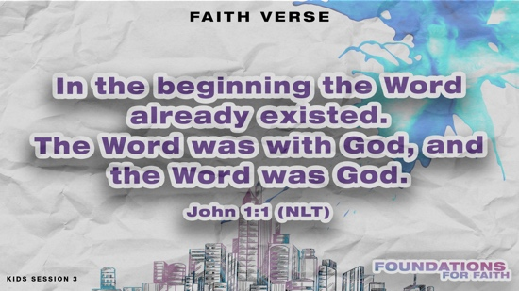
- Optional: Show the Faith Verse Slide.

In the beginning the Word already existed.
The Word was with God, and the Word was God.
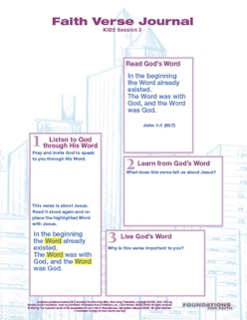
John 1:1 (NLT)

God wants to speak to us through His Word. Let’s look at today’s Faith Verse and see what He might want to say to us through it.
- Hand out the Faith Verse Journal Page and pencils. Guide kids through the activity.

4 FAITH QUESTIONS
You Will Need | Getting Ready
- Scissors  - 4 Questions Pages, one set per group | - Print and cut apart the 4 Questions Pages, one set per group. Keep questions and answers separate.  - Choose how to use this activity: Simple matching, Concentration-style find the pairs, etc.
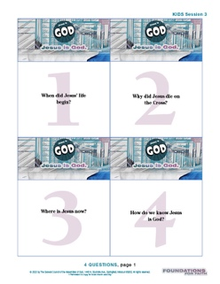
Who’s ready for a challenge? (Group response) Today, we’ve learned about a very important foundation for our faith. We believe that . . . Jesus is God. Let’s find out what more we need to know about that. [Answers: 1=B, 2=C, 3=A, 4=D]
- Proceed with the activity you chose using the Four Questions Pages cards.
- Discuss what’s written on each card as time allows.

ACTIVITY PAGE A | Jesus’ Life in Sequence (A simpler activity for younger kids)
You Will Need | Getting Ready
- Pencils or pens, one per kid  - Crayons or markers  - Activity Page A, one per kid | - Print copies of Activity Page A, one per kid.

We’ve talked about how We believe that . . . Jesus is God. One of the reasons we know that is because His life is not like anyone else’s.
- Hand out a copy of the Activity Page A and a pencil to each kid.
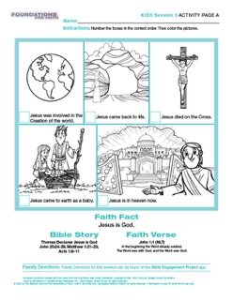

Our Activity Page shows pictures about Jesus. Let’s see if you can put them in order from first to last. Remember, Jesus is God, so He has always existed. Which picture shows the very beginning? (Group response) Write a 1 by that picture. Then, let’s see if we can figure out the order of the other pictures.
- Help kids complete this activity. Then, let them color the pictures if time allows.

ACTIVITY PAGE B | Jesus’ Life Maze
You Will Need | Getting Ready
- Pencils or pens, one per kid  - Crayons or markers  - Activity Page B, one per kid  - Optional: Answer Page B | - Print copies of Activity Page B, one per kid.
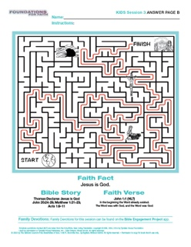
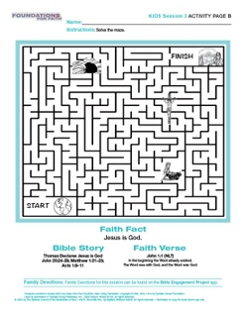
We believe that . . . Jesus is God. We know this is true because even though Jesus was born and died during His time on earth, He existed before He came to earth. Then after Jesus died, He went back to heaven to sit next to God the Father. Jesus’ life is not like anyone else’s.
- Hand out a copy of the Activity Page B and a pencil to each kid.

Because Jesus is God, He has always existed. Let’s start at Creation. Then, follow the path through the events of Jesus’ life in

order to get to heaven on the other side.
- When kids are finished, let them color the pictures if time allows.

__________________________ To read the full, official version of the Statement of Fundamental Truths, visit ag.org/beliefs/statement-of-fundamental-truths

