

LEADER OVERVIEW

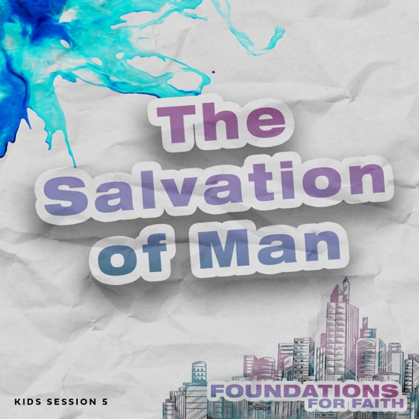
Foundations for Faith is designed to teach kids what we believe and why. These sessions cover core teachings—
or doctrines—that come from the Bible. Today’s session focuses on:

Foundation 5: We can be a Christian because Jesus died for us. Jesus died on the Cross and took the punishment for our sins. He gave us the only way that we can be
forgiven for the wrong things we have done. When we accept Jesus as our personal Savior and tell Him we are sorry for our sin, He forgives us. Then, with the help of the Holy Spirit, we can live according to God’s Word and not continue to do those things that are wrong and don’t please God. Our spirit will be in agreement with God’s Spirit, and we will live a holy life.¹

In this session, kids will discover that God has made a way for us to be saved. Our sin separates us from God. But because God didn’t want us to be separated from Him, He sent Jesus to be our Savior. Jesus died and rose again, so we can be saved and live with God forever.
Bible Lesson | Faith Fact
Jesus Died for You and Me  Luke 23:33–48; 24:1–9; John 3:16 | We believe that . . .  Jesus died so we can be saved.
Faith Verse
Romans 10:9–10 (NLT)
If you openly declare that Jesus is Lord and believe in your heart that God raised him from the dead, you will be saved. For it is by believing in your heart that you are made right with God, and it is by openly declaring your faith that you are saved.

First time leading Foundations for Faith Kids?
Passing on what we believe to kids is important, so pray and invite God to guide you as you prepare and present this session. To find out more about all the resources available to help you lead Foundations for Faith Kids, check out the Foundations for Faith Kids Overview.
__________
¹ To read the full, official version of the Statement of Fundamental Truths, visit ag.org/beliefs/statement-of-fundamental-truths
PREPARING FOR THE SESSION
You Will Need | Getting Ready
Large Group  - Bible  - Worship songs (Song options: “Holy Spirit Come” Official Lyric Video by Yancy, “It Is Finished” Official Lyric Video by Gateway Worship)  - Paper money, one dollar or greater  - For groups not using a phone or tablet only, add:  - Projector or TV  - Laptop  - Foundations for Faith Countdown Video  - Faith Fact Slide  - Bible Lesson Video  - Teaching Point Slides 1–3  - Response Verse Slide  - Pages to Print:  - Teaching Time Signs 1–5  Small Group Activities  - Ten or more boxes of all shapes and sizes  - Gift-wrapping paper  - Scissors  - Tape  - Tape measure  - Smartphone or timer  - Toilet paper, two rolls per group  - Pencils or pens, one per kid  - Faith Verse Slide  - Crayons or markers  - Scissors, one per kid  - Transparent tape, one roll per two kids  - Pages to Print:  - Faith Fact Fun Pages  - Faith Verse Journal Page  - 4 Questions Pages  - Activity Page A and/or B1 and B2 | Large Group  - Download videos and slides if needed.  - Select worship song(s) and have them ready to play.  - Print the Teaching Time Signs 1–5.  Small Group Activities  - Wrap all the boxes in the gift-wrapping paper.  - Print the Faith Verse Journal Page, one per kid.  - Print and cut apart the 4 Questions Pages, one set per group. Keep questions and answers separate.  - Choose how to use the 4 Questions activity: Simple matching, Concentration-style find the pairs, etc.  - Print copies of Activity Page A and/or Activity Pages B1 and B2, one per kid.
Additional resources for promoting Foundations for Faith Kids are available at:
app.BibleEngagementProject.com

LARGE GROUP (45 Minutes)

INTRODUCTION

Countdown Video
- Play the Foundations for Faith Countdown Video. Encourage kids to say the Faith Facts with the video.
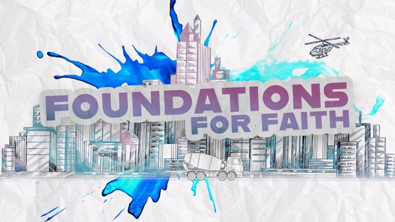

Welcome
Hey, kids! I’m glad you’re here! I hope you are having an amazing week. Last time, we talked about sin and how everyone needs Jesus. Today, we’ll discover how we can be saved because Jesus took the punishment for our sins. I thought I would start by telling you my story, so you’ll know how I became a Christian and started following Jesus.
- Briefly share your testimony.

Faith Fact
We’ll talk a lot about salvation and how to become a Christian today. That’s why our Faith Fact is We believe that . . . Jesus died so we can be saved. Those of us who are saved became Christians when we asked Jesus to forgive our sins and come into our life as our personal Savior. Can anyone guess what image represents today’s Faith Fact? (Allow responses.) It’s a cross. That’s where Jesus died for you and me. His story doesn’t end there! He defeated death and rose again. He’s alive in heaven, and every Christian will be with Him someday.

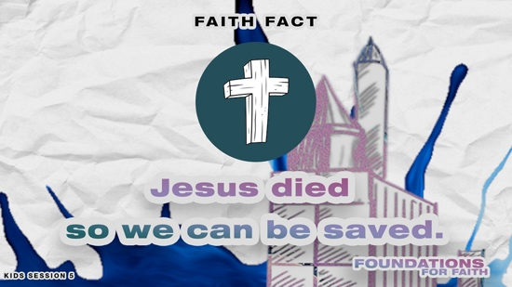
- Show the Faith Fact Slide.

Let’s say the Faith Fact again. I’ll start the Faith Fact by saying, “We believe that . . .” That’s your cue to finish the phrase with me. We believe that . . . Jesus died so we can be saved. Now let’s add some actions. (Demonstrate) When you say, “Jesus died,” spread out your arms like a cross and look down at the floor. Then, when you say, “saved,” put your hands over your heart. Let’s try it. We believe that . . . Jesus died so we can be saved. Let’s try that one more time. We believe that . . . Jesus died so we can be saved. I think we’re ready to start today’s session.

GAME | Resurrection Tag
You Will Need | Getting Ready
No supplies are needed for this activity. | No prep is needed for this activity.

Let’s play a game that will remind us that Jesus not only died but also rose again. When Jesus came back to life is His Resurrection. Has anyone ever played Freeze Tag? (Group response) Let’s play a similar game called Resurrection Tag. When the game begins, the person who is “It” will chase everyone to freeze them by tagging them with one hand. When you’re tagged, you must lie down on the floor and play dead. You can only be resurrected or come back to life when another kid tags you. Then, you’ll jump up and yell, “Jesus is alive!” Let’s play.
- Play the game as time allows. Choose others to be “It” as you play.

That was fun! You showed so much excitement about Jesus when you were resurrected. That’s the kind of excitement we should have when we remember that Jesus died and rose again for us so our sins could be forgiven.

WORSHIP

That’s worth praising Him right now! Who’s ready to worship God with me? (Group response) Let’s start by thanking God on our own for sending Jesus. Then, we’ll worship Him together by singing!
- Give kids some time to worship God on their own. Then, lead the kids in singing one or two praise songs. See options at the beginning of the session.

Prayer
What an incredible time of worshipping God together! Let’s pray together because we have so much to be thankful for.

Dear God, we love You, and we know You love us. Thank You for sending Jesus to die for us. Help every one of us to open our heart and mind to all You have for us. Amen.

BIBLE LESSON | Jesus Died for You and Me
You Will Need | Getting Ready
- Bible  - Bible Lesson Video  - Teaching Time Signs 1–5  - Teaching Point Sides 1–3 | - Download the Bible Lesson Video.  - Print the Teaching Time Signs 1–5.  - Download the Teaching Point Slides 1–3.

Today, we’ll look at what the Bible says to discover why We believe that . . . Jesus died so we can be saved. To get us started, let’s watch this video.

Video Introduction
- Play the Bible Lesson Video.

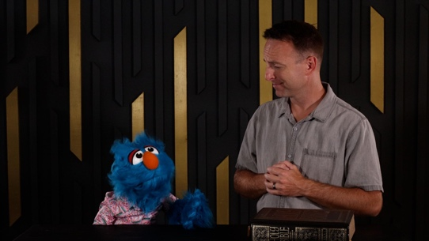

What did you like best about that video? (Group response) I’m glad Jeremy is there to help Hank figure things out! That video really got us ready for our Bible lesson today! So here we go.

Teaching Time
Do you have a favorite superhero movie? (Group response) Shout out which superhero it’s about. (Group response) A lot of the best superhero movies follow a similar story. The world comes under attack, the superhero steps in to save the day, and he risks his own life in the process. Is your favorite movie like that? (Group response) They can be great movies, but they aren’t even close to the greatest event in history! Jesus gave His life to save the whole world. Let’s find out more as we read God’s Word to find out what happened.
- Choose kids to hold the five signs in order and reveal them one at a time during the teaching.

God wants a relationship with us.
- Show the Teaching Point 1 Slide.
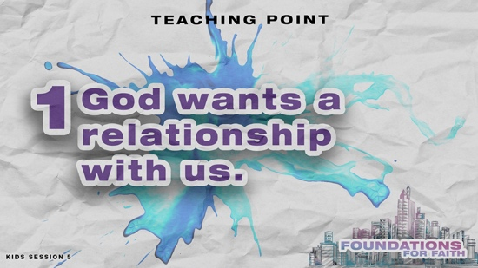

Did you know that God cares about the world and the people who live in it? (Group response) That’s because God created the world and everything in it. He didn’t just create people to serve Him. He wanted people to choose to be in relationship with Him.
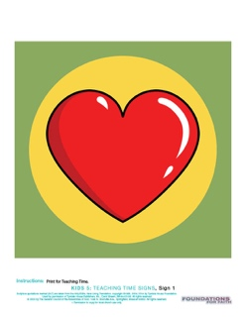
- Hold up the Teaching Time Sign 1: Heart.

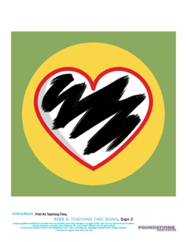
That’s one reason why God gave people the ability to make their own decisions. Sadly, people don’t always make good decisions. All through history, people have made decisions to act against God’s instructions. Sin separated people from God.
- Hold up the Teaching Time Sign 2: Black Heart.

Until sin was dealt with, there was no way for people to be in a very close relationship with God like Adam and Eve had in the Garden of Eden. The consequence for their sins was death. That didn’t mean immediate death. Sin without God’s help leads people to being separated from God forever. After Adam and Eve sinned, sin entered the world. God was ready to help people fix their relationship with Him, so He did something incredible.
- Read John 3:16.

Jesus, the Son of God, came to live on earth. He lived a perfect life, free from sin. He fed the hungry, healed the sick, and taught people how to be in right relationship with God. Jesus was the only one who could restore our relationship with God, and that’s why He came to earth.

2. Jesus gave His life for our sins.
- Show the Teaching Point 2 Slide.
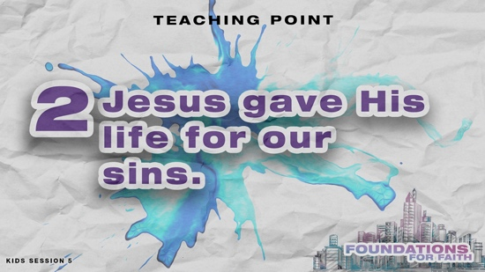

Everyone has sinned. The Bible tells us the punishment for our sins is death. There is nothing we can do to save ourself from this punishment. Jesus, who lived a perfect life, chose to take our punishment. He gave His life so that our sins could be forgiven and our punishment could be paid. That’s why We believe that . . . Jesus died so we can be saved. Let’s read about His death. Turn to Luke 23:33–48.
- Read Luke 23:33–48.

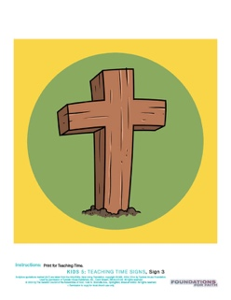
Jesus had been arrested by the Jewish religious leaders and brought to trial before the Roman governor. Jesus was sentenced to death on a cross.
- Hold up the Teaching Time Sign 3: Cross.

His life wasn’t taken from Him. Jesus was the Son of God. If He had wanted to, He could have freed himself. Instead, He chose to give His life and take the punishment that each of us deserved.

3. Jesus defeated death to save us.
- Show the Teaching Point 3 Slide.
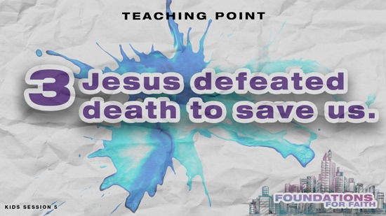

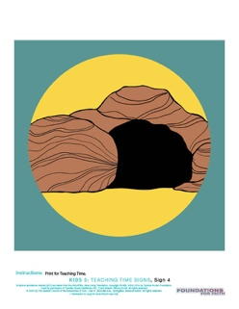
Jesus’ death on the Cross was an important moment in history, but there was another event that happened three days later that was just as important! Does anyone know what it was? (Allow responses.) That’s right! Jesus died on the Cross, His body was placed in a tomb, but three days later He rose from the dead!
- Hold up the Teaching Time Sign 4: Empty Tomb.

Let’s find out who Jesus trusted to be the first people to find out this good news.
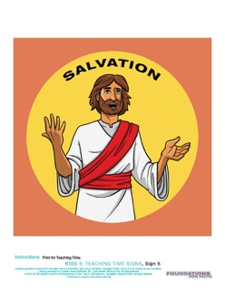
- Read Luke 24:1–9.

Who discovered that Jesus was alive? (Allow responses.) A group of women were the first people to discover the empty tomb and share about Jesus’ resurrection. Jesus had defeated death. This was good news because it proved that Jesus’ death would save people from their sins.
- Show the Teaching Time Sign 5: Salvation.

If Jesus never rose from the dead, then people may have argued that Jesus was just like anybody else who died on a cross. Jesus’ death and resurrection made a way for our salvation. That’s why We believe that . . . Jesus died so we can be saved.

When we receive His gift of salvation, our life changes as we obey God and His Word. With the help of the Holy Spirit, we can stop doing things that are wrong and don’t please God. We’ll ask for His forgiveness when we mess up. As we live for God, other people will be able to see the difference in us because we’re becoming more like Jesus. Salvation is the best gift ever!

OBJECT LESSON | Dollar Giveaway
You Will Need | Getting Ready
- Paper money, one dollar or greater | No prep is needed for this activity.

(Show kids the money.) Have you ever had money like this before? (Group response) What would you spend this money on if it were yours? (Allow responses.) How do you normally get money? (Allow responses.) That’s right! Most of the time you have to do chores for your money or at least be well-behaved. What if I told you that I’m giving this away today and that you don’t have to do anything to get it! Who wants it? (Group response)
- Pick a kid and give the money to that kid.

The only thing the kid had to do to receive that gift was respond to my question. Salvation is like that, too. We believe that . . . Jesus died so we can be saved. If we want to receive God’s gift of salvation, we must also choose to accept it.

PRAYER AND RESPONSE
You Will Need | Getting Ready
- Response Verse Slide  - Faith Fact Slide | - Download the Response Verse Slide.  - Download the Faith Fact Slide.

- Consider playing a worship song softly in the background while kids pray.

When we hear and read God’s Word, we should respond. Today, we talked about why We believe that . . . Jesus died so we can be saved. That’s true no matter how messed up your life might be. It doesn’t matter what your family is like. Everyone can be saved from their sins if they ask God to do it. Let’s read this Scripture together that explains what we have to do.
- Show the Response Verse Slide.
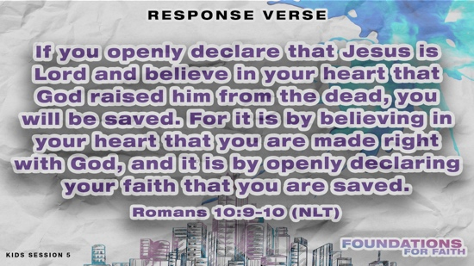

- Read Romans 10:9–10.

All you have to do to invite Jesus to be your Savior is to believe that He died on the Cross for your sins and rose from the dead. Then, you have to declare that Jesus is the Lord of your life. If you want to make that decision today, then I’ll ask you to openly declare that by standing up. (Pause for response.) Thanks for being bold! Let’s finish by praying a prayer of salvation together.
- Have kids repeat the prayer after you.

Dear God, thank You for sending Jesus to die on the Cross. I believe that He gave His life as a sacrifice for the forgiveness of my sins. I declare that Jesus is Lord of my life. Please help me to follow You faithfully. Amen.

If you prayed that prayer, you are now a Christian because you asked Jesus to be your Savior. I encourage you to tell your parents and others that you have decided to follow Jesus.

DISMISSAL
Got more time? Choose one or more Small Group Activities to reinforce what kids are learning.

I’ve had an amazing time learning about Jesus and how He came to be our Savior. I want everyone I know to choose to ask Jesus into their life, and that includes each one of you.

Faith Fact Recap
- Show the Faith Fact Slide.

One very important truth we need not only to remember but also to tell others about is our Faith Fact. We believe that . . . Jesus died so we can be saved. I’m so glad you came today! I can’t wait to see you next time.
- Send home the Activity Page(s) and Journal Page, if used.
- Tell everyone the date and time for the next session.
- Remind parents that there are Family Devotions available on the app.

SMALL GROUP ACTIVITIES

Choose one or more of these activities to extend kids’ learning as time allows. All activities are led by a small group leader.

GROUP CONNECTION | Testimony Time
You Will Need | Getting Ready
No supplies are needed for this activity. | No prep is needed for this activity.

We’ve talked about how We believe that . . . Jesus died so we can be saved. Let’s talk more about what we’ve learned from God’s Word today.
- Have kids sit in a circle on the floor.

What was your favorite part of the Bible lesson about Jesus? (Allow responses.) Today’s Bible story is one of the most important ones in the Bible. Jesus chose to come and die for you and me so that our sins can be forgiven, and we can be saved.
- Briefly share your testimony if you haven’t done so already.

If you’ve asked Jesus to forgive your sins and be your Savior, would you like to tell the group about it? Who would like to share? (Allow responses.)

Optional: Salvation Prayer

If this small group doesn’t immediately follow Large Group or you feel someone in your group is ready to accept Jesus as their Savior, proceed with this section. If not, skip to Prayer Time.

If you haven’t asked Jesus to forgive your sins and be your Savior, and you’d like to, I’ll lead you in a prayer to do that now.
- Pray with anyone who responds by having them repeat this prayer.

Dear Jesus, thank You for choosing to die on the Cross for my sins. I know I have done wrong things. Forgive me for sinning against You. I invite You to come into my life to be my Lord and Savior. Amen.

Prayer Time

Does anyone have a prayer need that you’d like the group to pray for?
- Have kids share and pray for each other’s prayer requests.
- Keep track of kids’ prayer requests and review them each time you meet.

Today, we’ve talked about the gift of salvation. We believe that . . . Jesus died so we can be saved. Let’s thank Him for that incredible gift.

Dear God, thank You for Your amazing gift of salvation. We don’t deserve it. Thank You for loving us so much that Jesus would choose to die for us. We love You and want to follow You. Amen.

GAME | Stack the Presents
You Will Need | Getting Ready
- Ten or more boxes of all shapes and sizes  - Gift-wrapping paper  - Scissors  - Tape  - Tape measure  - Smartphone or timer | - Wrap all the boxes in the gift-wrapping paper.

Let’s play a game! Today’s game is Stack the Presents. We’ll divide into teams. Each team will get sixty seconds to build the tallest freestanding stack of presents they can. You can’t lean your presents against anything or hold onto them. When time is up, I’ll measure how tall your stack of presents is. The team with the tallest stack will win.
- Choose which team will begin and start the timer. Keep playing until you have a winner.

That was a great game! Do you like receiving gifts? (Group response) What’s the best gift you have ever received? (Allow responses.) The Bible tells us about the greatest gift that God has given us. Do you remember what the greatest gift is? (Allow responses.) Yes, it’s Jesus! He’s the only way we can be forgiven for our sins. That’s why We believe that . . . Jesus died so we can be saved.

FAITH FACT ACTIVITY | Mummy Wrap Object Lesson
You Will Need | Getting Ready
- Toilet paper, two rolls per group | No prep is needed for this activity.

Let’s start by saying our Faith Fact together. We believe that . . . Jesus died so we can be saved. Before they put Jesus in the tomb, they carefully wrapped His body in linen strips. His followers discovered those cloths lying there when they looked into the tomb (John 20:3–7). So, here’s what we’re going to do. First, we need some volunteers.
- Choose three volunteers.
- Hold up a roll of toilet paper.

One volunteer will get wrapped up by the rest of you with this roll of toilet paper kind of like Jesus was wrapped in linen cloths. The Bible tells us that Jesus had a different cloth on His head, so only wrap from the neck down. The other two volunteers will help me.
- Follow the next instructions carefully.
- Choose a strong kid (or yourself) to be volunteer A. Have volunteer A hold their arms against their body. Have the rest of the group wrap volunteer A from neck to toes. Encourage them to cover up volunteer A, but don’t allow them to go around too many times.
- Choose a small kid to be volunteer B. Have volunteer B hold both arms against his body. Choose one kid in the group to wrap volunteer B as many times as time allows, covering the midsection and arms. If the kid wrapped volunteer B enough, he won’t be able to break free. However, you may want to whisper to volunteer B not to try too hard to break the toilet paper.

Okay, I think that looks great. Everyone, sit down except our two volunteers. Let’s see what you remember from today’s Bible lesson. Why did Jesus need to die on the Cross and then get wrapped up like this? (Allow responses.) Everyone has sinned, so we are separated from God. Sin ties us up. Volunteer B, try to set yourself free.
- Have volunteer B try to break free and hopefully he isn’t successful.

We can’t get out of our sins and their consequences on our own. How did Jesus help us? (Allow responses.) Jesus died and was buried, but then what happened? (Allow responses.) Jesus was resurrected and came back to life. He left behind the cloth strips He was wrapped in. Volunteer A, can you set yourself free to show us what Jesus might have done?
- Have volunteer A break out of the toilet paper.

When we accept Jesus as our Savior, He forgives our sins and sets us free!
- Have volunteer A remove the toilet paper from volunteer B.

Jesus died so that we can be free! I’m so thankful that He was willing to make a way for us to be forgiven! What’s the best part about being forgiven of your sins? (Allow responses.) Jesus is willing to set us free from our sins when we ask Him.

FAITH VERSE JOURNAL
You Will Need | Getting Ready
- Pencils or pens, one per kid  - Faith Verse Journal Page, one per kid  - Faith Verse Slide | - Print copies of the Faith Verse Journal Page, one per kid.

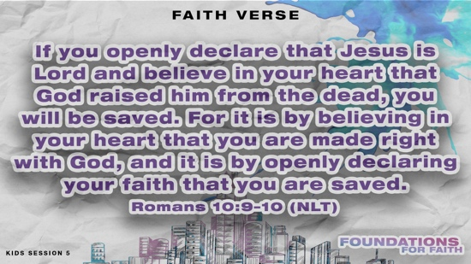
- Optional: Show the Faith Verse Slide.

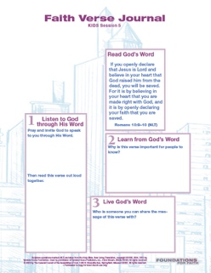

God wants to speak to us through His Word. Let’s look at today’s Faith Verse and see what He might want to say to us through it.
- Hand out the Faith Verse Journal Page and pencils. Guide kids through the activity.

4 FAITH QUESTIONS
You Will Need | Getting Ready
- Scissors  - 4 Questions Pages, one set per group | - Print and cut apart the 4 Questions Pages, one set per group. Keep questions and answers separate.  - Choose how to use this activity: Simple matching, Concentration-style find the pairs, etc.
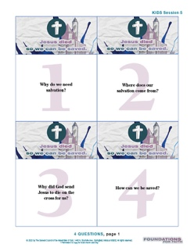
Who’s ready for a challenge? (Group response) Today, we learned about a very important foundation for our faith. We believe that . . . Jesus died so we can be saved. Let’s find out what more we need to know about that.
[Answers: 1=B, 2=A, 3=C, 4=D]
- Proceed with the activity you chose using the 4 Questions Pages cards.
- Discuss what’s written on each card as time allows.

ACTIVITY PAGE A | Dot-to-Dot Evangelism (A simpler activity for younger kids)
You Will Need | Getting Ready
- Crayons or markers  - Activity Page A, one per kid | - Print copies of Activity Page A, one per kid.
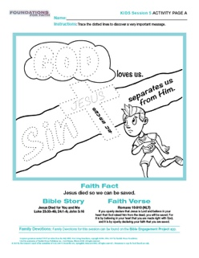
Our Activity Page today shows a very important message, but it’s not finished. We need your help to see the message!
- Hand out the Activity Page A and crayons to each kid.

Can you trace the dotted lines, so we can read the message? I want to know what it says. Don’t you? (Group response)
- Guide kids through the activity. Trace God first and then sin.
- Talk about how sin separates us from God.

I think this is showing us what our Bible lesson was about! Let’s trace what’s in the middle.
- Trace the cross and Jesus.

What do you see in the picture? (Allow responses.) What do you think the important message is? Let’s read it together. “God loves us. Sin separates us from Him. Jesus saves us.” Hey, Jesus dying on the Cross is like a bridge that connects us to God! That goes with our Faith Fact. We believe that . . . Jesus died so we can be saved. Who is someone you can tell this important message to? (Allow responses.) Well done, everyone!
- Let the kids color the picture if you have extra time.

ACTIVITY PAGE B | Cross Puzzle
You Will Need | Getting Ready
- Scissors, one per kid  - Transparent tape, one roll per two kids  - Activity Pages B1 and B2, one of each per kid | - Print copies of Activity Pages B1 and B2, one of each per kid.
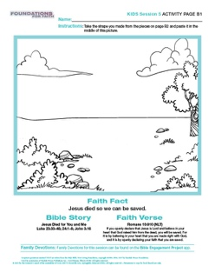
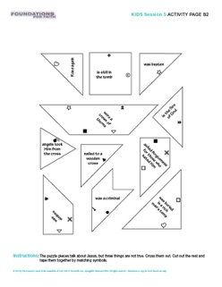
Our Faith Fact is We believe that . . . Jesus died so we can be saved. We learned a lot about Jesus in our Bible lesson today. Our Activity Page will help us remember some important things about Jesus, but it looks like you need to figure out how it all fits together.
- Hand out Activity Page B1 and B2 and scissors to each kid.
- Hand out the transparent tape for two kids to share.

Let’s read the directions and follow what they say to complete this page.

