

LEADER OVERVIEW

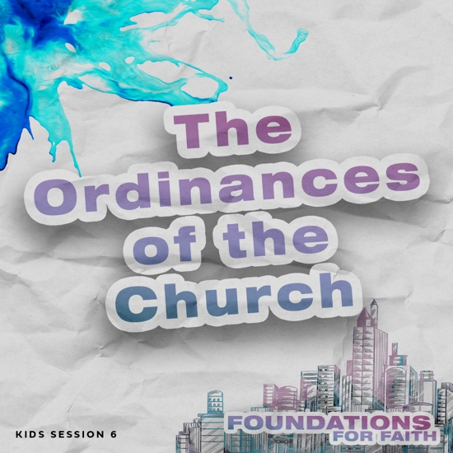
Foundations for Faith is designed to teach kids what we believe and why. These sessions cover core teachings—
or doctrines—that come from the Bible. Today’s session focuses on:

Foundation 6: We obey and remember Jesus when we take Communion and are baptized in water. The Bible commands everyone who accepts Jesus as Savior to be baptized in water. When we are completely covered by water, we show how Jesus took our sins away when He died. When we come out of the water, we show how we now have a brand-new life in Jesus.

Jesus’ followers share Holy Communion to remember His death on the Cross. The bread and grape juice used in Communion are symbols of Jesus’ body that was beaten for our healing and His blood that takes away our sins. Jesus commanded all those who accept Him as Savior to honor Him in Holy Communion until He comes back to take His followers to heaven.¹

In this session, kids will discover that Jesus gave us instructions to do two very important things when we become Christians: take Communion and be baptized in water. These ordinances help us remember the sacrifice Jesus made for us when He died on the Cross and the new life we have through Him.

Bible Lesson | Faith Fact
Jesus Taught Us to Remember Him  Matthew 28:18–20; Luke 22:14–20;  Romans 6:4; 1 Corinthians 11:23–26 | We believe that . . .  We obey Jesus through Communion and  water baptism.
Faith Verse
Matthew 28:19–20 (NLT)
“Therefore, go and make disciples of all the nations, baptizing them in the name of the Father and the Son and the Holy Spirit. Teach these new disciples to obey all the commands I have given you. And be sure of this: I am with you always, even to the end of the age.”

First time leading Foundations for Faith Kids?
Passing on what we believe to kids is important, so pray and invite God to guide you as you prepare and present this session. Then read through the session and consider how to best present it to the kids you lead. Always start with the Large Group teaching. Then add extra Small Group Activities if you have time. Some of the activities are designed for older or younger students, so consider which ones will best fit your group.

To find out more about all the resources available to help you lead and promote Foundations for Faith Kids, check out the Foundations for Faith Kids Overview.

_______________
To read the full, official version of the Statement of Fundamental Truths, visit ag.org/beliefs/statement-of-fundamental-truths

PREPARING FOR THE SESSION
You Will Need | Getting Ready
Large Group  - Bible  - Worship songs (Song options: “Holy Spirit Come” Official Lyric Video by Yancy, “It Is Finished” Official Lyric Video by Gateway Worship)  - Smartphone or timer  - Bottles of water, one per team  - Small cheese crackers, ten per team  - Communion cups, two per team  - Larger clear plastic cups, one per team  - Grape juice  - Small pitchers, one per team  - Paper towels  - Plastic tablecloth(s)  - Table(s)  - Whiteboard  - Marker  - Optional: Photos of yourself as a child  - Communion bread and juice as served in your church  - For groups not using a phone or tablet only, add:  - Projector or TV  - Laptop  - Foundations for Faith Countdown Video  - Faith Fact Slide  - Bible Lesson Video  - Teaching Point Slides 1–3  - Bible Story Slides 1–2  - Dirty penny  - 1 tsp of salt  - ¼ cup of vinegar  - Clear glass  - Piece of bread or whatever your church serves for Communion  - Cup of grape juice  Small Group Activities  - Glass or bowl of water  - Communion cup of juice  - Piece of bread or Communion wafer  - Small items, no more than twenty, including some that remind kids of Jesus (cross, Baby Jesus and manger from nativity, fish, round rock, etc.)  - Tray  - Towel  - Paper, one sheet per kid  - Pencils or pens, one per kid  - Male doll that can get wet  - Clear tub large enough to immerse the doll in  - Water  - Optional: Access to the church’s baptistry  - Optional: Consider having the pastor lead this activity  - Consider planning a time for kids to be baptized in water and share that at the end of this teaching.  - Pencils or pens, one per kid  - Faith Verse Slide  - Scissors  - Crayons or markers  - Pages to Print:  - Faith Fact Fun Pages  - Faith Verse Journal Page  - 4 Questions Pages  - Activity Page A and/or B | Large Group  - Download videos and slides if needed.  - Select worship song(s) and have them ready to play.  - Empty the bottles of water so they are half full.  - Pour the grape juice into the small pitchers, one per team.  - Set up the table(s) with stations for two teams. Place the items by the stations.  - Mix the salt and vinegar in the clear glass.  - Optional: Consider a Communion service as a response to this session. If so, follow the guidelines of your church and consider inviting parents (and possibly the congregation) to join the kids.  Small Group Activities  - Gather the items and place them on the tray. Cover them with the towel.  - Fill the tub with water.  - Arrange access to the baptistry.  - Invite the pastor to lead this activity.  - Print copies of the Faith Verse Journal Page, one per kid.  - Print and cut apart the 4 Questions Pages, one set per group. Keep questions and answers separate.  - Choose how to use this activity: Simple matching, Concentration-style find the pairs, etc.  - Print copies of the Activity Page A and/or Activity Page B, one per kid.

LARGE GROUP (45 Minutes)

INTRODUCTION

Countdown Video
- Play the Foundations for Faith Countdown Video. Encourage kids to say the Faith Facts with the video.
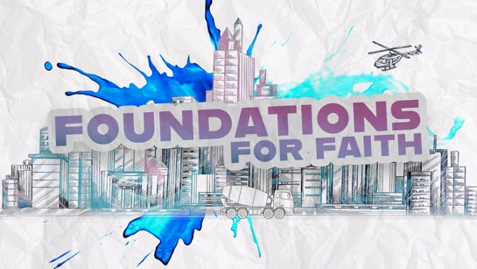

Welcome
Hi, kids! I’m glad you’re here. I love watching you learn the truths of the Bible. I hope you are reading God’s Word and praying when you are at home. Have you found a special place where you can be alone to pray? (Group response) It’s important to have a spot where you can be quiet and talk to God.

Today, I’m excited to tell you about two instructions in the Bible that Jesus wants us to do. (Show the Bible.) There are many instructions, but these two are special. We call them ordinances. That’s a big word that simply means it’s something Jesus ordered us to do like a command. It means they are really important for us to remember.

Faith Fact
We want to remember to obey these two ordinances: Communion and water baptism. So our Faith Fact today is: We believe that . . . We obey Jesus through Communion and water baptism. Can anyone guess what image represents today’s Faith Fact? (Allow responses.) Well, you can’t do these things without water, bread, and grape juice, so that’s exactly what our image shows.
- Show the Faith Fact Slide.

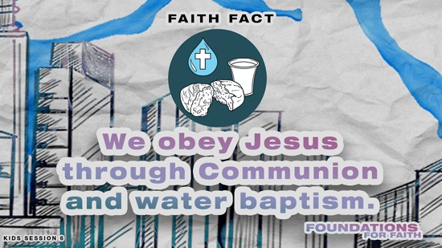

Let’s say today’s Faith Fact again. I’ll start the Faith Fact by saying, “We believe that . . .” That is your cue to finish the phrase with me. Let’s try it. We believe that . . . We obey Jesus through Communion and water baptism. Great! This time let’s add some actions (demonstrate). When you say, “Jesus,” point up. When we say, “Communion,” pretend to drink the grape juice. Then, when we say, “Water baptism,” hold your nose and bend down and touch the floor with your other hand. Think you can remember to do all of that? (Group response) Ready? We believe that . . . We obey Jesus through Communion and water baptism. Let’s say it one more time with the actions. We believe that . . . We obey Jesus through Communion and water baptism. I think we’re ready to start today’s session.

GAME | Minute to Win It
You Will Need | Getting Ready
- Smartphone or timer  - Bottles of water, one per team  - Small cheese crackers, ten per team  - Communion cups, two per team  - Larger clear plastic cups, one per team  - Grape juice  - Small pitchers, one per team  - Paper towels  - Plastic tablecloth(s)  - Table(s)  - Whiteboard  - Marker | - Empty the bottles of water so they are half full.  - Pour the grape juice into the small pitchers, one per team.  - Set up the table(s) with stations for two teams. Place the items by the stations.

Communion and water baptism use three elements to help us remember what Jesus has done for us: grape juice, bread, and water. We’ll learn a lot more about that later, but first, let’s have some fun. We’ll do these challenges boys against girls with two people competing in each challenge.

For the first challenge, we’ll use bottles of water. Players will take turns holding their bottle by the cap six to eight inches above the table and dropping the bottle so it stands upright on the table. They’ll keep going for one minute to see how many times each team can do it. I need everyone else to help me keep track of the score.
- Choose kids to compete and kids to keep track of the score on the whiteboard.
- Variation: Have the kids hold the water bottle upside down by the cap six to eight inches above the table and flip it over so it stands upright on the table.

For the second challenge, we’ll use crackers for our bread. Your team will have one minute to stack the cheese crackers as high as you can before time is up. The players must take turns placing the crackers and can’t hold the stack to keep it stable. The rest of the team will keep track of how many crackers you can stack. If the crackers fall, you can try again if there’s still time. You’ll get one point for each cracker in your team’s stack.
- Choose kids to compete and kids to keep track of the score on the whiteboard.

For the third challenge, you’ll take turns moving the grape juice from one cup to the other. First, players will carefully pour grape juice from the pitcher into the Communion cups. Then, they’ll move it into the big cup without spilling. Teams will get one point for each time the juice is poured into the larger cup. The team with the most juice in the large cup at the end of the time will get five points. At the end of the minute, I’ll soak up the spilled juice. The team with the least juice on the paper towel will get five points. Let’s go!
- Choose kids to compete and kids to keep track of the score on the whiteboard.
- Add up the scores and determine the winner.

WORSHIP

That was a lot of fun! Now, let’s turn our attention toward God. Who is ready to worship Him with me today? (Group response) Let’s worship Him together right now!
- Lead the kids in singing one or two praise songs. See options at the beginning of the session.

Prayer
When we worship God, we often think about singing praise songs to Him. Did you know that obeying what He wants us to do is worship, too? When we take Communion or get baptized in water after we become a Christian, we are worshipping Him. Prayer is worship. Let’s talk to God now.

Dear God, thank You for being here and loving us. Help us to learn from Your Word today why Communion and water baptism are so important for us to do. Amen.

BIBLE LESSON | Jesus Taught Us to Remember Him
You Will Need | Getting Ready
- Bible  - Teaching Point Slides 1–3  - Bible Story Slides 1–2  - Optional: Photos of yourself as a child  - Communion bread and juice as served in your church | - Download Teaching Point Slides 1–3.  - Download Bible Story Slides 1–2.

Today, we’ll look at what the Bible says to discover why We believe that . . . We obey Jesus through Communion and water baptism. To get started, let’s watch this video.

Video Introduction
- Play the Bible Lesson Video.
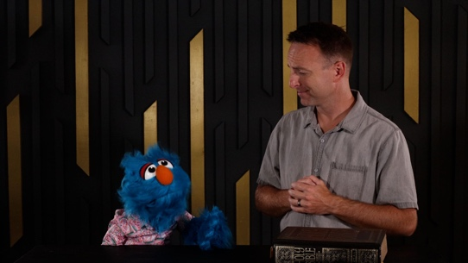

Anybody want to try Hank’s snack? Raise your hand. (Group response) Well, at least Jeremy had a chance to teach Hank a little about Communion and water baptism. Let’s find out more about what God’s Word says about why We believe that . . . We obey Jesus through Communion and water baptism.

Teaching Time
Have you ever looked at old family photos from before you were born? (Group response) It’s always fun to see the way people dressed and how the people have changed over time. It’s also good to remember where you came from and remind yourself of what makes your family special.
- Optional: Show photos of yourself as a child.

We don’t have any photos of Jesus to help us remember Him while He was growing up. But when Jesus lived on earth, He showed us two things we could do to remember and celebrate His life. Let’s find out more about that.
- Keep Large Group time moving along by having an adult read the verses aloud.

1. Remember, Jesus Gave His Life
- Show the Teaching Point 1 Slide.
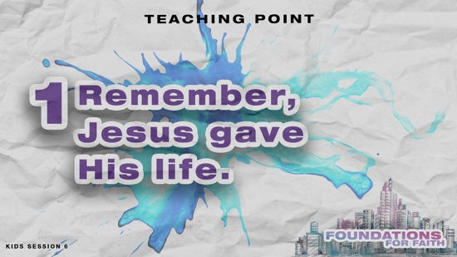

Throughout the Bible, God gave His people special ways to remember and celebrate important things He had done for them. For example, when God brought His people out of Egypt, He instructed them to celebrate Passover every year. It was a special feast when God’s people remembered how God had saved them from slavery in Egypt. God saved the Israelites from His final plague in Egypt when they spread the blood of a lamb or goat on the doorposts of their houses. Passover also reminded the Israelites that God had saved them before and that He would save them again.
More than a thousand years had passed since the Israelites came out of Egypt by the time Jesus walked on the earth. Do you think God’s people were still celebrating Passover every year? (Group response) Yes, they were!
- Show the Bible Story 1 Slide.

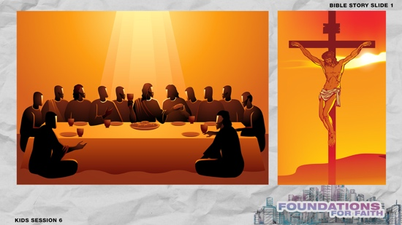

It was near the end of Jesus’ time on earth that He and His disciples ate their last Passover meal together. When they remembered how the lamb was sacrificed many years ago in Egypt, the disciples didn’t realize that Jesus had come to give His life for them so they could be saved from their sins. Jesus was going to be the Lamb whose blood would save all people. So He wanted to give them and us a new way to remember Him. Let’s see how Jesus wanted everyone to remember His death.
- Read Luke 22:14–20.

Wow! What did Jesus use when He told His disciples to remember Him? (Allow responses.) Jesus picked up the bread and a cup, and demonstrated how we can remember His death. We call it Communion. Communion is when we come together as Christians to eat bread and drink juice as we remember Jesus’ death on the Cross. It also reminds us that Jesus provides healing and that He’s coming back one day, but we’ll talk about those things in later sessions. Has anyone ever taken Communion before? (Group response)
- Show kids the Communion elements.

The bread represents Jesus’ body that was broken, and the juice represents His blood that was shed. Jesus gave His life so that we can have our sins forgiven and be saved. That’s an important thing for us to remember!

2. Remember, Jesus Gave Us a New Life
- Show the Teaching Point 2 Slide.
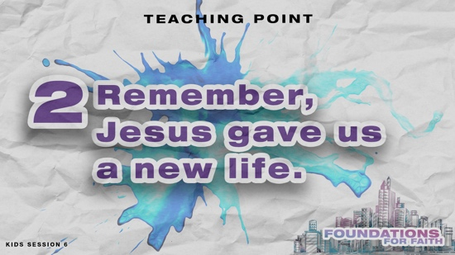

Jesus gave us another way to remember Him that He also did at the very beginning of His ministry. He didn’t just come to die for us. He came to give us a new life. About three years before Jesus died on the Cross, He visited His relative, John, at the River Jordan. Most people in that area didn’t know who Jesus was yet. God used John the Baptist to prepare people for Jesus’ coming. Part of preparing people for Jesus was John allowing people to first confess their sins. Then, he baptized them by submerging them in water.
- Show the Bible Story 2 Slide.

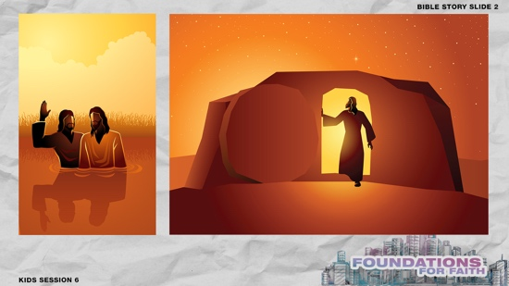

When Jesus showed up to be baptized, John was confused. At first, John refused to do it. John somehow knew that Jesus didn’t need to be baptized. Instead, Jesus chose to be baptized to set an example for us to follow. Jesus knew that water baptism was an important way for us to remember the new life God has given us through Jesus’ death and resurrection. Let’s read about what baptism means in the Bible.
- Read Romans 6:4.

Jesus set the example for all His followers to be baptized. That includes you and me. Once we’ve asked Jesus to forgive our sins and to be our Savior, we should be baptized. When we go under the water, it’s a reminder of Jesus’ death. Going down into the water reflects how we die to our selfish wants and leave that old life and our sins behind us. When we come up from the water, it’s a reminder of how Jesus rose from the dead. When we do this, we are rising to a new life with Jesus. Baptism is about leaving our old life behind, and showing the world we are committing to our new life with Jesus.

3. Remember, Jesus wants us to obey Him
- Show the Teaching Point 3 Slide.
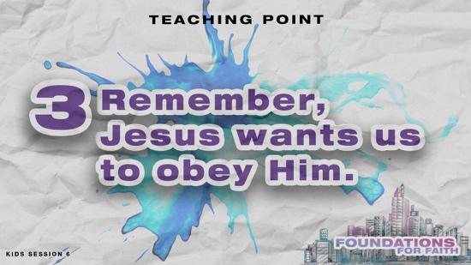

Jesus set the example for us to follow. He demonstrated Communion and water baptism, and He instructed us to do them, too. During some of His last instructions to His disciples, Jesus instructed or commissioned them to go into the world. Let’s listen to what He told them to do.
- Read Matthew 28:18–20.

Did you hear Jesus tell us about water baptism? (Group response) Jesus wanted His disciples to go into the world telling everyone the good news about Him. Jesus told the disciples to baptize those who chose to follow Him. He wants everyone to obey these commands.

That wasn’t the only instructions Jesus left for His followers. Several years later, the apostle Paul wrote about how Jesus had given instructions for how we should take Communion. Let’s read what Paul wrote.
- Read 1 Corinthians 11:23–26.

These verses were written by Paul years after Jesus went back to heaven. Were Jesus’ followers still remembering to take Communion? (Group response) They definitely were, and we still remember Jesus through Communion today.

Jesus wanted His disciples to take Communion and experience water baptism because these are reminders of His death and resurrection. When we remember Jesus’ death and resurrection, we are reminded of who Jesus is and everything He has done for us. Keeping that in mind, it’s much easier to remember why We believe that . . . We obey Jesus through Communion and water baptism.

OBJECT LESSON | New Life in Jesus
You Will Need | Getting Ready
- Dirty penny  - 1 tsp of salt  - ¼ cup of vinegar  - Clear glass | - Mix the salt and vinegar in the clear glass.

Water baptism is something that we do after we choose to commit to following Jesus. It’s a decision to allow Jesus to transform our whole life. It represents walking away from a life of sin and toward new life with Jesus! It’s something like this dirty penny.
- Hold up the penny. Then, put it in the liquid as you talk.

It goes into the liquid dirty, but it comes out clean! When we commit to following Jesus, we start a new life with Jesus. We’re clean just like the penny. (Hold up the clean penny.)

Can this coin get dirty again? (Group response) We can let our heart get dirty again, too. Only for us, our heart gets dirty from sin. Sometimes as life goes on, it can be easy to do the bad things we used to do. We make mistakes or mess up. It’s not always easy to follow Jesus.

Communion reminds us to stay on that right path and live our new life following Jesus. As we remember Jesus’ death, we are reminded of His sacrifice for us. That will help us to see our sin so that we can ask for His forgiveness and stay on the right path.

PRAYER AND RESPONSE
You Will Need | Getting Ready
- Piece of bread or whatever your church uses for Communion  - Cup of grape juice | No prep is needed for this activity.

- Consider playing a worship song softly in the background while kids pray.

When we hear and read God’s Word, we should respond. Today we talked about why We believe that . . . We obey Jesus through Communion and water baptism.
- Hold up the bread and juice.

Communion and water baptism are about remembering. At Communion when Christians take the bread and the juice, we take time to remember Jesus’ death on the Cross. Let’s do that remembering part right now. Close your eyes and remember how much Jesus loves you. Think about what it must have been like for Jesus to die such a painful death for you and me. Remember that Jesus suffered on the Cross so your sins could be forgiven. This is the perfect time to thank Him for forgiving you and loving you.
- Pause for a few moments while kids remember and reflect.

Now let’s talk to Jesus in prayer. Repeat after me.

Dear Jesus, this bread and cup of juice reminds me that You died on the Cross for my sins. I am grateful for all You have done in my life. I am so grateful that You have washed my sins away. I want to serve You and obey You, Jesus. In Your name I pray. Amen.

Optional: Salvation Prayer
If kids don’t know Jesus as their Savior, consider sharing about salvation. See the Salvation Guide.

DISMISSAL
Got more time? Choose one or more Small Group Activities to reinforce what kids are learning.

Thanks for joining me for an amazing time of remembering Jesus together! I love getting to learn more with you about what we believe!

Faith Fact Recap
- Show the Faith Fact Slide.

One truth we need to remember always is today’s Faith Fact. We believe that . . . We obey Jesus through Communion and water baptism. I’m so glad you came today! I can’t wait to see you next time.
- Send home the Activity Page(s) and Journal Page, if used.
- Tell everyone the date and time for the next session.
- Remind parents that there are Family Devotions available on the app.

SMALL GROUP ACTIVITIES

Choose one or more of these activities to extend kids’ learning as time allows. All activities are led by a small group leader.

GROUP CONNECTION | Remember Him
You Will Need | Getting Ready
- Glass or bowl of water  - Communion cup of juice  - Piece of bread or communion wafer  - Small items, no more than twenty, including some that remind kids of Jesus (cross, Baby Jesus and manger from nativity, fish, round rock, etc.)  - Tray  - Towel  - Paper, one sheet per kid  - Pencils or pens, one per kid | - Gather the items and place them on the tray. Cover them with the towel.

We talked about how We believe that . . . We obey Jesus through Communion and water baptism. What is one important thing you remember from the Bible lesson we heard today? (Allow responses.)
- Share something you remembered from the Bible Teaching Time.

Do you think you’re good at remembering things? (Group response) I’ve got a way we can find out. I have some items that are covered up right now. In just a moment, I’ll give you a little time to study them. Then, I’ll cover them back up, and you’ll write down as many items as you can remember. Let’s play.
- Optional: You may want to pair younger kids with a partner for this activity.
- Give kids a sheet of paper and a pencil.
- Uncover the items for about 30 seconds. Then, cover them again with the towel.
- Give kids time to write down the items they remember.

Count the items on your list. How many items did you remember? (Allow responses.) Let’s see if together we remembered everything we saw.
- Have kids take turns naming the items they wrote down.
- Uncover the items and compare results.

How did we do at remembering? (Group response) Working together to remember things is so much better than just trying to remember on your own. That’s one reason we remember Jesus by celebrating Communion and water baptism with others. We get to remember Jesus together. The Bible also helps us remember Him. Our Faith Fact reminds us that We believe that
. . . We obey Jesus through Communion and water baptism. Together we can remember and obey Him.

Prayer Time
We need Jesus’ help to remember all that He has done for us. We’ll pray about that in just a moment. First, who has a prayer need that you’d like the group to pray for?
- Have kids share and pray for each other’s prayer requests.
- Keep track of kids’ prayer requests and review them each time you meet.

Let’s pray together.

Dear Jesus, thank You so much for all You are doing for each one of us. Help us to remember what You have done for us by dying on the Cross. Help us to obey You and follow You in Communion, in water baptism, and throughout our life. We never want to forget all that You have done for us. Amen.

GAME | Who’s the Leader?
You Will Need | Getting Ready
No supplies are needed for this activity. | No prep is needed for this activity.

In our Bible lesson, we discovered that when we take Communion and are baptized in water, we’re obeying Someone. Who is it? (Group response) Both Communion and water baptism are things we do that show others we are following Jesus. Let’s play a game about that.
- Have the kids sit in a circle.

I’ll choose one person to be “It.” That person will stand in the middle of the circle and close their eyes tightly. Then, I’ll choose one of you to be leader. The leader will start an action, like clapping or nodding your head. Everyone else needs to quickly follow the leader. The person in the middle will open their eyes. When everyone is following, the leader will change the action and do a different action for everyone to follow. Meanwhile, the person who’s “It” will try to guess who the leader is. Let’s play.
- Choose kids to be “It” and the leader. Then, play the game.
- Keep playing until everyone has had a turn to be “It” or the leader if time allows.

FAITH FACT ACTIVITY | Water Baptism Tour and Teaching
You Will Need | Getting Ready
- Male doll that can get wet  - Clear tub large enough to immerse the doll in  - Water  - Optional: Access to the church’s baptistry  - Optional: Consider having the pastor lead this activity  - Consider planning a time for kids to be baptized in water and share that at the end of this teaching. | - Fill the tub with water.  - Arrange access to the baptistry.  - Invite the pastor to lead this activity.

Let’s focus on water baptism. We get baptized after we become Christians. Even Jesus was baptized in water when He lived on earth. Let’s talk more about it.
- Optional: Take kids on a tour of the baptistry, showing them where people wait before they are baptized. Then let kids walk down into the empty pool. If your group is small, consider doing the teaching there.

When we are baptized in water, we’re telling everyone that Jesus is the only God we’re going to serve for the rest of our life. When we become Christians, we make Jesus our Leader and ask Him to forgive our sins. He can do that because He paid for our sins when He died on the Cross for us.
- Take the doll and stand it up in the water.

When we’re baptized, we go down into the water. This represents being buried like Jesus was. (Dip the doll completely under the water.) It reminds us that our sins have been washed away. Then, when we come up out of the water, we remember how Jesus was raised from the dead. (Raise the doll out of the water.) We too are raised out of our old life as a new creation who is a follower of Jesus. We obey Jesus when we are baptized in water.
- Share your testimony of being baptized in water.
- Allow kids who have been baptized to share with the group.
- Give kids an opportunity to ask questions about being baptized.

FAITH VERSE JOURNAL
You Will Need | Getting Ready
- Pencils or pens, one per kid  - Faith Verse Journal Page, one per kid  - Faith Verse Slide | - Print copies of the Faith Verse Journal Page, one per kid.
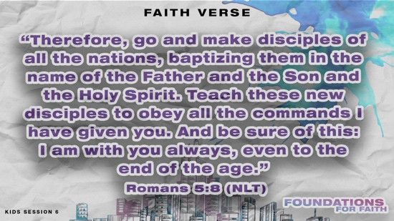
- Optional: Show the Faith Verse Slide.

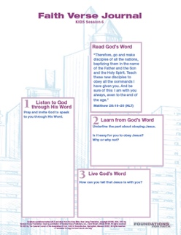
“Therefore go and make disciples of all the nations, baptizing them in the name of the Father and the Son and the Holy Spirit. Teach these new disciples to obey all the commands I have given you. And be sure of this: I am with you always, to the very end of the age.”
Matthew 28:19–20 (NLT)

God wants to speak to us through His Word. Let’s look at today’s Faith Verse and see what He might want to say to us through it.
- Hand out the Faith Verse Journal Page and pencils. Guide kids through the activity.

4 FAITH QUESTIONS
You Will Need | Getting Ready
- Scissors  - 4 Questions Pages, one set per group | - Print and cut apart the 4 Questions Pages, one set per group. Keep questions and answers separate.  - Choose how to use this activity: Simple matching, Concentration-style find the pairs, etc.
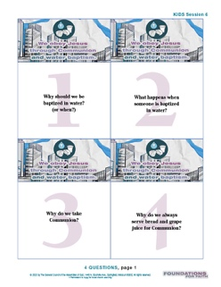
Who’s ready for a challenge? (Group response) Today, we’ve learned a very important foundation for our faith. We believe that . . . We obey Jesus through Communion and water baptism. Let’s find out what more we need to know about that. [Answers: 1=D, 2=B, 3=C, 4=A]
- Proceed with the activity you chose using the 4 Questions Pages cards.
- Discuss what’s written on each card as time allows.

ACTIVITY PAGE A | Following Instructions (A simpler activity for younger kids)
You Will Need | Getting Ready
- Crayons or markers  - Activity Page A, one per kid | - Print copies of Activity Page A, one per kid.
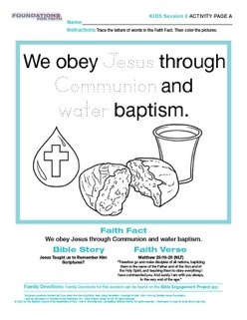
In our Bible lesson, we talked about two important things that Jesus wants Christians to do. What are they? (Allow responses.) The answer is in our Faith Fact. We believe that . . . We obey Jesus through Communion and water baptism.
- Hand out the Activity Page A and crayons or markers to each kid.

First, trace the letters of some important words in our Faith Fact. Then, let’s see how carefully you can obey my instructions as you color the pictures about our Faith Fact. First, color the cross red to help us remember what Jesus did for us. (Pause while kids color.) What color should the water drop be? (Allow responses.) Color it blue. (Pause while kids color.) Next, color the juice purple. (Pause while kids color.) Finally, color the bread yellow or brown. (Pause while kids color.) Great job obeying my instructions. I hope you always remember to obey Jesus’ instructions because We believe that . . . We obey Jesus through Communion and water baptism.

ACTIVITY PAGE B | What’s Missing?
You Will Need | Getting Ready
- Pencils, one per kid  - Activity Page B, one per kid | - Print copies of Activity Page B, one per kid.

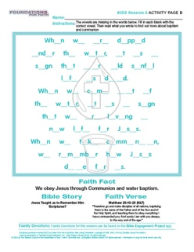
We discovered today that there are a couple of ways we remember what Jesus did for us. We believe that . . . We obey Jesus through Communion and water baptism. Something is missing from our relationship with Him if we don’t obey Him in these ways.
- Hand out a copy of the Activity Page B and a pencil to each kid.

See if you can figure out what the missing letters are to find out more about the meaning of Communion and water baptism.

