

LEADER OVERVIEW
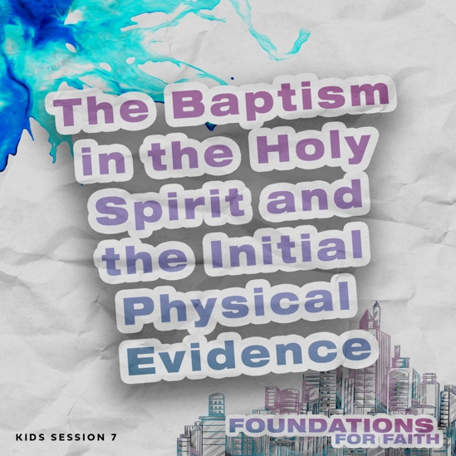
Foundations for Faith is designed to teach kids what we believe and why. These sessions cover core teachings—
or doctrines—that come from the Bible. Today’s session focuses on:

Foundation 7: The baptism in the Holy Spirit is God’s gift to us. Jesus promised a special gift—the baptism in the Holy Spirit—to everyone who believes in Him. The baptism in the Holy Spirit gives us power to live and work for God. The Holy Spirit also gives us special gifts to help the Church grow strong and healthy.

Foundation 8: When we are baptized in the Holy Spirit, we will speak in tongues. A person who is baptized in the Holy Spirit will speak in a language he or she has never learned. God may give some people a special gift of speaking in an unknown language to help the Church, but anyone who follows Jesus can be baptized in the Holy Spirit and receive His power.

In this session, kids will discover that the baptism in the Holy Spirit is God’s gift to us. When we’re baptized in the Holy Spirit, He is more active in our life, and we know we’ve received that gift when we speak in tongues. He also gives us power to share our faith with others. The Holy Spirit wants to be our Coach and our Guide to help us become more like Jesus.

Bible Lesson | Faith Fact
The Holy Spirit Baptizes People  Acts 1:3–5, 8; 2:1–4, 38–39 | We believe that . . .  When we are baptized in the Holy Spirit, we will speak in tongues.
Faith Verse
Acts 2:4 (NLT)
And everyone present was filled with the Holy Spirit and began speaking in other
languages, as the Holy Spirit gave them this ability.

PREPARING FOR THE SESSION
You Will Need | Getting Ready
Large Group  - Bible  - Worship songs (Song options: “Holy Spirit Come” Official Lyric Video by Yancy, “It Is Finished” Official Lyric Video by Gateway Worship)  - Large open area for playing the game  - Two clear glasses of water  - Two packets of Alka-Seltzer®  - For groups not using a phone or tablet only, add:  - Projector or TV  - Laptop  - Foundations for Faith Countdown Video  - Faith Fact Slide  - Bible Lesson Video  - Teaching Point Slides 1–3  Small Group Activities  - Paper cutter or scissors  - Crayons or markers  - Card stock (optional)  - Door or hard surface for kids to knock on (floor, table, wall, etc.)  - Faith Fact Activity Audio Track  - Pencils or pens, one per kid  - Faith Verse Slide  - Scissors  - Red, orange, and yellow tissue paper or construction paper  - Pencils or pens, one per kid  - Glue sticks, one per kid  - Crayons or markers  - Pages to Print:  - Group Connection Page  - Faith Verse Journal Page  - 4 Questions Pages  - Activity Page A and/or B | Large Group  - Download videos and slides if needed.  - Select worship song(s) and have them ready to play.  Small Group Activities  - Print and cut apart the Group Connection Page, one per four kids. Print on card stock (optional).  - Print the Faith Verse Journal Page, one per kid.  - Print and cut apart the 4 Questions Pages, one set per group. Keep questions and answers separate.  - Choose how to use the 4 Questions activity: Simple matching, Concentration-style find the pairs, etc.  - Cut the colored paper into small pieces.  - Print copies of Activity Page A and/or Activity Page B, one per kid.

LARGE GROUP (45 Minutes)

INTRODUCTION

Countdown Video
- Play the Foundations for Faith Countdown Video. Encourage kids to say the Faith Fact with the video.
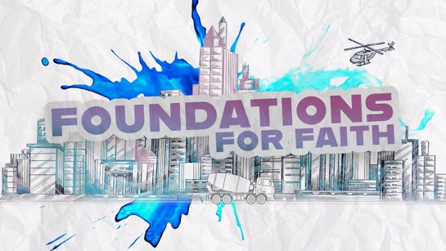

Welcome
Welcome, everyone! It’s great to see you today. We have something so exciting to talk about that it may change your life forever. Today, we’ll learn about one of God’s special gifts for Christians. We already know that Jesus gave His life to forgive our sins so that we can become Christians. Then, God the Father sent another Gift to us to help us live our life for Him. That Gift is the Holy Spirit.

Faith Fact
When we’re filled with the Holy Spirit, we call it the baptism in the Holy Spirit. We can know we are baptized in the Holy Spirit because we’ll speak in tongues, a language that we haven’t learned that God allows us to speak. Our Faith Fact says: We believe that . . . When we are baptized in the Holy Spirit, we will speak in tongues. Can anyone guess what image represents today’s Faith Fact? (Allow responses.) It’s fire. We’ll discover why that represents being baptized in the Holy Spirit later.
- Show the Faith Fact Slide.
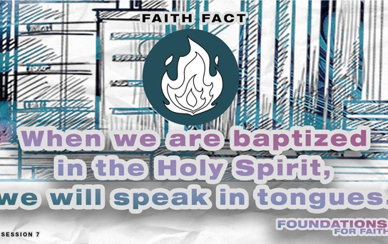

Let’s say today’s Faith Fact again. I’ll start the Faith Fact by saying, “We believe that . . .” That’s your cue to finish the phrase with me. Let’s try it. We believe that . . . When we are baptized in the Holy Spirit, we will speak in tongues. Great! This time let’s add some actions (demonstrate). When you say, “When we are baptized in the Holy Spirit,” lift your hands over your head like you are worshipping or asking God for something and then bring your hands down to cover your heart. Then, when you say, “we will speak in tongues,” bring your fingertips to your mouth and then move them out to represent speaking. Let’s try it. We believe that . . . When we are baptized in the Holy Spirit, we will speak in tongues. Let’s say it one more time with the actions. We believe that . . . When we are baptized in the Holy Spirit, we will speak in tongues. I think we’re ready to find out more about God’s gift of the Holy Spirit.

GAME | The Helper
You Will Need | Getting Ready
- Large open area to play the game | No prep needed for this activity.

After we’re baptized in the Holy Spirit, He helps us to grow closer to God and become more like Jesus. The Holy Spirit helps us to pray and tell others about Jesus. Let’s play a game about helping. To play this game, you’ll be on a team. The goal is to get everyone on your team to the finish line. But you can only take baby steps to get there. That means with every step you’ll touch the heel of your back foot to the toe of your front foot (demonstrate).

Walking that way represents going through life on our own. We can do good things and grow closer to God, but that isn’t God’s best plan for us. He wants to give us the Holy Spirit to help us. Each team will choose one member to be the Helper. When the Helper holds someone’s hand, they can move as fast as they can to the finish line together. They can even run there. When that team member is across the finish line, the Helper can go to another teammate to help until everyone is across the line. Let’s play.
- Divide group into teams. Let each team choose their Helper and play the game.

How did the Helper make a difference for your team? (Allow responses.) When we’re baptized in the Holy Spirit, He will make a big difference in our life, too.

WORSHIP

The gift of the Holy Spirit is just one of many reasons we have to praise God. Who is ready to worship Him with me today? (Group response) Let’s do that by singing right now!
- Lead the kids in singing one or two praise songs. See options at the beginning of the session.

Prayer
Let’s thank God for the amazing gift of the Holy Spirit. Pray with me.

Dear God, You think of everything. You knew we would need help to become more like Jesus, so You gave us the gift of the baptism in the Holy Spirit. Thank You for that amazing gift! Help us to learn more about the Holy Spirit today. Amen.

BIBLE LESSON | The Holy Spirit Baptizes People
You Will Need | Getting Ready
- Bible  - Teaching Point Slides 1–3 | - Download the Teaching Point Slides 1–3.

Today, we’ll look at what the Bible says to discover why We believe that . . . When we are baptized in the Holy Spirit, we will speak in tongues. To get started, let’s watch this video.

Video Intro
- Play the Bible Lesson Video.

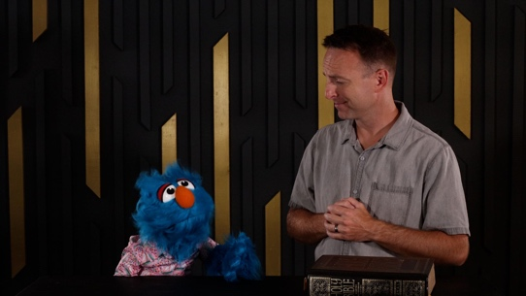

The good news is that Hank wanted to learn about the baptism in the Holy Spirit just like us. But he definitely didn’t have all the facts right! Let’s find out more about what God’s Word says about why We believe that . . . When we are baptized in the Holy Spirit, we will speak in tongues.

Teaching Time
Have you ever tried doing something without the right tools? (Group response) Imagine trying to bake a cake without an oven or build a house without any tools. It would be very frustrating and almost impossible! Well, Jesus left His disciples with an almost impossible task, too. He wanted that small group of people from the small country of Israel to spread His message to the entire world. It must have felt like an impossible task to do, but Jesus had a plan to help them! Let’s find out what Jesus had planned. Turn to Acts 1:3–5 to see what Jesus told His disciples before He went back to heaven.
- Keep Large Group time moving by having an adult read the verses aloud.

- The baptism in the Holy Spirit was promised to Jesus’ followers.
- Show the Teaching Point 1 Slide.
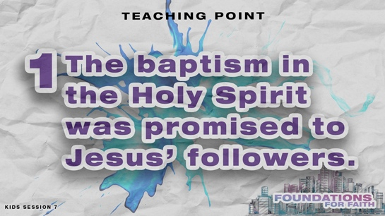

- Read Acts 1:3–5.

What did Jesus tell His disciples to wait for? (Allow responses.) They needed to wait for the gift that God had promised to send. Have you ever had to wait for a gift? (Group response) How does it feel when you have to wait for your birthday or Christmas presents? (Group response) It can be so hard waiting for good things. Remember, the disciples had seen Jesus after He was raised from the dead. They knew that Jesus is God, and they wanted everyone to know the good news about what He had done. That must have made it really hard for them to obey Jesus and wait, rather than hurrying out to tell people about Jesus.

Jesus wanted people to know the good news about salvation, but He knew it was more important for the disciples to have everything they needed first. Jesus promised the baptism in the Holy Spirit because the Holy Spirit would give the disciples everything they needed to do the task Jesus had given them. Did you know Jesus’ promise of the Holy Spirit wasn’t just for His disciples? It’s for everyone. We can also receive this incredible gift from God if we ask for it and wait for God to give it to us.

2. The Holy Spirit first came on the Day of Pentecost.
- Show the Teaching Point 2 Slide.
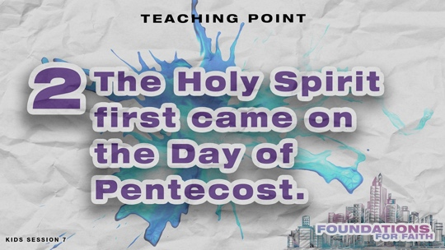

The disciples waited for days after Jesus went back to heaven. They spent time praying and worshipping God in the upper room of a house. They probably didn’t know what it would be like when God would send the Holy Spirit. Then, the feast of Pentecost came. Jews from many different nations were gathered in Jerusalem for this yearly celebration. Let’s find out what happened.
- Read Acts 2:1–4.

Wow! Have you ever experienced anything like that? (Group response) Jesus kept His promise. He sent the Holy Spirit to help the disciples. The believers who were gathered there that day received the gift of the Holy Spirit. You might be wondering: How do we know that they were baptized in the Holy Spirit? We know they were baptized in the Holy Spirit because they spoke in a language from God that they had never learned. We call that speaking in tongues. That was something the disciples never could have done on their own. It proved that they had been baptized in the Holy Spirit.

Did you know people still experience the baptism in the Holy Spirit today? (Group response) There usually isn’t a sound of rushing wind or what looks like flames of fire that settles on people. But, we know that people experience the baptism in the Holy Spirit because God allows them to speak in a new language that they haven’t learned. With this new language, people can pray and talk privately with God to strengthen their faith. That’s why We believe that . . . When we are baptized in the Holy Spirit, we will speak in tongues.

3. The Holy Spirit gives us power to live and work for God.
- Show the Teaching Point 3 Slide.
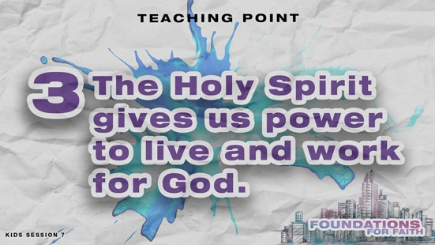

Remember why the disciples needed the Holy Spirit? They had a big, scary, impossible task ahead of them—to help the whole world know about Jesus! But the same leaders who wanted Jesus to die wouldn’t be happy with the disciples if they were spreading Jesus’ message to the world. Those leaders had Jesus killed, so it makes sense for His disciples to be afraid.

There was one disciple who had struggled with fear for a while. When Jesus was arrested, Peter was so afraid of being arrested that he lied three times by telling people that he didn’t know Jesus. After Peter was baptized in the Holy Spirit, he was completely changed! He stood in front of a big crowd and preached with boldness. Let’s read about it.
- Read Acts 2:38–39.

Peter’s life was forever changed on the Day of Pentecost. He led three thousand people to become Christians and join the Church on that one day. The Holy Spirit gave him boldness. The Church grew quickly because the power of the Holy Spirit helped the disciples do the difficult things Jesus had told them to do. When we experience the baptism in the Holy Spirit, we are filled with the power of the Holy Spirit, too. That’s exactly what Jesus promised before He went back into heaven.
- Read Acts 1:8.

The Holy Spirit fills us with power so we can live for God and go do His work! It’s not about improving our own life. Instead, the baptism in the Holy Spirit is about giving us the boldness and power to love God more and show His love to others.

OBJECT LESSON | Holy Spirit Power
You Will Need | Getting Ready
- Two clear glasses of water  - Two packets of Alka-Seltzer® | No prep is needed for this activity.

The Bible tells us that when we make the decision to believe in Jesus and ask Him to forgive our sins, He forgives and saves us, and the Holy Spirit lives in us. That means the Holy Spirit lives in every Christian.
- Add an unopened packet of Alka-Seltzer to one of the glasses of water.

When we’re saved, God gives us the Holy Spirit to lead and guide us throughout our everyday life. For example, have you ever been tempted to do something wrong, and you felt funny on the inside like you shouldn’t do it? (Group response) That feeling was the Holy Spirit guiding you to do the right thing.

Since the Holy Spirit is already living in every Christian, why do we also need to be baptized in the Holy Spirit? Just like Jesus’ disciples, we need everything the Holy Spirit has to offer us if we want to complete the plans God has for us. A lot of Christians just live their life with the Holy Spirit in them, but they aren’t full of His power.

If we aren’t filled with the Holy Spirit’s power, then we’re missing out on so much of the help that He can give us! When we receive the baptism in the Holy Spirit, we are filled with God’s power.
- Open the other packet of Alka-Seltzer and add it to the other glass of water.

God’s power overflows in our life. The Holy Spirit helps us as we tell others about Jesus and pray for those in need. He may even use us in surprising ways like praying for people who need to be healed.

PRAYER AND RESPONSE
You Will Need | Getting Ready
No supplies are needed for this activity. | No prep is needed for this activity.

- Consider playing a worship song softly in the background while kids pray.

When we hear and read God’s Word, we should respond. Today, we talked about why We believe that . . . When we are baptized in the Holy Spirit, we will speak in tongues.

The disciples prayed and worshipped as they waited for the Gift Jesus had talked about. God did send His promised gift, and the disciples were baptized in the Holy Spirit. Today, we’ll respond by praying for the power of the Holy Spirit. Who would like to receive this gift from God? (Allow responses.)

Let’s pray and ask God for this gift. If you seek God with all your heart, then God is faithful to hear your request and answer. Let’s pray together and trust God’s timing. He may baptize you in the Holy Spirit right away. Or like the disciples, it might not happen right away, and you’ll need to wait and keep asking. Remember, you’ll know that you have received this gift from God when you speak in tongues.
- Consider having those who have received the baptism in the Holy Spirit pray for those who haven’t.

Dear God, thank You for giving the Holy Spirit to be our Helper. Thank You for also offering the power of the Holy Spirit, who helps us do Your plans for our life. Amen.

Optional: Salvation Prayer
If kids don’t know Jesus as their Savior, consider sharing about salvation. See the Salvation Guide.

DISMISSAL
Got more time? Choose one or more Small Group Activities to reinforce what kids are learning.

What an amazing time I’ve had learning more about the Holy Spirit with you! We talked about how we can ask God to baptize us in the Holy Spirit. We learned that when He does, we’ll speak in a language that He gives us that we haven’t learned. Best of all, the Holy Spirit will help us in so many ways! Who remembers one way the Holy Spirit helps us? (Allow responses.)

Faith Fact Recap
- Show the Faith Fact Slide.
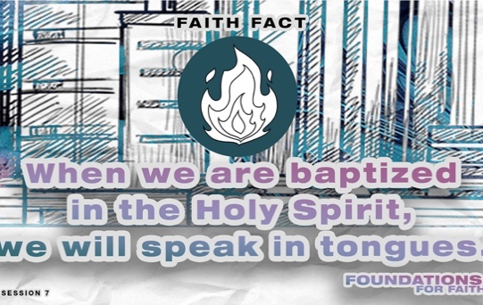

One truth we need to remember always is our Faith Fact. We believe that . . . When we are baptized in the Holy Spirit, we will speak in tongues. I’m so glad you came today! I can’t wait to see you next time.
- Send home the Activity Page(s) and Journal Page, if used.
- Tell everyone the date and time for the next session.
- Remind parents that there are Family Devotions available on the app.

SMALL GROUP ACTIVITIES

Choose one or more of these activities to extend kids’ learning as time allows. All activities are led by a small group leader.

GROUP CONNECTION | Power to Grow
You Will Need | Getting Ready
- Paper cutter or scissors  - Crayons or markers  - Card stock (optional)  - Group Connection Page | - Print and cut apart the Group Connection Page, one per four kids. Print on card stock (optional).
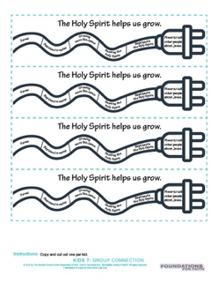

We talked about how We believe that . . . When we are baptized in the Holy Spirit, we will speak in tongues. Think about your answer to these questions. Then, choose one to share with the group. (Have kids sit in a circle on the floor.)
- What was your favorite part of the Bible lesson today?
- What is one thing you learned about the Holy Spirit?

Our Faith Fact tells us one thing that will happen when we’re baptized in the Holy Spirit. What is it? (Allow responses.) We’ll speak in tongues, or a new language. The Bible tells us another important thing about the Holy Spirit. Listen carefully as I read Acts 1:8, “But you will receive power when the Holy Spirit comes upon you. And you will be my witnesses, telling people about me everywhere—in Jerusalem, throughout Judea, in Samaria, and to the ends of the earth.”

What did Jesus say in this verse? (Allow responses.) The Holy Spirit gives us power to tell other people about Jesus everywhere we go. Raise your hand if you’ve told someone about Jesus and how much He loves them. (Group response)
- Hand out a bookmark from the Group Connection Page and crayons to each kid.

This bookmark is a reminder of some of the ways we can grow closer to God. No matter how long someone has been a Christian, they should never stop growing. The Holy Spirit helps every believer with that. On this bookmark are some of the ways we grow. Color in the parts of the cord that are already true about you. Then, put this bookmark in your Bible as a reminder to keep asking God to help you grow closer to Him in all these ways.
- Talk with kids as they fill out the bookmarks. This activity will help you to know where they are on their faith journey.

Prayer Time

Let’s pray together now. Who has a prayer need that you’d like the group to pray for?
- Have kids share and pray for each other’s prayer requests.
- Keep track of kids’ prayer requests and review them each time you meet.

Today, we’ve talked a lot about the Holy Spirit. Let’s thank God for that special gift now.

Dear God, thank You for the amazing gift of the Holy Spirit. I pray that each person in our group will be baptized in the Holy Spirit and keep growing closer to You. Help all of us to tell others about Jesus, too. Amen.

GAME | Knock, Knock Relay
You Will Need | Getting Ready
- Door or hard surface for kids to knock on (floor, table, wall, etc.) | No prep is needed for this activity.

Our game today is called Knock, Knock Relay. It teaches us about the baptism in the Holy Spirit, but I’ll wait to tell you how it does that after we play. You’ll each have a turn to run to the door and knock. There’s always a catch. Before it’s your turn, I’ll whisper to each of you how many times you need to knock before you can open the door. We’ll count along while you knock. Then, you’ll run back to the group, so the next person can go. We’ll keep playing until everyone has had a chance to knock and open the door.
- Optional: Time how long it takes to play the game.
- Whisper a different number of knocks from 1 to 20 to each kid.

That was fun! Here’s how the game ties into why We believe that . . . When we are baptized in the Holy Spirit, we will speak in tongues. We learned that we need to ask God to baptize us in the Holy Spirit. With salvation, God responds immediately when we ask. However, He doesn’t always baptize everyone in the Holy Spirit right away. Remember how the disciples had to wait? (Group response) Sometimes we need to keep asking, too. If you’ve asked God to baptize you in the Holy Spirit and it hasn’t happened yet, keep on asking. Then, be patient and trust that God will answer at just the right time.

FAITH FACT ACTIVITY | Speaking in Tongues
You Will Need | Getting Ready
- Faith Fact Activity Audio Track | No prep needed for this activity.

Our Faith Fact says We believe that . . . When we are baptized in the Holy Spirit, we will speak in tongues. In our Bible story, we learned that Peter and other believers spoke in languages they didn’t know when they were baptized in the Holy Spirit. There was a crowd around, and the other people understood what the believers were saying. Maybe it sounded a little like this. Listen to see if you understand what is being said. Raise your hand when you do.
- Play the Faith Fact Activity Audio Track recording.



Did anyone understand everything that these people were saying? (Group response) I’m not surprised. Everyone was speaking a different language, but they were all saying the same thing. They were saying our Faith Verse. How many of them do you think God understands? (Allow responses.)
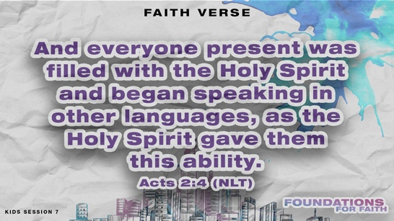
- Optional: Show the Faith Verse Slide.

When Christians are baptized in the Holy Spirit, God gives them the ability to pray in a language they don’t know. We call that speaking in tongues. When we’re speaking in tongues, we’re saying words of prayer and praise to God. We don’t understand what we’re saying, but God does. Speaking in tongues isn’t just something we do to show we’ve been baptized in the Holy Spirit. Ephesians 6:18 reminds us to pray in the Spirit often.

FAITH VERSE JOURNAL
You Will Need | Getting Ready
- Pencils or pens  - Faith Verse Journal Page, one per kid  - Faith Verse Slide | - Print copies of the Faith Verse Journal Page, one per kid.
- Optional: Show the Faith Verse Slide.

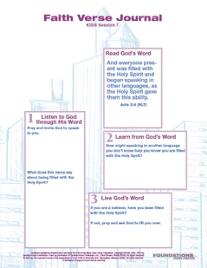
And everyone present was filled with the Holy Spirit and began speaking in other languages, as the Holy Spirit gave them this ability.
Acts 2:4 (NLT)

God wants to speak to us through His Word. Let’s look at today’s Faith Verse and see what He might want to say to us through it.
- Hand out the Faith Verse Journal Page and pencils. Guide kids through the activity.

4 FAITH QUESTIONS
You Will Need | Getting Ready
- Scissors  - 4 Questions Pages, one set per group | - Print and cut apart the 4 Questions Pages, one set per group. Keep questions and answers separate.  - Choose how to use this activity: Simple matching, Concentration-style find the pairs, etc.
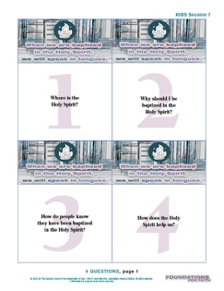
Who’s ready for a challenge? (Group response) Today, we’ve learned about a very important foundation for our faith. We believe that . . . When we are baptized in the Holy Spirit, we will speak in tongues. Let’s find out what more we need to know about that. [Answers: 1=B, 2=D, 3=A, 4=C]
- Proceed with the activity you chose using the 4 Questions Pages cards.
- Discuss what’s written on each card as time allows.

ACTIVITY PAGE A | Pentecost Sight and Sounds (A simpler activity for younger kids)
You Will Need | Getting Ready
- Red, orange, and yellow tissue paper or construction paper  - Pencils or pens, one per kid  - Glue sticks, one per kid  - Crayons or markers  - Activity Page A | - Cut the colored paper into small pieces.  - Print copies of Activity Page A, one per kid.

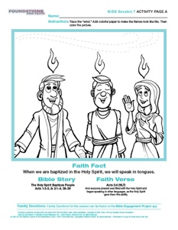
Our Bible story was about the very first time followers of Jesus were baptized in the Holy Spirit. God made sure it was unforgettable for them. Everyone saw and heard amazing things that day.
- Hand out the Activity Page A and crayons to each kid.

Jesus promised that He would send them a special gift, so His followers were together praying. First, they heard a sound like a loud wind. Can you trace the lines of the wind on your paper?
- Pause while kids trace the wind lines.

Our symbol for our Faith Fact is a flame. Does anyone remember why that was important in our Bible story? (Allow responses.) Everyone there saw what looked like flames of fire over each person’s head. These flames in our picture don’t look much like fire right now. Let’s see if we can help them to look more real.
- Give kids a small piece of each color of paper. Have them glue pieces of red, orange, and yellow paper on top of each flame.
- Let them color the rest of the picture.

That day everyone there was baptized in the Holy Spirit and began speaking in a language that they hadn’t learned. The Holy Spirit still baptizes people today. We may not hear the sound of wind or see fire above someone’s head, but our Faith Fact tells us what we will hear. Say it with me as a reminder. We believe that . . . When we are baptized in the Holy Spirit, we will speak in tongues.

ACTIVITY PAGE B | Holy Spirit Match Up
You Will Need | Getting Ready
- Pencils, one per kid  - Activity Page B, one per kid | - Print copies of Activity Page B, one per kid.
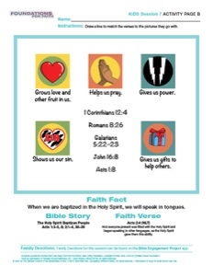
We believe that . . . When we are baptized in the Holy Spirit, we will speak in tongues. That’s just the beginning of many amazing ways the Holy Spirit helps us.
- Hand out a copy of the Activity Page B and a pencil to each kid.

On this page are pictures that represent ways the Holy Spirit helps us. You’ll need to look up each of the Bible verses. Then, draw a line from the Bible verse to the picture that best matches what it says about the Holy Spirit.
- Assist kids as needed to complete the activity. You may want to do the page together.

To read the full, official version of the Statement of Fundamental Truths, visit ag.org/beliefs/statement-of-fundamental-truths

