

LEADER OVERVIEW
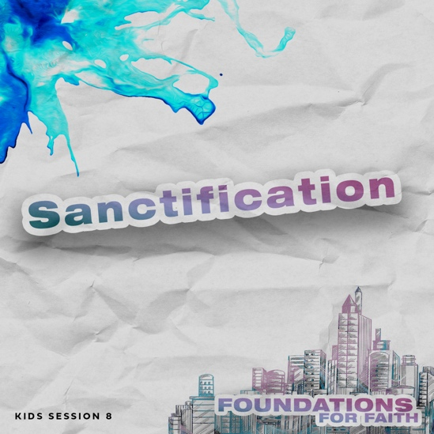
Foundations for Faith is designed to teach kids what we believe and why. These sessions cover core teachings—
or doctrines—that come from the Bible. Today’s session focuses on:

Foundation 9: With God’s help, we can be more like Jesus. Sanctification means giving ourselves to God and doing what is right. The Holy Spirit helps us to make choices that please God and to say no to sin.

In this session, kids will discover that sanctification is a process that begins when we invite Jesus to be our Savior, but it takes our whole life to become more like Him. As we grow to be more like Jesus with God’s help, other people will see Him in us.

Bible Lesson | Faith Fact
The Rich Young Ruler  Mark 10:17–27; Romans 12:1–2 | We believe that . . .  We can be more like Jesus with God’s help.
Faith Verse
Romans 12:2 (NLT)
Don’t copy the behavior and customs of this world,
but let God transform you into a new person by changing the way you think.

First time leading Foundations for Faith Kids?
Passing on what we believe to kids is important, so pray and invite God to guide you as you prepare and present this session. Always start with the Large Group teaching. Then, add extra Small Group Activities if you have time. Some of the activities are designed for older or younger students, so consider which ones will best fit your group.

To find out more about all the resources available to help you lead and promote Foundations for Faith Kids, check out the Foundations for Faith Kids Overview.
PREPARING FOR THE SESSION
You Will Need | Getting Ready
Large Group  - Bible  - Red balloons, twenty to thirty  - Tarp or floor-safe tape to mark the playing area, about 10’ x 10’  - Smartphone with timer or stopwatch  - Worship songs (Song options: “All Around” Official Lyric Video by Planet-  shakers; “More Like Jesus” Lyric Video by Passion)  - Balloons, two  - BBQ skewer (wooden or metal)  - Vegetable oil  - Paper towel  - For groups not using a phone or tablet only, add:  - Projector or TV  - Laptop  - Foundations for Faith Countdown Video  - Faith Fact Slide  - Bible Lesson Video  - Teaching Point Slides 1–3  - Bible Lesson Slides 1–2  Small Group Activities  - Cup to hold the slips, one per group  - Bottles of water, two per group  - Red food coloring  - Permanent marker  - Optional: Funnel  - Pencils or pens, one per kid  - Faith Verse Slide  - Scissors  - Crayons or markers  - Pages to Print:  - Game Page  - Faith Verse Journal Page  - 4 Questions Pages  - Activity Page A and/or B  - Activity Page B Answer Page | Large Group  - Download videos and slides if needed.  - Select worship song(s) and have them ready to play.  - Inflate the balloons and tie them.  - Place a tarp up front on the stage or tape a 10’ x 10’ playing area.  - Place about ten balloons on the tarp.  - Blow up balloons and tie them.  - Watch this video to see how to do the object lesson: https://www.youtube.com/watch?v=wgslfOnvnpA  Small Group Activities  - Print and cut apart the Game Page, one set per group.  - Fold the slips and place them in a cup.  - Remove the paper labels from the water bottles.  - Write Jesus on one bottle and You on the other with the permanent marker.  - Add red food coloring to the bottle labeled “Jesus.”  - Print and cut apart the Game Page, one set per group.  - Fold the slips and place them in a cup.  - Print the Faith Verse Journal Page, one per kid.  - Print and cut apart the 4 Questions Pages, one set per group. Keep questions and answers separate.  - Choose how to use this activity: Simple matching, Concentration-style find the pairs, etc.  - Print copies of Activity Page A and/or Activity Page B, one per kid.

LARGE GROUP (45 Minutes)

INTRODUCTION

Countdown Video
- Play the Foundations for Faith Countdown Video. Encourage kids to say the Faith Facts with the video.


Welcome
Welcome, everyone! It’s good to see you here. Today, we’ll talk about sanctification. Who’s heard that word before? (Group response) Sanctification is something important that happens after we become a Christian. When we ask Jesus to be our Savior, our life is given to God. Then, the Holy Spirit lives in us. He’s there to help us become like Jesus. That’s what sanctification is all about. I’m so excited that we get to learn more about our faith together!

Faith Fact

Let’s start with our Faith Fact. Our Faith Fact today is We believe that . . . We can be more like Jesus with God’s help. Can anyone guess what image represents today’s Faith Fact? (Allow responses.) God wants other people to see Jesus in us. So, our image is a mirror with Jesus’ reflection in it. It reminds us to reflect Jesus as we grow in our faith.
- Show the Faith Fact Slide.
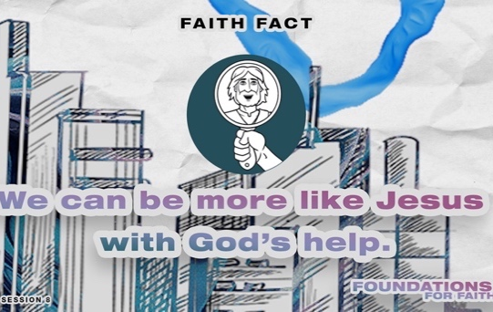

Let’s say today’s Faith Fact again. I’ll start the Faith Fact by saying, “We believe that . . .” That’s your cue to finish the phrase with me. Let’s try it. We believe that . . . We can be more like Jesus with God’s help. Great! This time let’s add some actions (demonstrate). When you say, “We,” point to other people in the room. Then, when you say, “Jesus,” point up. Ready? We believe that . . . We can be more like Jesus with God’s help. Let’s say it one more time with the actions. We believe that . . . We can be more like Jesus with God’s help. I think we’re ready to start.

GAME | Balloon Challenge
You Will Need | Getting Ready
- Red balloons, twenty to thirty  - Tarp or floor-safe tape to mark the playing area, about 10’ x 10’  - Smartphone with timer or stopwatch | - Inflate the balloons and tie them.  - Place a tarp up front on the stage or tape a 10’ x 10’ playing area.  - Place about ten balloons on the tarp.

I’m so glad God has given us the Holy Spirit. He helps us be more like Jesus because it’s not always easy to say no to sin. Let’s play a game that shows what that can be like. (Hold up a balloon.) We’ll use these balloons to represent sin. For each round, each team will have two volunteers who play together. One team’s volunteers will stand in the playing area. We’ll call them the inside team. Their job will be to avoid the red balloons in the playing area. If they touch a red balloon, they’re out.

But that’s not the only challenge. The other team’s volunteers will be the outside team. They’ll be tossing in more red balloons until time is up. If balloons come to the edge of the playing area, they can gently kick those balloons back in too. The inside team needs to dodge those new balloons and not touch the ones on the ground either. Let’s see who can succeed at that for one minute. Then the teams will choose new volunteers, switch roles, and play again. Everyone, get ready to cheer for your team!
- Divide the group into teams (boys vs. girls or similar) and choose two volunteers for each team in each round.
- Ask other leaders or older kids to toss in the other balloons. As the balloons come to the edge of the playing area, toss them in again.
- Start the timer and play the game for one minute. If that’s too easy, increase the time.
- Choose new volunteers and play again.

Today’s lesson is about how We believe that . . . We can be more like Jesus with God’s help. One way we do that is by staying away from sin. We must watch for temptation to sin just like the players had to keep their eyes on the balloons. Then, we need to be willing to move away from sin and watch for things that tempt us to do wrong. We can do that with God’s help.

WORSHIP

We’ll find out more ways we can become like Jesus, but first let’s pause and worship Him. Who is ready to worship God with me today? (Group response) Let’s worship Him by singing right now!
- Lead the kids in singing one or two praise songs. See options at the beginning of the session.

Prayer
When we worship God by singing, praising, or thanking Him, we get closer to Him. That’s another great way we can become aware of ways we need to be more like Jesus. Let’s pray and ask God to show us how we need to do that.

Dear God, we don’t just want to know about our faith and what we believe. We want to live it out. Help each of us to want to be more like Jesus. Thank You for sending Your Holy Spirit to help us do that. Amen.

BIBLE LESSON | The Rich Young Ruler
You Will Need | Getting Ready
- Bible  - Teaching Point Slides 1–3  - Bible Lesson Slides 1–2  - Money | - Download the Teaching Point Slides 1–3 and the Bible Lesson Slides 1–2.  - Put the money in your pocket before telling the Bible story

I’m excited to discover more about why We believe that . . . We can be more like Jesus with God’s help. I hope you are too. To get us started, let’s watch this video.

Video Intro
- Play the Bible Lesson Video.

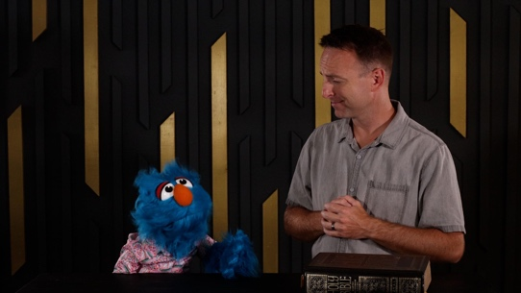

Hank sure was confused about how to become more like Jesus, wasn’t he? (Group response) I’m glad Jeremy was able to help him understand that it’s more about how we are on the inside than trying to dress up like Jesus on the outside. Let’s see how God can show us more about this from His Word.

Teaching Time
Have you ever been playing in the dirt and got your clothes covered in mud? (Group response) It can be fun for a little while, but when your parents find out, they usually aren’t happy about it—especially if they have to clean up after you or throw away your ruined clothes. Days later even after taking a bath or shower, you may still find dirt in your hair, under your nails, or in your ears. That’s not fun.
- Optional: Tell story of a time as a kid when you got in trouble for getting dirty.

Before we commit our life to following Jesus, our life is a mess because of sin. Sin may seem fun and enjoyable for a short time, but after a while, you realize it just ruins your life. God’s punishment for sin is death, but thankfully, Jesus has stepped in. He rescues us from our mess and helps us to clean sin out of our life when we ask Him. The first step is when we ask Jesus to forgive us for the wrong things we’ve done. That’s called salvation. The steps of cleaning our life of sin and being closer to God is called sanctification. It’s God helping us become more like Jesus! That’s our Faith Fact. We believe that . . . We can be more like Jesus with God’s help.

God wants us to live holy.
- Show the Teaching Point 1 Slide.
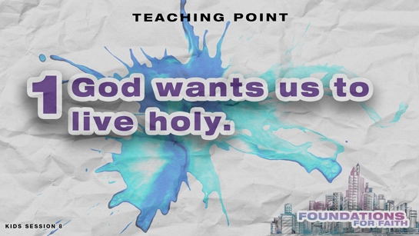

Have you ever experienced a time when you were different from everyone else? Maybe you had to separate from people because you were sick or maybe you wore a crazy colorful outfit that made you stand out. You probably felt like this lamb.
- Show the Bible Lesson Slide 1.

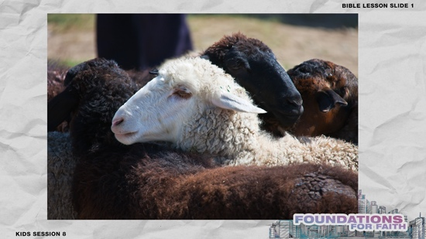

In some ways, God wants us to live like that. Sanctification means to be set apart for God’s use, and that should change how we live. We call that living a holy life. It’s about living a life away from sin, so we can better serve God. That means our life should look different from the lives of people around us who don’t know Jesus. Let’s see what a holy life looks like in our Bible story.
- Read Mark 10:17–20.

God’s people knew God was pleased when they obeyed His commands. They chose to live holy by separating themselves from sin and following God’s commands. Back in Jesus’ time, living a holy life was important just like it is today. In this conversation, Jesus reminded the man about some of God’s commandments he needed to follow.

God still has rules for us today. Jesus said that if we love Him, we’ll obey His commandments (John 14:15). We find God’s rules for a holy life in the Bible. He wants us to separate from the crowd by living a holy life free from sin. The man said he had obeyed all the commandments. But do you think he had lived a sinless life? (Group response) We know he hadn’t because only Jesus has lived a sinless life.

As Christians, we must choose to make good choices to avoid sinful behaviors, but there will be times we all fail to make the best decisions. Thankfully, with God’s help, we can live a holy life. He helps us each day to be more like Jesus. Over time, we can look back on our life and see how far God has brought us by helping us overcome sin and live a life set apart for Him.

2. God wants us to be completely devoted to Him.
- Show the Teaching Point 2 Slide.
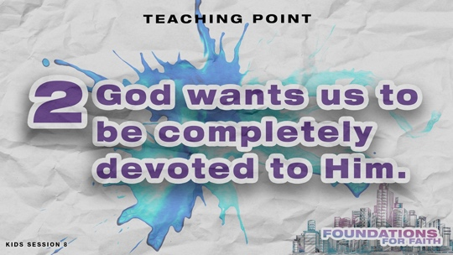

Now, we get to the other part of sanctification. Remember, when we accept Jesus, our life is devoted for God’s use. Our life is dedicated to Him and His will. Do your parents or grandparents have special dishes that they only use when you have visitors or for special holidays? (Group response) Maybe you have shoes that you only wear at certain times like basketball sneakers or rain boots. This is a little like being devoted for God. When we chose to follow Jesus, our life was set apart right then for God and whatever plans He has for us. It doesn’t matter how dirty and sinful our life was, we became clean enough to be devoted to God because of Jesus.

The man who spoke to Jesus was reminded that how we live is part of our relationship with God. The man believed that he was following God’s commands to the best of his ability. He was set apart from others by his behavior. But, there’s more to being like Jesus than just following rules. Do you think Jesus’ life was devoted to God in every way? (Group response) Let’s keep reading our Bible story to find out.
- Read Mark 10:21–23.

Wow! This is a great example of how Jesus knows exactly what our next steps in life should be. What did Jesus tell the man to do? (Allow responses.)
- Take the money from your pocket and hold it up.

Was the rich man willing to give up his money to follow Jesus? (Group response) No, he wasn’t. (Put the money back in your pocket.) He may have followed God’s commands, but he wasn’t completely devoted to Him. He left sad because even though he wanted eternal life, he wasn’t willing to do everything it takes to follow Jesus. Remember, without Jesus, everyone’s life is a mess because of sin! When we commit our life to following Jesus, He’s like a shepherd who leads us.
- Show the Bible Lesson Slide 2.
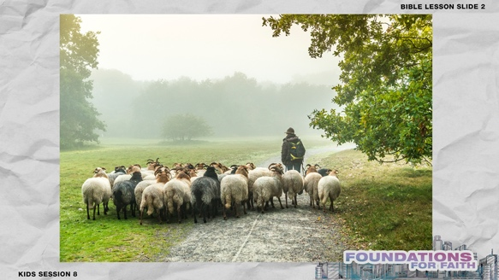

Jesus immediately rescues us from our sin like a shepherd rescues his sheep if they are in trouble. Jesus can do that because He died on the Cross for us. When we ask, He forgives us and cleans up our life so that we are in right relationship with God. Then, God claims us as His own child. Even though we still might not act perfectly all the time, if we have given our life to Jesus and to living a holy life, we’re sanctified. We can be confident that we will inherit eternal life with God.

3. God lets us choose.
- Show the Teaching Point 3 Slide.
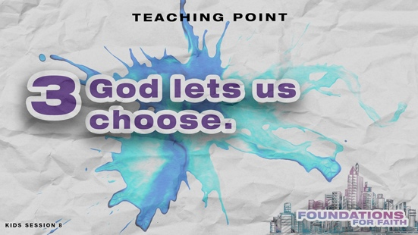

When you read this Bible story, you might feel sorry for the rich man. It was a really hard thing that Jesus told him to do. But Jesus never forced him to do it. He let the rich man make his choice. Jesus knew that the man’s choice would reveal what he was most devoted to. Jesus lets us make our own choices, too. Let’s see what the Bible says about the choices we should make.
- Read Romans 12:1–2.

Many of us can look back to a time when we decided to follow Jesus. But God wants us to make the choice every day to be more like Jesus, to live a holy life, and to be set apart for Him to use. That’s what our Faith Verse means when it says God wants to transform us. We believe that . . . We can be more like Jesus with God’s help. On our own, that’s impossible. But thankfully, the Holy Spirit helps us make better choices and become more like Jesus.

OBJECT LESSON | Pierce the Balloon
You Will Need | Getting Ready
- Balloons, two  - BBQ skewer (wooden or metal)  - Vegetable oil  - Paper towel | - Blow up balloons and tie them.  - Watch this video to see how to do the object lesson: https://www.youtube.com/watch?v=wgslfOnvnpA

How often does God want you to choose to live a holy life for Him? (Group response) You’re right! He wants us to choose it every day! Our Bible story reminds us how important it is that we are completely devoted to following God and making good choices by following His rules and by living for Him. Remember, that doesn’t mean we still won’t be tempted to sin. Even with our best efforts, it’s inevitable that there will be times when we will fail and mess up.
- Poke the skewer into the side of one of the balloons. The balloon will pop.

In our own strength, it’s really challenging to make good choices. Temptation comes and leads to sin if we give in to the temptation, and sin can ruin our lives. Throughout the Bible, there are some great people who loved God, but they still sinned. When they acted in their own strength, they failed. Thankfully, God sent the Holy Spirit to be our Helper. The Holy Spirit helps us to live a holy life and to make the right choices. As Christians, when temptations come, the Holy Spirit can help us resist and overcome them.
- Use the paper towel to cover the skewer with oil and then poke the skewer into the second balloon at the knot. The balloon shouldn’t pop as the skewer breaks the surface of the balloon.

With God’s help, we can overcome temptation and choose to live a holy life! The Holy Spirit can make the difference in our times of weakness.

PRAYER AND RESPONSE
You Will Need | Getting Ready
No supplies are needed for this activity. | No prep is needed for this activity.

- Consider playing a worship song softly in the background while kids pray.

When we hear and read God’s Word, we should respond. Today, we talked about why We believe that . . . We can be more like Jesus with God’s help. Let’s ask God to show us the areas in our life where we need to become more like Jesus.

Sometimes we aren’t even aware of all the sinful behavior in our life, but the Holy Spirit can show us where God wants us to change. Here’s how the Holy Spirit usually does that. When you’re doing something that you know isn’t right, do you ever feel funny on the inside? (Group response) That’s often how the Holy Spirit helps us know how to become more like Jesus. Other times, you might hear words or have thoughts. Let’s close our eyes and ask God for the Holy Spirit to show us any area of our life that He wants to change. I’m going to ask some questions to help us.
- Lead the kids to focus on one area at a time as they ask God to show them where they need to change.

Eyes: Cover your eyes with your hands. Do you look at anything you shouldn’t look at? Are you watching movies where people are doing things you shouldn’t see? Ask God to help you. Tell Him you’re sorry for watching bad things, and then, stop doing it.

Ears: Cover your ears with your hands. Are you listening to music that has bad words? Are you listening to people who say bad things about others? Are you spending enough time listening for God’s voice? Ask God to help you.

Mouth: Cover your mouth with your hands. Are you saying bad words? Are you telling lies? Are you saying bad things about someone? Ask God to help you be holy with your mouth.

Hands: Press your hands together. Are you doing anything with them that God wouldn’t like? Are you hurting people with your hands? Are you stealing or using something that doesn’t belong to you without permission? Is someone tempting you to do wrong? Ask God to help you with your hands so they will serve Him.

Let’s listen quietly for the Holy Spirit to speak to us. Then, I’ll close in prayer by having you repeat after me.
- Pause to allow the Holy Spirit to speak to kids. Then, have them repeat the prayer after you.

Dear God, thank You for showing me the ways that I have sinned. Please forgive me for how I have sinned against You. Help me to live a holy life for You and to be more like Jesus. Amen.

Our Faith Fact says that We believe that . . . We can be more like Jesus with God’s help. If the Holy Spirit showed you something that needs to change in your life, God will help you make that change. With His help, you will be more like Jesus.

Optional: Salvation Prayer
If kids don’t know Jesus as their Savior, consider sharing about salvation. See the Salvation Guide.

DISMISSAL
Got more time? Choose one or more Small Group Activities to reinforce what kids are learning.

We can learn so much about how to be more like Jesus from the Bible! No matter how much we read it, study it, and memorize it, there’s always something new to learn about God and how to live for Him.

Faith Fact Recap
- Show the Faith Fact Slide.

I’ve had a lot of fun learning about sanctification with you today! It can be hard to remember what sanctification means. Something that can help with that is our Faith Fact. We believe that . . . We can be more like Jesus with God’s help. I’m so glad you came today! I can’t wait to see you next time.
- Send home the Activity Page(s) and Journal Page, if used.
- Tell everyone the date and time for the next session.
- Remind parents that there are Family Devotions available on the app.

SMALL GROUP ACTIVITIES

Choose one or more of these activities to extend kids’ learning as time allows. All activities are led by a small group leader.

GROUP CONNECTION | Solve the Situations
You Will Need | Getting Ready
No supplies are needed for this activity. | No prep is needed for this activity.

- Have the kids sit on the floor in a circle.

In our Bible story today, we heard about a man who had a hard decision to make. What did Jesus tell him to do? (Allow responses.) We know this man tried to obey God’s commandments. We know Jesus loved him. But the man didn’t want to do everything Jesus told him that he needed to do. He didn’t want to sell his things and give his money to help poor people.

Some things the Bible tells us to do will be easy for us, and some things will be very hard. I’m going to read some situations that kids like you have faced. As I read, think about what they would be tempted to do. Then, decide what they should do if they truly want to be more like Jesus.
- Read each situation and lead kids in a discussion after, asking what they would be tempted to do and what they should choose to do.

- You got a bad grade on a test, and your teacher wants your parent to sign your test and you return it to school. You think you could probably just sign your parent’s name and your teacher would never know.
- It’s lunchtime and someone in your class forgot to bring their lunch. You know you have extra, but you really want to keep it all for yourself.
- You had an argument with your friend, and you both said hurtful things to each other. Now, your friend doesn’t want to talk to you.
- You are at a friend’s house, and your friend wants to watch a movie that you know you shouldn’t watch.
- Your grandpa asked you to come over and help him, and you promised you would go over right after school. Then, a friend invites you to come over and play.

Each of these situations talks about someone making a choice. Will they do what God wants them to do or not? The good news is that even when we face hard choices, God will help us to be more like Jesus when we ask Him to.

Prayer Time

Let’s pray together now. Who has a prayer need that you’d like the group to pray for?
- Have kids share and pray for each other’s prayer requests.
- Keep track of kids’ prayer requests and review them each time you meet.

It’s important to always remember that We believe that . . . We can be more like Jesus with God’s help. Let’s pray and ask Him to help us now.
- Have kids repeat this prayer after you.

Dear God, I want to be more like Jesus. But I know that it’s not easy to do. Help me to make right choices and live for You. Amen.

GAME | Copycat Charades
You Will Need | Getting Ready
- Game Page, one set per group  - Scissors  - Cup to hold the slips, one per group | - Print and cut apart the Game Page, one set per group.  - Fold the slips and place them in a cup.
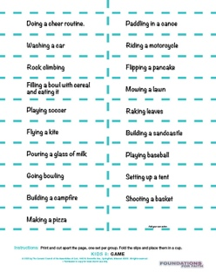
Today, we talked about sanctification and how We believe that . . . We can be more like Jesus with God’s help. One way to practice being more like someone is to imitate them. Let’s play Copycat Charades to see what that’s like. Everyone will get a turn to lead the group in an action. Then, the rest of you can guess what you think the action is.
- Let each kid draw a slip and act it out. Then, have kids imitate the action and guess what it is.

Which did you like better—leading or copying others? (Group response) Copycat Charades was a great reminder of how important imitation can be, especially when we’re imitating Jesus. The good news is that we don’t have to guess about what God wants us to do to be more like Jesus. The Bible tells us how to do that. We can read about Jesus and see how He lived. We believe that . . . We can be more like Jesus with God’s help.

FAITH FACT ACTIVITY | Sanctification Object Lesson
You Will Need | Getting Ready
- Bottles of water, two per group  - Red food coloring  - Permanent marker  - Optional: Funnel | - Remove the paper labels from the water bottles.  - Write Jesus on one bottle and You on the other with the permanent marker.  - Add red food coloring to the bottle labeled “Jesus.”

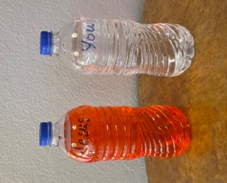
Today, we talked about how We believe that . . . We can be more like Jesus with God’s help. This object lesson will help us to better understand how sanctification works as we become more like Jesus.
- Hold up the bottles of water.

Who do these bottles of water represent? (Group response) Do these bottles labeled “Jesus” and “You” look alike? (Group response) How are they different? (Allow responses.)

We’ve learned that becoming more like Jesus is called sanctification. Do you think that happens immediately when we ask Jesus to forgive our sins and to come into our life and be our Savior? (Group response) Yes and no. Let me explain. When we ask Jesus into our life, God immediately begins to see us as sanctified because our sins are forgiven and Jesus is living in us. I’ll use these bottles to show you how that’s possible.

Without changing the color of the water, how might you think both bottles were filled with colored water? (Allow responses until someone suggests placing the colored water bottle behind the clear one.)
- Place the bottles as shown in the picture with the “Jesus” bottle behind the “You” bottle.
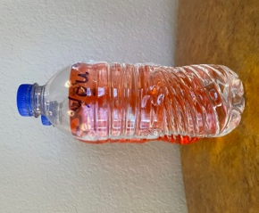

If I place the “Jesus” bottle behind the “You” bottle, do they look like they are both filled with the colored water? (Group response) That’s like how sanctification begins in our life when we ask Jesus to be our Savior. We don’t look exactly like Jesus yet (hold bottles apart), but because Jesus died for our sins and now lives inside us, God sees Jesus in us. (Hold the colored bottle behind the clear bottle again.)

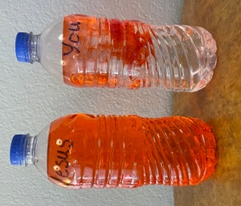
Does that mean when we ask Jesus into our life, we don’t need to try and become like Him anymore? (Group response) No. Is it okay with God if we live any way we want and don’t pay attention to obeying Him? (Group response) Definitely not. Becoming more like Jesus is something we will work at our whole life. Our Faith Verse reminds us to let God transform us. As He does that, we will become more like Jesus. If I wanted to do that with these bottles of water, what would I do? (Allow responses.)
- Add some food coloring to the clear water, but don’t shake it.

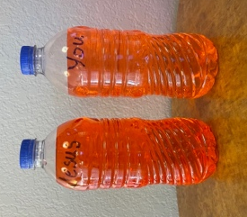
Is the water starting to look more like the water in the bottle labeled “Jesus”? (Group response) That’s how sanctification works. The more we focus on becoming like Jesus, the more other people will see Him in us. That’s what sanctification is about and We believe that . . . We can be more like Jesus with God’s help.
- Put on the lid and shake the bottle. Then, hold up the matching bottles.

FAITH VERSE JOURNAL
You Will Need | Getting Ready
- Pencils or pens, one per kid  - Faith Verse Journal Page, one per kid  - Faith Verse Slide | - Print copies of the Faith Verse Journal Page, one per kid.
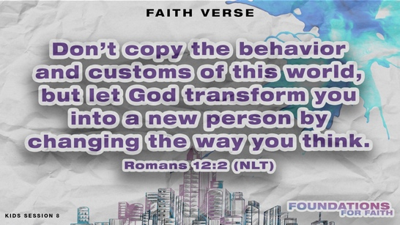
- Optional: Show the Faith Verse Slide.

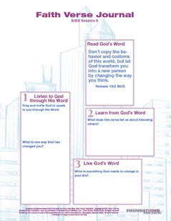
Don’t copy the behavior and customs of this world, but let God transform you into a new person by changing the way you think.
Romans 12:2 (NLT)

God wants to speak to us through His Word. Let’s look at today’s Faith Verse and see what He might want to say to us through it.
- Hand out the Faith Verse Journal Page and pencils. Guide kids through the activity.

4 FAITH QUESTIONS
You Will Need | Getting Ready
- Scissors  - 4 Questions Pages, one set per group | - Print and cut apart the 4 Questions Pages, one set per group. Keep questions and answers separate.  - Choose how to use this activity: Simple matching, Concentration-style find the pairs, etc.

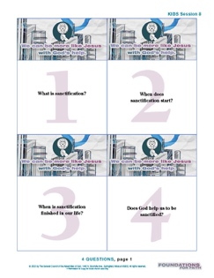
Who’s ready for a challenge? (Group response) Today, we learned a very important foundation for our faith. We believe that . . . We can be more like Jesus with God’s help. Let’s find out what more we need to know about that. [Answers: 1=C, 2=B, 3=D, 4=A]
- Proceed with the activity you chose using the 4 Questions Pages cards.
- Discuss what’s written on each card as time allows.

ACTIVITY PAGE A | Shadow Match (A simpler activity for younger kids)
You Will Need | Getting Ready
- Crayons or markers  - Activity Page A, one per kid | - Print copies of Activity Page A, one per kid.

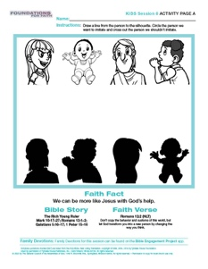
Today, we talked about how We believe that . . . We can be more like Jesus with God’s help. I’ve got an activity about that for us to do. Let’s look at our Activity Page. What do you see? (Allow responses.)
- Hand out the Activity Page A to each kid.

Everyone on the page has a shadow. A shadow is what happens when we stand in the sun or a bright light. We can see an outline of ourself on the ground. Can you draw lines to match up the pictures with their shadows?
- Pause as kids connect the images.

You did a great matching everyone up with their shadow. We’ve learned that there is Someone that we’re supposed to look like in our life. Who is that? (Allow responses.) Jesus! Can you find someone who isn’t following Jesus in their actions? (Group response) Circle that picture.
- Pause as kids complete this step.

Our Faith Fact reminds us that We believe that . . . We can be more like Jesus with God’s help. As we make choices to please God, we will become more like Jesus. Others will see Him in our life. Circle Jesus’ picture as a reminder of who we want to be like. Then, you can color the rest of the pictures.
- Allow time for kids to complete the page.

ACTIVITY PAGE B | Stand Out with Jesus
You Will Need | Getting Ready
- Crayons or markers  - Activity Page B, one per kid  - Activity Page B Answer Page | - Print copies of Activity Page B, one per kid.  - Print the Activity Page B Answer Page as needed.


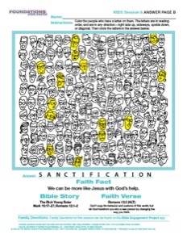
Have you ever seen a chameleon before? (Group response) It’s a small lizard that can change its color to blend in with its surroundings. Did you know there are “chameleon” Christians? (Group response) They act like Jesus when they are around other believers, but when they are with non-Christians, they try to blend in. Do you think that’s how God wants us to live for Him? (Group response) Definitely not.

Our Faith Fact reminds us that We believe that . . . We can be more like Jesus with God’s help. Who remembers the long word we use to describe that? (Allow responses.) It’s sanctification. As we become more like Jesus, we should stand out from the crowd, not blend in. This is what our Activity Page is about today.
- Hand out the Activity Page B and crayons to each kid.

You’ll color all the people who have a letter on them. When you’ve found all the hidden letters, you will have spelled the word sanctification. This challenge isn’t easy, but I think you’re up for it.
- Give kids time to complete the activity. Help them find all the letters if they run out of time.

Great job helping people stand out from crowd! That’s a reminder of how God wants us to be. Jesus stood out from the crowd, and we should too. Our Faith Verse is a great reminder of how to make that happen. Let’s read it together.
- Direct kids’ attention to the verse at the bottom of the Activity Page.

To read the full, official version of the Statement of Fundamental Truths, visit ag.org/beliefs/statement-of-fundamental-truths

