

The One True God

Foundations for Faith Overview
We were never meant to do life alone—especially as followers of Jesus. Disciples grow best in community. Jesus himself modeled this concept by gathering a small group of followers to live and minister alongside Him every day. Even now when believers gather to seek God, relationships are forged, iron-sharpening discussions happen, and genuine accountability can develop.

During the next several sessions, you will journey together through foundational truths—or doctrines—of the Bible. Don’t let the word doctrine put you off. It simply refers to a teaching that comes from Scripture. Our doctrine impacts our decisions more than we might realize. For example, if we have a doctrinal belief that God heals, we are more likely to pray in faith, see Him deliver others from sickness, and experience our own healing. If we don’t believe in healing, we will not expect it or pray for it, and we may even speak out against it. The experiences we have as we follow Jesus largely depend on our doctrine.

The Book of Acts describes a group of Jews in Berea (17:10–15) who, like us, were seeking to better understand Scripture’s most foundational doctrines. After hearing Paul and Silas’s gospel message, they searched the Scriptures every day on their own to verify and fully understand the truth. The result? Many people believed the good news of Jesus and were changed for eternity. As you study Scripture and discuss doctrine together, may the Holy Spirit do the same for you.

SESSION OVERVIEW
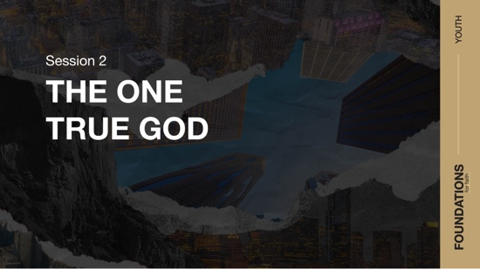

Foundation 2: WE BELIEVE there is one God, eternally existent in three Persons: God the Father, God the Son, and God the Holy Spirit (Deuteronomy 6:4; Matthew 28:19; John 14:16–17).

This session will explore the existence of the one true God and how we should rightly respond to Him. Students will look at what creation says about Him and His existence as the Trinity. Last session’s conversation regarding the Scriptures being inspired is foundational to this session. It was God who inspired the Bible, so it makes sense to turn to the Bible to better understand Him. After all, the Bible contains God’s words about who He is and what He does. Through knowing the one true God better, we can pursue a right relationship with Him that honors His desires for us and leads to eternal life with Him.

NOTE: Foundations for Faith covers so much important information that you may need to break some sessions into two parts in order to cover all the vital teaching provided.

You Will Need | Getting Ready
- Foundation Slide  - Session 2 Video  - Question Slides 1–3  - Bibles for every student, preferably all the same translation | No prep is needed for this activity.

ENGAGE
Welcome
Take this time to welcome everyone, introduce new students, learn names, and thank everyone for coming. Your friendliness here can create a comfort level that encourages student participation later.

Opening Prayer
Prayer thoughts: Thank God for everyone present and for the journey you’ll take together over the next several weeks. Pray for the needs of students and their families. Pray for your church and its leaders. Pray that everyone will be challenged to learn and grow in their relationship with God.

Introduction

Question
What is something you’ve never seen but still know exists? How do you know it’s real?

We can’t see everything we know is real, just like some of the things you mentioned. Some things aren’t physical, and other things are too small or far away for each of us to personally see. But we still know they exist. Some of those things make us want to investigate the proof for ourself.

It can be like that with what we know about God, too. That investigation could look like talking with strong Christians, reading the Bible for ourself, or even praying to God for answers. When there’s something about God we don’t understand, it’s good to ask questions. Today, we’ll hopefully answer a few of your questions about the one, true God.

WHAT WE BELIEVE
Foundation for Faith: The One True God
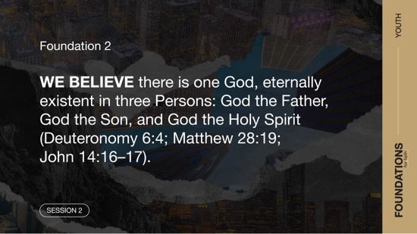

Foundation 2: WE BELIEVE there is one God, eternally existent in three Persons: God the Father, God the Son, and God the Holy Spirit (Deuteronomy 6:4; Matthew 28:19; John 14:16–17).

As we look at what the Bible says about our one true God, we’ll explore one of the greatest mysteries of the Bible—the Trinity. Our one God exists as God the Father, God the Son, and God the Holy Spirit. Our God is three in one. Before we explore further, let’s do a group activity together.

GROUP ACTIVITY | For Real?
You Will Need | Getting Ready
No supplies are needed for this activity. | No prep is needed for this activity.

Knowing what to believe isn’t always easy. Most likely, you’ve heard some pretty bizarre and amazing so-called facts in your life. But how can we know whether they’re true? Let’s see what you believe or don’t believe about some of them. I’ll read a statement and if you think it’s true, raise your hand. But first, put away your phones.
- Read each statement and then pause to allow students time to respond.
- Eating carrots helps your eyesight.
- The CIA once tried to use cats as spies.
- If you swallow a piece of gum, it takes seven years to digest.
- You can see the Great Wall of China from space.
- It’s illegal to chew gum in Singapore.
- The moon landing happened before luggage with wheels was invented.
- Bulls hate the color red.
- Left-handed people have more accident-related injuries than right-handed
people.
- A cockroach can live up to a week without its head.
- Touching a frog gives a person warts.

Now, I’m sure you’re curious to know what’s true and what isn’t. The first statement, “Eating carrots helps your eyesight,” is interesting. The first marketing of carrots giving good eyesight has been argued to just be World War II propaganda and misinformation. Some claimed it to be true to explain why certain airplane pilots were so good at their job, but the real reason was the secret development of radar. That said, the beta-carotene in carrots gets converted to vitamin A by your body, and that does help eye health. So, it’s true.
- Options: Have students research an item and report back to the group now or in the next session or share the answers with them:
[Answers: 1 = True; 2 = True; 3 = False; 4 = False; 5 = True; 6 = True; 7 = False; 8 = True;
9 = True; 10 = False.]

We hear so much information that, at times, it can be tough to know what’s true. Some people base their opinions on what other people tell them or what they read online. Sadly, that’s even how some people decide whether they believe God is real or not. So the question is, how can we know that God is the real, true God? Let’s look at three questions to help us come to a resolution. First, how can we know that God exists? Second, what does it look like when people deny God? And third, how can we get closer to the one true God?

Watch
But first, let’s watch this video to focus in on today’s foundational truth.

- Play the Session 2 Video.

CONSIDER WHAT THE BIBLE SAYS
You Will Need | Getting Ready
- Foundation Slide  - Question Slides 1–3  - Bibles for every student, preferably all the same translation | No prep is needed for this activity.

Ensure each student has access to a Bible, preferably the same version.

How can we know that God exists?
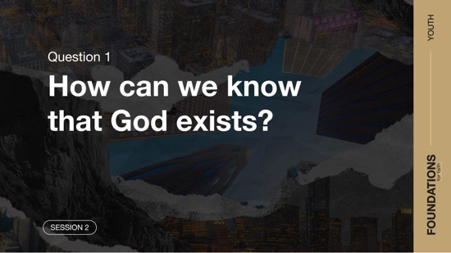

To begin our discussion today, let’s start with the first question: How can we know that God exists? To find the answer, let’s look at the first verse in the Bible.

Read Genesis 1:1.

Question
What does this verse tell us about God’s existence?

These first words of the Bible tell us a lot about God. Without God, there is no beginning, there is no creation, and that means there would be no people. Nothing existed before Him, and nothing existed without Him. God is the One who set everything into motion. Verses like this from the Bible help us understand who our Creator is.

How many of you know someone who doesn’t believe in God? Raise your hand. (Pause for students to respond.) You may have someone in your family or have teachers or friends at school who don’t think there is a God. Let’s look at another Bible passage that has something to say about God’s existence and people who don’t believe in Him.

Read Romans 1:18–23.

Question
What do these verses say about the existence of God?

Question
When you look around at God’s creation, what does that tell you about Him?

The writer of Romans, the apostle Paul, wrote that although we can’t see God, we can see the work of His hands. When we see the earth, sky, and everything else He has made, we can see His power and His character. We see evidence of the Creator from Genesis 1:1 because creation points to the existence of a Creator. But rather than respond rightly to Him, some people choose to suppress that truth.

Question
How might people suppress the truth about God?

They can willfully ignore or conceal the evidence of God’s existence. This is a lot like the question about carrots earlier. Rather than admit the existence of radar, certain people said that carrots helped the eyesight of the pilots. Similarly, there are people who try to cover up God’s existence even though they know better.

Question
What’s the difference between someone who doesn’t yet know God and someone who suppresses the truth about God?

Some people haven’t had the opportunity to decide if they will follow God. But others make a clear choice to deny Him. The verses we read explain that those who deny the natural evidence of creation become foolish and start to worship other things instead of the one true God.

Question
Why do you think some people who know about God still refuse to follow Him?

The evidence for God’s existence is all around us. Creation is too perfect to have happened by chance. A Creator had to create everything we see.

What does it look like when people deny God?
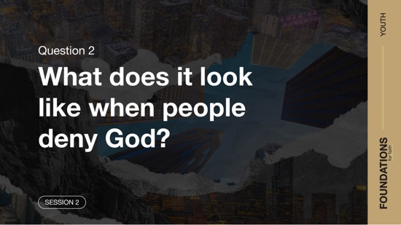

In the previous verses, we read that those who reject worshipping God can end up worshipping the creation. Now let’s look at the second question: What does it look like when people deny God? Let’s read the next verses to see what that led to.

Read Romans 1:24–32.

Question
What do you think it means that people traded the truth about God for a lie?

Question
Do you think people still worship created things rather than the Creator? Explain.

Everyone worships something or someone. Human beings were designed by God to be creatures of worship. Even if they don’t call it “worship,” a person’s attitude toward people or things can look a lot like the attitude Christians have toward God. Maybe they worship money, relationships, sports, perfect grades, or even themselves. In essence, these things become idols. We read about it in Romans 1, and we see it happening around us today.

Question
How do you think the unnatural sexual relations described in verses 26–27 are related to rejecting worshipping and serving God?

Humans are also a part of God’s creation. Did you know that when He created us, God had specific purposes and intentions in mind? The Bible reveals many of those to us. When we reject following God’s plan, it leads us down a path that is contrary to the very nature God created us to have. And, like the verses noted, there is a penalty for choosing to reject His design. Rejecting God brings harm to ourself and our relationship with Him. But worshipping and serving Him leads us to a life closer to the way we were created to live.

Question
What does verse 32 say that justice requires for those who reject living as the one true God expects?

The verses we’ve read list a lot of different sins. Probably all of us have done something on that list. And those kinds of actions lead to death. So, can we fix things, and if so, how?

How can we get closer to the one true God?
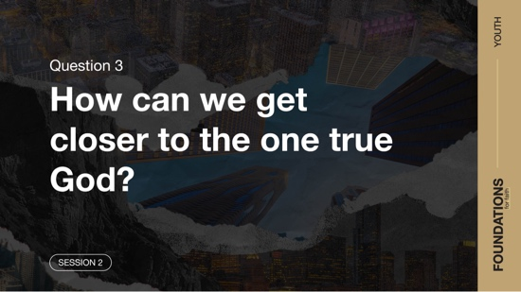

That leads us to the third big question: How can we get closer to the one true God? Understanding God isn’t easy. Thankfully, His Word reveals things about Him to us. And learning about Him can lead to restoring and improving our relationship with Him. To start down that path, let’s unpack the last part of today’s foundation: “one God, eternally existent in three Persons: God the Father, God the Son, and God the Holy Spirit.”

Bible verses like Deuteronomy 6:4 clearly tell us that there is only one God. But other parts of the Bible (for example, John 20:28–29; Acts 5:3–4; 1 Corinthians 8:6) reveal that the Father, the Son (Jesus), and the Holy Spirit are all God. Though it’s hard to understand and to explain, somehow, the one God exists and interacts with us as three distinct Persons. And each Person of this Trinity is important in restoring our relationship with the one God and overcoming the death that comes from our sin.

Read John 14:6.

Question
What does this verse say Jesus offers?

Our path to life and a right relationship with God the Father comes through Jesus. When we make Jesus the Leader of our life and put our faith in Him, we receive salvation and a restored relationship with God our Father (Romans 10:9–10). But it’s not only the Father and Son working to restore our life and relationship.

Read Romans 8:14–16.

Question
What parts do these verses say the Holy Spirit plays in us being a child of God the Father?

Our restored relationship with the Father results in God’s very Spirit living in us (1 Corinthians 6:19). The Holy Spirit guides us to live right, like God’s obedient children. The Holy Spirit directs us away from the sin that destroys our relationship with God and toward the life He created us to live.

Question
How have you or someone you know described the Holy Spirit’s leading?

Sometimes the Holy Spirit’s leading comes through a quiet inner voice. Sometimes He speaks through the Bible or another Christian friend. The one true God exists, and He has good plans for our life. His existence should be on display in the lives of His people. When we choose to live for the one true God, we should do all we can to get to know Him. He created us. He knows us best. And His way of life leads to an eternity with Him. Let’s review today’s foundation one more time.

WHAT WE BELIEVE
Foundation for Faith: The One True God

Foundation 2: WE BELIEVE there is one God, eternally existent in three Persons: God the Father, God the Son, and God the Holy Spirit (Deuteronomy 6:4; Matthew 28:19; John 14:16–17).

There was never a moment that God didn’t exist (Psalm 90:2). Creation points us to God and reveals that He exists (Psalm 19:1–2). From the first words of the Bible through its last book (Genesis 1:1; Revelation 4:11), we are told that all life began with Him. This God exists in three Persons, which we call the Trinity. God the Father, Jesus the Son, and the Holy Spirit exist in a perfect union that is our one, true God. And that same God who created us has made a way for us to have a relationship with Him that leads to life.

Why Does This Matter?

If we only know facts about God without believing He’s the one true God, we can’t have a relationship with Him. God gave His Son, Jesus, as a gift to bring us eternal life (John 3:16). There is salvation in no one else but God (Acts 4:12). So, what we believe about God determines our eternity. We must move beyond belief and into action, imitating Him in all we do (Ephesians 5:1). Living in God’s will gives us direction, meaning, and purpose.

REFLECT
The Bible shows us that we are without excuse when it comes to believing in the one true God. All we have to do is look at creation around us. For our world to exist, there had to be a Creator capable of creating life from nothing. Plus, we can’t overlook the fact that millions of lives have been changed by the powerful, all-knowing, and loving God. There are many things we’ve never seen in life, yet we still believe in them. Because we have evidence, we know they’re real. In the same way, we have evidence of our amazing God. The question that remains to be answered is this: What are we going to do with this knowledge?

Listen to God
Let’s take time to think about whether our life shows that we trust the Bible. These questions are meant to start a conversation between you and God. Sharing your responses with the group is completely voluntary.
- Pause for a few moments of silent reflection after reading the questions. Then ask students if they want to share. Sharing your personal response may also be helpful to the students.

Question
How should knowing God is real change how you live?

Question
Who in your life that doesn’t believe in God needs to hear the truth about Him?

ACTIVATE
Think about what you’ve learned about God from this session. If you still have questions about certain facts, find someone you trust who’s been a Christian for quite a while and ask that person for help. You don’t have to figure out everything about God on your own. Learning with others brings us closer to Him as well as other Christians.

CONCLUSION

Knowing God exists is the first step in our journey through life with Him. From there, we continue by putting our faith in Jesus and following the guidance of the Holy Spirit. God is not distant. He lives in His people and wants to be part of our everyday life. He wants you to be part of His family. When we embrace our relationship with Him, we experience more of His presence, power, and purpose in our life.

Salvation Opportunity
Include this if you think there may be some in the group who do not have a personal relationship with Jesus.

Believing in a god is much different than believing in the God and trusting Him with your life. If you’ve never taken that step of faith and asked Jesus to be Lord of your life, today can be the day everything changes.

Is anyone here that we can pray for who doesn’t have a relationship with Jesus or wants to renew their relationship with Him?

Take a moment to acknowledge those who respond, and thank them for their desire to make things right between themselves and God. Pray with them as you close in prayer or after the group time is over. Following group time, talk more about where they are in their walk with God and how you might be able to help.

Prayer
Father God, thank You for the opportunity to have a relationship with You. Thank You for being Someone we can put our faith and trust in, and for guiding us into truth. We ask that our family and friends who don’t know You would come to believe that You are the one true God—and that You would use us to reach them with Your love. In Jesus’ name, we pray. Amen.

Dismissal
I look forward to seeing each of you next time. Some of you may have more questions about what we talked about. Never be embarrassed about asking questions. This is one reason we meet regularly. We love to hear your questions and thoughts as we talk about God’s Word. Most of all, take time to dig into the Bible on your own and search for answers. The devotions in the app will help you to discover even more about what God’s Word has to say about what we believe. See you all next time.

Endnote

To read the full, official version of the Statement of Fundamental Truths, visit ag.org/beliefs/statement-of-fundamental-truths.

