

The Fall of Man

Foundations for Faith Overview
We were never meant to do life alone—especially as followers of Jesus. Disciples grow best in community. Jesus himself modeled this concept by gathering a small group of followers to live and minister alongside Him every day. Even now when believers gather to seek God, relationships are forged, iron-sharpening discussions happen, and genuine accountability can develop.

During the next several sessions, you will journey together through foundational truths—or doctrines—of the Bible. Don’t let the word doctrine put you off. It simply refers to a teaching that comes from Scripture. Our doctrine impacts our decisions more than we might realize. For example, if we have a doctrinal belief that God heals, we are more likely to pray in faith, see Him deliver others from sickness, and experience our own healing. If we don’t believe in healing, we will not expect it or pray for it, and we may even speak out against it. The experiences we have as we follow Jesus largely depend on our doctrine.

The Book of Acts describes a group of Jews in Berea (17:10–15) who, like us, were seeking to better understand Scripture’s most foundational doctrines. After hearing Paul and Silas’s gospel message, they searched the Scriptures every day on their own to verify and fully understand the truth. The result? Many people believed the good news of Jesus and were changed for eternity. As you study Scripture and discuss doctrine together, may the Holy Spirit do the same for you.

SESSION OVERVIEW

Foundation 4: WE BELIEVE man and woman were created good and upright in the image of God. However, sin entered the world by their voluntary disobedience leading to humankind’s separation from God both physically and spiritually (Genesis 1:26–27; Romans 5:12–19).¹

Life in the Garden was perfect. Adam and Eve had each other, they lived in a beautiful place, and they had a close relationship with God. They had all of this without any sin in their world. There was no jealousy, hatred, anger, crime, or greed, that is, until they fell into sin. The two of them had everything they could ever want or need, and yet, they allowed themselves to be deceived by the enemy. And what a hard fall it was! Immediately after they sinned, they felt shame. They were separated from God and the Garden which He had prepared for them.

The lesson we learn from this story is how devastating sin is to our life. Where does sin come from? How does it influence our life? God created people to enjoy close fellowship with Him. But, we know that there is a real enemy of God and people—Satan. This enemy is bent on destroying God’s relationship with His creation. As followers of Jesus, we need to understand how the fall of Adam and Eve into sin has impacted us today—allowing shame and separation in our life and relationships.²

NOTE: Foundations for Faith covers so much important information that you may need to break some sessions into two parts in order to cover all the vital teaching provided.

You Will Need | Getting Ready
- Foundation Slide  - Session 4 Video  - Question Slides 1–3  - Bibles for every student, preferably all the same translation | - No prep is needed for this activity.

ENGAGE
Welcome
Take this time to welcome everyone, introduce new students, learn names, and thank everyone for coming. Your friendliness here can create a comfort level that encourages student participation later.

Opening Prayer
Prayer thoughts: Thank God for everyone present and for the journey you are taking together as you learn about the foundations of faith. Pray that the group would better understand the significant impact of sin and the hope we have to be reconciled through Jesus.

Introduction

Question
If you could know the future, would you want to? Why or why not?

Thinking about our future can be scary, especially if we choose to exclude God from it. Whether it’s good or bad, every decision we make will have a consequence. When the first humans made their decision to disobey God, they could never have imagined what would result from something that seemed so unimportant. When we choose to act in a way that is the opposite of what God wants, we sin, too. Even though sin entered the world through just those first two people, it continues to be everyone’s worst problem. So, today, we’ll talk about what we believe about sin.

WHAT WE BELIEVE
Foundation for Faith: The Fall of Man
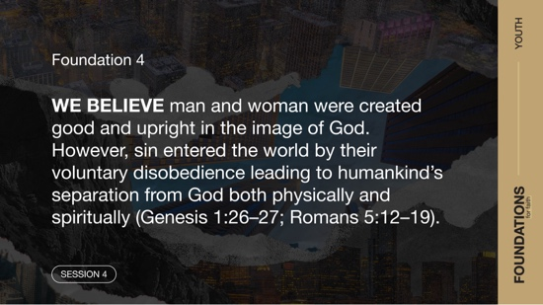

Foundation 4: WE BELIEVE man and woman were created good and upright in the image of God. However, sin entered the world by their voluntary disobedience leading to humankind’s separation from God both physically and spiritually (Genesis 1:26–27; Romans 5:12–19).

Sometimes, rules can feel restrictive. But ultimately, rules are usually very important. If a driver refused to obey a stop sign, both he and other drivers would be in danger. If a baker didn’t follow the recipe when baking a cake, the cake wouldn’t look or taste as it was supposed to. In the Garden of Eden, God gave specific rules to Adam and Eve. But because they disobeyed one of the rules, their relationship with God turned into something it wasn’t created to be. In our activity today, we’ll see just how important following the rules is.

GROUP ACTIVITY | Can You Follow the Rules?
You Will Need | Getting Ready
No supplies are needed for this activity. | No prep is needed for this activity.

We’re going to do an activity that will require you to follow my instructions. Everyone will sit on the floor in a straight line facing me. Starting with one end of the line, I’ll demonstrate an action that each of you will copy. When we reach the other end of the line, we’ll go back to the beginning and do the action again. But this time, there’s a catch. Each time we reach the end of the line and start over, I’ll add a new action to the list. Everyone must remember the actions and do them correctly in order. If someone makes a mistake, we’ll start back at the beginning of the line with the single action and begin again.
- Depending on the size of your group, you can pick how many actions your group will do from the suggested list below.
1. Pat your head.
2. Clap your hands once.
3. Blink twice.
4. Snap once.
5. Wave your hand.
6. Pat your knees.

7. Say your church name.

8. Tap your nose.

9. Pat your stomach.

10. Stand up and spin around.

Now we’ve seen how important it can be to follow the rules. Similar to the consequence for messing up in our game, Adam and Eve had consequences for their mistakes. Let’s read about what their life was like before they sinned, what caused them to sin, what happened after they sinned, and what that means for us today.

Watch
Let’s watch this video to focus in on today’s foundational truth.
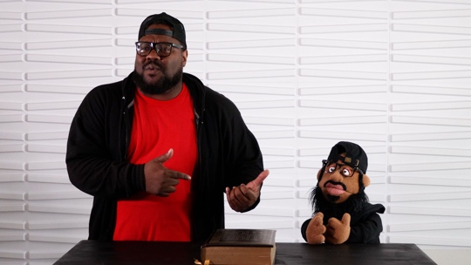
- Play the Session 4 Video.

CONSIDER WHAT THE BIBLE SAYS
You Will Need | Getting Ready
- Foundation Slide  - Question Slides 1–3  - Bibles for every student, preferably all the same translation | - No prep is needed for this activity.

Ensure each student has access to a Bible, preferably the same version.

Who tempts us, and how are we tempted?
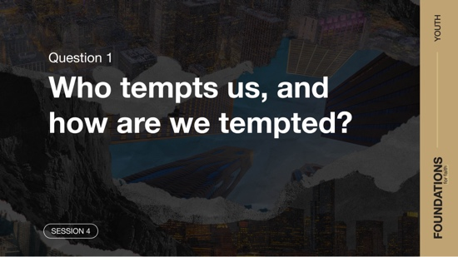

The first two people on earth had an amazing life. They had perfect fellowship with God and each other. There was no sin in their life at all. Imagine that! They never experienced what it meant to lie, cheat, steal, or be jealous. Everything was perfect until they came across an enemy of God who was out to destroy them.

In the middle of their perfect life, God also allowed them to have what we call a free will. Regardless of God’s instructions, they had the freedom to make decisions for themselves. That included choosing to obey God or not. Sadly, there was one decision the two of them made that carried a great cost. Let’s dig in a bit and see what we can learn from this.

Read Genesis 2:4–9, 15–17.

Question
Where did this first human live according to the verses we read?

Question
What do you think life would have been like in the Garden?

The beginning of the story of the first person starts with God taking action. He’s the one creating, and He’s the one setting the rules for His creation. In a beautiful garden full of everything needed to survive, God placed that first man and told him to avoid eating from just one tree. Not only did God give instructions to avoid eating from that tree, but He also explained that there was a harsh penalty for disobeying. Soon after this, God made a woman to live with the man. Let’s read a little more and find out what they did.

Read Genesis 3:1–5.

We don’t know how long the first people lived in the Garden, but eventually we come to this very important day. The man and woman were spending time in the Garden when a talking serpent showed up. That alone should tell us something weird was going on here! But, it may not have seemed weird to the first people. They didn’t have the experiences or human history we do.

The Bible later lets us know that the tempting serpent was our enemy, the devil (Revelation 12:9). Sin can still be like this for us today. One moment we are enjoying life with others, and then temptation shows up.

Question
What question did the serpent ask the woman?

Question
Why do you think the serpent asked this question?

With his opening question, the serpent put doubt into the heart of the woman. When the enemy tempts us, he sometimes uses the same strategy and questions the goodness and trustworthiness of God.

Question
In our life today, do you think the enemy still questions what God has said in the Bible? Why?

Question
Why do you think the enemy told the woman the truth that her eyes would be opened to know good and evil?

The devil will at times tell bits and pieces of truth, but that truth is always mixed with lies to tempt us. He appeals to our desire for pleasure and forbidden things. The woman seemed vulnerable as she listened to the lies of the enemy. We also have moments when we are more vulnerable to the lies of the enemy.

Read 1 Corinthians 10:13.

Question
What does this verse say about how God will help us when we’re faced with temptation?

The serpent, or devil, begins many temptations in our life with a lie. He will get us to question God’s truth and the way He says to live. The enemy will also try to tempt us when we are most vulnerable. We should be especially careful of the enemy’s lies when we have allowed some distance to come between us and God in our relationship.

What causes our separation from God and each other?
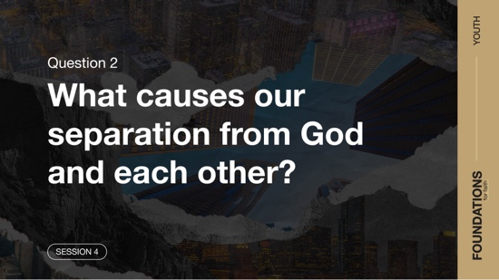

Read Genesis 3:6–8.

Following the serpent’s conversation with the woman, she noticed the fruit. What happened next was her choice to sin. But that sin didn’t stop there. She invited the man to take part in the sin as well. From there, things in their perfect lives began to unravel. They went from having a close relationship with God to literally trying to hide from Him. Their relationship was damaged.

The same is true for us today. At some point in your life, you’ve probably been encouraged to sin by someone. Why do people do this? Perhaps they feel better about their own sin if they can get someone else to do it with them. Let’s face it. If someone else does it, we can feel the pressure to ignore what we know to be right and give in to temptation.

Question
What was it that the woman wanted and believed she could have if she ate the fruit?

Question
Do you think sin more often just happens to people, or do you think people make their own choices to sin? Explain.

Note the steps from when temptation first came to the man and woman to the damage it did to their relationship with God.
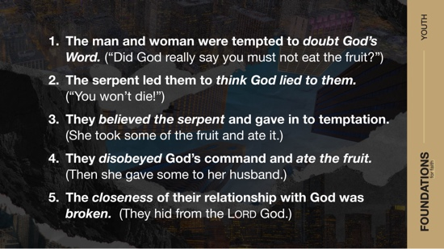

Question
Why do you think the man and woman hid from God?

Question
Why do you think sin brings shame into our life?

Question
What is the right response when we sin?

We already noted that sin separates us from God, but you may not have thought about how it also destroys our relationships with other people. Sin immediately brought separation into the man and woman’s relationship with each other. After eating the fruit, they saw each other differently. The two of them covered themselves, or hid themselves, from each other as well. Many times, sin separates us from the very people we love the most.

What are the consequences of sin?
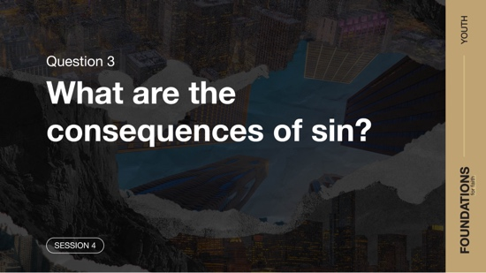

We have to ask the third big question: What are the consequences of sin?

Read Genesis 3:20–24.

Question
What was God’s response to Adam and Eve’s sin?

God made clothing from animal skins for the two of them to wear. Earlier, they had covered themselves with fig leaves to hide their nakedness from each other. Now God needed to cover them in response to their sin. We see here the first animal sacrifice. God immediately did something to cover their sin, so He could continue His relationship with them, although it would look different from then on.

Question
Why did God send them out from the Garden?

We may think God banished Adam and Eve from the Garden because He was mad at them. Instead, God was concerned that they would live forever in their sinful, broken state by eating from the tree of life. God wouldn’t allow that to happen. Instead, God had a different plan for restoring His relationship with humanity. Let’s go back in the chapter and read a few more verses.

Read Genesis 3:11–13.

Look at the response by Adam and Eve when confronted with their sin. Neither took responsibility for their actions. Instead, they pointed a finger at someone else. Adam blamed Eve, and Eve blamed the serpent. Adam went so far as to blame God when he said, “It was the woman you gave me.” Even today, people blame God when things go wrong because of their own sinful decisions.

Question
How has sin destroyed the lives of people all over the world?

The actions of these first people had an impact on every person after them. Their sin had consequences. And just like Adam and Eve, every person since then has chosen to sin against God’s good instructions and plans. Romans 3:23 clearly tells us that “everyone has sinned.” The result of that is exactly what God told the man and woman it would be—death (Romans 6:23). Sin separates us from God. We need to remember that every day when we’re faced with lots of choices that will either keep us close to Him or move us further away.

Question
Based on what you’ve learned, what would you tell someone who is making sinful choices?

Though we’ll get into it more in the next session, God has given us help for our sin problem—Jesus. In some of the verses of Genesis 3 that we didn’t read, there’s even a prophecy about how Jesus would overcome the serpent in order to bring salvation. Let’s recap exactly what we believe and why it’s important.

WHAT WE BELIEVE
Foundation for Faith: The Fall of Man

Foundation 4: WE BELIEVE man and woman were created good and upright in the image of God. However, sin entered the world by their voluntary disobedience leading to humankind’s separation from God both physically and spiritually (Genesis 1:26–27; Romans 5:12–19).

Sin was a direct result of Adam and Eve’s choice to disobey God’s law (Genesis 3:6–7). As a result, sin entered our world (Romans 5:12). God had told Adam that he would die if he ate from the tree (Genesis 2:17), but the serpent lied and said they wouldn’t die (Genesis 3:4). From there, it was up to Eve to believe the truth of God or the serpent’s deception. We saw that Adam and Eve chose to eat from the tree. This tells us that God gave them, and us, a free will to act. We each decide whether we want to live by God’s truth or sin by doing our own thing.

We should understand that God did not, nor has He ever, sinned. God is perfect in every way and is without sin (Deuteronomy 32:4; Job 34:10; Psalm 18:30; Matthew 5:48). He does not tempt us to sin in any way (James 1:13). No person is good enough on their own (Psalms 14:1–3; 143:1–2; Ecclesiastes 7:20; Romans 3:10, 23). Every person since Adam and Eve has been born with a sinful nature that draws us toward sinful actions (James 1:14–15). Our sinful nature is hostile toward God (Romans 8:7–8). As a result, we are destined to experience physical and spiritual death (Romans 5:12).

Why Does This Matter?
Understanding this foundational truth helps us to better understand our temptation to sin. To help us overcome sin, God sent His Son, Jesus, to die on our behalf because we are sinners. Through Christ’s death, we can be friends with God (Romans 5:8–11)! To experience this in our life, we must be born again (John 3:7), receiving what God’s Son, Jesus, did on the Cross for us (John 3:16).

Just as sin entered the world through Adam, the first man, we can be made right with God through one Man, Jesus (Romans 5:15–20). God is compassionate and removes our sin when we come to Him for forgiveness (Psalm 103:8–13). This matters because through the death of Jesus, God gave us victory over sin—both now and for all eternity (1 Corinthians 15:57–58). As a result, we can live a life without the shame of sin and be free to pursue God’s perfect will for our life.

REFLECT
Let’s consider the main idea for this session: Sin entered the world by Adam and Eve’s voluntary disobedience. This damaged humankind’s relationship with God. As a result of our sin, we deal with shame, guilt, and separation from God.

From this session, we see that followers of Jesus have two main challenges. First, we should do our best to avoid sin and, when we do sin, we should run to God for forgiveness. He is a forgiving God who cares for us and loves us. Second, we should live in a way that shows how good it is to avoid sin. Then those involved in sin can see how wonderful life can be when lived in obedience to God.

Listen to God
Let’s take time to think about whether our life shows that we trust the Bible. These questions are meant to start a conversation between you and God. Sharing your responses with the group is completely voluntary.
- Pause for a few moments of silent reflection after reading the questions. Then ask students if they want to share. Sharing your personal response may also be helpful to the students.

Question
Are there temptations that you are struggling with today? How can God help? How could a trustworthy friend or leader help?

Question
What is a step God may be calling you to take to help keep a tempting sin out of your life?

Salvation Opportunity
Include this if you think there may be some in the group who do not have a personal relationship with Jesus.

Our sin problem can only be fixed through a relationship with Jesus. Knowing Him, and His Word, can help us stay away from choices that could hurt us. Making the choice to follow Jesus is the best one we can ever make.

Is anyone here that we can pray for who doesn’t have a relationship with Jesus or wants to renew their relationship with Him?

Take a moment to acknowledge those who respond, and thank them for their desire to make things right between themselves and God. Pray with them as you close in prayer or after the group time is over. Following group time, talk more about where they are in their walk with God and how you might be able to help.

ACTIVATE
Take time today to ask God if there are any sin issues in your life. Don’t wait until tomorrow to cut sin out of your life. Deal with it immediately. If it’s a temptation that you often struggle to overcome, find a trustworthy Christian leader to talk to for help and wisdom.

CONCLUSION
Sin brings separation and shame. We clearly saw this in the lives of Adam and Eve and have experienced this in our life, too. We all are guilty of sin at times. The enemy tempts us with lies and even partial truths to get us to sin. He also does all he can to get us to question God and our relationship with Him. In other words, he is out to do all he can to get us to sin and be eternally separated from God.

Today was a reminder that the enemy will tempt us to sin, but we have the choice whether to sin or not. When we do sin, we can confess our sin to God and know that He is faithful to forgive us and help us through the temptations in life.

Prayer
Dear God, thank You that even though we may sin, You offer forgiveness. Thank You for the gift of salvation through Your Son, Jesus. Thank You for creating us with free will and for giving us the opportunity to choose You every day. We ask that our family and friends who don’t know You would turn away from sin, open their heart to You, and walk with You. Amen.

Dismissal
I look forward to seeing each of you next time. The devotions in the app will help you to discover even more about what God’s Word has to say about what we believe. I realize some of you may have more questions about this topic. Don’t be embarrassed to ask questions about anything we talked about. We are all here to learn from each other as we look into the Bible. This is one reason we meet. See you next time!

Endnotes

To read the full, official version of the Statement of Fundamental Truths, visit ag.org/beliefs/statement-of-fundamental-truths.
2 Portions of this session are adapted from Bible Engagement Project Youth Learn © 2021 by The General Council of the Assemblies of God, Springfield, Missouri 65802. Used by permission of the publisher.

