

The Salvation of Man

Foundations for Faith Overview
We were never meant to do life alone—especially as followers of Jesus. Disciples grow best in community. Jesus himself modeled this concept by gathering a small group of followers to live and minister alongside Him every day. Even now when believers gather to seek God, relationships are forged, iron-sharpening discussions happen, and genuine accountability can develop.

During the next several sessions, you will journey together through foundational truths—or doctrines—of the Bible. Don’t let the word doctrine put you off. It simply refers to a teaching that comes from Scripture. Our doctrine impacts our decisions more than we might realize. For example, if we have a doctrinal belief that God heals, we are more likely to pray in faith, see Him deliver others from sickness, and experience our own healing. If we don’t believe in healing, we will not expect it or pray for it, and we may even speak out against it. The experiences we have as we follow Jesus largely depend on our doctrine.

The Book of Acts describes a group of Jews in Berea (17:10–15) who, like us, were seeking to better understand Scripture’s most foundational doctrines. After hearing Paul and Silas’s gospel message, they searched the Scriptures every day on their own to verify and fully understand the truth. The result? Many people believed the good news of Jesus and were changed for eternity. As you study Scripture and discuss doctrine together, may the Holy Spirit do the same for you.

SESSION OVERVIEW
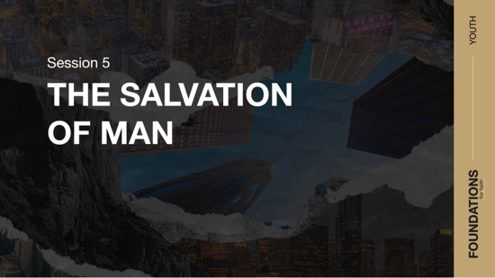
Foundation 5: WE BELIEVE the only means of being cleansed from sin is through the precious blood of Christ. We receive access to that by having faith in Jesus, repentance, and regeneration by the Holy Spirit for personal salvation (Luke 24:47; John 14:6; Romans 8:16; Titus 3:5).¹

In this session, we’ll look at two unique stories found in Scripture that can help us understand salvation. Both are centered on salvation and eternal life, but the main characters approached Jesus in different ways. Looking at both conversations can help us gain a more well-rounded perspective on what Jesus taught about salvation. People today approach Jesus in many ways as well. Some come and submit to Him as Lord and others turn their backs. It’s up to every person to decide if they will put faith in Him as the Solution to their sin problem or refuse His loving gift of salvation.²

NOTE: Foundations for Faith covers so much important information that you may need to break some sessions into two parts in order to cover all the vital teaching provided.

You Will Need | Getting Ready
- Group Activity Pages  - Optional: Construction paper, 6 sheets  - Foundation Slide  - Session 5 Video  - Question Slides 1–3  - Bible for every student, preferably all the same translation | - Print the Group Activity Pages and cut apart. If the pictures can be seen from the back, glue to construction paper.  - Mix up the pictures. Lay them face down on the floor in three rows of four pictures each.

ENGAGE
Welcome
Take this time to welcome everyone, introduce new students, learn names, and thank everyone for coming. Your friendliness here can create a comfort level that encourages student participation later.

Opening Prayer
Prayer thoughts: Thank God for everyone present and the journey you are taking together to learn more about what we believe. Pray that everyone will be open to hear about salvation, and that everyone would grow in their relationship with God as you look at the Bible.

Introduction

Question
How did you meet your best friend?

First impressions can tell us a lot about the people we meet. In just a moment, we’ll read about two people who approached Jesus. Although they approached Him for the same reason, the way each one came to Him was quite unique. Before we get into the stories, listen to today’s foundation statement about what we believe.

WHAT WE BELIEVE
Foundation for Faith: The Salvation of Man
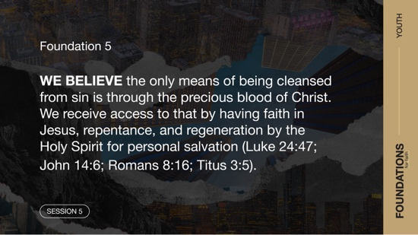
Foundation 5: WE BELIEVE the only means of being cleansed from sin is through the precious blood of Christ. We receive access to that by having faith in Jesus, repentance, and regeneration by the Holy Spirit for personal salvation (Luke 24:47; John 14:6; Romans 8:16;
Titus 3:5).

Last session, we talked about the massive damage sin caused for humanity. Sin has left a painful mark starting with the first man and woman and continuing in each of us. But God chose not to leave us helpless. Today’s session looks at His remedy for sin—salvation through Jesus.

GROUP ACTIVITY | Concentration
You Will Need | Getting Ready
- Group Activity Pages  - Optional: Construction paper, 6 sheets | - Print the Group Activity Pages and cut apart. If the pictures can be seen from the back, glue to construction paper.  - Mix up the pictures. Lay them face down on the floor in three rows of four pictures each.

Before getting into the discussion, let’s do a simple activity. One team at a time will choose two pieces of paper to turn over, trying to find matching images. If the images match when the two sheets are turned over, that team receives one point, and the papers remain face up. If the two images don’t match, both will be turned face down again, and no point is awarded. The team who matches the most images wins.
- Let the teams take turns turning over the papers, two at a time.
- After all the pairs have been chosen, congratulate the winning team.
- If the teams tie, congratulate both teams.

Each team had to look carefully and remember where the pictures were to get a match. In this session, we’re going to look at two Bible stories. There are some things in each story that are similar and some things that are different. As we read the stories, look for the differences and similarities to help us understand the foundation for this session. Two men came to Jesus at different times, and each had a conversation about salvation with Him. The way Jesus responded may not be exactly the way you might expect.

Watch
Let’s watch this video to focus in on today’s foundational truth.

- Play the Session 5 Video.

CONSIDER WHAT THE BIBLE SAYS
You Will Need | Getting Ready
- Foundation Slide  - Question Slides 1–3  - Bible for every student, preferably all the same translation | No prep is needed for this activity.

Ensure each student has access to a Bible, preferably the same version.

What does it mean to be born again?


Let’s begin with the first big question about salvation: What does it mean to be born again?

Read John 3:1–8.

Question
What do we know about Nicodemus from what we read?

Nicodemus was part of a religious group of the Jewish people called the Pharisees. People like him would help the Jewish people understand their religious traditions and the Scriptures. At the time of this story, the Scripture we’re referring to were just our Old Testament books. The New Testament hadn’t been written yet. So, this teacher of God’s truth had some true things to say about Jesus. Nicodemus pointed out that Jesus was a teacher and miracle worker from God.

Question
Why do you think Nicodemus approached Jesus at night?

Jesus took Nicodemus’s statements and went a very different direction! While Nicodemus was busy saying Jesus was sent from God, Jesus moved the conversation to getting into God’s kingdom. Jesus made salvation the point of the discussion. Jesus’ response to Nicodemus made it clear that just knowing that Jesus did miracles or that God sent Him wasn’t enough to obtain eternal life in God’s kingdom. If you want to get closer to God, you need more than just knowledge about Jesus.

Question
What did Jesus say was necessary for someone to see the kingdom of God?

Jesus said that a person must be spiritually cleansed and allow the work of the Holy Spirit in their life to receive a new spiritual life. This is an important part of what happens when a person receives salvation. The Holy Spirit works inside us when we put our trust in Jesus, and He begins making outside change to our life. When we mess up and sin, the Holy Spirit will speak to us and call us to repent of that sin. Salvation allows us to start over with a clean slate of sorts, and from there we can start living in a way that pleases God.

Question
How does putting your trust in Jesus give you a chance to start over again?

Why did Jesus come to earth?
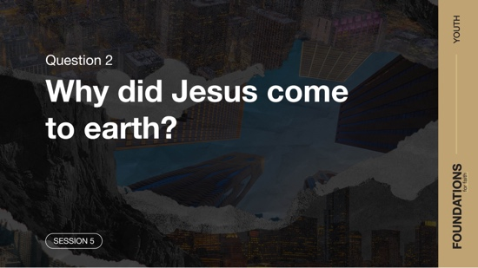

Let’s consider the second big question about salvation: Why did Jesus come to earth?

Read John 3:9–17.

Question
Where did Jesus (the Son of Man) come from according to verse 13?

Jesus came down from heaven. Being “lifted up” (John 3:14) was the main part of His mission on earth and why He left heaven. This refers to how Jesus would give His life on the Cross so that people could be saved. If you were with us last time, we talked about how living in sin leads to death and being forever separated from God. The death of Jesus on the Cross paid for our sin and gives us the opportunity to have spiritual life now and eternal life with God after this life ends. The way we get access to the wonderful thing Jesus did for us is by putting our faith and trust in Jesus.

Question
What do you think it looks like for someone to completely trust and depend on Jesus?

Question
How would you describe why God sent His Son Jesus to someone who isn’t a Christian?

We also see in the verses we read that God sent His Son, not to judge the world, but to bring the opportunity for salvation to all people. Jesus came to help us with the problems our sin created, not to throw our failures in our face. But to accept His gift of salvation and forgiveness, we have to come face-to-face with the truth that we need Jesus’ help.

Is salvation just about following God’s rules?


Now, let’s look at a story of someone else who came face-to-face with Jesus and learned more about salvation as we answer the question: Is salvation just about following God’s rules?

Read Mark 10:17–22.

Question
What is different about how this man approached Jesus and how Nicodemus approached Him?

In the first story we looked at, Nicodemus approached Jesus privately at night. There is also no indication that Nicodemus ran or knelt down in front of Jesus as this man did. This man approached Jesus publicly with the disciples and other people around. One other thing worth noting is that this man brought a question about life to Jesus. In the encounter with Nicodemus, Jesus was the one who began to talk about new life by being born again.

Question
What was the question this man asked Jesus?

Question
How is Jesus’ answer to this man different from what He told Nicodemus?

Jesus started listing some of God’s commandments in this conversation rather than talking about new birth. Don’t let this confuse you. Jesus wasn’t talking about different ways to get saved. Instead, He was telling this man how he was falling short. For us, Jesus was showing us another aspect of what it means to be saved—obedience.

Question
Why do you think Jesus told this man to obey the commandments instead of just telling him that he needed to be born again?

In Romans 10:9, we learn that part of salvation is making Jesus your Lord. Another way of saying that is to make Him the Leader of your life. After you’re saved, your goal is to obey Him as the One in charge of your life. Some days that’s easy, but other days that’s pretty hard. In the case of this man we read about, he was told to do something very hard.

Question
Do you think Jesus was saying all rich people need to give all their money away if they want to go to heaven? Explain.

For this man, his riches were in the way of his relationship with God. Unwilling to give up his money, he proved that he didn’t love God with all his heart and wasn’t ready to make Jesus his Leader. He loved his riches more than helping other people. The man thought he was good enough to earn eternal life on his own. But Jesus showed him that salvation comes to those who make God their first priority.

Question
Do you think some people believe doing good works will get them to heaven? What do you think?

Question
What are some things that people allow in their life that can get in the way of having complete trust and dependence on God?

Is Jesus the only way to heaven?


We’re finished looking at those two accounts for now. But before we go back to our foundation statement, there is one other thing we need to settle. Is Jesus the only way to heaven? We live in a world that says there are lots of ways to get to God. Other people say that you can choose whatever path you want in life, and they all lead to the same end. Let’s see what Jesus said about that.

Read John 14:6.

Question
Based on this verse, how does someone gain access to God the Father?

Question
How would you answer someone who says there are many ways to God?

There is only one Person who made a way for our sins to be forgiven and to restore our relationship with God—Jesus. He came to the earth to show us the way to the Father. He also bore our sins on the Cross and provided a way for us to be saved. As a result, He determines how someone can get to God and heaven. If there were other ways that work, He would have included them in this verse. Instead, Jesus told the disciples that He is the only way. It is only through Jesus that we can have eternal life. Now, let’s recap by looking back at what we believe and why it's important.

WHAT WE BELIEVE
Foundation for Faith: The Salvation of Man
Foundation 5: WE BELIEVE the only means of being cleansed from sin is through the precious blood of Christ. We receive access to that by having faith in Jesus, repentance, and regeneration by the Holy Spirit for personal salvation (Luke 24:47; John 14:6; Romans 8:16;
Titus 3:5).

Salvation is received through repentance toward God and faith in the Lord Jesus Christ. The word repent means to turn around or return. You might say, we are to turn from our current way of living and return to the God who created us. Everyone who calls on the name of the Lord will be saved (Romans 10:13), and salvation is a gift from God for all (Ephesians 2:8–9; Titus 2:11). We are made right with God through faith (Romans 3:27–28). We are saved because of God’s mercy, and we can start over because of the work of the Holy Spirit (Titus 2:14; 3:5–7). There is no other way for us to be saved but through Jesus (Acts 4:12).

Why Does This Matter?
As a result of Christ’s sacrifice for us, we can have eternal life (John 3:16). Jesus’ life was the perfect sacrifice—the only sacrifice for the world’s sin (Hebrews 4:15; 1 John 2:2). This means we can approach God with a clear conscience (Hebrews 10:22). No longer do we have to live under the control of sin (Romans 8:9–13; Galatians 1:4). We no longer have to live with condemnation (Romans 8:34). We are now children of God (John 1:12). We have been adopted and are now heirs with Christ (Romans 8:14–16) and will live forever with God.

REFLECT
According to the Bible, it simply isn’t enough to say you believe in God or Jesus. Nicodemus learned that. Salvation is putting your complete faith in Jesus and making Him the Lord of your life. It’s saying, “God, I can’t live without You, and I want You in my life.” Some people think that it’s enough to simply say they believe in Jesus or even just know that He died on a cross. Our everyday life must reflect what we believe. The Bible stories we just looked at show us that we must believe in our heart and obey God’s commands in our life.

Listen to God
Let’s take time to think about whether our life shows that we trust the Bible. These questions are meant to start a conversation between you and God. Sharing your responses with the group is completely voluntary.
- Pause for a few moments of silent reflection after reading the questions. Then ask students if they want to share. Sharing your personal response may also be helpful to the students.

Question
Who is someone in your life who needs to hear this message about Jesus? What opportunities might you have to share this with him or her?

Question
Do you have complete trust and dependence on Jesus in your life? If not, what is keeping you from that level of belief?

Salvation Opportunity
If this is the first time you heard and truly understand what it means to receive the salvation that Jesus brings, there’s no better time than now to ask Him to transform your life.

Is anyone here that we can pray for who doesn’t have a relationship with Jesus or wants to renew their relationship with Him?

Take a moment to acknowledge those who respond, and thank them for their desire to make things right between themselves and God. Pray with them as you close in prayer or after the group time is over. Following group time, talk more about where they are in their walk with God and how you might be able to help.

ACTIVATE
Share what you’ve learned from our discussion about salvation with someone who is a Christian. Ask them what they think about what you shared. Use this as practice to help you when you have an opportunity to share how someone is saved with a family member or friend who doesn’t know Jesus.

CONCLUSION
What we’ve discussed today centered on salvation. Salvation is possible because God sent His Son, Jesus, to die on a cross for us while we were still sinners. Accepting this gift opens the door for the Holy Spirit to renew our life. This is shown to the world as we live in obedience to our new Lord, Jesus. It’s not enough simply to believe in Jesus.

At the same time, we don’t earn salvation by simply giving our money to the poor or being good enough on our own. We don’t do good works to earn salvation; we obey Him because we are saved. And we can be saved because God loved the world enough to give Jesus.

Prayer

Father God, help each one of us to choose to obey You, even when it’s not easy. Show us who in our life needs to know more about Your love and forgiveness, and give us courage to share our testimony with them. Amen.

Dismissal
I look forward to seeing each of you next time. Don’t forget your challenge to practice sharing about the gift of salvation with a Christian friend. Also, remember to do the devotions in the app. I’ll see you next time.

Endnotes

To read the full, official version of the Statement of Fundamental Truths, visit ag.org/beliefs/statement-of-fundamental-truths.
2 Portions of this session are adapted from Bible Engagement Project Youth Learn © 2021 by The General Council of the Assemblies of God, Springfield, Missouri 65802. Used by permission of the publisher.

