

The Ordinances of the Church

Foundations for Faith Overview
We were never meant to do life alone—especially as followers of Jesus. Disciples grow best in community. Jesus himself modeled this concept by gathering a small group of followers to live and minister alongside Him every day. Even now when believers gather to seek God, relationships are forged, iron-sharpening discussions happen, and genuine accountability can develop.

During the next several sessions, you will journey together through foundational truths—or doctrines—of the Bible. Don’t let the word doctrine put you off. It simply refers to a teaching that comes from Scripture. Our doctrine impacts our decisions more than we might realize. For example, if we have a doctrinal belief that God heals, we are more likely to pray in faith, see Him deliver others from sickness, and experience our own healing. If we don’t believe in healing, we will not expect it or pray for it, and we may even speak out against it. The experiences we have as we follow Jesus largely depend on our doctrine.

The Book of Acts describes a group of Jews in Berea (17:10–15) who, like us, were seeking to better understand Scripture’s most foundational doctrines. After hearing Paul and Silas’s gospel message, they searched the Scriptures every day on their own to verify and fully understand the truth. The result? Many people believed the good news of Jesus and were changed for eternity. As you study Scripture and discuss doctrine together, may the Holy Spirit do the same for you.

SESSION OVERVIEW


Foundation 6: WE BELIEVE that the Bible directs all believers to participate in water baptism by immersion and in Holy Communion (Matthew 28:19; Romans 6:4;
1 Corinthians 11:26).¹

As followers of Jesus, we are commanded to be baptized in water (Acts 2:38). Even Jesus was baptized in water, which set an example for us. Additionally, baptism is a symbol of our identification with and acceptance of the sacrifice Jesus made on the Cross. It shows others that we recognize Jesus’ death, burial, and resurrection. Our baptism marks our death to a sinful lifestyle and resurrection to new life in Christ. Jesus’ command to go and make disciples included His command to baptize them (Matthew 28:18–20). ²

On the night Jesus was betrayed, He shared in Communion with His disciples. Unlike baptism, in which we typically participate once, we may share in Communion many times over the course of our life. Communion also serves as an act of remembering. Through it, we remember the blood Jesus shed and how His body was broken for our salvation. We are also reminded, through Communion, that Jesus brought salvation to our life. Sharing in Communion was a regular occurrence for the Early Church, and it should be a part of our life as a church family (Acts 2:42).

NOTE: Foundations for Faith covers so much important information that you may need to break some sessions into two parts in order to cover all the vital teaching provided.

You Will Need | Getting Ready
- Foundation Slide  - Session 6 Video  - Question Slides 1–3  - Bibles for every student, preferably all the same translation  - Bread or crackers and Communion cups of grape juice, enough for each student | - Prepare bread or crackers and grape juice in individual cups for students.

ENGAGE
Welcome
Take this time to welcome everyone, introduce new students, learn names, and thank everyone for coming. Your friendliness here can create a comfort level that encourages student participation later.

Opening Prayer
Prayer thoughts: Thank God for everyone present and this opportunity to learn. Ask that today’s discussion would help everyone to grow in their faith and understanding of who God is. Ask God to help everyone understand the meaning of water baptism and Holy Communion.

Introduction

Question
If you could change one thing about your school, what would it be?

Jesus’ coming to earth changed things. While He was here, He left instructions for His followers to do two things to remember Him until He comes again. Those are water baptism and Holy Communion—what we call ordinances of the Church. Ordinance isn’t a word that we use every day, but in this case, it’s the word we use to note practices that Jesus ordered His followers to do.

WHAT WE BELIEVE
Foundation for Faith: The Ordinances of the Church
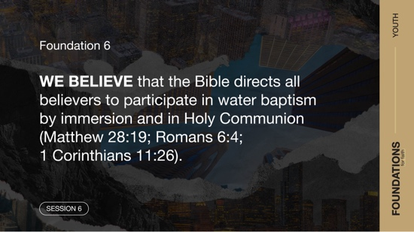

Foundation 6: WE BELIEVE that the Bible directs all believers to participate in water baptism by immersion and in Holy Communion (Matthew 28:19; Romans 6:4;
1 Corinthians 11:26).

Today, we’ll look at this important foundation of our faith as we discover why it is so important for Christians to choose to be baptized in water and to remember Jesus through Communion. Let’s get started.

GROUP ACTIVITY | Who Started It?
You Will Need | Getting Ready
No supplies are needed for this activity. | No prep is needed for this activity.

Today, we’re going to do an activity called “Who Started It?” Everyone will stand in a circle facing each other with one person standing in the middle. The person in the middle must guess which person in the circle is starting a movement. When I say go, the designated starter will begin a movement. They may raise a hand, step one foot to the right or left, or move their head. It can be any movement the starter wishes to do, and they can change the movement during each round as often as they want.

Everyone else in the group must copy the movement the starter is doing without the person in the middle guessing who the starter is. If the person in the middle correctly guesses who the starter is, they switch places. Then we’ll pick a new starter for the next round. If the person in the middle guesses incorrectly three times, a different starter and person in the middle will be chosen.

Here is some advice to those standing in the circle: Don’t begin following the starter at the same time as everyone else. You don’t want to give away who the starter is. The object is to not allow the person in the middle to guess who started the action.
- Have the person in the middle close their eyes when you choose the starter to keep them from seeing your choice.

Many things in life gain fame by someone starting and others following. Jesus started something when He came to earth. He set an example for His followers to be baptized in water and participate in Communion. As His followers, we look to Jesus and do our best to follow His example. Let’s look into these ordinances some more.

Watch
Let’s watch this video to focus in on today’s foundational truth.

- Play the Session 6 Video.

CONSIDER WHAT THE BIBLE SAYS
You Will Need | Getting Ready
- Foundation Slide  - Question Slides 1–3  - Bibles for every student, preferably all the same translation  - Bread or crackers and Communion cups of grape juice, enough for each student | - Prepare bread or crackers and grape juice in individual cups for students.

Ensure each student has access to a Bible, preferably the same version.

One of the wonderful things about Jesus is that He did what He told us to do. He told us to love others, and during His life He showed what love should look like. He told us to serve, and He demonstrated this over and over. In the verses we’ll read, we see He was baptized in water. This is something He commanded every one of His followers to do.

Why was Jesus baptized?
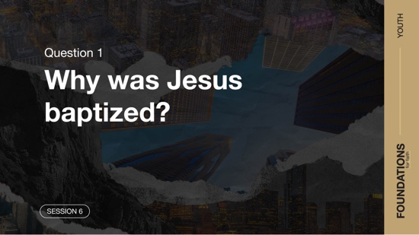

Read Matthew 3:13–17.

Three of the four Gospels—Matthew, Mark, and Luke—tell us about the baptism of Jesus. The fact that these writers included this event in their writings shows us its importance.

Question
Who baptized Jesus?

Question
What message do you think Jesus gave us by being baptized by John?

Jesus showed us that even though He was sinless, He did what was right before God by being baptized. Baptism also served to let us know that He was ready to begin His ministry. In the Bible, going through water often was a sign of new beginnings. It was a new beginning for humanity after the Great Flood, God’s people went through the Red Sea after leaving Egypt, and they also crossed the Jordan River before entering God’s Promised Land. In a similar way, our baptism is the water we go through that signifies the new life we’re starting with Jesus after our salvation.

Also, like Jesus, when we’re baptized, we’re fully immersed in water. That means every part of our body goes under the water. That was Jesus’ example, it was how the Early Church did it, and it’s how we continue to do it.

Question
Would you feel differently about water baptism if Jesus had never done it? Explain.

Why should we be baptized?
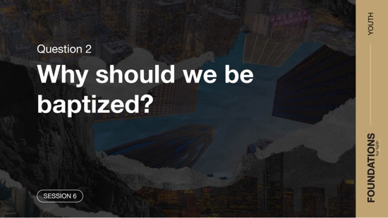

Read Matthew 28:18–19.

After Jesus gave His life, died, and was resurrected, He visited His followers several times to give them some final instructions before He returned to heaven. The verses we read are some of the more famous ones.

Question
In these verses, what did Jesus instruct every new disciple, or follower, to do?

This is the main reason water baptism is an ordinance. Jesus ordered that all His followers be baptized. It’s also why this is so important. If someone has been saved, we should encourage him or her to be baptized in water at the first opportunity. To refuse to be baptized is to refuse to follow Jesus’ instructions. The apostle Paul gave us even more insight into the importance of water baptism.

Read Romans 6:3–7.

Question
How would you describe the way baptism symbolizes being buried and raised to life with Jesus?

Through baptism, we show what it means to be dead to sin and born into a new life through Jesus. Water baptism is an outward sign of our commitment to Jesus. As we’ve mentioned, baptism is also a picture of what Jesus did for us. He died, was buried, and rose from the grave.

Question
Based on the verses we read, how are we set free from the power of sin?

Jesus’ death and resurrection defeated the power of sin. When we put our trust in Jesus and what He did, we are no longer under the power of sin. This doesn’t mean we won’t ever sin again. But it does mean that we no longer serve sin and now can overcome temptation. Jesus sets us free from sin’s power.

Question
How can your baptism be used to share your faith and salvation experience with friends and family who don’t know Jesus?

Question
How do you think people view water baptism today?

Water baptism is a physical act that has a far-reaching spiritual impact on our life. It also is an opportunity to demonstrate our trust in Jesus and show others that we are all in when it comes to our relationship with Jesus.

Let’s turn our attention to the second ordinance of the Church—Holy Communion.
- Have the Communion elements ready to use as an illustration. Later, you will have the opportunity to partake in Communion with the group.

Why should we participate in Communion?



Read 1 Corinthians 11:23–26.

These verses are the apostle Paul passing on instructions about a meal Jesus ate with His disciples that is sometimes called the Last Supper. The essence of that meal is what we base Communion on. Do you remember why we said we’re baptized? It was an order from Jesus. The verses we heard also help us to know why we believe Communion was ordered by Jesus. He instructed His disciples, “Do this in remembrance of me.” Let’s talk about this passage now.

Question
What do the verses we read say Jesus did on the night He was betrayed?

Of all the things Jesus could have done with His disciples that night, He broke bread and shared a cup with them. Much like baptism, Communion is symbolic of a deeper spiritual truth for our life.

Question
What do the bread and cup represent?

The bread is a symbol of the body of Jesus. Breaking the bread represents the broken body of Jesus as a result of the beating He took and His death on the Cross. The cup is a picture of His blood shed for our sin. We use this as a pattern when we take Communion. Usually, Communion happens at church or another gathering of Christians. We eat bread or something similar and drink grape juice together as we remember what Jesus did for us.
- Show the Communion elements as you talk about Communion.

Question
What are we announcing when we participate in Communion?

When we receive Communion, we are saying, “I remember what You did for me, Jesus. Thank You!”

Question
Why is this important for us to remember Jesus’ death?

Remembering the death of Jesus reminds us of what He did and how we should now live until He returns. Communion is a way to help us remember. It reminds us of all we have to be thankful for, knowing that we have eternal life, and that Jesus is with us in every part of our earthly life. We are not alone, and we don’t have to go through life alone. Let’s look back once more at the statement of what we believe.

WHAT WE BELIEVE
Foundation for Faith: The Ordinances of the Church

Foundation 6: WE BELIEVE that the Bible directs all believers to participate in water baptism by immersion and in Holy Communion (Matthew 28:19; Romans 6:4;
1 Corinthians 11:26).

The ordinance of baptism by immersion in water (not sprinkling) is commanded in the Scriptures (Mark 16:16). All who repent and believe on Jesus Christ as personal Savior and Lord are to be so baptized. This act of baptism symbolically declares to everyone that the old sinful nature and lifestyle of the baptized believer died with Christ at salvation. A new spiritual being has been raised with Christ through His resurrection to live a new life (Matthew 28:19; Mark 16:16; Acts 10:47–48; Romans 6:4).

The Lord’s Supper or Communion, using bread and the fruit of the vine (grape juice), is a memorial of Christ’s suffering and death (1 Corinthians 11:26). Eating and drinking the symbols of Christ’s suffering and death expresses our awareness that through salvation we (1) have been made right with God, and (2) share the divine nature of eternal life through our Lord Jesus Christ (2 Peter 1:4). Communion also reminds us to look forward to Christ’s second coming (1 Corinthians 11:26).

Why Does This Matter?

Demonstrating your faith and commitment to Jesus is important for a few reasons. First, by participating in both water baptism and Communion, we affirm our faith that Jesus is Lord over our life. Both ordinances speak of who we are in Christ and what Jesus did for us. Second, we tell the Lord Jesus that we are fully committed to our relationship with Him. We also show our family and friends that we have decided to follow Jesus. This may open doors to share our faith with others. The Book of James tells us that faith without action is useless (James 2:14–17). Being baptized and participating in Communion are two ways of putting action to our faith.

REFLECT
Water baptism and Communion are two ordinances of the Church that have been observed by believers for more than two thousand years. We get to be a part of that amazing heritage. Baptism marks the beginning of a new journey with Jesus. It signifies us walking in new life and demonstrates our commitment to Him. Communion serves as a reminder of who we are in Christ through His death. It’s a time of celebration, remembering, and being thankful for Jesus. Although both water baptism and Communion are physical activities, we must remember that they are symbolic of greater spiritual meanings for our life.

Listen to God
Let’s take time to think about whether our life shows that we trust the Bible. These questions are meant to start a conversation between you and God. Sharing your responses with the group is completely voluntary.
- Pause for a few moments of silent reflection after reading the questions. Then ask students if they want to share. Sharing your personal response may also be helpful to the students.

Question
Have you been baptized in water? If not, what may be holding you back?

Question
Are you ready to share in Holy Communion?

Examine your life. In the verses after the Corinthians passage we read, Paul explained how important it is to think about your own life before taking Communion. In a moment, we will take Communion together, and it’s important that you ask forgiveness for any sin in your life before we do.

ACTIVATE
We would be wrong to discuss water baptism and Communion and not follow through on either. And so, we are going to share in Communion now. In addition, we’ll have an opportunity for anyone who hasn’t been water baptized to do so. We’ll let you know the date when this will take place. You may even want to share this with family members to see if they want to be baptized with you or come to share in this celebration.

If members of your family are followers of Jesus, consider having Communion at home with them. Share with them what you’ve learned from our discussion.

CONCLUSION

The two ordinances of the Church, water baptism and Communion, are important parts of our faith. As we grow in our faith, we begin to realize more of their importance and meaning. Most likely, many of you have been baptized in water or have participated in Communion before. However, some may not have fully understood why we do either or what they mean. Hopefully through our discussion, you now have a better understanding. These are two spiritual markers that are important parts of your walk with Jesus.

Salvation Opportunity
Include this if you think there may be some in the group who do not have a personal relationship with Jesus.

For those who have a relationship with Jesus, Communion and water baptism have significant meaning. There may be some who have never participated in either because they don’t have a relationship with Jesus. Both Communion and water baptism should happen after someone surrenders their life to Jesus and accepts His forgiveness for their sin. It is then that a Christian follows Jesus’ example of being baptized in water and sharing in Communion to remember His sacrifice. Both serve as reminders of Jesus giving His life to save us from our sin.

Is anyone here that we can pray for who doesn’t have a relationship with Jesus or wants to renew their relationship with Him?

Take a moment to acknowledge those who respond and thank them for their desire to make things right between themselves and God. Pray with them as you close in prayer or after the group time is over. Following group time, talk more about where they are in their walk with God and how you might be able to help.

Prayer
Father God, thank You for the opportunity to show others what it means to be a follower of Jesus. We are also grateful that Jesus gave His life for our salvation. We celebrate this by receiving Communion today. Amen.

- Have everyone take a moment to examine their life for any sin prior to receiving Communion. Also, share that only those who have a relationship with Jesus should receive Communion. Then, distribute the bread and cups of grape juice.

Dismissal
I look forward to seeing each of you next time. I’ll let you know the next opportunity to be baptized in water, so keep checking for it. The devotions in the app will help you to discover even more about what God’s Word has to say about water baptism and Communion.

Endnotes

To read the full, official version of the Statement of Fundamental Truths, visit ag.org/beliefs/statement-of-fundamental-truths.
2 Portions of this session are adapted from Bible Engagement Project Youth Learn © 2021 by The General Council of the Assemblies of God, Springfield, Missouri 65802. Used by permission of the publisher.

