

The Baptism in the Holy Spirit and the Initial Physical Evidence

Foundations for Faith Overview
We were never meant to do life alone—especially as followers of Jesus. Disciples grow best in community. Jesus himself modeled this concept by gathering a small group of followers to live and minister alongside Him every day. Even now when believers gather to seek God, relationships are forged, iron-sharpening discussions happen, and genuine accountability can develop.

During the next several sessions, you will journey together through foundational truths—or doctrines—of the Bible. Don’t let the word doctrine put you off. It simply refers to a teaching that comes from Scripture. Our doctrine impacts our decisions more than we might realize. For example, if we have a doctrinal belief that God heals, we are more likely to pray in faith, see Him deliver others from sickness, and experience our own healing. If we don’t believe in healing, we will not expect it or pray for it, and we may even speak out against it. The experiences we have as we follow Jesus largely depend on our doctrine.

The Book of Acts describes a group of Jews in Berea (17:10–15) who, like us, were seeking to better understand Scripture’s most foundational doctrines. After hearing Paul and Silas’s gospel message, they searched the Scriptures every day on their own to verify and fully understand the truth. The result? Many people believed the good news of Jesus and were changed for eternity. As you study Scripture and discuss doctrine together, may the Holy Spirit do the same for you.

SESSION OVERVIEW
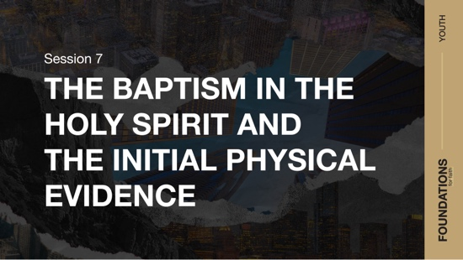
Foundation 7: WE BELIEVE that the baptism in the Holy Spirit is given to believers who ask for it. This experience is distinct from and subsequent to the experience of new birth. Spirit baptism gives believers power to live and serve God and gifts to fulfill the mission of the Church. With the baptism in the Holy Spirit comes experiences such as an overflowing fullness of the Spirit, a deepened reverence for God, an intensified consecration to God and dedication to His work, and a more active love for Christ, for His Word, and for the lost (Luke 24:49; Acts 1:4, 8; 2:4).

Foundation 8: WE BELIEVE that the first sign a believer has been baptized in the Holy Spirit is that he or she has spoken in a language that was not learned and was given by the Holy Spirit (Acts 2:4; 1 Corinthians 12:4–10, 28).¹

We are familiar with how God sent His only Son, Jesus, to sacrifice His life on a cross for us. Jesus’ death brought us forgiveness. Following His death and resurrection, Jesus left earth and returned to heaven. Just before He left, He told His followers to wait for the gift of the Holy Spirit. They were waiting for the baptism in the Holy Spirit. 2

In response, believers from the Early Church gathered to pray and wait. After some time, they received exactly what Jesus had promised. This baptism in the Holy Spirit empowered early believers to share the gospel of Jesus. But the promised Holy Spirit was not just for the Early Church. The Baptism is for us who believe today as well. And just as the Early Church experienced the sign of speaking in unknown languages, we too experience the same today.

NOTE: Foundations for Faith covers so much important information that you may need to break some sessions into two parts in order to cover all the vital teaching provided.

You Will Need | Getting Ready
- Foundation Slide  - Session 7 Video  - Question Slides 1–4  - Bibles for every student, preferably all the same translation | No prep is needed for this session.

ENGAGE
Welcome
Take this time to welcome everyone, introduce new students, learn names, and thank everyone for coming. Your friendliness here can create a comfort level that encourages student participation later.

Opening Prayer
Prayer thoughts: Thank God for the group members who will have this opportunity to learn God’s truth. Ask that they gain understanding of these foundational truths regarding the baptism in the Holy Spirit and its purpose for each person’s life. Ask that those who have not yet received the Baptism would be open to this gift and receive all that God has promised for them.

Introduction

Question
Would you describe yourself as someone who is usually open to new things or skeptical of them? Why?

We may not always understand how or why God does the things we read about in the Bible.
Some people get tripped up on trying to understand things and miss what God has for their life. What we’re talking about today fits that description. Jesus had an amazing gift for His followers that would help them to fulfill His mission. That gift is still available for us today if we’re open to it.

WHAT WE BELIEVE
Foundation for Faith: The Baptism in the Holy Spirit and the Initial Physical Evidence
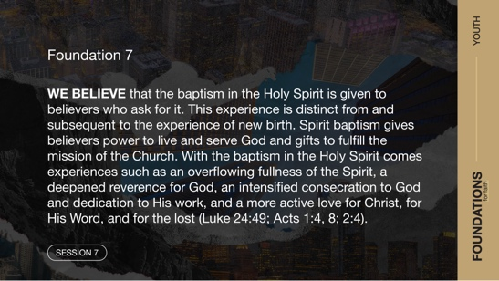
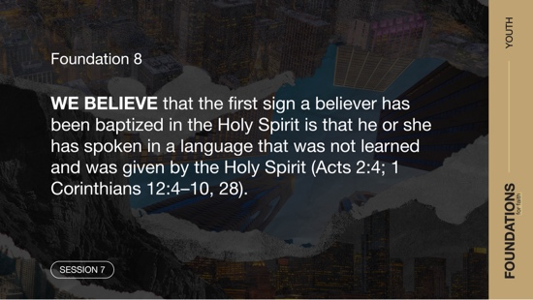
Foundation 7: WE BELIEVE that the baptism in the Holy Spirit is given to believers who ask for it. This experience is distinct from and subsequent to the experience of new birth. Spirit baptism gives believers power to live and serve God and gifts to fulfill the mission of the Church. With the baptism in the Holy Spirit comes experiences such as an overflowing fullness of the Spirit, a deepened reverence for God, an intensified consecration to God and dedication to His work, and a more active love for Christ, for His Word, and for the lost (Luke 24:49; Acts 1:4, 8; 2:4).

Foundation 8: WE BELIEVE that the first sign a believer has been baptized in the Holy Spirit is that he or she has spoken in a language that was not learned and was given by the Holy Spirit (Acts 2:4; 1 Corinthians 12:4–10, 28).

As we continue to learn about the foundations for our faith, we’ll read several Bible passages to explore these two beliefs.

GROUP ACTIVITY | We Match
You Will Need | Getting Ready
No supplies are needed for this activity. | No prep is needed for this activity.

We are going to do an activity called “We Match.” The object of this game is to discover four things that every member of your group has in common. For example, your group may discover that all of you are the same age. When your group discovers the four similarities, shout out, “We match.”
- Divide the group into two or three smaller groups. Preferably, have at least four students in each group. For larger groups, divide the students into four or five smaller groups.
- If you do multiple rounds of this game, have students form different groups.

Our game was all about discovering the similarities we share with others. We have more in common than we are probably aware. There’s a story in the Bible about an experience that some of the first Christians had that we could share with them. To set up our story, we need to begin with an encounter Jesus had early in His ministry. His experience paved the way for a special gift from God for all believers.

Watch
Before we begin, let’s watch this video to focus in on today’s foundational truth.

- Play the Session 7 Video.

CONSIDER WHAT THE BIBLE SAYS
You Will Need | Getting Ready
- Foundation Slide  - Question Slides 1–4  - Bibles for every student, preferably all the same translation | No prep is needed for this activity.

Ensure each student has access to a Bible, preferably the same version.

Did Jesus experience the Holy Spirit’s power?


Before Jesus started His ministry on earth, He was tempted by the devil for forty days. This took place in the wilderness. Remember, even though Jesus is God, He was fully human and lived and was tested like us (Hebrews 2:17–18). So how did He overcome this challenging time, and what was the outcome? Let’s take a look at the verse just before Jesus’ temptation.

Read Luke 4:1.

Question
How is Jesus described in this verse?

Jesus, the Son of God, was working in the power of the Holy Spirit. The Matthew 4:1 version of this event also lets us know He was guided by the Holy Spirit. He wasn’t leaning on His own human strength. Instead, He was showing us what it meant to rely on the Person of the Holy Spirit. The next several verses of Luke 4 contain some details of the forty days of Jesus’ temptation by the devil. It was following these details that we read our next verse.

Read Luke 4:14.

Question
What similarity do you notice between how Jesus was described in verse 1 and in verse 14?

Verses 1 and 14 paint a picture of a Jesus whose Person is jam-packed with the Holy Spirit’s strength. While Jesus lived on earth, He showed His followers then and now the kind of relationship we could have with the Holy Spirit one day. Jesus’ life is an example of what’s possible when we open our life to the Holy Spirit’s power and guidance. The same Holy Spirit who empowered Jesus wants to empower us today for ministry.

Question
Does it change your opinion on our need for power from the Holy Spirit knowing that Jesus was empowered by Holy Spirit?

Who baptizes believers in the Holy Spirit?


In the verses you’re about to read, John the Baptist is the one speaking. He served God by preparing people for the coming Messiah—Jesus. The message he shared was so important that all four Gospels captured it (Matthew 3:11; Mark 1:8; John 1:33).

Read Luke 3:15–16.

Question
Who baptizes believers in the Holy Spirit?

Question
Why do you think this matters?

Jesus was filled with power from the Holy Spirit. He understood that to accomplish all He was assigned to do, He had to be Spirit-empowered. The same Jesus who wanted to be empowered by the Spirit is the One who wants to baptize us in the Holy Spirit. But being baptized in the Holy Spirit isn’t something we can do on our own. To receive that gift requires that we first have a right relationship with God by being saved through Jesus. The next section explains that a little more.

Is the baptism in the Holy Spirit for everyone?
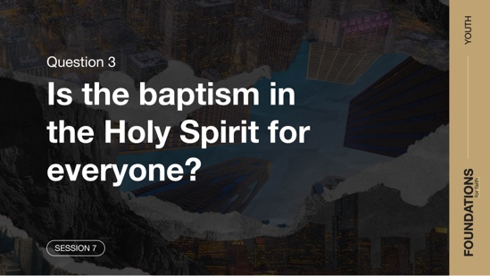

Read Acts 1:3–5.

As already talked about, Jesus was filled with the Holy Spirit before beginning His ministry. The verses we just read show that He wanted the same for His followers. In the days just before Jesus returned to heaven, one of His last instructions to His followers was to wait to be baptized in the Holy Spirit. Rather than pushing them to preach to the world right away, Jesus basically told them to wait on that amazing gift.

Question
What did Jesus tell His followers to do to receive this gift from God the Father?

Question
What does Jesus’ instruction to wait in Jerusalem for the baptism in the Holy Spirit say about how important He thought it was?

Just as Jesus was assigned a task and His first followers had tasks, believers today still have tasks given to us by God. We should understand that we can’t do our best at the role God has for us without the Spirit’s help. We need the power of the Holy Spirit in our life, just as these followers did. Let’s read what happened after they waited.

Read Acts 2:1–4.

Question
Who was at this meeting, and how many of them were filled with the Spirit?

At this time, Jesus had already died, been resurrected, and returned to heaven. Those meeting together were followers of Jesus who likely had been waiting for the gift He had promised was coming. And every person there received the gift of the baptism in the Holy Spirit. No one was left out! The believers finally received the Holy Spirit empowerment Jesus had ministered with.

Question
How does it encourage you in your faith to know that we can receive and be empowered by the Holy Spirit just as Jesus was?

The first action after the believers were baptized in the Holy Spirit was Peter standing up to a crowd who questioned what was going on. He stood in power and boldness. It was what Jesus said would happen in Acts 1:8 when He said that they would receive power and they would be His witnesses. That is exactly what happened with Peter. Toward the end of Peter’s sermon, he explained who this gift of God is for.

Read Acts 2:38–39.

Question
Who did Peter explain that the gift of the baptism in the Holy Spirit is for?

How can we know we’ve been baptized in the Holy Spirit?
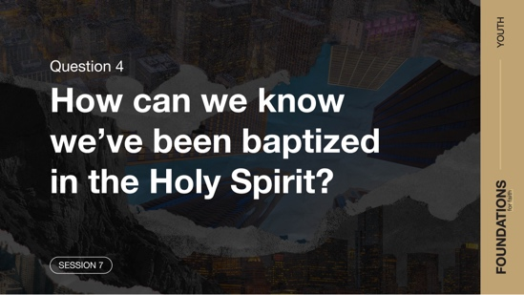

In Acts 2:1–4, we saw that the initial physical evidence, or the result, of being baptized in the Holy Spirit was speaking in other languages, also called tongues. This is speaking in a language that a person has not learned and is given by the Holy Spirit. To find out if this part of the Baptism is normal, we need to see if this happens anywhere else in Scripture or if it only was for the Day of Pentecost. Let’s take a look.

Read Acts 19:1–7.

Question
Had these believers heard of or received the Holy Spirit before meeting Paul?

They hadn’t heard of or received the Holy Spirit before Paul’s visit. The baptism they had received was John’s baptism. That was a baptism of repentance. In other words, they were believers who had already experienced salvation.

Question
What happened to these believers that showed they had been baptized in the Holy Spirit?

Question
Why do you think God gave us an initial, physical evidence of being baptized in the Holy Spirit?

Just as water baptism is proof of our commitment to Jesus and His gift of salvation, speaking in languages we’ve never learned as the Holy Spirit allows us is proof of our receiving the gift of the Holy Spirit. Even the Early Church knew this! In Acts 10:44–46, another group received the baptism in the Holy Spirit. The Bible clearly says that the people who traveled with Peter recognized that these new believers were baptized in the Holy Spirit because they heard the new believers speak in tongues.

Before we leave the topic of tongues, let’s look at one more thing. While speaking in tongues is the initial, physical sign that someone has received the baptism in the Holy Spirit, that’s not all it is. Praying in tongues also can become a part of your personal prayer time, it can bring you closer to God, and it allows the Holy Spirit to guide your prayers. It can even be used in a special way when Christians gather, but that’s a different discussion.

Question
What is something you’ve learned from our discussion on the Holy Spirit?

Of course, you may have questions about what we’ve discussed. Never hesitate to ask a leader about this discussion or any other questions you have about the Bible or Jesus. One of the best ways for each of us to grow is through discussion about what the Scriptures are saying and how we best live them out in our life.

WHAT WE BELIEVE
Foundation for Faith: The Baptism in the Holy Spirit and the Initial Physical Evidence

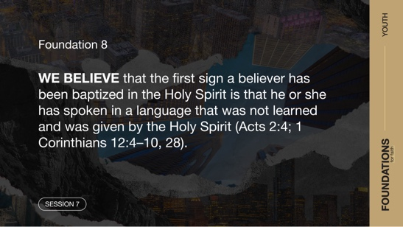
Foundation 7: WE BELIEVE that the baptism in the Holy Spirit is given to believers who ask for it. This experience is distinct from and subsequent to the experience of new birth. Spirit baptism gives believers power to live and serve God and gifts to fulfill the mission of the Church. With the baptism in the Holy Spirit comes experiences such as an overflowing fullness of the Spirit, a deepened reverence for God, an intensified consecration to God and dedication to His work, and a more active love for Christ, for His Word, and for the lost (Luke 24:49; Acts 1:4, 8; 2:4).

Foundation 8: WE BELIEVE that the first sign a believer has been baptized in the Holy Spirit is that he or she has spoken in a language that was not learned and was given by the Holy Spirit (Acts 2:4; 1 Corinthians 12:4–10, 28).

Why Does This Matter?
Emphasis on the baptism in the Holy Spirit is a major focus of the Pentecostal movement, of which the Assemblies of God is a part. The Holy Spirit, the third Person of the Trinity, empowers us to do the works of Jesus on earth. We shouldn’t think that being baptized in the Holy Spirit is some sort of merit badge to earn. Rather, we should understand that receiving the baptism in Holy Spirit enables us to live more closely to God, better serve Him, and more effectively share the good news of Jesus with a hurting world.

We should also remember that speaking in tongues is not the end goal of being baptized in the Holy Spirit. The goal is to give more of our life to be led and empowered by the Holy Spirit, just as Jesus was. Speaking in tongues is the first physical sign that we have been baptized in the Holy Spirit. If there was no evidence, it might be confusing whether a person had been baptized or not. Additionally, speaking in tongues is another way to allow the Holy Spirit to lead our prayers.

REFLECT
We can trust the Scriptures for examples of how being Spirit baptized affects our walk as a follower of Jesus. Here are a few ways the Holy Spirit equips and empowers us. The question is, how open are you to receiving everything the Holy Spirit offers?
- We are filled with power. (Luke 24:49; Acts 1:8)
- We live a life of overflowing fullness of the Spirit. (John 7:37–39)
- We experience a deepened reverence for God. (Acts 2:43; Hebrews 12:28)
- We have an intensified consecration to God and His work. (Acts 2:42; 4:8)
- We have a more active love for Christ, for His Word, and for the lost. (Matthew 28:18–20)
- We can possess a supernatural boldness to share God’s Word. (Acts 4:31)
- We live a life of thanks and deeper concern for others. (Ephesians 5:18–21)
- We minister in the gifts of the Spirit. (1 Corinthians 12:4–11).

Listen to God
Let’s take time to think about whether our life shows that we trust the Bible. These questions are meant to start a conversation between you and God. Sharing your responses with the group is completely voluntary.
- Pause for a few moments of silent reflection after reading the questions. Then ask students if they want to share. Sharing your personal response may also be helpful to the students.

Question
Has there been a time when you were aware of the Holy Spirit’s presence or power operating in your life? What may be keeping that from being a more common event?

Question
How open are you to experiencing more of the Holy Spirit’s power in your life?

ACTIVATE
If you have been baptized in the Holy Spirit, pray in your prayer language regularly. Pray that the Holy Spirit gives you power to share about Jesus with others and walk in obedience to His commands. For those who have not yet received the baptism in Holy Spirit, be encouraged to seek this gift from God. That may include reaching out to a leader if this experience is new to you, and you have questions you’d like to ask.

CONCLUSION

When Jesus left the earth, He didn’t leave us to figure out life on our own. He left the Holy Spirit for us. The Holy Spirit helps every believer walk through life, but He also has more for you. The baptism in the Holy Spirit, for every person who has been saved, is an opportunity to receive more from Him. Jesus baptizes us for the purpose of having greater power to be His witnesses. How do we know that we’ve been baptized in the Holy Spirit? God gave us the sign of tongues as proof—eliminating any confusion as to whether someone is baptized in the Holy Spirit or not.

Salvation Opportunity
Include this if you think there may be some in the group who do not have a personal relationship with Jesus.

Before we can be filled with the Holy Spirit and speak in tongues, we must know Jesus. Jesus is the One who baptizes us in the Holy Spirit. If there is anyone here who doesn’t have a relationship with Jesus, today can be the day you have that conversation with Him.

Is anyone here that we can pray for who doesn’t have a relationship with Jesus or wants to renew their relationship with Him?

Take a moment to acknowledge those who respond and thank them for their desire to make things right between themselves and God. Pray with them as you close in prayer or after the group time is over. Following group time, talk more about where they are in their walk with God and how you might be able to help.

Prayer
God, thank You for sending Jesus to give His life for us. Jesus, thank You that You didn’t leave us alone on earth. Thank You for giving us the Holy Spirit so we can walk with power to do Your will and share Your love with others. We ask You to give all Your followers a greater hunger for the Holy Spirit’s empowerment and a greater desire to do Your will. Amen.

Dismissal
I look forward to seeing each of you next time. Don’t forget to grow in your relationship with the Holy Spirit. That includes praying regularly in your prayer language if you have been baptized in the Holy Spirit. Let’s continue to seek all that God has for us in our relationship with Him. The devotions in the app are a great way to discover even more about what the Bible has to say about our relationship with the Holy Spirit.

Endnotes
To read the full, official version of the Statement of Fundamental Truths, visit ag.org/beliefs/statement-of-fundamental-truths.
2 Portions of this session are adapted from Bible Engagement Project Youth Learn © 2021 by The General Council of the Assemblies of God, Springfield, Missouri 65802. Used by permission of the publisher.

