

Sanctification

Foundations for Faith Overview
We were never meant to do life alone—especially as followers of Jesus. Disciples grow best in community. Jesus himself modeled this concept by gathering a small group of followers to live and minister alongside Him every day. Even now when believers gather to seek God, relationships are forged, iron-sharpening discussions happen, and genuine accountability can develop.

During the next several sessions, you will journey together through foundational truths—or doctrines—of the Bible. Don’t let the word doctrine put you off. It simply refers to a teaching that comes from Scripture. Our doctrine impacts our decisions more than we might realize. For example, if we have a doctrinal belief that God heals, we are more likely to pray in faith, see Him deliver others from sickness, and experience our own healing. If we don’t believe in healing, we will not expect it or pray for it, and we may even speak out against it. The experiences we have as we follow Jesus largely depend on our doctrine.

The Book of Acts describes a group of Jews in Berea (17:10–15) who, like us, were seeking to better understand Scripture’s most foundational doctrines. After hearing Paul and Silas’s gospel message, they searched the Scriptures every day on their own to verify and fully understand the truth. The result? Many people believed the good news of Jesus and were changed for eternity. As you study Scripture and discuss doctrine together, may the Holy Spirit do the same for you.

SESSION OVERVIEW
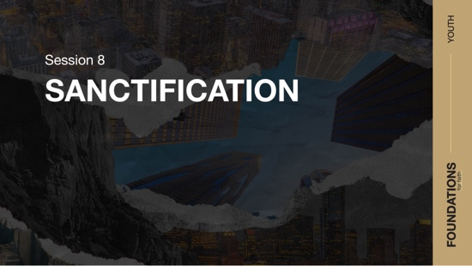

Foundation 9: WE BELIEVE in the sanctifying work of Jesus at salvation to dedicate us to God and the power of the Holy Spirit by whose indwelling the Christian is enabled to live a holy life (Romans 12:1–2; Galatians 5:16–25; 1 Peter 1:15–16).

Sanctification essentially means to be set apart. For the Christian, this is both an initial event at salvation and an ongoing work of the Holy Spirit that continues throughout our life. Once we accept Jesus as Savior, we are sanctified in the sense that we are set apart for God’s purposes. Also, as we submit to the Spirit of God, we are transformed, or renewed, making us more like Jesus and further separated from sin. God has set apart every follower of Jesus as holy, and our response to His action should be to live in a way that reflects that special status. We never reach perfection in this life, but through the help of the Holy Spirit, we can make progress down the path of sanctification daily as we become more like Jesus.2

NOTE: Foundations for Faith covers so much important information that you may need to break some sessions into two parts in order to cover all the vital teaching provided.

You Will Need | Getting Ready
- Foundation Slide  - Question Slides 1–3  - Bibles for every student, preferably all the same translation | - No prep is needed for this session.

ENGAGE
Welcome
Take this time to welcome everyone, introduce new students, learn names, and thank everyone for coming. Your friendliness here can create a comfort level that encourages student participation later.

Opening Prayer
Prayer thoughts: Thank God for everyone present and for the journey you’ll take together over the next several weeks. Ask God to help everyone understand what changes they need to make to live a holy life. Ask that everyone would understand what it means to give ourself completely to God. Pray that each day as we follow Jesus, we would become more like Him.

Introduction

Question
What’s something you’ve slowly gotten better at over time? What did you do to get better?

Getting better at a skill is a long process. People who are the best at what they do—professional athletes, world-renowned artists, or brilliant inventors—spend years practicing their craft. And just like them, we must give ourself completely to something if we want to become better at it.

And today’s topic is all about becoming. We’ll think about how we become something new when we’re saved, and that process of becoming continues for the rest of our life. We’re becoming more like Jesus, and that process is called sanctification. That word may sound complex, but we’ll get into the idea behind it in the session, and it’s not that tough.

WHAT WE BELIEVE
Foundation for Faith: Sanctification
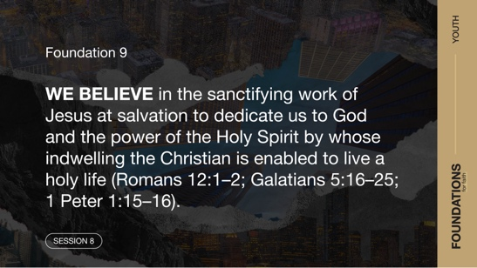
Foundation 9: WE BELIEVE in the sanctifying work of Jesus at salvation to dedicate us to God and the power of the Holy Spirit by whose indwelling the Christian is enabled to live a holy life (Romans 12:1–2; Galatians 5:16–25; 1 Peter 1:15–16).

Jesus’ death on the Cross opened the door for us to be sanctified. When we accept Him as our Savior, we’re set apart for God and His plans and will for our life. This doesn’t mean that we’ll never sin again, but it means that since we’re in relationship with Him, we should act like it. Our life should change as we work to avoid and remove sin. We don’t do that alone though. The Holy Spirit in our life gives us power to live like someone who is sanctified. Let’s jump into an activity related to the idea of change.

GROUP ACTIVITY | Quick Change
You Will Need | Getting Ready
No supplies are needed for this activity. | No prep is needed for this activity.

For this activity, everyone needs to find a partner and face them. When I say, “Quick change,” both people will turn around so they aren’t facing their partner. At this point, both people will change two things about their appearance. For example, you might untie a shoe, tuck your hair behind your ear, or roll one sleeve. Then when I say, “Turn around,” each person will attempt to guess what the two changes are made by their partner. The first person in each pair to correctly guess what the two changes are moves on to the next round.

The winners will then find another person who won to pair up with, and then we will begin a new round. This time, change three things. The winner of that round moves on to the next round until we have a winner.
- You may want to adjust the number of things to change each round. Keep in mind that the higher the number, the more difficult the activity becomes.

Life is full of changes. A big change happened when you decided to follow Jesus. Some of you might not have noticed it right away, sort of like the activity we just did. On the other hand, some of you may have noticed a difference right away when you asked Jesus to forgive you for the wrong things you’ve done and accepted Him as your Savior and Lord. Either way, we have all changed. We continue to change each day that we walk with Jesus. Let’s look at what the Bible says about the changes going on in our life now that we have a relationship with Jesus.

Watch
Let’s watch this video to focus in on today’s foundational truth.
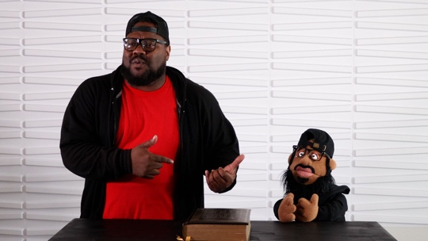
- Play the Session 8 Video.

CONSIDER WHAT THE BIBLE SAYS
You Will Need | Getting Ready
- Foundation Slide  - Question Slides 1–3  - Bibles for every student, preferably all the same translation | No prep is needed for this activity.

Ensure each student has access to a Bible, preferably the same version.

Today’s topic is sanctification. Yes, sanctification is a complicated sounding word, but it’s not too hard to understand. Just think of it this way: Sanctification is being set apart for something special. Does your family have special dishes that are set aside only for special occasions? Or maybe you have a pair of sneakers that you only wear if you’re playing on a gym floor. That’s kind of like the idea of sanctification, except we’re talking about your life and being set apart for God.

Jesus gets us started in the process of sanctification, and we continue the process as the Holy Spirit helps us. To get us started, think of sanctification as the journey to become more like Jesus. As we walk that path, we follow less of the world’s way of living. Instead, we follow Jesus and the life He has for us. We’re separated from sin and set apart to serve God.

When does sanctification start?
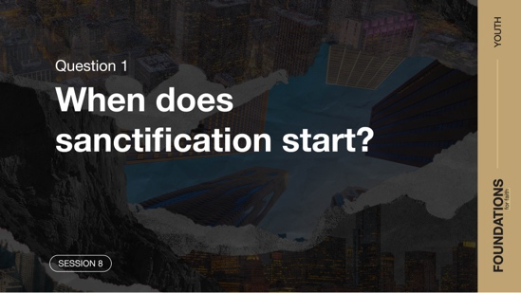

Let’s talk about the first big question: When does sanctification start?

Often in nature, things must die for new life to happen. One place we can see this is in trees. Their seeds drop to the ground and are cut off from the life of the tree. But that seed’s death allows a new tree to sprout to life. As we read these verses from one of the letters written by the apostle Paul, look for this idea of death creating new life.

Read Romans 6:1–5.

Question
In what ways did you see the idea of death producing life in these verses?

In verse 3, we find out that these verses are talking about those who were “joined with Christ Jesus in baptism.” If you were here a few sessions ago, you might remember that we talked about water baptism, and we even looked at some of these verses. Our baptism is the clue that these verses are talking about followers of Jesus. Being baptized in water is one way we show others that we’re a Christian and are starting a new life following Jesus.

Question
What do these verses say we “die to”?

Question
What do you think it looks like when a person dies to sin?

Those are some really good thoughts. When we follow Jesus, we’re putting to death our old way of life. Then, because of what Jesus did for us, we get to start a new life. This is when our sanctification begins. The moment we choose to follow Jesus, we’re set apart to live a new life that pleases God.

Read Romans 6:6–12.

Question
What happens when we allow ourselves to be “crucified with Christ”?

Of course, these verses aren’t saying that we have to die on a literal cross like Jesus did. It explains that as we leave our old life behind and start our new life with Jesus, something special happens. The power that our sins had over us is gone. We don’t have to be in bondage to the sinful choices we made before being saved. Jesus paid the penalty so that we can be set apart as special and different from everyone else still enslaved to their sins.

Question
Is it wrong to have sinful desires? Explain.

Each of us is tempted to sin, and we’ll keep being tempted the rest of our life. There’s nothing wrong with being tempted. The wrongdoing happens when we give in to the temptation. As the famous church leader Martin Luther wrote, “You cannot prevent the birds from flying in the air over your head, but you can prevent them from building a nest in your hair.”3 In other words, we’ll battle with thoughts of sin throughout our life. But because of being set apart for a new life in Jesus, we can choose to push out those thoughts and avoid sinning.

What are Christians set apart to do?
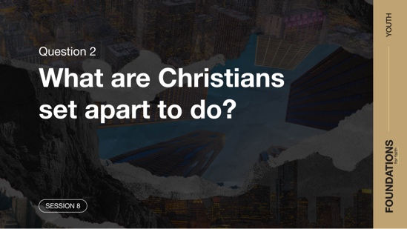

Read Romans 6:13–14.

Question
What do you think it looks like to “give yourselves completely to God”?

Question
Do you use your body as an instrument for God’s glory rather than your own? How?

When we’re tempted, it’s an opportunity either to be used as a tool for evil or for God. In a way, we’re like a musical instrument. We can either be a part of making good music or bad. Our new life in Jesus allows us to make good choices that give God glory. And every time we make those good choices, we’re walking the path of sanctification. This is what it means to live a sanctified life. We are immediately made right before God because of Jesus, but we’re also in the constant process of becoming instruments for His glory.

Read Romans 6:15–18.

Question
What does it mean that we become slaves of whatever we choose to obey?

Question
If Jesus’ death broke the power of sin, why do you think we still struggle with sin?

The struggle with sin is something every human will always deal with in this life. Remember, sanctification is an ongoing process. We will never achieve perfection on earth. Only Jesus lived that. Life for the follower of Jesus is a continual choice of who we will serve. Even though we’re free to say no to sin, being tempted to sin continues to be part of our nature. The key is not to allow it to rule over our life. Instead, those who are set apart for God’s purposes let Him be in charge.

Question
How would you put the idea of “righteous living” in your own words?

A few times in the verses we read, the idea of “righteous living” came up. Another way to unpack that idea is living according to what God says is right. This is what Christians are set apart to do. We live in the way that God has determined is right. Jesus freed us to start living that way, and the next section unpacks a big part of how that happens.

Who is the Leader in a sanctified life?
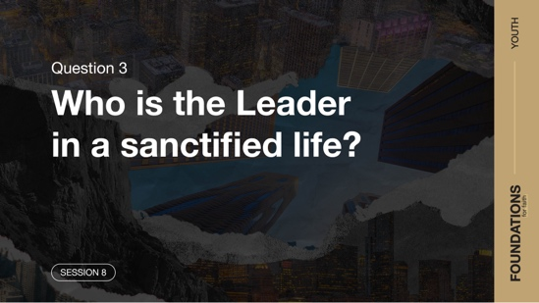

Our last question is: Who is the Leader in a sanctified life? Let’s turn to another of the apostle Paul’s letters. He seemed to write letters with similar themes. In this one, he reminded us that our journey with Jesus and doing the right thing is a process. The key to doing this is allowing the Holy Spirit to lead us.

Read Galatians 5:16–21.

Question
What does it mean to let the Holy Spirit guide our life? What is the outcome?

Question
What two forces do these verses say are fighting each other?

The Holy Spirit is within every follower of Jesus. The Spirit and our sinful desires fight for control over our life. That battle is constantly going on inside us. We win that battle by following the direction of the Holy Spirit. Have you ever felt the urge to sin, but something else inside you was pushing you away from the sin? That may have been the leading of the Holy Spirit. Over time, we learn to better recognize when He’s speaking. One simple way to decide if it’s Him is to ask, “Is this feeling leading me closer to God or further away?”

Question
Based on these verses, what are some outcomes for those giving in to sinful desires?

Giving in to sinful desires makes our life a mess. But being led by the Holy Spirit moves us into position to be a part of God’s plans. It’s an ongoing process over the course of our life. But this process is the journey of sanctification. The verses we read listed what following sinful desires produces. Next, let’s look at what following the Spirit produces.

Read Galatians 5:22–25.

Question
What does following the Holy Spirit produce in the life of a follower of Jesus?

Question

How might someone use this list to determine how much the Holy Spirit is leading in his or her own life?

This list of traits is usually called the fruit of the Spirit. These qualities show up in the life of each one who is led by the Spirit. They’re a good test for us to see how we’re doing in living a sanctified life. Are you often responding to people in anger rather than gentleness? Are you filling your life with drama instead of walking in peace? Are you more likely to blurt out something mean than being kind and self-controlled? If so, you probably need to focus more on listening and obeying the Holy Spirit’s leading. This is the journey of sanctification.

WHAT WE BELIEVE
Foundation for Faith: Sanctification
Foundation 9: WE BELIEVE in the sanctifying work of Jesus at salvation to dedicate us to God and the power of the Holy Spirit by whose indwelling the Christian is enabled to live a holy life (Romans 12:1–2; Galatians 5:16–25; 1 Peter 1:15–16).

Sanctification is all about being set apart to and for God’s purposes. It’s not solely the idea of being separated from something. It also implies being separated to something. Only by the power of the Holy Spirit can we live the holy life God desires (1 Peter 1:15–16).

Why Does This Matter?
Sanctification is the process of disconnecting from a sinful lifestyle and turning to God with all our heart, soul, mind, and strength (Mark 12:30). For each of us, this will be a lifelong process. The enemy will attempt to discourage you by yelling in your ear that you’ll never be able to overcome your sin. Understanding that we are on a journey to become more like Jesus each day gives us confidence. Without understanding this process, we attempt to live our life as His follower in our own strength. We can try, but the fact is, we can’t do it on our own. And God doesn’t want us to try to. He gave us His Holy Spirit to help us overcome sin and gave us the power to fulfill our purpose. As we grow in our holiness, we begin to take on the image of our Creator and better reflect Jesus in our speech, attitude, and lifestyle.

REFLECT
Knowing that the Holy Spirit helps us walk through the process of change is reassuring. He is helping us to become more like Jesus. We learn to cooperate with Him in the sanctification process. We have a part to play, and God has parts. God’s parts came through Jesus’ work on the Cross and the Holy Spirit’s continued help. Our part is to reject sin and follow God’s direction. As we learn to yield our life, the Holy Spirit will help us progress on the journey of sanctification.

Listen to God
Let’s take time to think about whether our life shows that we trust the Bible. These questions are meant to start a conversation between you and God. Sharing your responses with the group is completely voluntary.
- Pause for a few moments of silent reflection after reading the questions. Then ask students if they want to share. Sharing your personal response may also be helpful to the students.

Question
Are you following the Holy Spirit’s leading toward a sanctified life? How so or why not?

Question
Who is another Christian in your life who can help you recognize the growth or lack of the fruit of the Spirit in your life?

Question
What are the next steps in your life on the journey of sanctification?

ACTIVATE
Take a moment to pray with someone in your group. Form groups of two or three to pray for each other. Pray that each of you would learn to walk in holiness in greater ways. Don’t hesitate to speak with a pastor or leader if you need help in an area. Perhaps you’ve prayed and done all you can to break free from a sin but are having a difficult time. Let someone you trust help you.

Write out the fruit of the Spirit. Tape them to your mirror or locker as a reminder of the areas you’re wanting to grow in and be made holy.

CONCLUSION

Sanctification is a big word that means being set apart. As we become more like Jesus, we are being set apart from sin. But it’s much more than begin set apart from something. It’s also being set apart toward something. That something is becoming like Jesus and being part of God’s plans for you. Answering His call means living differently from how you did before surrendering to Jesus. It’s now time to live a holy life and fulfill the mission He has for you.

Salvation Opportunity
Include this if you think there may be some in the group who do not have a personal relationship with Jesus.

Perhaps you’ve never considered the idea of living a life devoted to God. Before we can even think about taking the journey to being sanctified, we must know the One we’re being set apart to live for. Today is an opportunity for you to give your life to Jesus and begin living a life devoted to Him.

Is anyone here that we can pray for who doesn’t have a relationship with Jesus or wants to renew their relationship with Him?

Take a moment to acknowledge those who respond, and thank them for their desire to make things right between themselves and God. Pray with them as you close in prayer or after the group time is over. Following group time, talk more about where they are in their walk with God and how you might be able to help.

Prayer
Father God, thank You that You sent Your Son so we could not only have eternal life one day, but also have a life that pleases You today. Help us to be set apart for You. Teach us to better hear and obey Your Holy Spirit’s leading. Allow us to be an example for others who inspires them to fully obey and trust You. In Jesus’ name, we pray. Amen.

Dismissal
I look forward to seeing each of you next time. Don’t forget your challenge to speak with someone who can help you with your next steps on the sanctification journey. Let’s help each other keep moving forward down that path. Also, the devotions in the app will help you to grow in your understanding of sanctification. See you next time!

Endnotes

To read the full, official version of the Statement of Fundamental Truths, visit ag.org/beliefs/statement-of-fundamental-truths.
2 Portions of this session are adapted from Bible Engagement Project Youth Learn © 2021 by The General Council of the Assemblies of God, Springfield, Missouri 65802. Used by permission of the publisher.
3 Martin Luther, The Large Catechism, “Explanation of the Lord’s Prayer,” Sixth Petition.

