

LEADER OVERVIEW

Volume Overview—Run the Race
In these sessions, kids will discover that God has a plan for each one of them and the importance of listening to and doing what God says. They will also learn about the hope of Jesus’ return and what it will be like to live with God forever.

SESSION 1: Timothy Learns from Paul—  2 Timothy 3:10–17  Faith Fact: God has a plan for me. | SESSION 2: Faith and Works—James 1:19–27; 2:14–26  Faith Fact: God wants me to take action.
SESSION 3: Jesus Is Coming Back—  1 Thessalonians 4:13–18; 5:1–11  Faith Fact: Jesus is coming back. | SESSION 4: New Heaven and New Earth— Revelation 21:1–10, 21–27  Faith Fact: I can live with God forever.

SESSION OVERVIEW


In this session, kids will learn about discipling others from the example of Paul and Timothy. They will be reminded that God has a plan for each one of them.

Bible Lesson | Faith Fact
Timothy Learns from Paul  2 Timothy 3:10–17 | God has a plan for me.
Faith Verse
Philippians 3:14 (NLT)
I press on to reach the end of the race and receive the heavenly prize
for which God, through Christ Jesus, is calling us.

Listen Kids is part of an entire kids’ discipleship strategy. Get access at KidminRoadmap.com.
PREPARING FOR THE SESSION
You Will Need | Getting Ready
Large Group  - Bible  - Worship songs (Song suggestions: “Zeal” by The Belonging Co; “Way Maker” by Hillsong; “See a Victory” by Elevation Worship; “Yes and Amen” by Chris Tomlin)  - Poster board or index cards  - Marker  - For groups not using a phone or tablet only, add:  - Projector or TV  - Laptop  - Countdown 5-Minute Video  - Theme Intro Video  - Faith Fact Slide or Motion Graphic  - Game Time Slide or Motion Graphic  - Countdown60 Video  - Bible Lesson Video A  - Bible Lesson Video B  - Faith Verse Video or Slide  Small Group  - Bibles, one per kid  - Small Group Activity Page, one per kid  - Colored pencils | Large Group  - Download videos and slides if needed.  - Select worship song(s) and have them ready to play.  - List the following categories on a piece of poster board or on individual index cards: Color, Number, TV Show, Board Game, Movie, Dessert, Food, Restaurant, Video Game App, Hobby, Sport, Instrument, Song, Cereal, Ice Cream Flavor, Animal.  Small Group  - Print the Small Group Activity Page, one per kid.
Check out all the promotional and extra media files available for this theme. To access the Bible Engagement Project from a computer, visit App.BibleEngagementProject.com.

Find the corresponding Bible Fact-Pak® question numbers for this session in the Volume Additional Assets on the mobile or Web app.

LARGE GROUP (30 Minutes)
See what’s needed at the beginning of the session.

INTRODUCTION
- Optional: Play the Countdown 5-Minute Video.



Welcome

Welcome! I’m so glad you’re here! After Jesus went back to heaven, His followers shared the good news about Jesus with many people, and the Church grew. Today, we’ll talk about Paul and how he trained others to spread the word about Jesus. Let’s watch this video, and then we’ll get started.
- Play Theme Intro Video.



Paul took care of the people he loved and discipled them. Do you know what it means “to disciple” someone? (Allow responses.) When you disciple someone, you are teaching him or her how to follow Jesus. A disciple of Jesus is someone who believes in Jesus and follows His teachings.

When you disciple people, you might be a part of them asking Jesus into their lives, but it goes deeper than a one-time decision. Discipleship involves helping and supporting people as they learn what it means to live their life the way God wants them to live. Paul helped many people and even entire groups of people learn that God has plans for them.

Faith Fact
- Show the Faith Fact Slide or Motion Graphic.



Today’s Faith Fact tells us that God has a plan for each one of us. The Faith Fact is God has a plan for me. Let’s say our Faith Fact with a big emphasis on the words God, plan, and me. Make those three words way louder than the other words in the Faith Fact. Let’s try it. God has a plan for me. Let’s say it a couple more times. (Pause for kids to repeat the Faith Fact.) Now that was some good work!

GAME | My Favorites
You Will Need | Getting Ready
- Poster board or index cards  - Marker | - List the following categories on a piece of poster board or on individual index cards: Color, Number, TV Show, Board Game, Movie, Dessert, Food, Restaurant, Video Game App, Hobby, Sport, Instrument, Song, Cereal, Ice Cream Flavor, Animal.

- Show the Game Time Slide or Motion Graphic.


Do you think you know me well? (Group response) What about the other kids who are here today? (Group response) We’ll see how well we all know each other, and we’ll learn some new things about each other in today’s game. I will start by choosing a category and naming two things in that category. (You may want to give an example.) Only one option will be my favorite, and you will guess which one you think it is. One person who guesses correctly will get to choose the next category and share his or her options.
- Option: If using the poster board, show the entire list to the kids. You can make a mark beside each category as it is chosen.
- Option: If using the index cards, write one category per card. You can lay them face up or face down for the kids to choose from.
- Play as many rounds as time allows.

It was a lot of fun being able to share our favorite things with each other. One of my favorite things to do is worship God.

WORSHIP

It’s always a good time to worship God, but there is nothing better than worshipping God with other people who love worshipping Him, too. Let’s worship together by singing!
- Lead the kids in singing one or two praise songs. See suggestions at the beginning of the session.

BIBLE LESSON | Timothy Learns from Paul (2 Timothy 3:10–17)

When I am worshipping God, I am often reminded that God loves me and that He has a plan for me. Let’s pray and ask God to teach us how to disciple others the way Paul did.

Prayer

Dear God, thank You for giving us the example of Paul to learn from. Help us to disciple our friends and the people around us who haven’t known You as long as we have. Amen.

Video Intro

Before we get started with the Bible story, let’s check in with the Challenge Accepted team and see what they’re up to.
- Play Bible Lesson Video A.

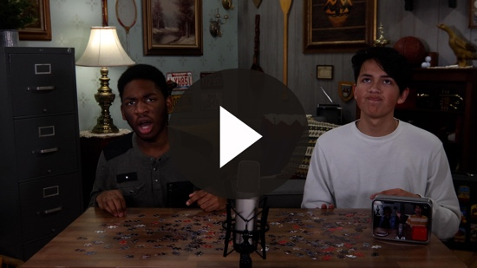

Wow! I don’t know if I could put that puzzle together in the amount of time they had. What about you? (Group response) I wonder how that ties in with our Bible story today.

Teaching Time
If you have your Bible, turn with me to 2 Timothy 3:10–17. (Allow time for the kids to turn to the passage in their Bible.)

Have you ever thought about the kind of job you want to do when you’re older? (Group response) Maybe you would want to be a sports star, a police officer, a movie star, a nurse, or even an astronaut.
- Tell the kids what job you wanted to do when you were their age.

We all have different dreams of who we want to be when we grow up. Maybe you don’t have an idea of the life you want to live when you’re older, and that’s okay, too. None of us knows what our life will look like in twenty years. The only one who knows is God!
- Show the Faith Fact Slide or Motion Graphic.



God has a plan for each of us. Let’s say the Faith Fact together. God has a plan for me. He knows our future, and I promise you that His plans are the best plans!

In our Bible story today, we hear about a young man named Timothy. God had big plans for Timothy’s life and God used Paul, the guy we have been learning about, to prepare Timothy for the future.

God used Paul to talk to other people too. For example, when God rescued Paul and Silas from prison, they talked about Jesus with a jailer. He and his entire family believed in Jesus and were baptized in water. Paul went on from there to preach to many people, to write letters to churches and people, and to make many more disciples. Some of Paul’s letters later became books in the New Testament.

Two of those letters were to a disciple named Timothy who became a spiritual son to Paul. He wanted to help Timothy learn God’s truth. He discipled him. Do you remember what that means? (Allow responses.) That’s right! Paul taught Timothy everything that he knew about God so that Timothy could go and do the same things Paul was doing. Our Bible reading was written toward the end of Paul’s life. It is a part of a letter Paul wrote to Timothy just before Paul believed he was going to die.

What would you share with someone in a letter if you knew you were about to die? (Allow responses.) Those are some great answers. It’s interesting that when Paul was close to death, it was important to him that he taught Timothy to continue to share the love of God with everyone around him. Let’s find out what Paul decided were the most important things to share with Timothy in 2 Timothy 3:10–17.
- Read 2 Timothy 3:10–13.

What are the important ideas that Paul shared with Timothy in verses 10–13? (Allow responses.) He talked about the things that were important to him and the example of how he had lived his life. Paul wanted Timothy to know that he had been mistreated because of his faith in God.

Has anyone ever mistreated you because of your faith in God? (Group response) Paul warned Timothy that he would probably be treated badly if he told others about his faith in God. Paul also warned Timothy to look out for evil people who might try to trick him into believing things that aren’t true.

Let’s continue reading in verses 14–17. Make sure you listen carefully to hear more of the important ideas Paul shared with Timothy.
- Read 2 Timothy 3:14–17.

What is Paul saying in those verses? (Allow responses.) Paul told Timothy to be faithful to what he had learned. Paul emphasized the importance of knowing the truth. He talked about the importance of Scripture to teach us what is right and true and to prepare us to do good things for God. Paul shared even more advice with Timothy later.

One of the big things we can take away from Paul’s example is that he cared about helping others grow as disciples. He wanted to help others learn to follow Jesus. Paul wanted to teach others to love Jesus and become more like Him. Paul knew that he wouldn’t be around forever. He needed to train disciples who could follow in his footsteps and take his place by continuing to preach the good news about Jesus. Paul didn’t wait until he was about to die to start making disciples.

He started telling others about Jesus and training his replacements soon after he became a follower of Jesus. Paul knew that God had a plan for his life. God wanted Paul to share his life as an example to others so they could learn the truth that God has a plan for their lives as well.

Faith Verse
Our Faith Verse reminds us that God’s plan isn’t for us to win anything on earth. God wants us to be working toward heavenly goals, not earthly ones. Let’s say the verse and learn the actions together.
- Show the Faith Verse Video or Slide.

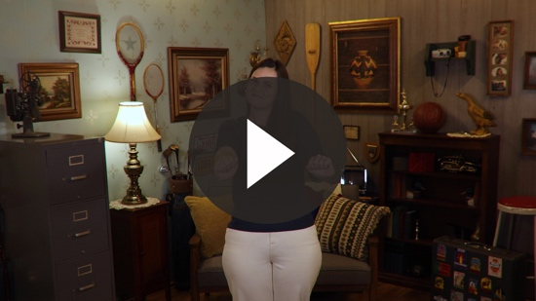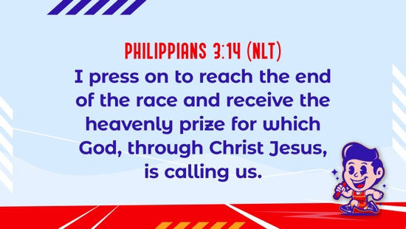

Philippians 3:14 (NLT)
I press on to reach the end of the race and receive the heavenly prize for which God, through Christ Jesus, is calling us.

It’s easier to focus on earthly things because they are right in front of us. God’s plan for us is so much bigger and greater than what we can see or understand right now.

PRAYER AND RESPONSE
You Will Need | Getting Ready
No supplies are needed for this activity. | No prep is needed for this activity.

Consider playing a worship song softly in the background while kids pray.

Do you know what God’s plan is for your life? Have you taken the time to ask Him and listen for what He says? We need to make sure that our prayer time includes time to ask God questions and time to listen for Him to speak.

If you aren’t doing this already, add a minute or two to your prayer time just to listen. This might be hard at first because you are not used to it. You may not hear anything at all, but when you take time to listen to God, you will be able to feel Him in your heart.

We may miss what God is saying if we never take time to listen. God wants to share His plan for your life with you. He doesn’t want to keep it secret. He wants you to know about His plan for you.

We already know one thing that is a part of His plan for all of us. Does anyone know what that is? (Group response) If we are a follower of Jesus, God wants us to disciple others. We all have the responsibility of sharing Jesus with others and helping those who have known Him for less time than we have. Who in your life can you start discipling today?
- Give kids time to pray.
- Lead them in a salvation prayer.

Worship Song
Play one or two worship songs.

Video Wrap-Up

Before we go to our small group activities, let’s see how the challenge worked out for the Challenge Accepted team.
• Play Bible Lesson Video B.

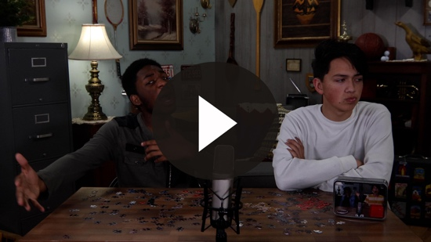

Let’s all accept the challenge that the team gave us. Spend time talking and listening to God while you put together a puzzle. Remember our Faith Fact?
- Show the Faith Fact Slide or Motion Graphic.

Say it with me. God has a plan for me. That Faith Fact is enough to give us the encouragement we need to face the days ahead with God’s help. Remember to make time to ask God questions and listen for Him to speak to you this week.
- Dismiss kids to Small Group time or to go home if your group time ends here.

SMALL GROUP (30 Minutes)
This section can be done in conjunction with the large group, or on its own if you do small groups with your kids. During Small Group time, the goal is to connect the kids with the Word of God and to each other. All activities are led by the small group leader.

GROUP CONNECTION | Getting to Know You
You Will Need | Getting Ready
- Countdown60 Video | No prep is needed for this activity.

How well do you know each other? How often do you take the time to listen to others instead of talking about yourself? We are going to find out. Find a friend or make a new one today. We will get to know each other as much as possible in one minute. After one minute, we will come back together as a group, and you will share what you learned about the other person.
- Have the kids partner up for this game. It’s best if boys partner with boys and girls partner with girls.
- If there is an odd number of kids, allow a group of three.
- Give the kids one minute each to share as many details as possible about themselves with their partner(s).
- If the group is larger, break up into two or three smaller groups for this part to make the activity take less time.
- Play Countdown60 Video.



Did you learn something new about your partner? Listening to one another is a great way to know someone better. It works the same when we pray. When we listen to God, we learn about Him.

BIBLE LESSON RECAP | Timothy Learns from Paul (2 Timothy 3:10–17)
You Will Need | Getting Ready
- Bibles, one per kid | No prep is needed for this activity.

Paul had many meaningful relationships with people. He knew how to connect to different types of people, and they were drawn to him. Paul taught many people how to follow Jesus. Timothy was one of them. Timothy was like a spiritual son who looked up to Paul as an example of how he should live.

When Paul knew his life was coming to an end, he shared some important advice with Timothy. Let’s see if we can figure out what Paul’s advice was for Timothy as we read 2 Timothy 3:10–17 together.
- Choose one kid to read 2 Timothy 3:10–13 and another kid read 2 Timothy 3:14–17.

What is one thing that you remember about our Bible lesson? (Allow responses.)

Faith Fact

Paul knew what God’s plan was for his life, and he wanted to help others find God’s plan for their life, too.
- Show the Faith Fact Slide or Motion Graphic.

Our Faith Fact tells us that God has a plan for us. Say it with me. God has a plan for me.

GROUP DISCUSSION

Feel free to use all or just a few questions as a jumping-off place for good discussion. Questions marked with * are designed for more conversation. Adjust the questions based on the age or maturity of your group. Typically, older kids will be able to dive a little deeper than younger ones.

Questions

What is the best advice Paul gave to Timothy?

Who helped you become a Christian?

Who teaches you truths about God’s Word?

* What is a truth that you have learned from God’s Word?

*What can you learn from Paul’s example?

*How can you disciple others like Paul did?

Who is someone who could be your “Timothy,” someone you could teach about God’s Word and be an example for?

Who is someone who could be your “Paul,” someone you can look up to as an example of how you should live?

How can you know God’s plan for your life?

* How can you tell the difference between God’s plan and your own plans?

APPLICATION AND RESPONSE

Have you ever asked God what His plan is for your life? Take some time to do that today. Take some time every day to ask God questions and just listen. I know it’s hard, but it does get easier with time and practice. We may not hear what God is saying to us unless we make time to listen to Him.

Make It a Habit
Select a simple visual reminder of the session’s Faith Fact.

- Show the Faith Fact Slide or Motion Graphic.

Remember our Faith Fact today? Let’s say it together. God has a plan for me. Each day this week, I want you to notice if your day went as planned. When you wake up, write down a few things you plan to do that day. At the end of the day, write down whether all the things you planned to do happened. If not, write down why things didn’t go the way you planned.

Many days you will probably realize that things didn’t go completely the way you planned, and that’s okay. We can try to plan out our days, but what we really need to do is ask God to show you His plans for the day. Take a few moments each day to pray and ask God to help you follow His plan instead of your own. What else could we use to remember?
- Make notes of what the kids share.

Prayer
Let’s pray and ask God to share His plan for our life with us. Pray this with me.

Dear God, thank You for caring about me enough to have a plan for my life. Help me to take the time to listen and hear Your voice. Amen.

FAITH VERSE REVIEW
You Will Need | Getting Ready
No supplies are needed for this activity. | No prep is needed for this activity.

Our Faith Verse for today is Philippians 3:14. It reminds us that God’s plans for our life are to get us to a heavenly goal. Let’s say the Faith Verse and do the actions for the verse together.
- Show the Faith Verse Video or Slide.

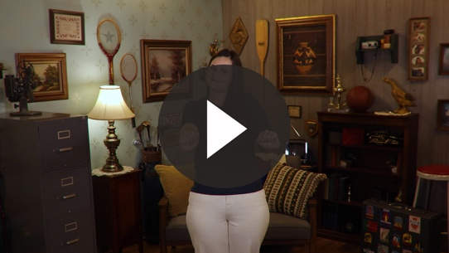

Philippians 3:14 (NLT)
I press on to reach the end of the race and receive the heavenly prize for which God, through Christ Jesus, is calling us.

- Review the Faith Verse with the kids a few times.

Faith Verse Fun | Together We Can!

Since we started learning a new Faith Verse, we are going to have to work together to remember it. Now, that we have reviewed it a couple of times, we will break it down to one word at a time. I’ll start. If you know the next word in the verse, jump up and say it. Let’s see if we can get the whole verse together.
- Say the verse together again as a group.
- Then, play the game again.
- Play several rounds, attempting to go faster with each round.

ACTIVITY PAGE | God’s Plans for Me
You Will Need | Getting Ready
- Activity Page, one per kid  - Colored pencils | - Print copies of the Activity Page, one per kid.

Today, we have learned that God has a plan for me. Have you ever thought about what that plan might be for you? (Allow responses.) On your Activity Page, I want you to draw what you think God might want for you in the future.

You can draw the job you think God might plan for you. Or you could draw a character quality that you think God wants you to have. For example, if you think God might want you to be a person who disciples others, then you can draw yourself with one or two others as you tell them about the Bible. Remember that you don’t have to be a pastor or kids leader to disciple others.
- Help kids think of an occupation or an example of a character quality, if needed. They may think of the character quality, but not know how to draw it.
- Option: Divide the group into older and younger kids. Encourage the younger kids to draw their future occupation. Encourage the older kids to think about and draw a character quality.

Prayer

Dear God, thank You for having a plan for my life that is much better than anything I could come up with on my own. Help me to disciple others and point them to You and the plan You have for them. Amen.

FAITH FACT RECAP
- Display the Faith Fact Slide or Motion Graphic as parents are coming into the room.
- Maximize the time you have with your kids, so that parents see what their kids have learned. Have the kids repeat the Faith Fact, and then dismiss them to their parents.

This is the answer to the question your adults are going to ask: “What did you learn today?” Let’s say the Faith Fact together: God has a plan for me.

Remember to take time every day to ask God what His plan is and listen for Him to speak. See you next time!

DISMISSAL
- Send home the Activity Page.
- Remind parents that there are Family Devotions available on the app to do with their kid.
- Tell everyone the date and time for the next session.

