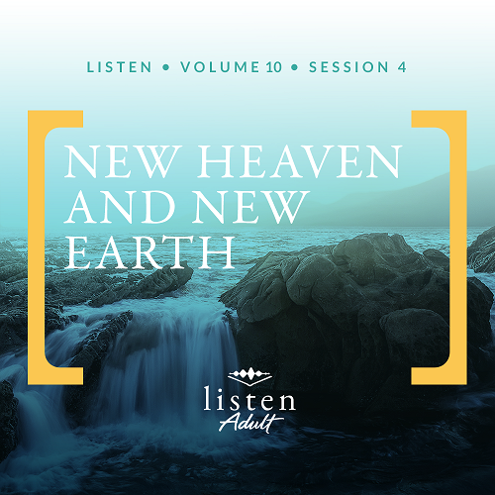Group Session
Small Group Study
Overview
The Book of Revelation was written by John. Seen as a political enemy of the Roman Empire for spreading the gospel of Jesus, John had been exiled to the island of Patmos. While on the island, an angel appeared to him as he was worshipping. John recorded everything revealed to him which included messages to seven churches in Asia Minor (modern-day Turkey). The messages teach us about Jesus’ expectations for His church as well as many end-time events. As the book winds down, it includes today’s discussion—a beautiful depiction of a new heaven and earth that serves as an encouragement for all believers to continue in faith until the very end.

To access the Bible Engagement Project library from a computer, visit App.BibleEngagementProject.com.

Engage
QUESTION
Have you ever watched a great movie or read a great book that ended poorly? Why did it disappoint you?
While movies and books might surprise or even disappoint us with the ending, neither will be true about the Bible. Through Jesus, God has given us the opportunity to be with Him forever. In the final book of the Bible, Revelation, God revealed much about the end of this age, which includes a new heaven and a new earth. While we don’t know God’s timing, we can look forward to this final era with hope.
Watch
As we watch this video, consider this question:
QUESTION
What are you most looking forward to about heaven?

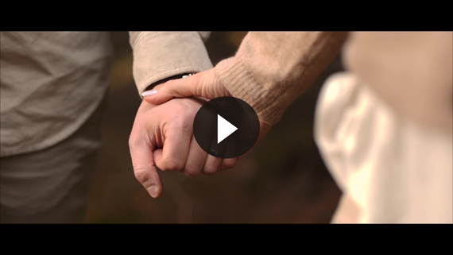

Consider
When it comes to movies, are you a fan of tragedies like this one? In an award-winning war film, the main character was charged with taking a message to the commander of his brother’s battalion on another front. The commander is about to launch an attack, mistakenly believing he has the advantage. In reality the enemy has the upper hand. The main character and his friend face many odds and traverse through hostile territory with the letter. And just when you think they may make it to the destination, the boy is killed. It was tragic—enough to make someone want to stop watching the rest of the film. It was a sad ending for the boy and a bad ending for the movie. Bad endings make disappointing storytelling.

Real life sometimes feels like a tragedy, too. Good people suffer, bad people get away with wrongdoing, and young people die. Christians who walk in obedience face trials of many kinds while it seems those who do not follow God have a smooth path. Life confounds us with bad endings. But we can put our hope in God, who has given us prophecies and made a way for a great ending to this age.

QUESTION
Think of the analogy of our life here on earth being like a war. In light of this, why does it make sense that bad things happen to the “good guys”?

What the Bible Says
The Book of Revelation might read like a horror story to the nonbeliever. But for Christians, it’s a story of hope: hope that all wrongs will be righted, hope that God will turn our temporary defeats into permanent victory.
Our sovereign, eternal God will do away with sin and death. He will invite us into a new heaven and a new earth, a place where He will dwell with us and we with Him.
As we experience the various “bad endings” of this earthly life, we can wait with hope for the end of this age. We can know that our God, who designed a beautiful beginning for His sons and daughters in the Garden, has also determined a beautiful ending that extends into eternity.
Our Current Home
Read Revelation 21:1–2.
The Bible is the story of God and His people. The story began in the uncorrupted Garden of Eden, where humans walked with God. Then the sin of humans started a great cascade of redemption. What sin has ravaged, God is redeeming, starting with men and women. At the end of days, God will redeem all things, including the earth. This will culminate at the end of the old heaven and the old earth with the arrival of the new.
QUESTION
In what ways has the earth deteriorated over time?

QUESTION
As we wait for God to bring a new heaven and a new earth, what can we do to steward the earth well in the meantime?
Our New Home
Read Revelation 21:3–4.
God’s desire has always been to live with His people. But our continuous struggle with sin separates us from Him. Still, examples throughout biblical history show us where God “walked” with men and women who were set apart. At the end of time, all of us who are alive in God will dwell with Him forever. This is the destiny and reward of every believer.
QUESTION
Share a time when someone’s presence helped to ease your troubles.

QUESTION
How do you imagine being with God in eternity may be different than walking with Him on earth?
Victory and Blessing
Read Revelation 21:5–10.
At the end of history, God will make all things new. He will reward those who believe in Him with an absolute victory over death. We’ll possess the inheritance of blessings prophetically promised to us. Conversely, those who rejected God during their earthly life will inherit the curse of their sin: they will be cast in the fiery lake and experience the second death—eternal separation from God. The choice is ours to make.
QUESTION
How can we encourage one another as we look forward to the day of victory and blessing?
QUESTION
What can we do today to reduce the number of people who will ultimately be cast into the lake of fire?

Light and Life
Read Revelation 21:21–27.
Our eyes will feast on the loveliness of the New Jerusalem. The beauty of the ornate gems used to construct the walls and gates of the city will be dim compared to the glory of God visible throughout the place. No specified place of worship will exist because the whole city will be a temple. Life in the New Jerusalem will revolve around our God. The city will need no light. All nations will join together, walking in the light of the glory of the Son of God for all eternity.
QUESTION
What do you think it will be like to live in a place without darkness and sin?

Reflect
The hard news of the apocalypse detailed in Revelation pales in comparison to the hope of eternity promised in this final book of the Bible. No matter what battles we face today, whether health battles, relationship woes, or financial struggles, our ultimate outcome will be victory in all things through Jesus. We must persevere because participating in this victory is only meant for those who remain faithful to the end.
Having our eyes on the day when we will fully experience the glory of God should fill us with hope. It allows us to put our trust in our sovereign God who orchestrated the beginning and will bring about the end in our favor. He is the Alpha and the Omega, the beginning and the end. What He began in the Garden will be completed someday. May we all be there to see it in its fullness—to see Him in His fullness.

Listen to God
The goal of Listen is not only to gain an understanding of God’s Word, but also to pause and listen to what God might want to say to us about what we have read and shared. Be silent for a few moments and reflect on the following questions. Choose the one that most resonates with what God is saying to you now. Then complete the others during Day 1 of your devotion time this week.

Personal Reflection Questions
Record your answers to the following questions in the space provided or in your personal journal.
QUESTION
Earlier we talked about people whose presence eases our troubles. Imagine how being with Jesus will multiply that feeling exponentially. How will seeing Jesus face-to-face impact you?

QUESTION
God will wipe away all tears at the end of time. What circumstances are you currently experiencing where the hope of this promise is encouraging?

QUESTION
In the city of light, darkness will have no room. What darkness from this world are you looking forward to seeing extinguished the most?

QUESTION
God promises to make all things new. We can ask God in prayer to make “new” the things that grieve our hearts and need to be changed today. Is there anything in your life that you can place before God, so He can make it new? In prayer ask God to intervene in this situation.
Prayer Requests
Note any requests from the group and remember to pray for them during the week.
Before next time, continue to listen with the personal devotions.
Did You Know?
The island of Patmos John references in Revelation 1:9 is a small island about ten miles long and six miles wide in the Aegean Sea in modern-day Greece. Although often perceived that Patmos was a barren deserted island meant for prisoners and exiles of the Roman Empire, archaeology of the island today tells us a different story. As early as the third century BC, the small island had a sizable city with a high traffic port, as well as large temples to Apollo, Dionysus, and Artemis and even public structures such as a hippodrome and a gymnasium.

