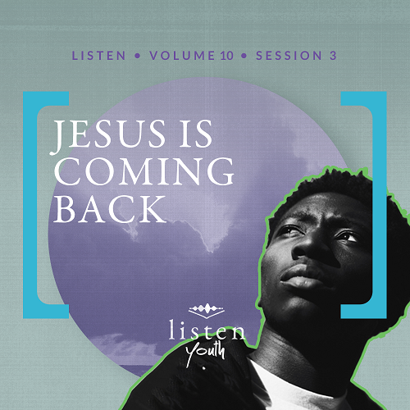Group Session
Small Group Study
Overview
Commonly referred to as the rapture of the Church, Jesus’ return for His followers is the central theme of this session. This topic has been discussed, debated, and speculated about for over two thousand years. While the details may be challenging to work through, the central theme is easy to embrace—the resurrected Jesus will return to ensure the resurrection of His followers. This discussion promises to be one students won’t soon forget.
You Will Need
- Paper, one sheet per student
- Markers or colored pencils
- Candy or small prizes
Getting Ready
- First time leading Listen for Youth? Look here for the Facilitator Guide.

To access the Bible Engagement Project library from a computer, visit App.BibleEngagementProject.com.

Engage
Welcome
Welcome guests and thank everyone for being a part of today’s session. Remind everyone that groups of students all over the world are meeting during the week to discuss the Bible and engage in the daily devotions.
Opening Prayer
Prayer thoughts: Take a few moments to ask God for the presence and assistance of the Holy Spirit for this group discussion. Ask the Lord to fill the students’ heart with hopeful anticipation of His return. Ask God to help you live with optimism, expectancy, and urgency when it comes to the task of sharing the gospel with others in the meantime.
Introduction
The last time we came together, we talked about how our faith and actions should work together. We also talked about how those good deeds express our faith outwardly for others to see.
This time we’re going to explore an event that the timing is something of a mystery. We’re going to talk about the return of Jesus and what that means for His followers. We usually call Jesus’ return the Rapture.
QUESTION
Can anyone tell me what we mean when we say, “the Rapture?”

We’ll find out soon what the Bible says about the Rapture. Jesus is coming back for those who have committed their lives to Him. As we talk about Jesus’ return and what that will mean for us, let’s direct our thoughts toward eternity.
Did You Know?
The word rapture isn’t in the Bible. But we get that word from an event that is very clear in the Bible! First Thessalonians 4:17 describes Christians being “caught up” to meet Jesus in the air. The concept of “caught up” in Latin is the word raptus (found as rapiemur in the Latin translation of this Bible passage). That’s the source of our English word rapture.
Group Activity
My Dream Trip
You Will Need:
- Paper, one sheet per student
- Markers or colored pencils
- Candy or small prizes

No prep is needed for this activity.
The idea of flying to meet Jesus and going with Him to a new forever home seems way better than any vacation. But if you could squeeze in one dream trip anywhere on earth before He comes, where would you choose? Don’t answer that out loud! We’re going to have some fun with it.
We’ve got some paper and markers here. I want you to take three minutes and draw a picture or some clues about your dream trip location. But you can’t use any words on your drawing! After I say that time is up, we’ll see if we can figure out which location your picture is depicting.
• Depending on the size of your group, either allow students to share their picture with the whole group or in smaller groups of three to five.
• When completed, give everyone a piece of candy or small prize, and award those whose pictures were guessed correctly with an extra prize.
As you dream about your next vacation, let’s watch this video.

Watch
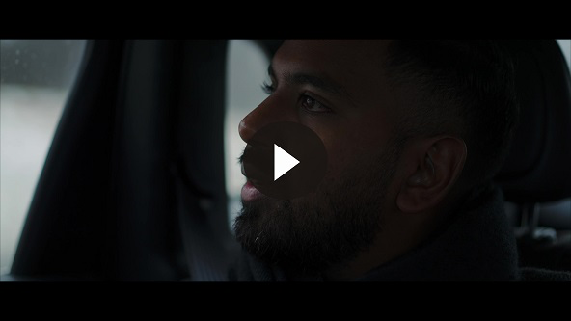
QUESTION
What is something the video mentioned that you didn’t know?

Consider
Ensure each student has access to a Bible, preferably the same version.
As we read Paul’s letter to the church in Thessalonica, we find that he wants to stir hope in the hearts of the reader. He tells about the endgame plan of Jesus. Jesus is coming back for His followers. Because we’re going to read a large portion of Scripture, let’s read a little, then discuss, read a little, and then discuss. Get ready.
Death and Hope
Read 1 Thessalonians 4:13–14.
QUESTION
When you think of dying, what emotions do you feel?

QUESTION
How does knowing that Jesus was brought back to life after death affect your view of death?

When a believer whom we love passes away, we can grieve with hope. We can remember that God has a plan and future not just for believers who are alive, but also for those who have died. That plan is an eternity with Him!
A Meeting in the Clouds
Read 1 Thessalonians 4:15–18.
QUESTION
What all happens according to the verses we just read?
First Thessalonians 4:14 tells us that we can trust that there is life after death because Jesus rose from the dead. He defeated death, and all believers will defeat death too.
QUESTION
When the Lord returns, where is He taking believers?

QUESTION
Why do you think Paul, the writer of 1 Thessalonians, tells us to encourage others with these words? How can we do that?

Like a Thief
Read 1 Thessalonians 5:1–3.
QUESTION
According to these verses, how will the Lord’s return happen?

This verse, as well other statements Jesus made, make it clear that we can’t know exactly when the Rapture will happen. This should be pretty evident since a return can’t be unexpected if you know when it will happen! Yet, people over the last two thousand years have become obsessed with trying to figure out exactly when Jesus will return. Rather than focusing on when He will return, instead we should work to always be ready for Him!
QUESTION
How might not knowing the timing of Jesus’ return influence how Christians live?

Be Alert!
Read 1 Thessalonians 5:4–11.
QUESTION
Paul uses imagery of being awake in the light rather than asleep in the dark. How does that imagery connect to our lives and the return of Jesus?

QUESTION
What do you think Paul means by being protected by “the armor of faith and love”?

QUESTION
Based on 1 Thessalonians 5:9, what can save us from God’s anger?

QUESTION
What action of Jesus opened the door for us to live with Him forever?

The words of Paul weren’t written to scare us. No Christian should go to bed in fear that Jesus will come back before morning. Instead, this is good news! It should be encouraging for us in rough times as well as an encouraging word we can share with other Christians when they are struggling. The resurrection and return of Jesus is the gateway to an amazing eternity with Him!

Reflect
The Believer’s Mindset
QUESTION
How should we live in light of knowing Jesus is coming back for His followers?

Since we don’t know when Jesus is returning, we should be ready each day of our lives. As our faith and love for Jesus grow each day, we can be prepared for His return.
QUESTION
How should knowing Jesus can return at any moment impact our desire to tell others about Him?

What Does This Mean for Me?
QUESTION
What feelings does Jesus’ return stir up in you?

Let’s revisit 1 Thessalonians 5:8. It reminds us to protect ourselves with confidence in our salvation.
QUESTION
Is the return of Jesus something that should provoke fear in us or hope?

QUESTION
Are any of you nervous or uncertain about the status of your salvation? If so, why?

It’s not unusual for Christians to feel insecure about their salvation. All of us can be challenged by those doubts. In those moments, it’s good to remind ourselves that our salvation is not hanging by a thread. It is held in the strong hands of God, and He is full of grace, mercy, and love.
Digging Deeper (Optional)
Let’s take a few minutes to examine a parable Jesus shared in the Gospel of Matthew.
QUESTION
How many of you are routinely late or always the last to be ready when your family is going somewhere? If that doesn’t describe you, does someone in your family come to mind?

For those who are habitually late, this parable may make you want to change your ways!
Stay Ready
Read Matthew 25:1–13.
QUESTION
After hearing this parable, what do you think Jesus was trying to teach us?

QUESTION
What are some things you can do to stay ready in your faith?

Being prepared isn’t just about the return of Jesus. It’s a valuable lesson for life in general. We prepare so that when an opportunity presents itself, we’re ready. We should try to be ready for every opportunity God places in our path.
QUESTION
What are some necessary attributes we need in our lives to stay ready?

Activate
We’ve spent time exploring and discussing many things Paul shared in 1 Thessalonians 4 and 5 as well as the return of Jesus. His return is something we should anticipate eagerly, not dread anxiously. Now let’s discuss how we can turn this belief into action.
QUESTION
Revisiting 1 Thessalonians 5:11, what are some practical steps we can take to encourage and build each other up in our faith?

QUESTION
What are some specific things we can do in our group to build up each other’s faith?
Conclusion
As followers of Jesus, we want to live with hopeful anticipation about the return of our Savior. Because of our confidence in Him, we shouldn’t live in fear or anxiety about His return. We can be eager for that amazing reunion. Yet, while on earth, we shouldn’t wait passively for the Rapture. Paul reminded us that we should consistently encourage other believers, intentionally build them up in their faith, and declare the gospel around the world.
Salvation Opportunity
Include this if you think there may be some in the group who do not have a personal relationship with Jesus.

As you listened today, maybe you know you aren’t ready for Jesus to return. I want to give anyone here today an opportunity to surrender to Jesus.

Is there anyone here that we can pray for who doesn’t have a relationship with Jesus or wants to renew their relationship with Christ?

Take a moment to acknowledge those who respond and thank them for their desire to make things right between themselves and God. Pray with them now or after the group time is over. Following group time, talk more about where they are in their walk with God and how you might be able to help.

Take a moment to celebrate those who prayed for salvation and remind everyone that Jesus is coming back!
Prayer
Father, we’re looking for the day we get to see our soon-returning King. We invite You into our lives in a fresh way to prepare us for that day. Help us to listen closely to Your words as You speak to us. Thank You for the reminder that we need to stay alert for Jesus’ return. Help us to share this good news with others. We pray for others all over the world who don’t know Jesus that they would surrender their lives in preparation for His return. Amen!
When Jesus returns, He will take His followers to spend eternity with Him. Next time we’ll look more closely at that eternity after the Rapture. The Bible tells us there will be new heaven and a new earth. Our discussion will give you some idea of what it will be like.

