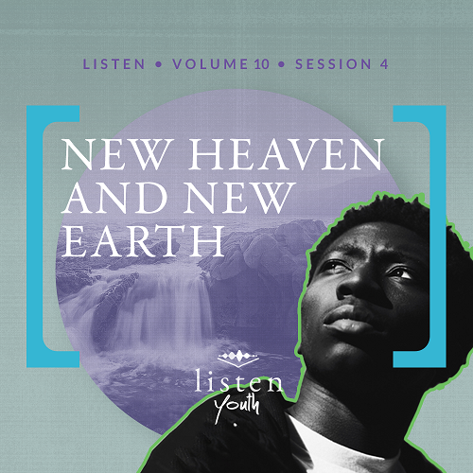Group Session
Small Group Study
Overview
This session brings the Listen journey through the Bible to an end as we look at the last book in the Bible—Revelation. God promises us a new heaven and new earth if we choose to follow Him.
You Will Need
- Whiteboard or chalkboard
- Dry erase markers or chalk
- Ice cream or some other type of dessert
- Bowls, spoons, napkins, etc., as needed for the dessert
Getting Ready
- Arrange for someone to prepare the dessert while students are completing the Group Activity.
- First time leading Listen for Youth? Look here for the Facilitator Guide.

To access the Bible Engagement Project library from a computer, visit App.BibleEngagementProject.com.

Engage
Welcome
Thank everyone for attending and their time participating in Listen. Make sure guests feel welcomed and included.
I have some bad news and some good news. First, the bad news. Today is the last day of our Listen journey through the Bible. There is good news, however! Our journey with God will keep going strong. Next time we’ll start a brand-new topic with lots of great discussion! You certainly don’t want to miss it!
So, don’t forget to go through the Listen devotions during this final week between today and the next time we gather.
Opening Prayer
Prayer thoughts: Take a moment to offer prayerful praise to the Lord. Ask the Lord to help you see Him in every detail of life. Ask God for the Holy Spirit to help you understand the culture of God’s kingdom and better know the ways of God.
Introduction
The last time we met, we looked at the return of Jesus, the Rapture, and what this means for us on a daily basis in our faith journey. During this session, we’re going to the end of the Bible. In Genesis 1, the Bible started with the phrase, “In the beginning God” (Genesis 1:1). At the end of the Bible, we see God is finalizing what He began in Genesis. God is both the beginning and the end. He is also everything in between.
Did You Know?
Have students share one Did You Know? Bible fact from Listen that stuck out to them. You may want to be prepared to share a few you remember as well.
Group Activity
Write a Story
You Will Need
- Whiteboard or chalkboard
- Dry erase markers or chalk
- Ice cream or some other type of dessert
- Bowls, spoons, napkins, etc., as needed for the dessert
Getting Ready
- Arrange for someone to prepare the dessert while students are completing this activity.

Before we explore God’s Word, we’re going to write a story. I’m going to write the first sentence and the last sentence on the board. Then each of you will write one sentence, continuing the story one author at a time. The story can take any turn you wish. It can become funny, dramatic, or whatever (appropriate) direction you choose when it’s your turn to write. However, it must be one continuous story, and it must end with the last sentence.
• If you have a smaller group, allow each student to write a couple of sentences.
• Write the first and last sentences on the board as you share them.
Here’s the first sentence: Austin woke up Monday morning knowing this would be one of the most important weeks of his life.
And here’s the last sentence: There Austin was, standing triumphantly, in the midst of the celebration, having achieved his dream. He had finished what he started.
Before we begin our story, I have one more piece of good news. To celebrate these forty sessions together, we have a treat for everyone to enjoy! Thank you for being a part of these incredible discussions on our Listen through-the-Bible journey. Thank you for bringing insight and asking such amazing questions. Now on to writing our story.
• Distribute the treats.
• Allow students time to write the story.
• Read the story aloud to the group.
Just like our story, the Bible has a beginning and an end, with a lot of content in the middle written by different authors. However, all of the content is influenced by the beginning and end. No matter what everyone wrote, we already knew the beginning and the end.
As we think about the possibilities of publishing our story, let’s watch this video to introduce today’s discussion.
Watch
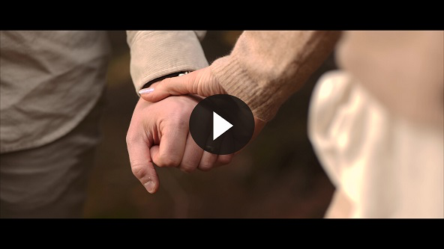
QUESTION
What captured your attention from the video?

Consider
Ensure each student has access to a Bible, preferably the same version.
John wrote the Book of Revelation—the last book in the Bible. As we read a few of the verses, put yourself in John’s shoes. Imagine seeing and feeling what he must have felt as God showed him incredible things. Let’s discover how the big story of Scripture ends.
God’s Home
Read Revelation 21:1–3.
In the end, there will be a new heaven and new earth for the rest of eternity. God and His people will dwell together in His home forever.
QUESTION
How do you picture this new place?

QUESTION
What do you imagine it will be like to live with God in His home?

The Atmosphere of God’s Home
Read Revelation 21:4–7.
QUESTION
What does Revelation 21:4 tell us about the atmosphere or culture of God’s home in eternity?

QUESTION
What do you think God means in Revelation 21:6 when He says He’s the beginning and the end?

God’s Word tells us that everything begins and ends with God. Everything! But this doesn’t just illuminate God’s involvement in the beginning and end. Our Listen journey through the Bible has shown that every detail in between is saturated with God.
QUESTION
What do you think God means by the terms thirsty and victorious in Revelation 21:6–7?

QUESTION
What promises does God make for those who are thirsty and victorious?

No Admittance
Read Revelation 21:8–10.
QUESTION
Who will not be allowed to reside in God’s eternal home?

QUESTION
What will happen to them after they die?

As we read these next verses, I want you to listen closely to how heaven is described.

Sun or Son?
Read Revelation 21:21–23.
QUESTION
What is most amazing to you about this description of heaven?

QUESTION
What do you think it means that the writer said, “I saw no temple in the city, for the Lord God Almighty and the Lamb are its temple”?

Could it mean that the worship of God no longer would be regulated to a specific place? Is it possible that worship and adoration in God’s home are not set to a schedule? Might worshipping God be like breathing—something we do all the time? Just imagine what that might be like!
QUESTION
Why do you think it’s important to know that the city does not need a sun or moon?

Our present experience on the earth is heavily impacted by the earth’s rotation around the sun. Our lives are regulated by night and day, dark and light, years, months, hours, and minutes. But in heaven our lives will revolve around God.
The Door Is Always Open
Read Revelation 21:24–26.
QUESTION
What can we learn about God’s nature if the gates of His eternal home will never be closed?

God is welcoming. Sometimes Christians might give the impression that God is looking for reasons to keep people out. But the truth is that Jesus went to the most extreme measure possible, His death on a cross, to bring people into eternity with Him.

Reflect
Choose This Day
Read Revelation 21:27.
QUESTION
Who will be allowed to enter?

QUESTION
What about the people who can’t spend eternity with God? Do you think He sends these people to hell, or do they choose it themselves? Why?
Those who refuse God and choose to worship something other than Him have made the choice not to enter the gates of God’s home. They have chosen another destiny. Evil has no place in the eternal home of God.
God lets us choose our own eternal destiny. As we look a little more closely at God’s home, the new heaven and earth, we can get excited about living in heaven forever. But making it there is not the real point. Choosing God is the big point.
QUESTION
How does it make you feel to know that some will choose not to reside in God’s home forever? Why?

QUESTION
Do you think God wants anyone to choose not to be with Him for all eternity? Why or why not?

QUESTION
How does knowing that some people will not spend eternity with God affect your desire to share the gospel with others?
Digging Deeper (Optional)
Beauty
Read Revelation 21:18–21.
QUESTION
In simple terms, God’s eternal home will be absolutely beautiful. Why do you think God inspired the writer to include all these details?

Everything good in this life originated with God. He’s the ultimate source of beauty. Just look at the beautiful world He created! And God chooses to share His beauty with us. The jewels and precious materials described in these verses are found on earth too. God doesn’t just reserve the good stuff for someday; it’s on earth for people to experience and enjoy right now.
God doesn’t limit this to the beautiful things He created. Emotions like love, compassion, kindness, and joy are not reserved for heaven alone. We can experience them on earth because of God. He’s the ultimate source of these too.
QUESTION
What other beautiful things can we enjoy on earth today that will also be in heaven?
We know that our new home with God will be unsurpassed in beauty and splendor. Our current ways of earning a living, systems of creating wealth, and struggles with poverty will all be irrelevant in a place where the gates are made of pearl and the streets of gold.

Activate
We’ve spent some time examining the end of the Bible. We’ve been given a sneak peek of the eternal experience in God’s home.
QUESTION
Knowing that God has plans for an eternal home where we will live with Him, what does this teach us about our time on earth?

If God wants us to live with Him in eternity, it means He wants us to live with Him right now as well. He is not waiting to connect with us until we get there. Through Jesus, God makes it possible to have a personal relationship now, before we ever find ourselves in eternity.
Go through Revelation chapters 21 and 22 and make note of all the things you can look forward to.
Conclusion
Our God is so good, and He legitimately wants us! Throughout human history, since the first pages of the Bible, God makes it clear that He wants you to choose Him. He sent Jesus to make wrong things right. He will also send Jesus again to bring all His followers into an eternity together. He will live with us in His holy city for all eternity.
In large part, this is the message of the whole Bible. God wants you! He will adorn your eternity with beauty, and He will fill your present with love. His heavenly home is just one of many proofs that His heart is for you and with you.
Salvation Opportunity
Include this if you think there may be some in the group who do not have a personal relationship with Jesus.

There may be some here who heard about eternity for the first time today. Or maybe you aren’t sure where you’ll be when there’s a new heaven and earth, and you’d like to be sure. You can choose to be sure right now.

Is there anyone here that we can pray for who doesn’t have a relationship with Jesus or wants to renew their relationship with Jesus?

Take a moment to acknowledge those who respond and thank them for their desire to make things right between themselves and God. Pray with them now or after the group time is over. Following group time, talk more about where they are in their walk with God and how you might be able to help.

We want to celebrate with those who surrendered your life to Jesus during our journey through Listen! I also want to say a huge thanks for joining us over these past sessions. I can’t wait until the next time we get together!
Prayer
Wonderful God, thank You for this time of gathering with friends to learn from Your Word and listen to You. Thank You for the Holy Spirit and His teaching and help in understanding Your Word. Our prayer today is that no one is left behind, but that all would hear and follow You so we can spend eternity with You. In the matchless name of Jesus, I pray these things. Amen.

