LEADER OVERVIEW

Volume Overview—Run the Race
In these sessions, kids will discover that God has a plan for each one of them and the importance of listening to and doing what God says. They will also learn about the hope of Jesus’ return and what it will be like to live with God forever.

SESSION 1: Timothy Learns from Paul—  2 Timothy 3:10–17  Faith Fact: God has a plan for me. | SESSION 2: Faith and Works—  James 1:19–27; 2:14–26  Faith Fact: God wants me to take action.
SESSION 3: Jesus Is Coming Back—  1 Thessalonians 4:13–18; 5:1–11  Faith Fact: Jesus is coming back. | SESSION 4: New Heaven and New Earth— Revelation 21:1–10, 21–27  Faith Fact: I can live with God forever.

SESSION OVERVIEW
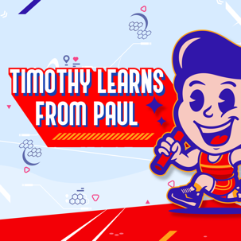
In this session, preschoolers discover that God has a plan for me. When God gives you a plan, He walks alongside you to help you do it. We will talk about Paul giving Timothy final instructions. Part of those instructions were to remember the Scriptures that he had learned. God gave us the Bible so we would be “equipped for every good work.” We are to learn what the Bible has to say and then follow it. Each session is designed to help the kids in your group learn what the Scriptures say. These lessons are foundation stones in their faith that they will build their life upon.

Bible Lesson | Faith Fact
Timothy Learns from Paul  2 Timothy 3:10–17 | God has a plan for me.
Faith Verse
Philippians 3:14 (NLT)
I press on to reach the end of the race and receive the heavenly prize
for which God, through Christ Jesus, is calling us.

Bible Engagement Project Preschool curriculum is connected with the intentional, yearlong ministry strategy for kids available at KidminRoadmap.com.
PREPARING FOR THE SESSION
You Will Need | Getting Ready
Preservice Activities  - Pretzel sticks  - Toys  - Options: Backpack, lunchbox, notebook for school, a small suitcase, camera, small map, a briefcase, laptop/tablet, travel drink mug  - White paper, optional  - Crayons, optional  Large Group  - Bible  - Worship songs (Song suggestions: “On the Board with the Lord” by Jana Alayra; “Who You Say I Am” by Hillsong Kids)  - For groups not using a phone or tablet only, add:  - Projector or TV  - Laptop  - Countdown 5-Minute Video  - Theme Intro Video  - Bible Lesson Video A  - Bible Lesson Video B  - Faith Fact Sound video (bell ringing)  - Faith Fact Slide or Motion Graphic  - Faith Verse Slide or Motion Graphic  Small Group  - Floor-safe tape, such as painter’s tape  - Small prizes, optional  - Small Group Activity Page, one per kid plus an extra  - Crayons, one set of the five colors per kid  - Resealable, plastic bags, one per kid  - Small Group Hands-On Learning Page, one for every two kids plus an extra  - Brown construction paper, one sheet per kid  - Glue sticks  - Scissors | Preservice Activities  - Set out toys and snacks.  - Decide what activity you are going to choose. Gather needed items.  Large Group  - Download videos and slides if needed.  - Select worship song(s) and have them ready to play.  Small Group  - Using floor-safe tape, create a path for the kids to follow.  - Print copies of the Small Group Activity Page, one per kid plus an extra.  - Color a sample of the Small Group Activity Page.  - Place crayons—one each of pink, yellow, green, purple, and gray—in a plastic bag, one per kid.  - Print copies of the Small Group Hands-On Learning Page, one per two kids plus an extra. Cut apart the two boxes.  - Make a sample of the Small Group Hands-On Learning Page craft to show kids.

Check out all the promotional and extra media files available for this theme. To access Bible Engagement Project from a computer, visit App.BibleEngagementProject.com.

PRESERVICE ACTIVITIES (30 Minutes)
See what’s needed at the beginning of the session.

Bible Story Warm-Up
Here are some items we take to certain places. For example, we would take this backpack to school. I’m going to hold up several items, and you will tell me what each is used for or where someone might take it. (Allow responses.)
- Alternate activity: What are some things you would plan to bring on vacation? You could also have them draw a picture of something they would bring.

Do you have to plan ahead for things? For example, if you are going to take your lunch to school or day care, do you need to plan ahead and help pack the lunch the night before?

Have you ever planned for a special event, such as your birthday?
Did your birthday always go the way you planned?
If not, who did you ask for help?
Does God care about what happens in your life?

Today we’re talking about how God has a plan for each of us!

Snack: Pretzel Sticks
As kids are eating the snack, share the following:

Can you make an arrow with your pretzels like this? (Make an arrow with pretzels.) Arrows can tell us what direction to go. Did you know God can also show us which way to go? He has a plan for us.

Free Play
Any extra time can be spent playing with toys.

LARGE GROUP (25 Minutes)
See what’s needed at the beginning of the session.

INTRODUCTION
- Optional: Play the Countdown 5-Minute Video.
- Use this time to pick up toys and transition to the large group area.


Welcome
Hi, kids! Who is excited to learn about God today? How do we learn about God? One way we learn about God is from His Word, the Bible. (Hold up the Bible.) Each story in the Bible tells us something about God, and today, we will learn that God has a plan for me. Do you know how we find out about that plan? We discover it by reading our Bibles and hearing stories from the Bible.

If you are ready to start our story for today, look at me through your binoculars. (Make two circles with your hands and place them over your eyes like binoculars.) Oh good! It looks like everyone can see me through their binoculars, and we are ready to begin.
- Play the Theme Intro Video.



BIBLE TIME | Timothy Learns from Paul (2 Timothy 3:10–17)

Bible Video A
God’s Word is so important in our life. It is important that we take time to see what the Bible tells us. Today, we will hear that God has a plan for me. Lizzy and her grandpa will help us with that. Let’s check in with them now.
- Play Bible Lesson Video A.

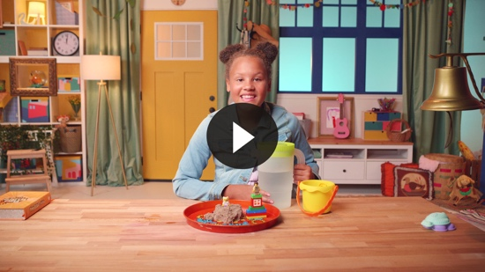

Faith Fact
That was amazing! You did a great job helping Lizzy solve all the clues. The quill pen and the treasure map were each a piece of our Bible story. We heard that God has a plan for me even when we don’t know the next step. God helps us to do what He has planned for us; we just need to trust Him. God gives us the strength to do all things. That is great news!
  - Play the Faith Fact Sound video.

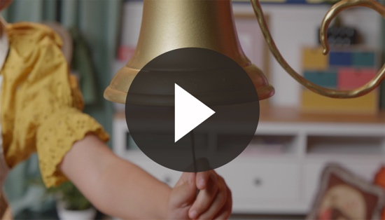

- Show the Faith Fact Slide or Motion Graphic.

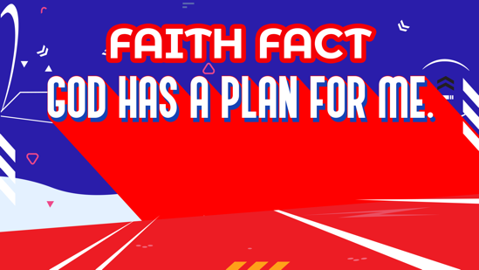

Perfect timing! Let’s shout out our Faith Fact. God has a plan for me.

WORSHIP
Let’s spend some time singing songs and thanking God for having a plan!

Praise
Are you glad God made you and me? Wave your hands up high. (Group response)
Are you glad God has a plan for you? Wave your hands down low. (Group response)
Are you glad God gives you strength to do it? Wave your hands up high. (Group response)
Who wants to thank God? Wave your hands down low. (Group response)

Prayer
Now let’s bow our head and pray. Repeat after me.

Dear God, thank You for having a plan for my life. Thank You for the Bible that helps me know what I should do. I’m so thankful that You are with me. Amen.

Sing
One way to give God thanks is worshipping Him by singing.
- Lead the kids in singing one or two songs. See suggestions at the beginning of the session.

BIBLE TIME continued | Timothy Learns from Paul (2 Timothy 3:10–17)

Bible Video B
Let’s go back and see what Lizzy is up to.
- Play Bible Lesson Video B.

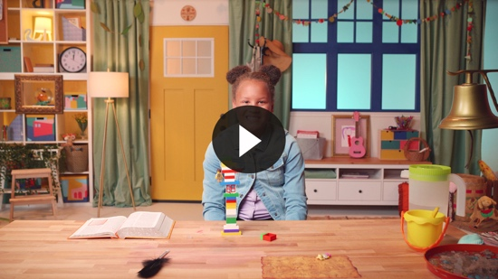

Faith Verse
- Show the Faith Verse Slide or Motion Graphic.

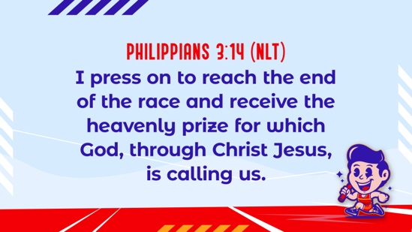

Philippians 3:14 (NLT)
I press on to reach the end of the race and receive the heavenly prize.

Lizzy helped us learn the first part of the Faith Verse. We’ll learn the rest of the verse later. I love that God gave us the Bible to help us know what to do. Every day His plan is always the best plan.

Response Time

Consider playing a worship song softly in the background while kids pray.

Isn’t it wonderful to know that God has a plan for our life? God has given us a tool to use when we aren’t sure what to do. Do you know what it is? I can give you a hint: it’s a book we read. (The Bible) That’s right! It’s the Bible! It is important for us to build our lives on the truths of the Bible. Who wants to build their lives on God’s Word with me? (Group response)
Closing
Did you have fun today, kids? We’ve heard that God has a plan for me even when we don’t know what to do. We’ve worshipped God by praising, praying, and singing. We’ve heard our new Faith Verse, too. We have had such a great time together today.
  - Play the Faith Fact Sound video.

Oh, do you hear that sound? You know what that means? (Group response) Do you remember what we’re supposed to do? (Shout out the Faith Fact.) Let’s say our Faith Fact now. God has a plan for me.
- Show the Faith Fact Slide or Motion Graphic.

Great job, friends!

Dismissal to Small Groups
Now it’s time to head to small group with your friends and do some more fun activities.
- Dismiss the kids by groups.

Leader Tip: This can be done by assigning colors to teams or by age groups. Note that some preschoolers may not know their age. Using a colored sticker, jersey, or wristband will help separate the kids and help identify their small groups.

SMALL GROUP (25 Minutes)
See supplies and prep instructions at the beginning of the session or in each activity below.

Leader Tip: All groups can do each activity at the same time. If you choose to rotate, you will need at least one leader per group.

Circle 1

GROUP CONNECTION

Follow the Path
You Will Need | Getting Ready
- Floor-safe tape, such as painter’s tape  - Small prizes, optional | - Using floor-safe tape, create a path for the kids to follow.

Goal: Kids will be reminded about how to follow a plan.

We are going to play Follow the Path. Let’s choose a leader who will start walking down our path. Everyone will follow the leader, making sure to stay exactly on the path.
- As the kids follow the path, give them encouraging feedback: “You are doing a great job following the path,” or “Good job staying with the leader and not going your own way.”
- Play this game several times, with different kids taking turns being the leader.
- Option: Give the kids a treat when they successfully finish the designated path. Ideas are a stamp for their hands, a sticker for their shirts, or a tasty treat.

Circle 2

ACTIVITY PAGE TIME

Color by Number
You Will Need | Getting Ready
- Activity Page, one per kid plus an extra  - Crayons, one set of the five colors per kid  - Resealable, plastic bags, one per kid | - Print copies of the Activity Page, one per kid plus an extra.  - Color a sample of the Activity Page to show the kids.  - Place crayons—one each of pink, yellow, green, purple, and gray—in a plastic bag, one per kid.

Goal: Kids will follow the coloring plan exactly.

Let’s look at the flowers on our page. We are going to color these flowers. But there is already a plan for how this picture will look when it is finished. Do you see these numbers? Each number represents a different color.
- Help the kids go through the coloring process number by number, color by color.
- If kids want to use a different color, remind them that we are following a plan.
- During the activity, interrupt and practice the Faith Fact: God has a plan for me.

These look so great! You all did a wonderful job following the plan.
  - Play the Faith Fact Sound video.

- Show the Faith Fact Slide or Motion Graphic.

Let’s practice our Faith Fact together: God has a plan for me. That was great!

Circle 3
FEET-TO-FLOOR GAME TIME

Add to It
You Will Need | Getting Ready
No supplies are needed for this activity. | No prep is needed for the activity.

Goal: Kids will follow the plan of actions they learn in the game.

Everyone, stand in a circle. I’m going to do an action. The friend to my right will do my action and add an action to the plan. The next friend to the right will do my action, the first friend’s action, and add another action to the plan. Each friend will get to add an action. At the end, we will do the entire plan of actions we created.
- Actions can include anything that can be done in that spot without moving around the room: jump up and down, do jumping jacks, do knee bends, pat head, or give neighbor a high five.
- Kids will likely need help remembering the actions.
- As the kids follow the plan, encourage them with positive praise.

Circle 4

HANDS-ON LEARNING

Bible Craft
You Will Need | Getting Ready
- Hands-On Learning Page, one copy for every two kids plus an extra  - Brown construction paper, one sheet per kid  - Glue sticks  - Crayons  - Scissors | - Print copies of the Hands-On Learning Page, one per two kids plus an extra. Cut apart the two boxes.  - Make a sample of the Hands-On Learning Page craft.

Goal: Kids will do a craft to remind them that the Bible is the main way God gives us His plan.
In today’s Bible story, Paul told Timothy to remember what he had learned from the Scriptures. This page has the whole Faith Verse on it. We’ve only learned part of it so far. Let’s say the Faith Verse now.

Philippians 3:14 (NLT)
I press on to reach the end of the race and receive the heavenly prize for which God, through Christ Jesus, is calling us.

I want you to think of something God has taught you. For example, God has taught me to love others. Now that you remember what God has taught you, draw a picture of that under the Faith Verse. If you can, write your name on the bottom of the page.
- Give each kid a piece of brown construction paper.
- Show them how to fold the paper in half so the half-sheet with the Faith Verse will fit inside.
- Help as needed.

Now, draw a cross on the front of the booklet you just folded. Finally, glue your Faith Verse page inside the booklet.
- You may need to help kids complete the craft.

FAITH FACT RECAP
- Display the Faith Fact Slide or Motion Graphic as parents are coming into the room.
- Maximize the time you have with your kids, so that parents see what their kids have learned. Have the kids repeat the Faith Fact and then dismiss them to their parents.

One thing I want you to remember from today is our Faith Fact. Let’s say it together. God has a plan for me.

DISMISSAL
- Send home the Activity Page and the Hands-On Learning Page craft with each kid.
- Remind parents that there are Family Devotions available on the app to do with their kid.
- Tell everyone the date and time for the next session.

