LEADER OVERVIEW

Volume Overview—Run the Race
In these sessions, kids will discover that God has a plan for each one of them and the importance of listening to and doing what God says. They will also learn about the hope of Jesus’ return and what it will be like to live with God forever.

SESSION 1: Timothy Learns from Paul—  2 Timothy 3:10–17  Faith Fact: God has a plan for me. | SESSION 2: Faith and Works—  James 1:19–27; 2:14–26  Faith Fact: God wants me to take action.
SESSION 3: Jesus Is Coming Back—  1 Thessalonians 4:13–18; 5:1–11  Faith Fact: Jesus is coming back. | SESSION 4: New Heaven and New Earth— Revelation 21:1–10, 21–27  Faith Fact: I can live with God forever.

SESSION OVERVIEW
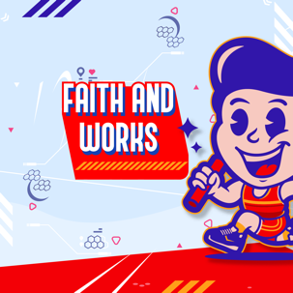
In this session, preschoolers discover that God wants me to take action. Having faith in God without action is useless faith. This can be hard to communicate and live out in our lives. Often, we can be tempted to rely more on our works rather than on God’s goodness and the fulfillment of His Word. Works are not to prove to God that we are worthy or to gain favor. Our works are natural extensions of our love and faith in Him.

Bible Lesson | Faith Fact
Faith and Works  James 1:19–27; 2:14–26 | God wants me to take action.
Faith Verse
Philippians 3:14 (NLT)
I press on to reach the end of the race and receive the heavenly prize
for which God, through Christ Jesus, is calling us.

Bible Engagement Project Preschool curriculum is connected with the intentional, yearlong ministry strategy for kids available at KidminRoadmap.com.
PREPARING FOR THE SESSION
You Will Need | Getting Ready
Preservice Activities  - Animal crackers  - Toys  Large Group  - Bible  - Worship songs (Song suggestions: “On the Board with the Lord” by Jana Alayra; “Who You Say I Am” by Hillsong Kids)  - For groups not using a phone or tablet only, add:  - Projector or TV  - Laptop  - Countdown 5-Minute Video  - Theme Intro Video  - Bible Lesson Video A  - Bible Lesson Video B  - Faith Fact Sound video (bell ringing)  - Faith Fact Slide or Motion Graphic  - Faith Verse Slide or Motion Graphic  Small Group  - Ball or stuffed toy  - Music player (stereo, phone, etc.)  - Kids worship music (preferably songs used in Large Group)  - Small Group Activity Page, one per kid  - Crayons  - Small to medium square box  - Card stock or construction paper  - Marker  - Tape  - Scissors  - Small Group Hands-On Learning Page, one per three kids  - Aluminum foil  - Crayons  - Glue sticks | Preservice Activities  - Set out toys and snacks.  Large Group  - Download videos and slides if needed.  - Select worship song(s) and have them ready to play.  Small Group  - Print copies of the Small Group Activity Page, one per kid.  - Write or tape the actions on the box, one on each side.  - Print copies of the Small Group Hands-On Learning Page on card stock, one per three kids. Cut apart the mirrors and give one to each kid.  - Cut out aluminum foil ovals the size of the mirrors, one per kid.  - Make a sample of the Small Group Hands-On Learning craft.

Check out all the promotional and extra media files available for this theme. To access Bible Engagement Project from a computer, visit App.BibleEngagementProject.com.

PRESERVICE ACTIVITIES (30 Minutes)
See what’s needed at the beginning of the session.

Bible Story Warm-Up
As kids play the game, they will be introduced to the Bible story.

Today, we will learn that God wants us to take action. Who knows what it means to take action? (Allow responses.) It means that when we learn something, we remember it and do it. We will play Simon Says. You know how to do actions like jump, clap your hands, and rub your tummy. In the game, you will do those actions and more when Simon says to.

Let’s practice. Simon says, “Stand up.” (Pause for kids to stand.) Okay, now sit down. (Pause.) Whoa, did Simon say to sit down? (Group response) So we all should have just stayed standing up. Does everyone understand how to play now? (Pause for kids to respond.) Then let’s play!
- Give kids directions that are easy to follow. Alternate between “Simon says” directions and simple directions.
- Kids should not be removed from the game if they make a mistake. The object is to help kids listen to directions and do them.
- Lead kids in actions like these:
- Jump
- Clap your hands three times
- Pat your head
- Rub your tummy
- High-five your neighbor

In our game, we could only do the actions that Simon told us. There are things God tells us to do, and we find them in the Bible. Today, we will learn that when we hear what the Bible tells us, we need to do it because God wants me to take action.

Snack: Animal Crackers
As the kids are eating the snack, have them choose an animal and make its sound or act out its movement.

Free Play
Any extra time can be spent playing with toys.

LARGE GROUP (25 Minutes)
See what’s needed at the beginning of the session.

INTRODUCTION
- Optional: Play the Countdown 5-Minute Video.
- Use this time to pick up toys and transition to the large group area.

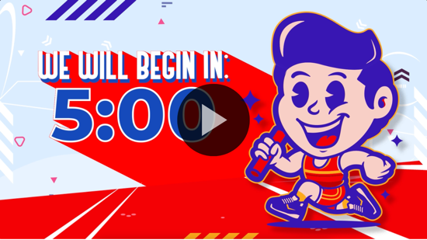

Welcome
Hi, kids! Who is excited to hear about how God wants our faith to dictate our actions? How do we learn about God and what He wants us to do? (Group response) That’s right! One way we learn about God is from His Word, the Bible. (Hold up the Bible.) Each story in the Bible tells us something about God. Today we will hear our Faith Fact that God wants me to take action.

If you are ready to start our story, give me two claps. (Pause for kids to respond.) Oh, I think we can clap louder than that. Are you ready? Let’s do it again. On the count of three, give me two claps. 1, 2, 3. (Pause for kids to respond.) Great job!
- Play the Theme Intro Video.

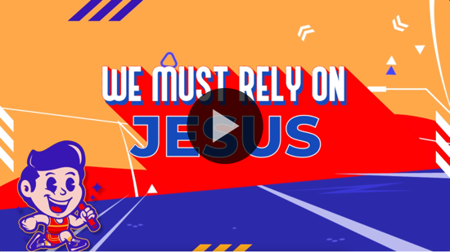

BIBLE TIME | Faith and Works (James 1:19–27; 2:14–26)

Bible Video A
God’s Word is so important in our life. It is important that we take time to see what the Bible tells us. Today, we will learn that God wants me to take action. But first Lizzy and her grandpa will help us with the Faith Verse. Let’s check in with them now.
- Play Bible Lesson Video A.

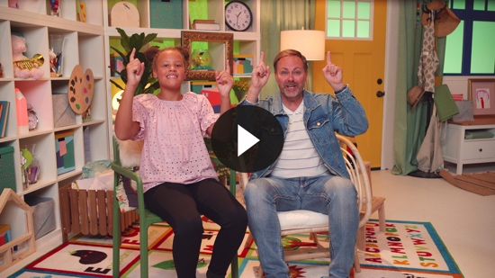

That was so much fun learning all the Faith Verse with Lizzy! Now that we’ve started learning it all, we can practice it together.

Faith Verse
Since Lizzy taught us the rest of the verse, let’s all try to say it together. Say the verse and do the actions with me.
- Show the Faith Verse Slide or Motion Graphic.

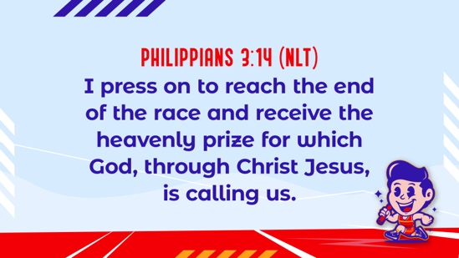

Philippians 3:14 (NLT)
I press on to reach the end of the race and receive the heavenly prize for which God, through Christ Jesus, is calling us.

That was really great! You’re getting the words and actions!

WORSHIP
Let’s spend some time singing songs and thanking God for His Word!

Praise
Are you glad God made you and me? High-five your neighbor. (Group response)
Are you glad God gave us the Bible? High-five your other neighbor. (Group response)
Are you glad God helps you remember and do what you’ve learned? Pat your head five times. (Group response)
Who wants to thank God? Rub your belly three times. Bonus points if you can pat your head and rub your belly at the same time. (Group response)

Prayer
Now let’s all bow our heads and pray together. You can say the words aloud after me.

Dear God, thank You for Your Word, the Bible. Thank You for helping me to have faith in You and to do what You’ve said in Your Word. Amen.

Sing
One way to give God thanks is worshipping Him by singing.
- Lead the kids in singing one or two songs. See suggestions at the beginning of the session.

BIBLE TIME continued | Faith and Works (James 1:19–27; 2:14–26)

Bible Video B
Now that we’ve worshipped God by singing, let’s check back in and see what Lizzy and her grandpa are up to.
• Play Bible Lesson Video B.

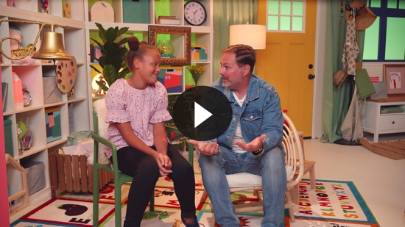

Wow! That was an awesome science experiment. I love that God gave us the Bible to help us know what to do. Every day we can take action and do what He says. This reminds me of our new Faith Fact.

Faith Fact
  - Play the Faith Fact Sound video.

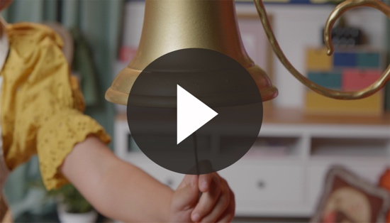

Oh! That’s become one of my favorite sounds. Do you know what it is? (Group response) That’s right, it means it’s time to hear our Faith Fact for today.
- Show the Faith Fact Slide or Motion Graphic.

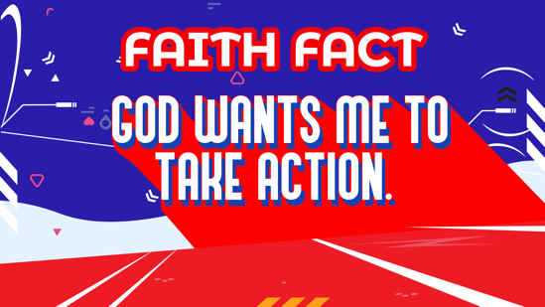

Can you say that with me on the count of 3? 1, 2, 3. God wants me to take action.

Let’s shout it out one more time. God wants me to take action. I’m so excited to learn today how God wants us to take action.

Response Time

Consider playing a worship song softly in the background while kids pray.
Today we got to see Lizzy take action and invite a friend to church. What are other ways we can take action on things God teaches us? (Praying, being kind to others, listening to our parents, etc.) That’s right! I’m excited to start taking action in my life! How about you? (Group response)
Closing
Did you have fun today, kids? We’ve heard that God wants me to take action. We’ve worshipped God by praising, praying, and singing. We’ve reviewed our Faith Verse, too. This week, let’s all try to remember what we heard about today and take action from what God has said in the Bible.
  - Play the Faith Fact Sound video.

Now, what are we supposed to do? (Shout out the Faith Fact.)
- Show the Faith Fact Slide or Motion Graphic.

Let’s say our Faith Fact now. God wants me to take action. Great job, friends!

Dismissal to Small Groups
Now it’s time to head to small group with your friends and do some more fun activities.
- Dismiss the kids by groups.

Leader Tip: This can be done by assigning colors to teams or by age groups. Note that some preschoolers may not know their age. Using a colored sticker, jersey, or wristband will help separate the kids and help identify their small groups.

SMALL GROUP (25 Minutes)
See supplies and prep instructions at the beginning of the session or in each activity below.

Leader Tip: All groups can do each activity at the same time. If you choose to rotate, you will need at least one leader per group.

Circle 1

GROUP CONNECTION

What Should You Do?
You Will Need | Getting Ready
- Ball or stuffed toy  - Music player (stereo, phone, etc.)  - Kids worship music (preferably songs used in Large Group) | No prep is needed for this activity.

Goal: Kids will be reminded to take action on the things God teaches us in the Bible.

Let’s sit in a circle. We have learned so much today. Now, we’re going to take time to share things we have learned. When I play the music, we will pass the ball around the circle. When the music stops, whoever has the ball has to say something God has taught them that they can take action on.
- If a kid can’t think of anything, help them think of something or have them say the Faith Fact.
- During the activity, interrupt and practice the Faith Fact. God wants me to take action.
- Play the Faith Fact Sound video.

- Show the Faith Fact Slide or Motion Graphic.

God wants me to take action. That was great!

Circle 2

ACTIVITY PAGE TIME

God Wants Me to Take Action
You Will Need | Getting Ready
- Activity Page, one per kid  - Crayons | - Print copies of the Activity Page, one per kid.

Goal: Kids will remember something God has taught them that they are doing.
The Bible has taught us so many things. What is one thing you have learned from the Bible? (Allow responses.) God wants us to take the things we learn and do them. Our Faith Fact for today tells us that God wants me to take action. Can you draw a picture of you doing something you learned from the Bible?
- If kids need help thinking of what to draw, here are some examples of things the Bible teaches.
- Love God
- Love others
- Listen to teachers
- Obey parents
- Forgive others when they have been unkind
- Go to church
- Give money to church
- Help others by giving food or clothing

Circle 3
FEET-TO-FLOOR GAME TIME

Take Action
You Will Need | Getting Ready
- Small to medium square box  - Card stock or construction paper  - Marker  - Scissors  - Tape or glue stick | - Write or tape the actions on the box, one on each side.

Goal: Kids will learn how to take action.

Who remembers our Faith Fact for today? (Group response) God wants me to take action. We are going to play a game. (Show box.) On each side of this box is an action. (Read actions.) You each will take turns rolling the box. I will read the action for you. Whatever it lands on, you will do that action. When you are done, shout the Faith Fact: God wants me to take action.
- With the marker, write one action on each side of the box. To cover text or art, write the actions on paper, cut them apart, and tape or glue one to each side of the box.
- Use any actions you choose. Below are some examples:
  - Jump up and down
  - Do a jumping jack
  - Do a deep knee bend
  - High-five your neighbors
  - Act like a monkey
  - Act like a dog or cat

Circle 4

HANDS-ON LEARNING

Make a Mirror
You Will Need | Getting Ready
- Hands-On Learning Page, one per three kids  - Card stock or construction paper  - Scissors  - Aluminum foil  - Crayons  - Glue Sticks | - Print copies of the Hands-On Learning Page on card stock, one per three kids plus an extra. Cut apart the mirrors and give one to each kid.  - Cut out aluminum foil ovals the size of the mirrors, one per kid.  - Make a sample of the Hands-On Learning Page craft.

Goal: To remind the kids they are reflections of God that should be doing what God told us to do in the Bible.
Here’s our chance to make our own mirror. We will color and decorate the outside edge of the mirror. Then we will glue this piece of foil to look like the mirror. As we make this mirror, let’s remember that God wants us to take action. That means He has a job for you and for me. It doesn’t matter how big or small you are; you can always make a difference.

FAITH FACT RECAP
- Display the Faith Fact Slide or Motion Graphic as parents are coming into the room.
- Maximize the time you have with your kids, so that parents see what their kids have learned. Have the kids repeat the Faith Fact and then dismiss them to their parents.

One thing I want you to remember from today is our Faith Fact. Let’s say it together. God wants me to take action.

DISMISSAL
- Send home the Activity Page and the Hands-On Learning Page craft with each kid.
- Remind parents that there are Family Devotions available on the app to do with their kid.
- Tell everyone the date and time for the next session.

