Ararat Gateway
Gateway Newsletter: Our God of Providence and Divine Appointments
April 4, 2022

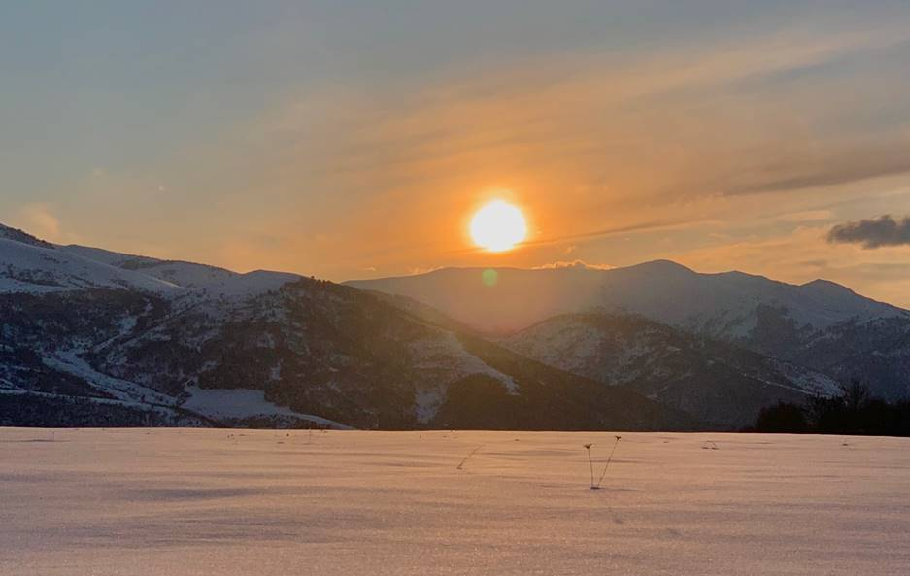
Sunset over the Mountains in Northern Armenia

Almost every day I have a testimony or two of divine appointments or sovereign moments that God has set up for me. I cannot possibly share them all, and each one could be a newsletter within itself. Again, thank you for your prayers and support. Below are a few recent stories:

February 7th, 2022: A Man Who Listened to the Holy Spirit (and I was blessed he did).

As I drove up to my house, I got out of my car and saw an elderly man I knew. We greeted each other. He looked at me intently, and said to me in Armenian, "Jacob, I know what you are doing for my country. When I feel better, I want to serve with you. For now, I want to give you my pension that I receive." He then pulled out a lump of money and gave me 100,000 dram (about $200). I was shocked. I asked, “you are giving this?” He said, "this is from the Lord, this is for ministry. God bless you." Then he hugged me and prayed over me. He told me he prays for me every morning. I felt so humbled today, and so blessed. I went in my home and had a prayer of thanksgiving. I am still shocked and humbled. Our Lord is good during the good times and the difficult times.
March 29th, 2022: Missionaries detained in Turkey, and the power of prayer.

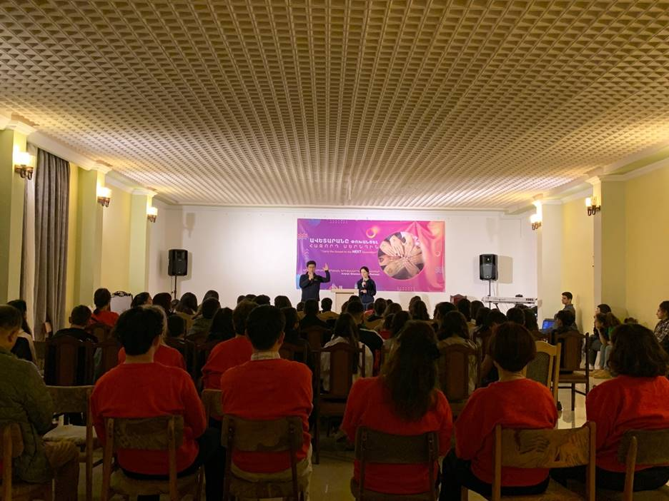

Armenian Youth Conference
From March 28-30th, I took part of a Youth Conference. This was organized by Ararat Mission Center, whom I partner with, and I was invited to be a speaker. I spoke three times on the Lordship of Christ: 1) over our bodies, 2) over our wills, and 3) over our future. My goal was to have them surrender their bodies, will, and desires for the service of the Lord and His glory. I wanted these 12–18-year-olds to recognize their talents that the Lord has given. I wanted to also inform them of the unreached and spiritually lost nature of their surrounding Muslim countries (Armenia is surrounded by Turkey, Azerbaijan, Iran, also Dagestan, Chechnya, Abkhazia are close by too). Many surrendered to the Lordship of Christ, others made decisions to reach their neighbors for the Kingdom of God.
Watch this sixteen-year-old girl decide to take the gospel to the Muslim world (one minute): https://youtube.com/shorts/r2JdoG3EDVY?feature=share
It was on March 29th, at 9:13 PM that I received a disturbing message from a pastor of one of our supporting churches in Missouri. Apparently, a team of four were traveling to do missions and humanitarian work in another Middle Eastern country, and three of these pastors (of whom I know), were detained by the police in Turkey, and their bags confiscated. They were told they were transporting “illegal” goods, (humanitarian aide), and they were being interrogated at that moment. The pastor in America (from their church) was asking my advice for what we could do. I had the number for American Services at the Istanbul Consulate on hand, and I gave a few pointers, (as I have had to contact our Embassy and Consulate in Turkey on many occasions for similar reasons).
Time of prayer for the detained missionary team
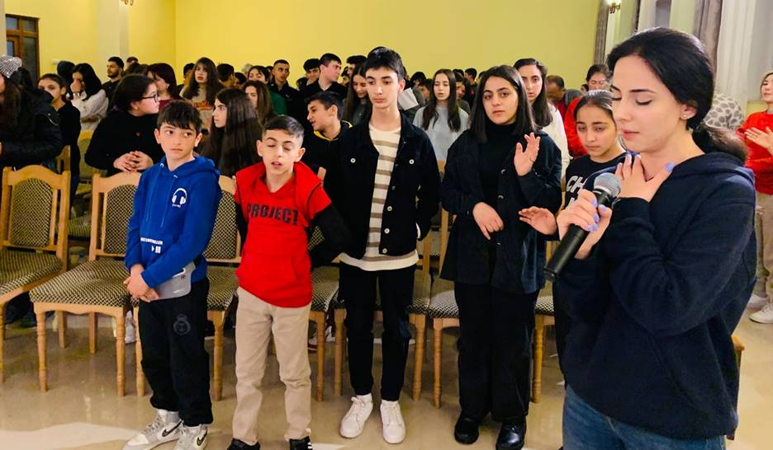

After this phone call and subsequent messages, I went back and spoke to the youth, and informed them that we had brothers detained on their way to spread the gospel to Muslims, and that they needed prayer. We had around 120 gathered that night for worship. At 9:35 PM our entire group broke out in prayer, and four youths also lead the group in prayer for those being detained. We concluded our prayer about 9:57 PM. Later that night at 12:51 AM, I received a message, “the team was just released. Thanks for the prayers and support!!!!”

Watch the prayer of the youth for the detained team (one minute): https://youtu.be/jLK_eIELZ4s
The next morning as we told the youth, they broke out cheering and praising the Lord. At 2:08 PM that day (March 30), I received a message from a Kurdish man in Turkey, that I used to serve with very closely, as he was one of my Kurmanji teachers. The message said, “Don’t worry man, he is safe.” I had not heard from this person in a long time, and was more puzzled by the message. He then sent a picture of him and the lead pastor that was arrested the previous night. I was shocked, how did these two connect? I began to get messages from other pastors that were wondering who the Kurdish man is that is helping the missionary team. God, through his divine providence, brought my Kurdish Christian friend into the lives of those detained missionaries (from a supporting church of ours), to help them with the legal work that they now were in the midst of with the Turkish government! I told my pastor friends, "you can trust this man, I have known him since his conversion, and we have worked together for years." It was there, at the law office in Istanbul, that I was speaking with the pastor from America, my Kurdish friend, and then the notary public asked who I was. It turns out she was Armenian! I then spoke to her in Armenian and thanked her for her help for our pastors. Eventually, the team made it to their destination.
The last day of our youth conference we had the youth give testimonies of the parts of the conference that most impacted them. Out of all that I listened to, it was the time between 9:35 PM – 9:57 PM. That was when they were praying for the detained missionary team to be released. I heard repeatedly that they felt something powerful from that prayer time, and that was the most meaningful and impactful time for them. It was no coincidence that I was trying to prepare the next generation of Armenian missionaries for Turkey and the surrounding Muslim countries, and that these youth ended up battling in a spiritual way, for a real situation, real time!

March 31st, 2022: I was delivered from the mouth of the dog.
“Enoch walked with God,. . .” (Genesis 5:24). It has been my practice for many years, something that I learned from my father, to take regular prayer walks. I find it difficult to have a lengthy prayer time at home, as there are too many distractions. In Armenia, my prayer “closet” is known as the hamalir (concert hall), and Tsiternakaberd Memorial Complex - this is the area where there is a memorial and museum concerning the Armenian Genocide.

I was about one-hour into my prayer walk, (and had about one more hour to go). I was on the outskirts of the main path, in a remote area, where no one goes. I was surrounded by trees, bushes, and the path was overgrown. I have done these prayer walks in this area for years. As I began to pray for my next subject, I was suddenly attacked. Or I should say an attempted attack. Six dogs suddenly surrounded me. One of them was huge, it was a shepherd type dog. This one was the leader of the pack. They all had their teeth out, barking, growling and coming at me. They had surrounded me. I have to admit, that I was startled and not expecting this.

Many of you know I taught MMA and self-defense – including self-defense against dogs. I was prepared to kill the large dog first. I started to walk away from them, or at least tried to. I also felt like this was some sort of spiritual attack. You can see places in the Bible where animals were possessed, or used by spiritual beings, including God using them. Demons are no exception to this rule, as they are looking for a physical body to relocate.

I immediately looked at the dogs, and shouted, “In Jesus’ name, stop.” The dogs stopped barking, turned around, and walked away. I cursed the dogs for what they had done (maybe they were demonized, maybe they were just “bad” dogs, but whatever the situation, they were out of line and outside of the order of creation). This was a short distraction and then I continued my prayer walk.

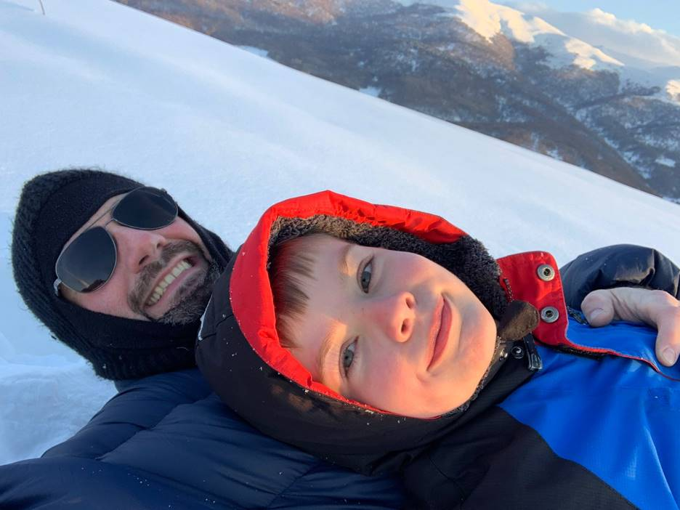

I hiked up a snowy mountain with Dow to watch the sunset.

Prayer Requests:

1. April 7-10, is the orientation weekend for our next missions school. Pray for the many students, guest students, and speakers that are gathering this week for our opening ceremonies. This will prepare them for the Muslim world. Our school continues until December of this year.
2. April 4-May 14, we have many teams desiring to serve in our ministry in Agarak during these days, pray God will lead them, lead us, and give us wisdom in what and how to do work together. Around 20 or more may be involved and we need the Spirit’s guidance in how to work together.
3. April 14, I have three guests arrive. We will drive to Agarak for our Easter Celebration. One of the guests will stay as an “intern” for us until the end of June. Pray for safety in our travels, and that many more will place their faith in Christ in the Agarak area. We will also have a guest preacher for the Sunday Easter Service, along with many other guests coming to Agarak. These guests will also be helping us with our Business as Missions endeavors, as well as having good fellowship!
4. April 30, I have another close guest that will arrive, again more travel to Agarak, and planning for Business as Mission.
5. Pray for our Business as Missions endeavor, as I want to have our legal documents complete by the end of April. However, may His will and His timing be done.
6. Pray for my son Dow, he is taking an importance test soon. He is in fourth grade. He is taking a comprehensive exam that will determine if he will go onto the 5th grade in the Armenian private school he is currently at – it is the best private school in Armenia. He is not stressed, and we have a tutor working with him often to prepare him. Keep this and his spiritual walk, along with our daughter, Annalee, in your prayers.

I am grateful for you all, and your prayers.

For the King,
Jacob
My daughte, Annalee. We had some fun in the snow.
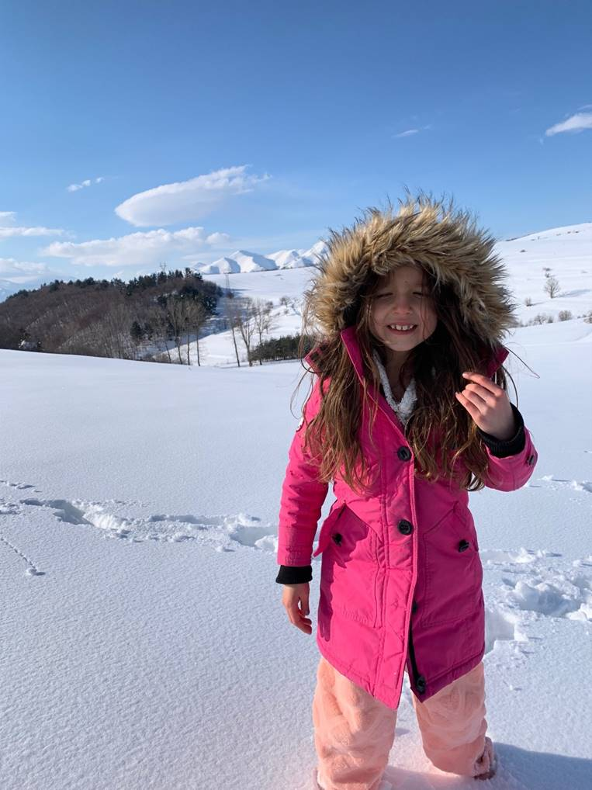
My six-year-old daughter’s first attempt to draw a building, this is a medieval Armenian church. She looked at the painting and tried to draw it.

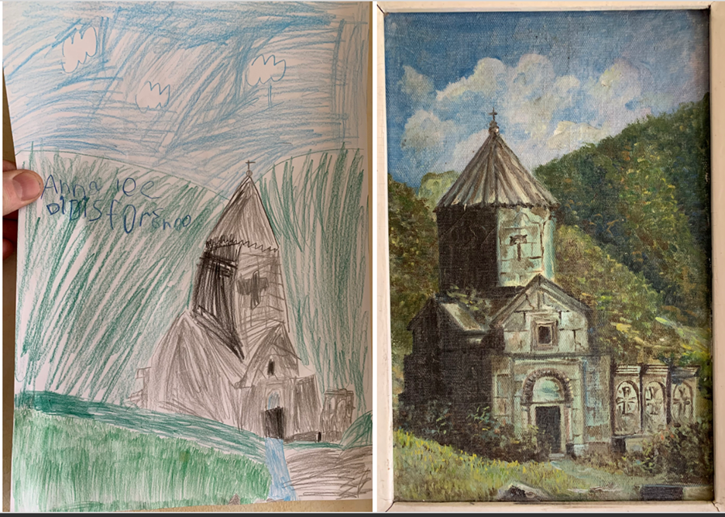

Support Financially

Online Giving:
https://pushpay.com/pay/visitgracewaymissionsasia/9JdQmltFxwjFGim-gy-gJg
Giving Type: Asia/Jacob

Checks:
Checks should be payable to: Graceway, and in the memo line please write the designation for: Asia/Jacob.

Checks can be mailed to:
Graceway
Attention; Accounting Office
5460 Blue Ridge Cut-off
Kansas City, MO 64133

Support Financially
Under Giving Type Select: Asia/Jacob

Copyright © 2022 Ararat Gateway, All rights reserved.
You are receiving this email because you opted in via our website.

Our mailing address is:
Ararat Gateway
15358 Twin Pines Road
Lowell, Arkansas 72745

Add us to your address book

Want to change how you receive these emails?
You can update your preferences or unsubscribe from this list.

