Casa Hogar del Niño de Acapulco is a children’s home that provides care, shelter, strength, love and hope in a Christian environment for orphaned and abandoned children in Acapulco, México.
We believe this is a home where each child can get to know a loving and faithful God who created them and has a divine purpose for their lives.
"The King will reply, 'I tell you the truth, whatever you did for one of the least of these brothers of mine, you did for me."
Matthew 25:40

Hello family! lots of things happening this month!
First of all we want to thank our dear sister Kaye and the Orangewood church for helping us to purchase a bigger monitor for the office, which will be used to take courses and classes for the staff.

Before
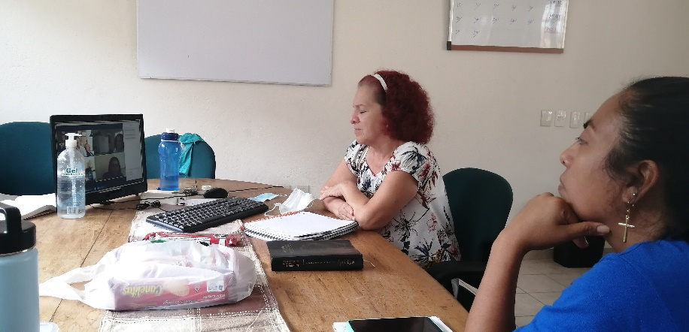
After!
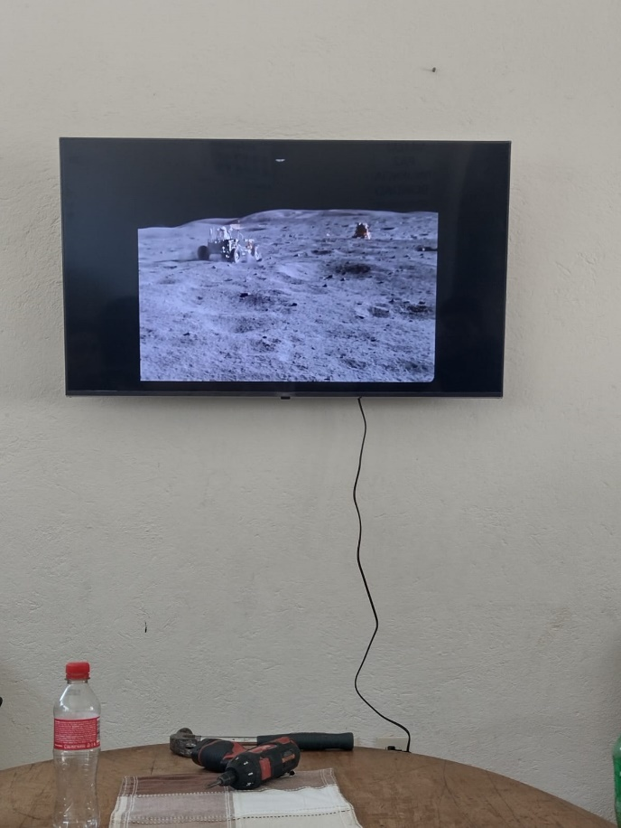
THANK YOU
_______________________

We welcome our beloved sisters, Dawn and Janet, who visited Casa Hogar, bringing with them a lot of joy and, as always, our children were super happy!

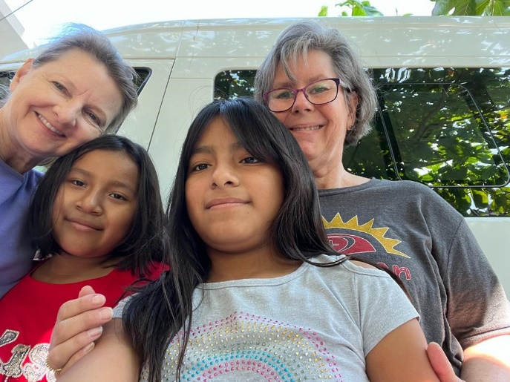
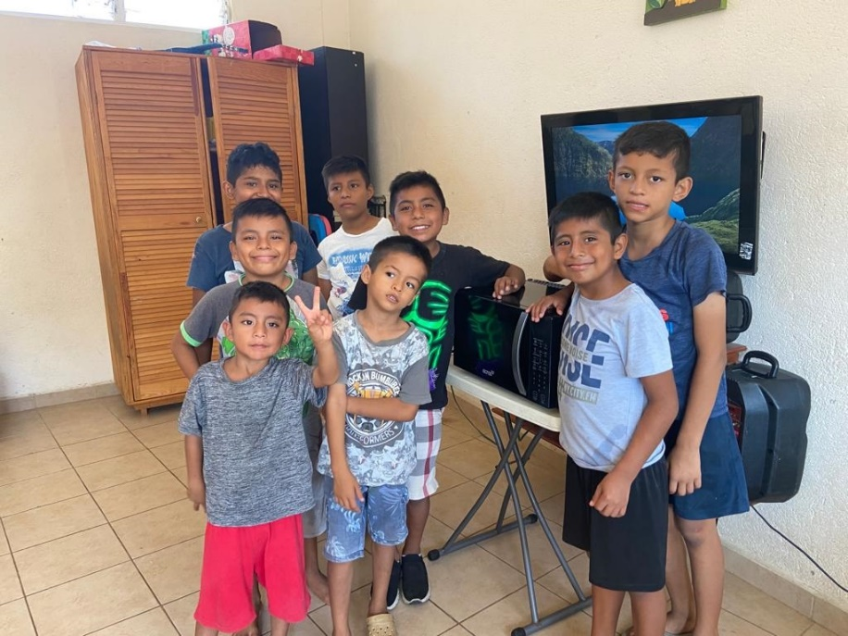
Happy to have a microwave! (The girls also got one!)
Thank you Janet.

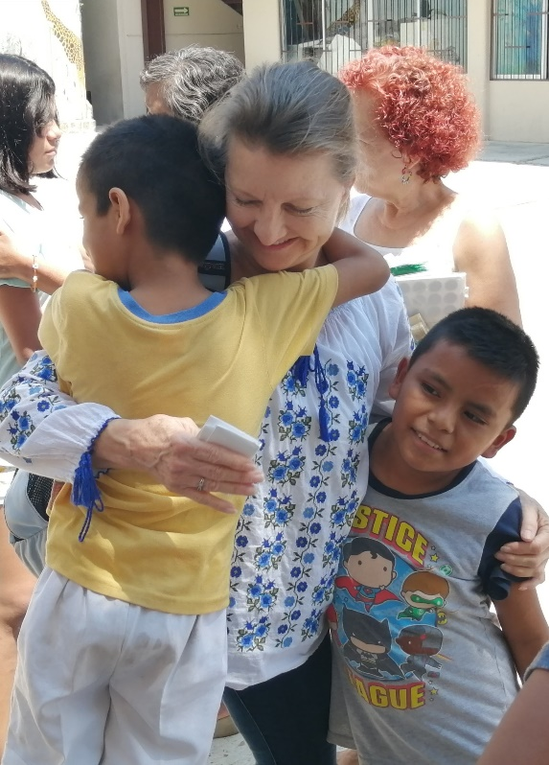

Thank you for sharing your gifts, your time and your love!
GOD BLESS YOU

When Holy Week arrives, our hearts are filled with great joy for the celebration of the greatest proof of love and power that God could show humanity: the death and resurrection of Jesus Christ to fulfill his plan of redemption.
Our Easter activities:
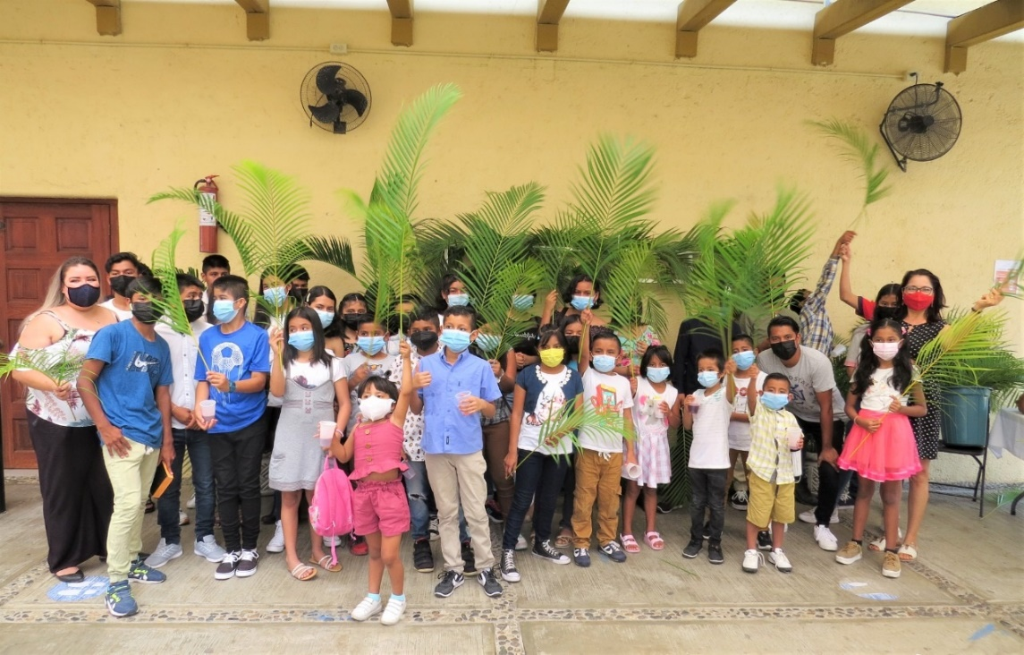

"Hosanna to the Son of David: Blessed is he that cometh in the name of the Lord, Hosanna in the highest" Mat 21:9

HOLY FRIDAY
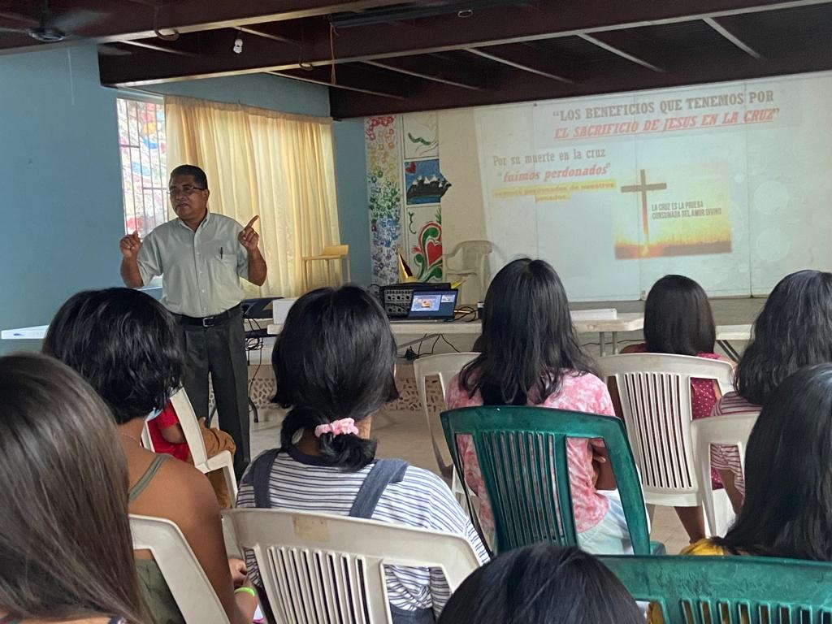
Easter Sunday. Presbyterian churches gather very early in the open-air auditorium called Sinfonia del Mar (Symphony of the sea) to praise and glorify the name of Jesus.
He is alive, he is risen!
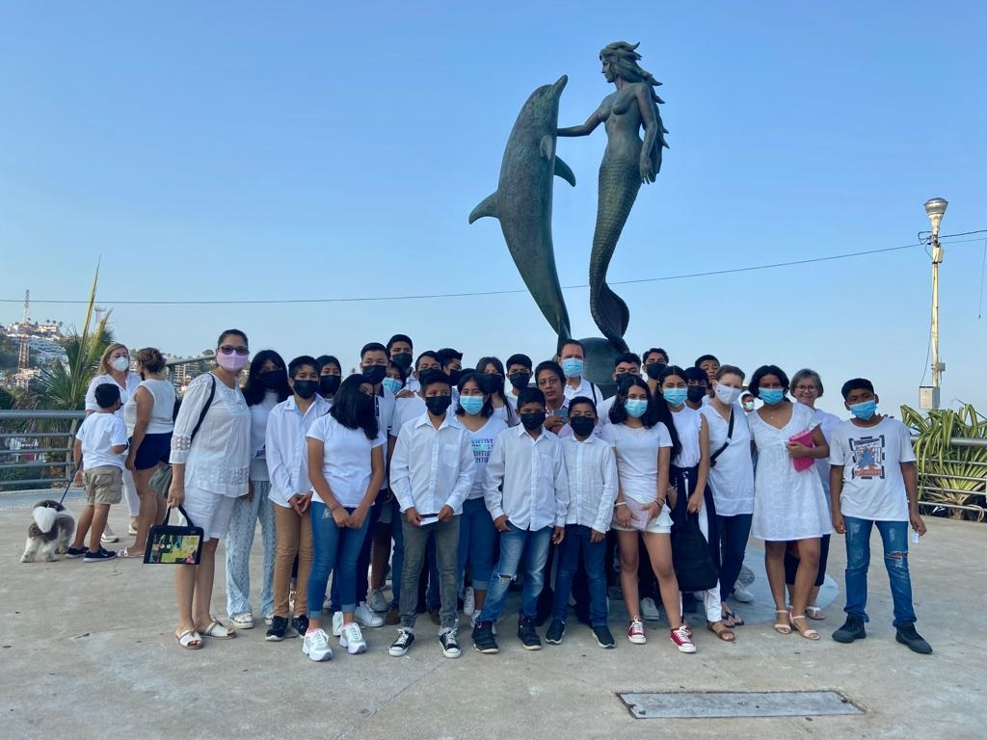
"Why seek ye the living among the dead? He is not here, but is risen."
Luke 24: 5b - 26a
Hallelujah!
_______________________________________

In Mexico we celebrate Children's Day on April 30th, so our kids had some fun! Take a look..
We thank God for the people who made the celebrations possible for our children.

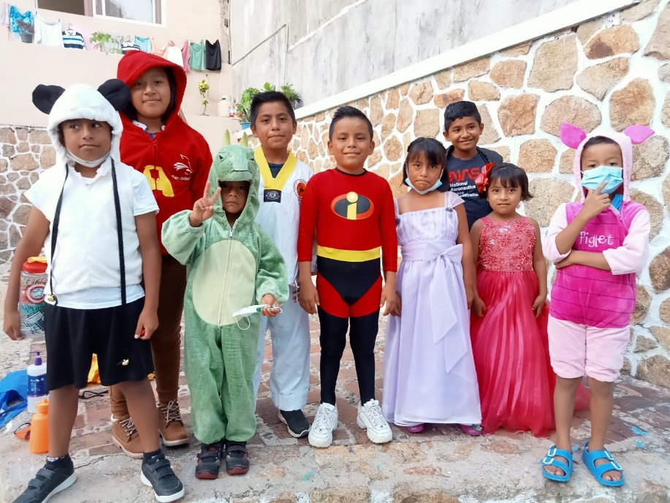
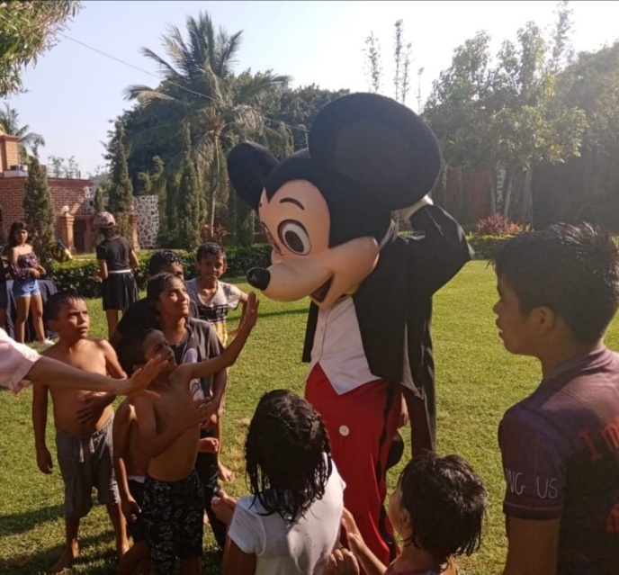
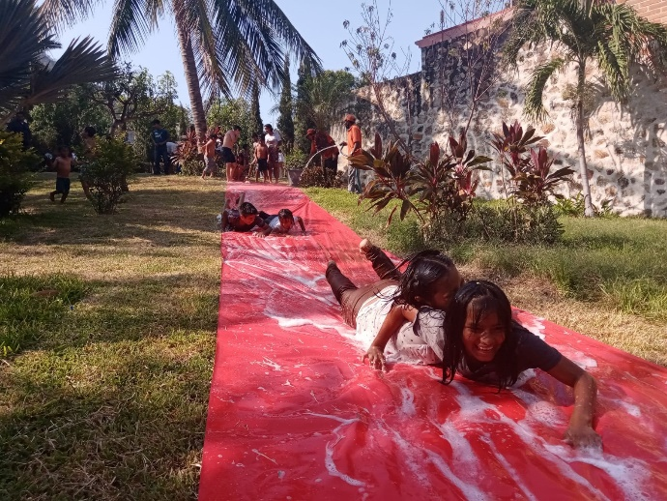
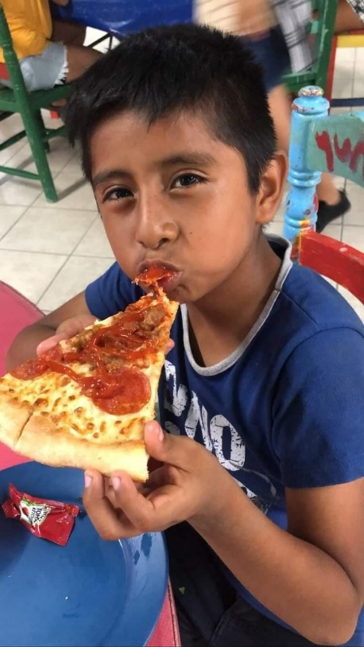

We are all important to God and He loves us from the moment of conception and before! However, children have a special place in God's heart.
Jesus recognized the value of children and gave us an example of how we should receive the kingdom of God. Have you ever seen a child receive a gift? He admires it and shows his pleasure by jumping and laughing. This is how we should receive the kingdom of God in our hearts, with great joy, valuing it as the most precious treasure we can receive (Matthew 13:44) because that is exactly what it is!
_______________________________________
We want to invite you to be part of the incredible work God is doing in the lives of the children at Casa Hogar!!
Come and Join us!
Please contact or visit us at:
casahogaracapulco123@gmail.com
or
www.jarsofclayministries.org

Benito turned 14
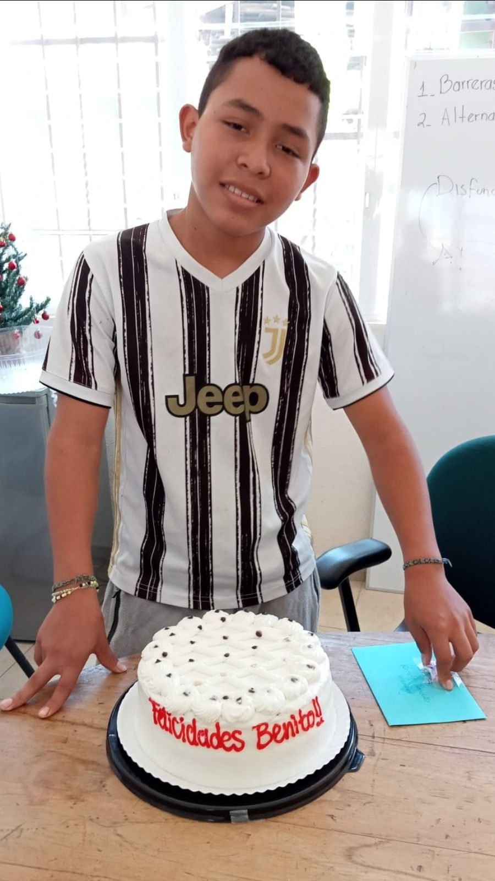

Ezequiel turned 14
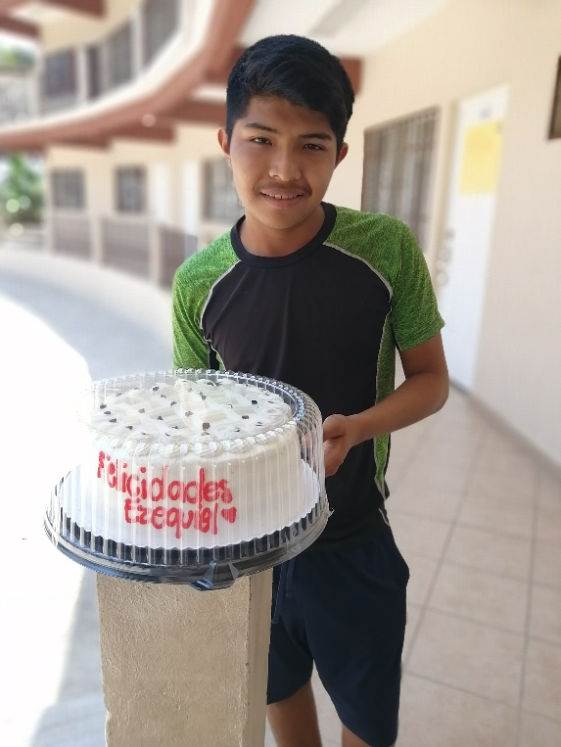

Adilene turned 15
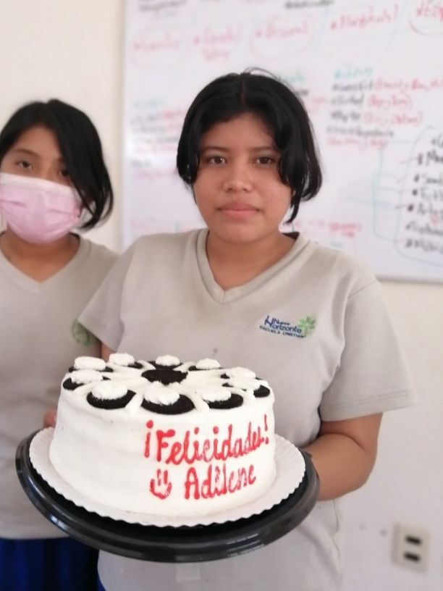
Naty turned 18
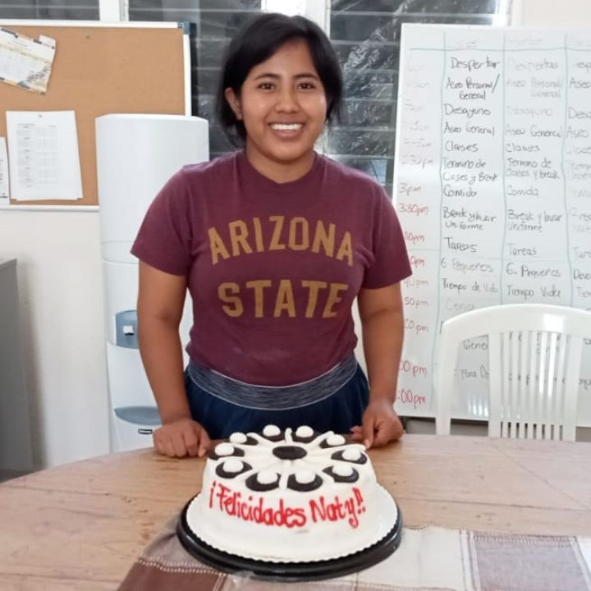

Join us in Prayer
We want to give thanks to God:
- For His great love and care for the children at Casa Hogar
- For His daily provision
- For each person who is part of this ministry in Mexico and the US
- For the people who will come in summer, may God speak his will to their lives
- For your faithful prayers
- For the life of Benito, Ezequiel, Adilene and Naty, keep working in their lives

Please join us in praying:
-For the people of Ukraine and Russia, for strength for pastors, missionaries and to keep our brothers safe
-For our brothers and sisters who are sick or in recovery
-For the staff at Casa Hogar (strength, fullness of the Spirit, communion among them, good testimony before the children)
-For each person who is supporting Casa Hogar
-For more people involved in Casa Hogar, interns, volunteers, summer groups.
-That we can carry out life projects in each child
- For "Jars of Clay Ministries" that the Lord will continue to provide.
How Can We Pray for You?
We at Casa Hogar love praying for you. If you have a specific request please email casahogaracapulco123@gmail.com so that we can pray for you!

